Simulation-Based Frequency-Domain Characterization of a Microwave Two-Port Network Using S-Parameters and Network-Analyzer Emulation

AIM
To characterize a microwave two-port network over the 8–12 GHz frequency range using MATLAB by simulating S11 and S21, calculating return loss and insertion loss, identifying the optimum frequency, and plotting the frequency response.

PROCEDURE
- Open MATLAB and create a new script file.
- Clear the Command Window, workspace, and open figures using clc, clear, and close all.
- Set the start frequency to 8 GHz, stop frequency to 12 GHz, frequency step to 0.01 GHz, and reference impedance to 50 ohms.
- Create the frequency vector and define the example model's center frequency as 10 GHz and bandwidth as 1 GHz.
- Calculate the reflection coefficient S11 and transmission coefficient S21 at every frequency point.
- Convert the magnitudes of S11 and S21 into decibels.
- Calculate return loss as the negative of S11 in dB and insertion loss as the negative of S21 in dB.
- Find the frequency at which the magnitude of S11 is minimum and obtain the corresponding S-parameter and loss values.
- Display the optimum frequency, S11, S21, return loss, and insertion loss in the MATLAB Command Window.
- Plot S11 and S21 against frequency, then plot return loss and insertion loss against frequency.

PROGRAM
clc;
clear;
close all;
% Input parameters
fstart = 8; % GHz
fstop = 12; % GHz
df = 0.01; % GHz
Z0 = 50; % Reference impedance in ohms
f = fstart:df:fstop;
% Simulated two-port network response (example model)
f0 = 10; % Center frequency in GHz
BW = 1; % Bandwidth in GHz
S11 = 0.3*(f-f0)./sqrt((f-f0).^2 + BW^2);
S21 = 0.95./sqrt(1 + ((f-f0)/BW).^2);
% Convert to dB
S11dB = 20*log10(max(abs(S11),1e-6));
S21dB = 20*log10(abs(S21));
% Return loss and insertion loss
RL = -S11dB;
IL = -S21dB;
% Find optimum frequency (minimum S11)
[~,idx] = min(abs(S11));
fopt = f(idx);
fprintf('MICROWAVE TWO-PORT NETWORK RESULTS\n');
fprintf('Optimum frequency = %.2f GHz\n',fopt);
fprintf('S11 at optimum frequency = %.2f dB\n',S11dB(idx));
fprintf('S21 at optimum frequency = %.2f dB\n',S21dB(idx));
fprintf('Return loss = %.2f dB\n',RL(idx));
fprintf('Insertion loss = %.2f dB\n',IL(idx));
% Plot S-parameters
figure;
plot(f,S11dB,'r','LineWidth',1.5);
hold on;
plot(f,S21dB,'b','LineWidth',1.5);
grid on;
xlabel('Frequency (GHz)');
ylabel('Magnitude (dB)');
title('Microwave Two-Port Network S-Parameters');
legend('S11','S21');
% Plot return loss and insertion loss
figure;
plot(f,RL,'r','LineWidth',1.5);
hold on;
plot(f,IL,'b','LineWidth',1.5);
grid on;
xlabel('Frequency (GHz)');
ylabel('Loss (dB)');
title('Return Loss and Insertion Loss');
legend('Return Loss','Insertion Loss');

OUTPUT
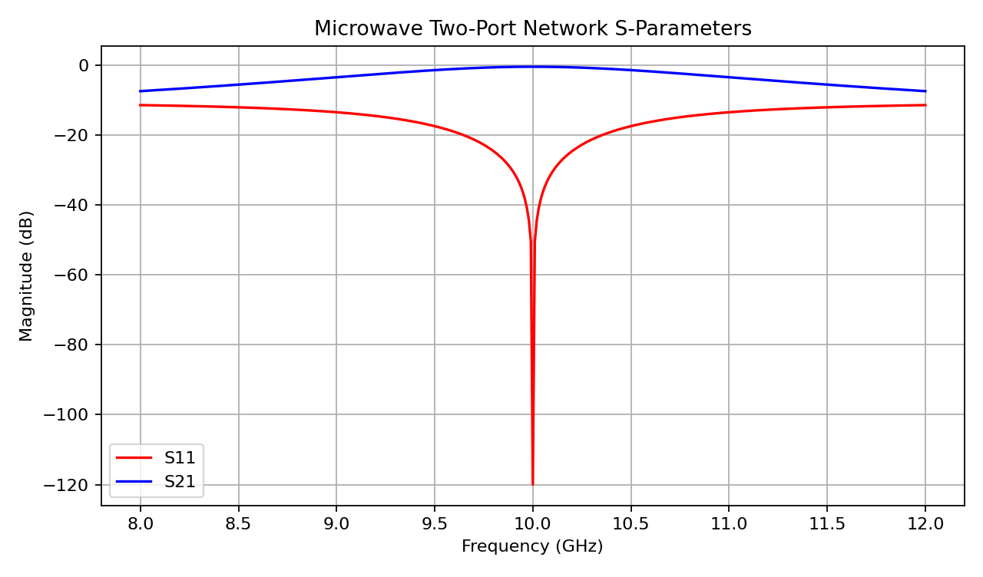
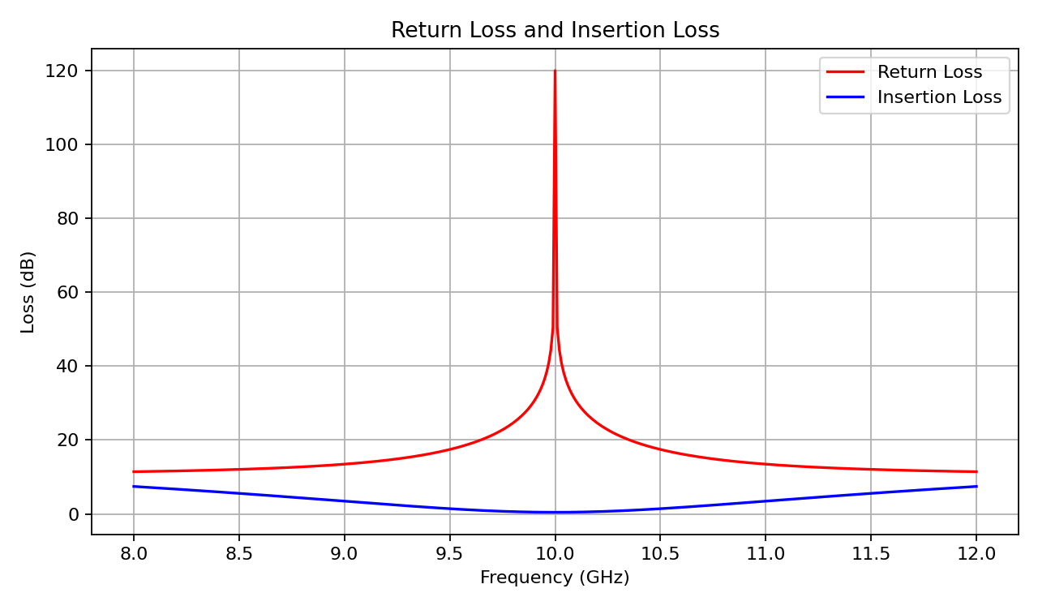
Optimum frequency = 10.00 GHz
S11 at optimum frequency = -120.00 dB
S21 at optimum frequency = -0.45 dB
Return loss = 120.00 dB
Insertion loss = 0.45 dB

RESULT
The frequency-domain response of the example microwave two-port network was simulated using MATLAB over 8–12 GHz. The S11 and S21 parameters were calculated and plotted, and return loss and insertion loss were obtained from their decibel values. The optimum frequency was identified as the point where the magnitude of S11 is minimum. The plots provide a visual characterization of the network response across the selected band.

