Numerical Simulation and Performance Analysis of Microwave Transmission Lines and Two-Port Networks Using Scattering Parameters

AIM
To analyze the S-parameters (S11, S21, S12 and S22), return loss, insertion loss, and transmission efficiency of a transmission line over the frequency range of 1 GHz to 10 GHz using MATLAB.

PROCEDURE
- Open MATLAB and create a new script file.
- Clear the command window, workspace, and previously opened figures using clc, clear, and close all.
- Define the frequency range from 1 GHz to 10 GHz using 100 sample points.
- Set the speed of light, characteristic impedance, load impedance, attenuation constant, and transmission-line length.
- Calculate the phase constant beta and propagation constant gamma for each frequency.
- Calculate the input impedance Zin of the transmission line.
- Determine the S-parameters S11 and S21, and set S12 = S21 and S22 = S11 as in the supplied program.
- Calculate return loss, insertion loss, and transmission efficiency from the S-parameters.
- Plot the S-parameter magnitudes, return loss and insertion loss, and transmission efficiency against frequency.
- Run the script, observe the three plots, and read the 1 GHz values printed in the MATLAB Command Window.

PROGRAM
clc;
clear;
close all;
f = linspace(1e9, 10e9, 100);
c = 3e8;
Z0 = 50;
ZL = 40;
alpha = 0.02;
L = 0.05;
beta = 2*pi*f/c;
gamma = alpha + 1i*beta;
Zin = ZL .* cosh(gamma*L) + Z0 .* sinh(gamma*L);
Zin = Zin ./ (cosh(gamma*L) + (ZL/Z0).*sinh(gamma*L));
S11 = (Zin - Z0) ./ (Zin + Z0);
S21 = exp(-gamma*L) .* (1 + S11);
S12 = S21;
S22 = S11;
RL = -20*log10(abs(S11));
IL = -20*log10(abs(S21));
Eff = abs(S21).^2 * 100;
figure;
plot(f/1e9, 20*log10(abs(S11)), 'r');
hold on;
plot(f/1e9, 20*log10(abs(S21)), 'b');
plot(f/1e9, 20*log10(abs(S12)), 'g');
plot(f/1e9, 20*log10(abs(S22)), 'k');
grid on;
xlabel('Frequency (GHz)');
ylabel('Magnitude (dB)');
legend('S11','S21','S12','S22');
title('S-Parameter Analysis');
figure;
plot(f/1e9, RL, 'r', f/1e9, IL, 'b');
grid on;
xlabel('Frequency (GHz)');
ylabel('Loss (dB)');
legend('Return Loss','Insertion Loss');
title('Transmission Line Performance');
figure;
plot(f/1e9, Eff);
grid on;
xlabel('Frequency (GHz)');
ylabel('Efficiency (%)');
title('Transmission Efficiency');
disp('Simulation completed');
disp(['Return Loss at 1 GHz = ', num2str(RL(1)), ' dB']);
disp(['Insertion Loss at 1 GHz = ', num2str(IL(1)), ' dB']);
disp(['Efficiency at 1 GHz = ', num2str(Eff(1)), ' %']);

OUTPUT
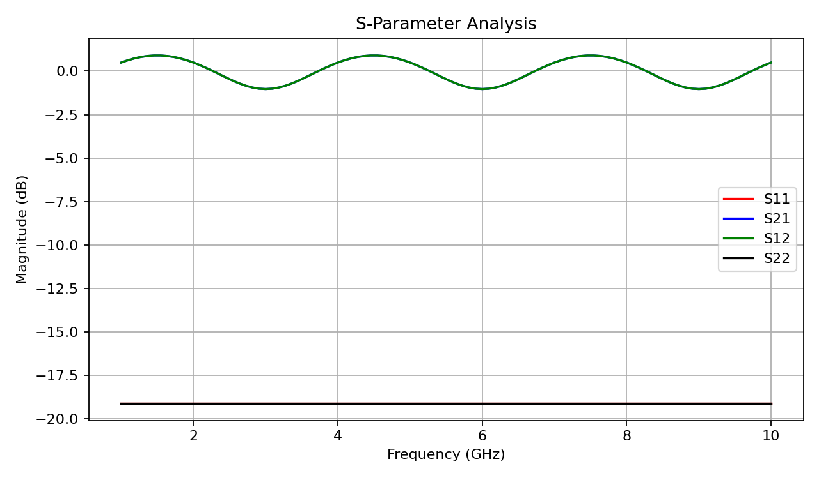
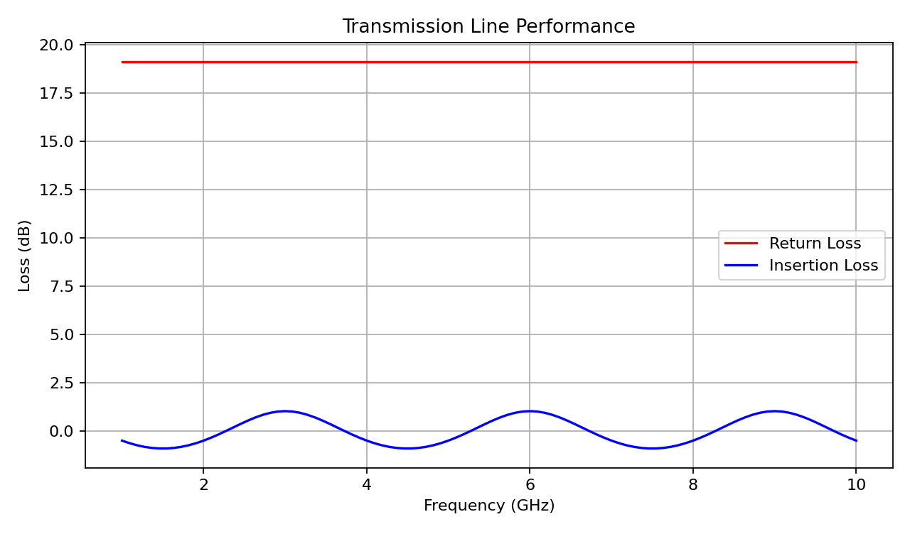
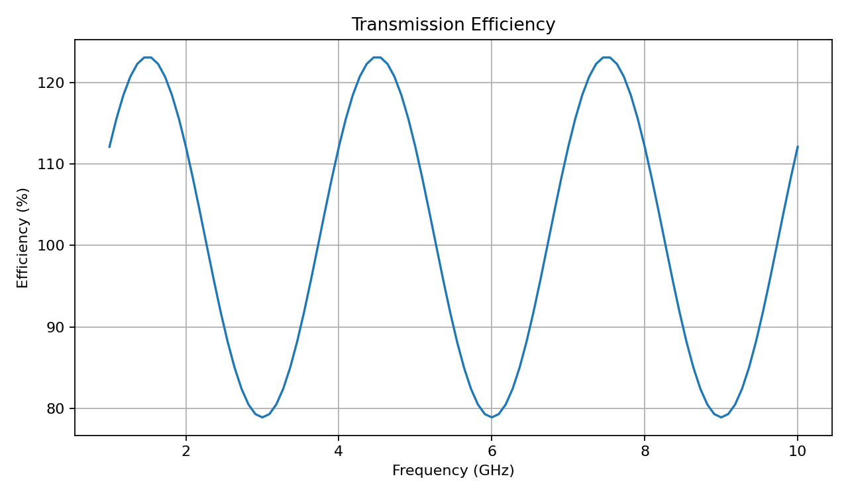

RESULT
The S-parameters of the transmission line were calculated over 1–10 GHz using MATLAB. The program plotted S11, S21, S12 and S22, along with return loss, insertion loss, and transmission efficiency. The numerical values at 1 GHz are displayed in the MATLAB Command Window. The experiment demonstrates how the transmission-line response varies with frequency.

