Numerical Simulation and Spectral Analysis of a Microwave Signal for Frequency-Domain Characterization Using Spectrum-Analyzer Concepts

1. Aim
To generate an amplitude-modulated microwave signal, analyze its frequency spectrum using the Fast Fourier Transform (FFT), identify the carrier and sideband components, and calculate the theoretical AM bandwidth using MATLAB.

2. Software Required
MATLAB

3. Procedure
- Open MATLAB and create a new script named ME_exp14.m.
- Clear the Command Window, workspace variables, and existing figure windows.
- Set the carrier frequency to 10 GHz, modulating frequency to 100 MHz, modulation index to 0.5, and sampling frequency to 50 GHz.
- Generate the carrier signal and message signal using cosine functions.
- Create the amplitude-modulated (AM) microwave signal using the specified modulation index.
- Plot the carrier and AM signals in the time domain.
- Apply a Hann window to the AM signal and calculate its FFT.
- Normalize the single-sided spectrum and convert its amplitude to dBV.
- Identify the lower sideband, carrier, and upper sideband frequencies and display their values in the Command Window.
- Plot the spectrum around the carrier and the wideband spectrum, calculate the theoretical AM bandwidth, and save the spectrum data to a CSV file.

4. MATLAB Program
clc;
clear;
close all;
% Microwave Signal Spectral Analysis Using FFT
%% 1. Input parameters
fc = 10e9; % Carrier frequency: 10 GHz
A = 1; % Carrier amplitude: 1 V
fm = 0.1e9; % Modulating frequency: 100 MHz
mu = 0.5; % Modulation index
fs = 50e9; % Sampling frequency: 50 GHz
T = 10e-6; % Observation time
t = 0:1/fs:T-1/fs;
N = length(t);
%% 2. Generate carrier and message signals
carrier = A*cos(2*pi*fc*t);
message = cos(2*pi*fm*t);
%% 3. Generate AM signal
amSignal = A*(1+mu*message).*cos(2*pi*fc*t);
%% 4. Plot time-domain signals
nShow = round(20e-9*fs);
tShort = t(1:nShow)*1e9;
figure;
subplot(2,1,1);
plot(tShort,carrier(1:nShow));
grid on;
xlabel('Time (ns)');
ylabel('Amplitude (V)');
title('10 GHz Carrier Signal');
subplot(2,1,2);
plot(tShort,amSignal(1:nShow));
grid on;
xlabel('Time (ns)');
ylabel('Amplitude (V)');
title('Amplitude-Modulated Microwave Signal');
%% 5. Calculate FFT spectrum
window = 0.5-0.5*cos(2*pi*(0:N-1)/(N-1));
Y = fft(amSignal.*window);
P2 = 2*abs(Y)/sum(window);
P1 = P2(1:floor(N/2)+1);
P1(1) = P1(1)/2;
if rem(N,2)==0
P1(end) = P1(end)/2;
end
freq = fs*(0:floor(N/2))/N;
spectrum_dBV = 20*log10(max(P1,1e-12));
%% 6. Find carrier and sidebands
[~,iC] = min(abs(freq-fc));
[~,iL] = min(abs(freq-(fc-fm)));
[~,iU] = min(abs(freq-(fc+fm)));
fprintf('MICROWAVE SPECTRUM ANALYSIS\n');
fprintf('Carrier frequency = %.2f GHz\n',fc/1e9);
fprintf('Modulating frequency = %.2f MHz\n',fm/1e6);
fprintf('Modulation index = %.2f\n',mu);
fprintf('Sampling frequency = %.2f GHz\n',fs/1e9);
fprintf('Frequency resolution = %.2f kHz\n',fs/N/1e3);
fprintf('\nSPECTRAL COMPONENTS\n');
fprintf('Lower sideband = %.2f GHz, %.3f V\n', ...
freq(iL)/1e9,P1(iL));
fprintf('Carrier = %.2f GHz, %.3f V\n', ...
freq(iC)/1e9,P1(iC));
fprintf('Upper sideband = %.2f GHz, %.3f V\n', ...
freq(iU)/1e9,P1(iU));
%% 7. Plot spectrum near the carrier
figure;
plot(freq/1e9,spectrum_dBV,'LineWidth',1.3);
grid on;
xlabel('Frequency (GHz)');
ylabel('Amplitude (dBV)');
title('Microwave Spectrum Analyzer Emulation');
xlim([9.5 10.5]);
%% 8. Plot wideband spectrum
figure;
plot(freq/1e9,spectrum_dBV,'LineWidth',1.3);
grid on;
xlabel('Frequency (GHz)');
ylabel('Amplitude (dBV)');
title('Wideband Microwave Signal Spectrum');
xlim([0 15]);
%% 9. Calculate theoretical bandwidth
BW = 2*fm;
fprintf('\nTheoretical AM bandwidth = %.2f MHz\n',BW/1e6);
fprintf('Lower sideband frequency = %.2f GHz\n',(fc-fm)/1e9);
fprintf('Upper sideband frequency = %.2f GHz\n',(fc+fm)/1e9);
%% 10. Save spectrum data
results = table(freq(:)/1e9,P1(:),spectrum_dBV(:), ...
'VariableNames',{'Frequency_GHz','Amplitude_V','Amplitude_dBV'});
writetable(results,'microwave_spectrum_results.csv');
fprintf('Spectrum data saved to CSV file.\n');

5. Output
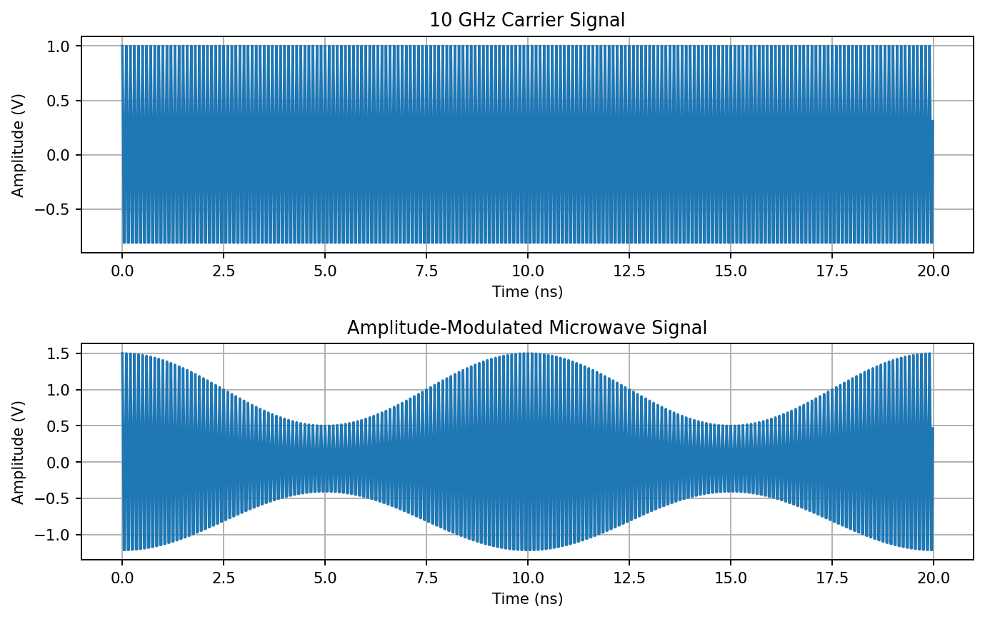
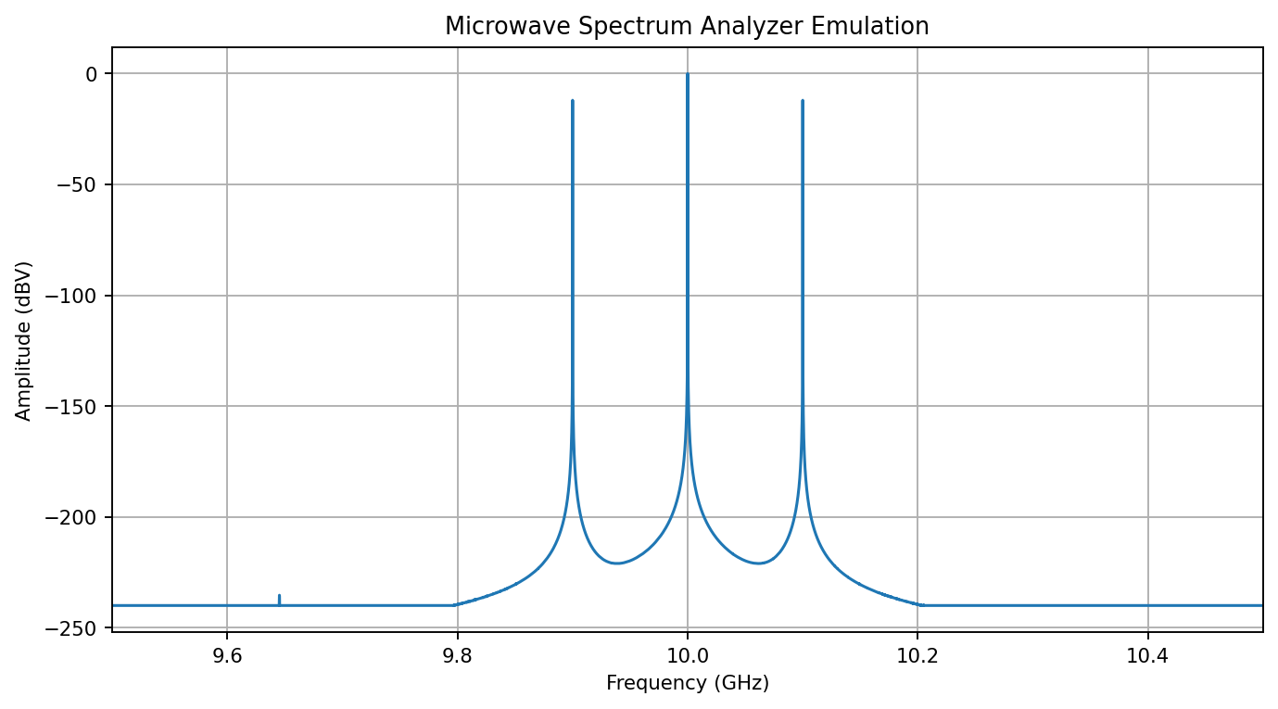

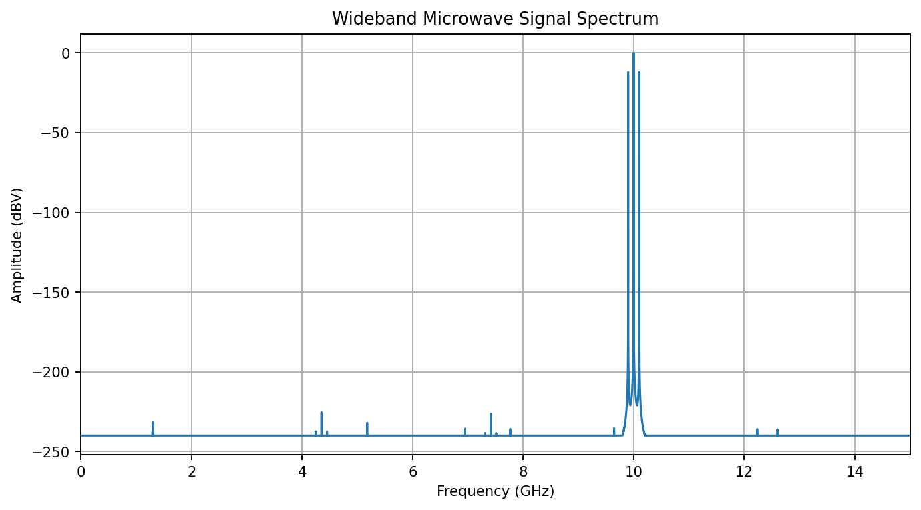

5.1 Command Window Output (Expected)
MICROWAVE SPECTRUM ANALYSIS
Carrier frequency = 10.00 GHz
Modulating frequency = 100.00 MHz
Modulation index = 0.50
Sampling frequency = 50.00 GHz
Frequency resolution = 100.00 kHz
SPECTRAL COMPONENTS
Lower sideband = 9.90 GHz, 0.250 V
Carrier = 10.00 GHz, 1.000 V
Upper sideband = 10.10 GHz, 0.250 V
Theoretical AM bandwidth = 200.00 MHz
Lower sideband frequency = 9.90 GHz
Upper sideband frequency = 10.10 GHz
Spectrum data saved to CSV file.

6. Result
An amplitude-modulated microwave signal with a 10 GHz carrier and 100 MHz modulating frequency was generated and analyzed using FFT. The lower and upper sidebands occur at 9.90 GHz and 10.10 GHz, respectively, and the theoretical AM bandwidth is 200 MHz. The spectrum data is saved as microwave_spectrum_results.csv.
Note: Results are based on the mathematical signal model in the supplied MATLAB script; they are not measured hardware data.

