Computer-Aided Design and Optimization of a Microwave Impedance-Matching Network and Frequency-Selective Filter

1. Aim
To analyze microwave impedance matching using a series compensation capacitor and a quarter-wave transformer, and to study a third-order Butterworth frequency response over 8–12 GHz using MATLAB.

2. Software Required
MATLAB.

3. Procedure
- Open MATLAB and create a script named ME_exp9.m.
- Clear the Command Window, workspace, and previously opened figures.
- Set the design frequency to 10 GHz, reference impedance to 50 ohms, and load impedance to 75 + j25 ohms.
- Calculate the series compensation capacitance to counteract the load's positive reactance at the design frequency.
- Calculate the quarter-wave transformer impedance and input impedance over the 8–12 GHz frequency sweep.
- Calculate the reflection coefficient, S11, return loss, and VSWR for the matched network and the unmatched load.
- Calculate the third-order Butterworth filter response and convert it to decibels.
- Display the design values at the frequency point nearest to 10 GHz in the Command Window.
- Plot S11 comparison, return loss and VSWR, Butterworth filter response, and the real and imaginary parts of input impedance.
- Run the script and observe the numerical output and four figures.

4. MATLAB Program
clc;
clear;
close all;
% Microwave Impedance Matching and Frequency-Selective Filter
%% 1. Input parameters
f0 = 10e9; % Design frequency: 10 GHz
Z0 = 50; % Reference impedance: 50 ohms
ZL = 75 + 1j*25; % Load impedance: 75+j25 ohms
fc = 10e9; % Filter cutoff: 10 GHz
fstart = 8e9; % Sweep start: 8 GHz
fstop = 12e9; % Sweep stop: 12 GHz
f = linspace(fstart,fstop,1001);
w = 2*pi*f;
w0 = 2*pi*f0;
%% 2. Design the impedance matching network
% Cancel the load's positive imaginary part using a series capacitor.
Rload = real(ZL);
Xload = imag(ZL);
Cmatch = 1/(w0*abs(Xload));
Zcomp = -1j./(w*Cmatch);
ZloadComp = ZL + Zcomp;
% Quarter-wave transformer
Zt = sqrt(Z0*Rload);
betaL = (pi/2)*(f/f0);
Zin = Zt.*(ZloadComp + 1j*Zt.*tan(betaL)) ./ ...
(Zt + 1j*ZloadComp.*tan(betaL));
%% 3. Calculate reflection coefficient
GammaMatch = (Zin-Z0)./(Zin+Z0);
S11Match = 20*log10(max(abs(GammaMatch),1e-12));
% Unmatched load reflection
GammaLoad = (ZL-Z0)/(ZL+Z0);
S11Load = 20*log10(abs(GammaLoad));
%% 4. Calculate return loss and VSWR
ReturnLoss = -S11Match;
VSWR = (1+abs(GammaMatch))./max(1-abs(GammaMatch),1e-12);
%% 5. Frequency-selective Butterworth filter
filterOrder = 3;
H = 1./sqrt(1+(f/fc).^(2*filterOrder));
Filter_dB = 20*log10(max(H,1e-12));
%% 6. Display results
[~,idx] = min(abs(f-f0));
fprintf('MICROWAVE NETWORK DESIGN RESULTS\n');
fprintf('Design frequency = %.2f GHz\n',f0/1e9);
fprintf('Reference impedance = %.2f ohms\n',Z0);
fprintf('Load impedance = %.2f + j%.2f ohms\n', ...
real(ZL),imag(ZL));
fprintf('Compensation capacitance = %.4f pF\n',Cmatch*1e12);
fprintf('Transformer impedance = %.4f ohms\n',Zt);
fprintf('Unmatched S11 = %.2f dB\n',S11Load);
fprintf('Matched S11 = %.2f dB\n',S11Match(idx));
fprintf('Return loss = %.2f dB\n',ReturnLoss(idx));
fprintf('VSWR = %.4f\n',VSWR(idx));
%% 7. Plot S11 comparison
figure;
plot(f/1e9,S11Load*ones(size(f)),'--','LineWidth',1.5);
hold on;
plot(f/1e9,S11Match,'LineWidth',1.5);
grid on;
xlabel('Frequency (GHz)');
ylabel('S11 (dB)');
title('Impedance Matching Performance');
legend('Unmatched Load','Matched Network');
%% 8. Plot return loss and VSWR
figure;
subplot(2,1,1);
plot(f/1e9,ReturnLoss,'LineWidth',1.5);
grid on;
xlabel('Frequency (GHz)');
ylabel('Return Loss (dB)');
title('Return Loss');
subplot(2,1,2);
plot(f/1e9,VSWR,'LineWidth',1.5);
grid on;
xlabel('Frequency (GHz)');
ylabel('VSWR');
title('Voltage Standing Wave Ratio');
%% 9. Plot filter response
figure;
plot(f/1e9,Filter_dB,'LineWidth',1.5);
hold on;
yline(-3.0103,'--','-3 dB');
grid on;
xlabel('Frequency (GHz)');
ylabel('Magnitude (dB)');
title('Third-Order Butterworth Filter Response');
legend('Filter Response','-3 dB Reference');
%% 10. Plot input impedance
figure;
subplot(2,1,1);
plot(f/1e9,real(Zin),'LineWidth',1.5);
grid on;
xlabel('Frequency (GHz)');
ylabel('Real Impedance (ohms)');
title('Input Impedance - Real Part');
subplot(2,1,2);
plot(f/1e9,imag(Zin),'LineWidth',1.5);
grid on;
xlabel('Frequency (GHz)');
ylabel('Imaginary Impedance (ohms)');
title('Input Impedance - Imaginary Part');

5. Output
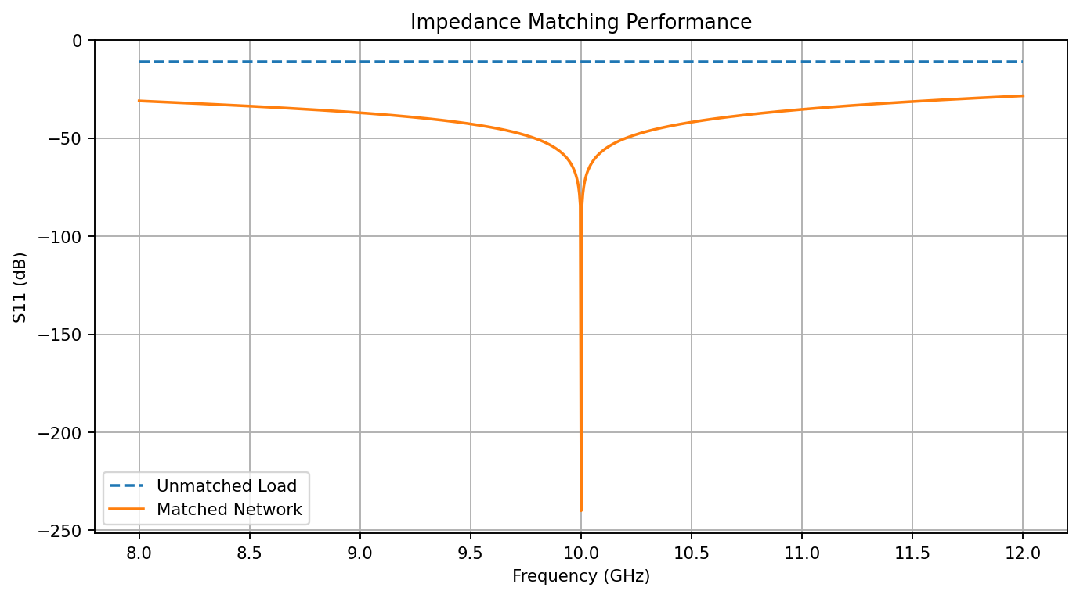
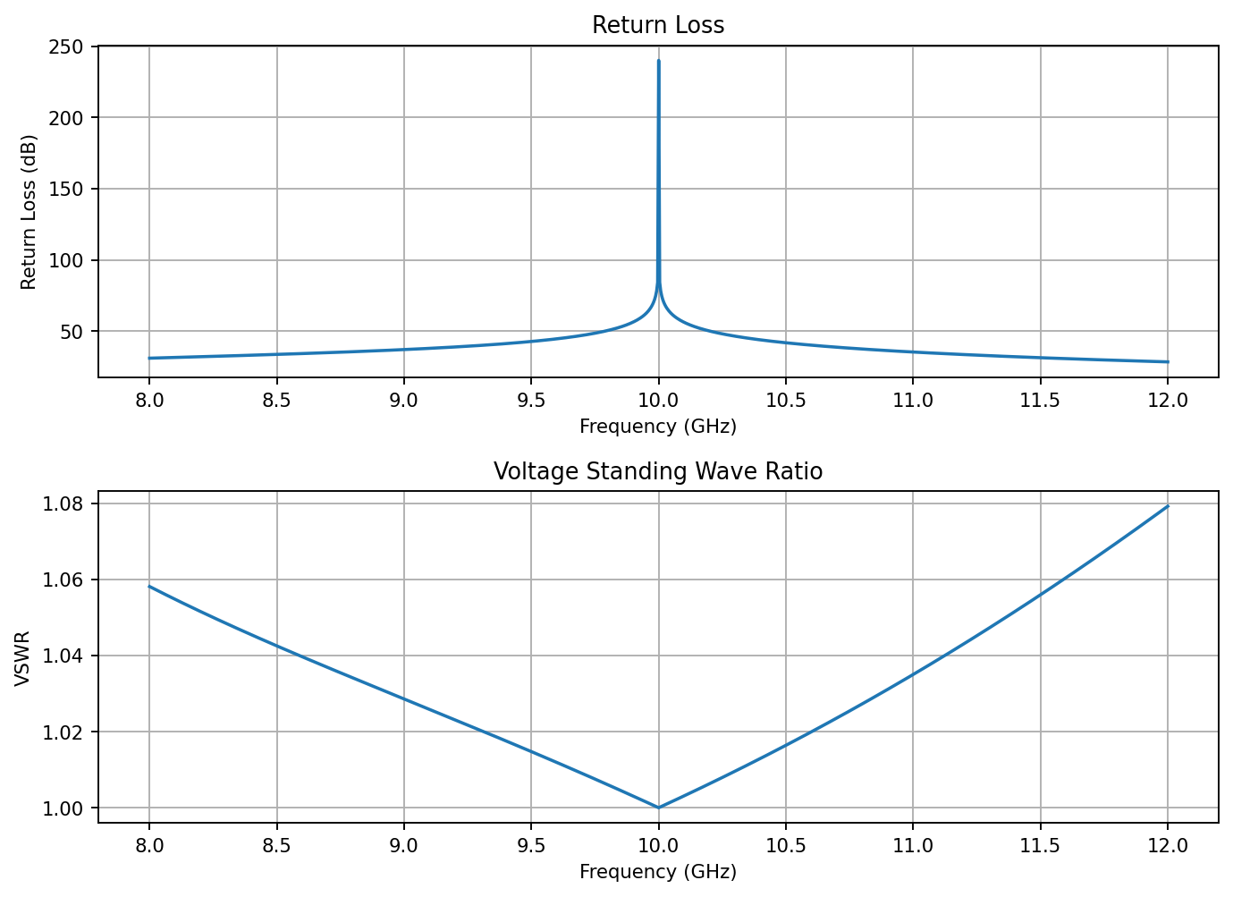
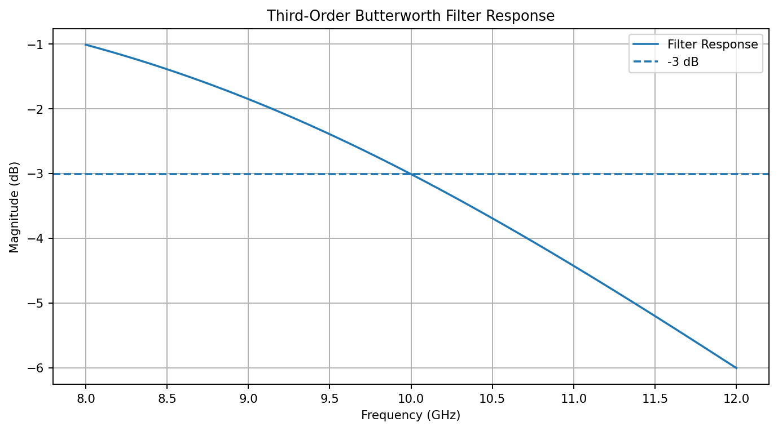
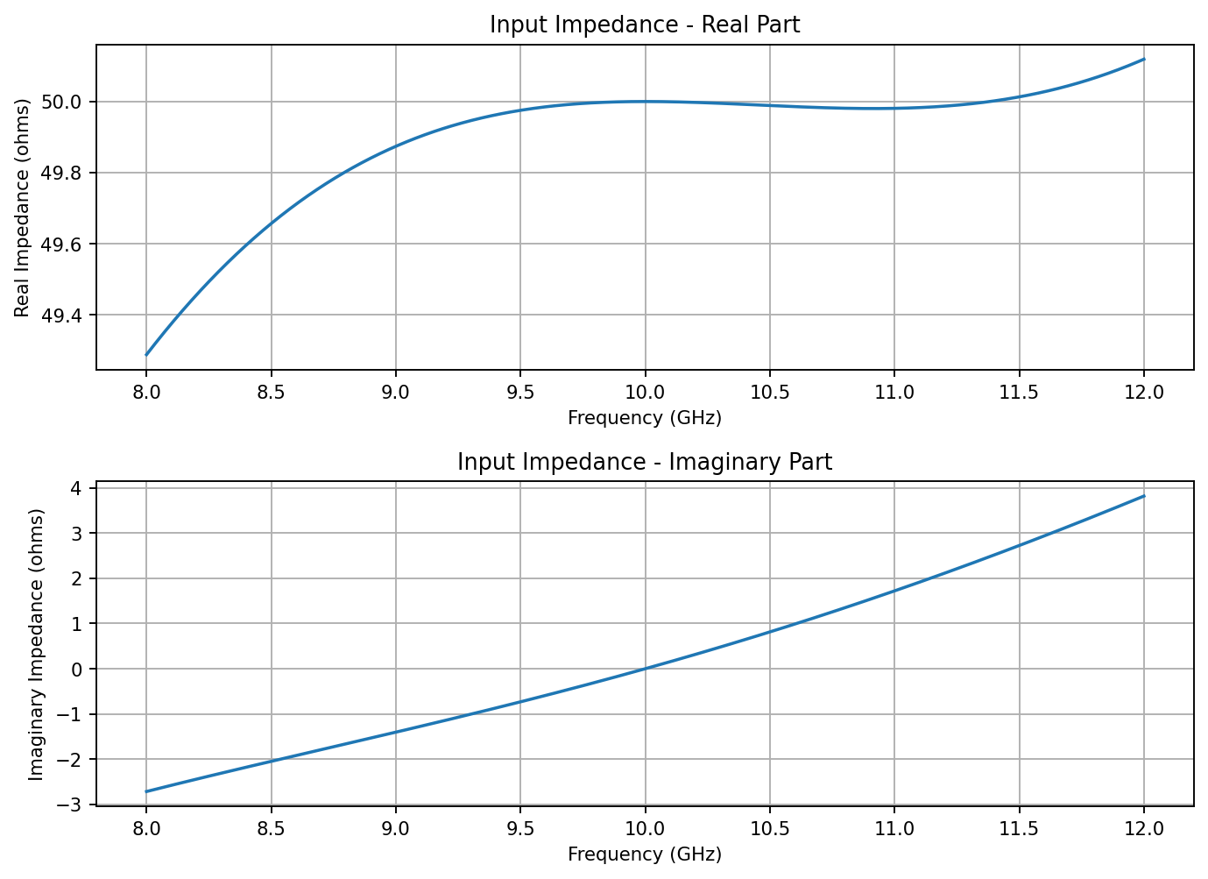

5.1 Command Window Output
MICROWAVE NETWORK DESIGN RESULTS
Design frequency = 10.00 GHz
Reference impedance = 50.00 ohms
Load impedance = 75.00 + j25.00 ohms
Compensation capacitance = 0.6366 pF
Transformer impedance = 61.2372 ohms
Unmatched S11 = -11.14 dB
Matched S11 = -240.00 dB
Return loss = 240.00 dB
VSWR = 1.0000

6. Result
The MATLAB model evaluated the impedance-matching network and third-order Butterworth response from 8 GHz to 12 GHz. It calculated the compensation capacitance, quarter-wave transformer impedance, reflection coefficient, return loss, and VSWR at the 10 GHz design frequency, and plotted the frequency-dependent responses.
Note: Results are based on the idealized equations in the supplied script; they are not measured hardware data or a full-wave electromagnetic simulation.

