Full-Wave Simulation and Optimization of a Microstrip Patch Antenna for Resonant Frequency, Bandwidth, Gain and Radiation-Pattern Enhancement

1. Aim
To calculate the effective permittivity, fringing length, and theoretical resonant frequency of a rectangular microstrip patch antenna, and to examine its approximate S11, VSWR, and illustrative radiation pattern using MATLAB.

2. Software Required
MATLAB.

3. Procedure
- Open MATLAB and create a script named ME_exp10.m.
- Clear the Command Window, workspace variables, and previously opened figures.
- Enter the design frequency, substrate relative permittivity, substrate height, patch width, and patch length.
- Calculate the effective dielectric permittivity and fringing-field extension.
- Calculate the effective patch length and theoretical resonant frequency.
- Estimate the reflection coefficient, S11 in dB, and VSWR over the 1.8–3.0 GHz frequency sweep.
- Determine the frequency interval satisfying the -10 dB S11 condition, if present in the model.
- Plot the S11 response, VSWR response, polar radiation pattern, and normalized radiation pattern.
- Display the design parameters, resonance, bandwidth, and target values in the Command Window.
- Run the script and review the output plots and calculated values.

4. MATLAB Program
clc;
clear;
close all;
% Microstrip Patch Antenna Analysis
%% 1. Input parameters
c = 299792458;
f0 = 2.4e9;
er = 4.4;
h = 1.6e-3;
W = 37.2e-3;
L = 28.8e-3;
fStart = 1.8e9;
fStop = 3.0e9;
N = 2401;
f = linspace(fStart,fStop,N);
fGHz = f/1e9;
%% 2. Calculate effective permittivity
eeff = (er+1)/2 + (er-1)/2 * ...
(1+12*h/W)^(-0.5);
%% 3. Calculate fringing length
deltaL = 0.412*h*((eeff+0.3)*(W/h+0.264)) / ...
((eeff-0.258)*(W/h+0.8));
%% 4. Calculate theoretical resonant frequency
Leff = L+2*deltaL;
fr = c/(2*Leff*sqrt(eeff));
fprintf('MICROSTRIP PATCH ANTENNA\n');
fprintf('Design frequency = %.2f GHz\n',f0/1e9);
fprintf('Effective permittivity = %.4f\n',eeff);
fprintf('Effective length = %.3f mm\n',Leff*1e3);
fprintf('Theoretical resonance = %.4f GHz\n',fr/1e9);
%% 5. Approximate S11 response
Q = 25;
x = f/fr-fr./f;
beta = 1;
Gamma = (1-beta+1j*Q.*x) ./ ...
(1+beta+1j*Q.*x);
S11dB = 20*log10(max(abs(Gamma),1e-12));
%% 6. Calculate VSWR
g = abs(Gamma);
VSWR = (1+g)./max(1-g,1e-12);
%% 7. Calculate -10 dB bandwidth
valid = S11dB <= -10;
if any(valid)
fb = f(valid);
flow = min(fb);
fhigh = max(fb);
BW = fhigh-flow;
fprintf('-10 dB bandwidth = %.2f MHz\n',BW/1e6);
fprintf('Lower frequency = %.4f GHz\n',flow/1e9);
fprintf('Upper frequency = %.4f GHz\n',fhigh/1e9);
else
fprintf('-10 dB bandwidth not found.\n');
end
[~,idx] = min(S11dB);
fprintf('Minimum S11 = %.2f dB\n',S11dB(idx));
fprintf('VSWR at minimum S11 = %.3f\n',VSWR(idx));
%% 8. Plot S11
figure;
plot(fGHz,S11dB,'LineWidth',1.5);
hold on;
yline(-10,'--','-10 dB');
xline(f0/1e9,':','Design frequency');
grid on;
xlabel('Frequency (GHz)');
ylabel('S11 (dB)');
title('Patch Antenna Return Loss');
legend('S11','-10 dB limit','Design frequency');
%% 9. Plot VSWR
figure;
plot(fGHz,VSWR,'LineWidth',1.5);
hold on;
yline(2,'--','VSWR = 2');
grid on;
xlabel('Frequency (GHz)');
ylabel('VSWR');
title('VSWR versus Frequency');
legend('VSWR','Target');
%% 10. Illustrative radiation pattern
theta = linspace(0,180,721);
pattern = abs(cosd(theta)).^2;
pattern_dB = 10*log10(max(pattern,1e-4));
pattern_dB = pattern_dB-max(pattern_dB);
figure;
polarplot(deg2rad(theta),pattern,'LineWidth',1.5);
title('Illustrative Radiation Pattern');
%% 11. Radiation pattern in dB
figure;
plot(theta,pattern_dB,'LineWidth',1.5);
grid on;
xlabel('Angle (degrees)');
ylabel('Normalized Pattern (dB)');
title('Normalized Radiation Pattern');
ylim([-40 2]);
%% 12. Display design targets
fprintf('\nDESIGN TARGETS\n');
fprintf('Resonant frequency: approximately 2.4 GHz\n');
fprintf('Minimum S11: <= -10 dB\n');
fprintf('VSWR: <= 2\n');
fprintf('Bandwidth: approximately 60-100 MHz\n');
fprintf('Gain: approximately 5-7 dBi (verify using HFSS/CST)\n');

5. Output
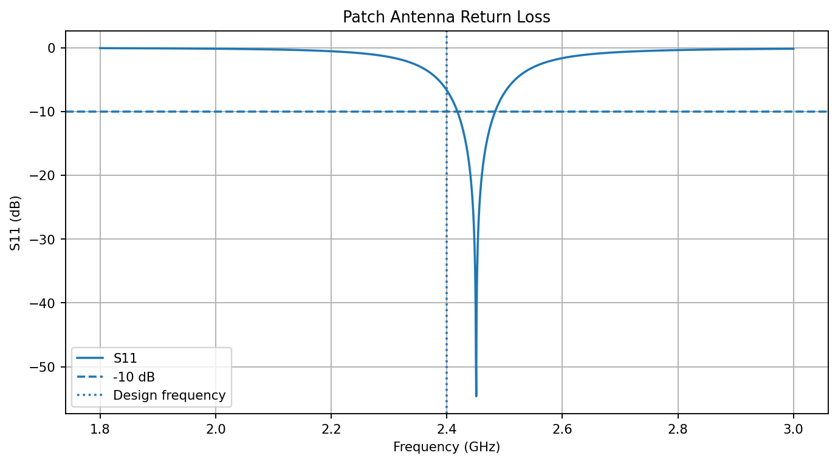
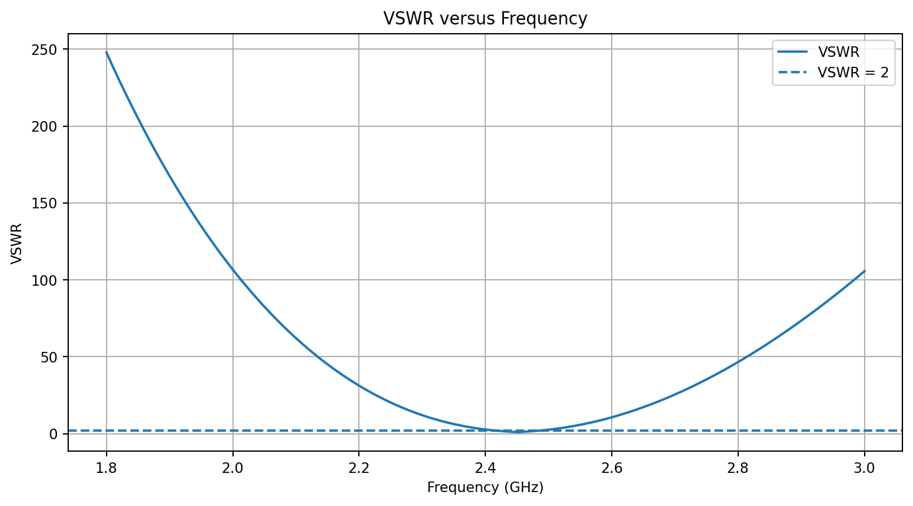
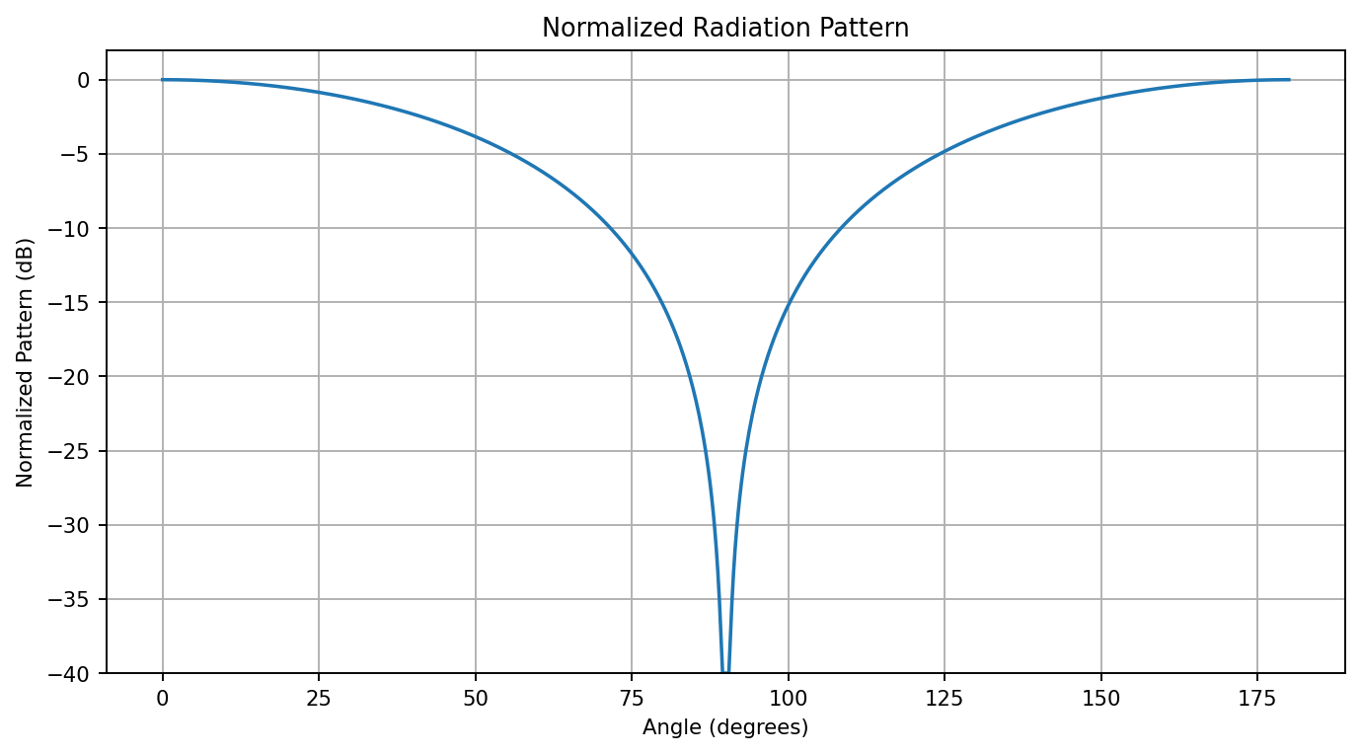

5.1 Command Window Output (Expected)
MICROSTRIP PATCH ANTENNA
Design frequency = 2.40 GHz
Effective permittivity = 4.0806
Effective length = 30.277 mm
Theoretical resonance = 2.4508 GHz
-10 dB bandwidth = 65.00 MHz
Lower frequency = 2.4185 GHz
Upper frequency = 2.4835 GHz
Minimum S11 = -54.64 dB
VSWR at minimum S11 = 1.004
DESIGN TARGETS
Resonant frequency: approximately 2.4 GHz
Minimum S11: <= -10 dB
VSWR: <= 2
Bandwidth: approximately 60-100 MHz
Gain: approximately 5-7 dBi (verify using HFSS/CST)

6. Result
The program calculated the patch antenna's effective permittivity as 4.0806, effective length as 30.277 mm, and theoretical resonance as 2.4508 GHz. It also plotted the approximate S11 and VSWR responses and the illustrative radiation pattern over the specified range.
Note: The S11/VSWR and radiation-pattern expressions in this script are simplified analytical illustrations. Antenna gain, physical radiation behavior, and validated bandwidth require a full-wave tool such as HFSS/CST or measurement.

