SIMULATION-BASED INVESTIGATION OF MICROWAVE SEMICONDUCTOR DEVICES AND FREQUENCY-CONVERSION CHARACTERISTICS OF A MICROWAVE MIXER

AIM
To simulate the frequency-conversion characteristics of a microwave mixer using MATLAB by calculating the intermediate frequency (IF), sum frequency, IF output power, and conversion loss, and by displaying the frequency components in an output spectrum.

PROCEDURE
- Open MATLAB and create a new script file.
- Clear the Command Window, workspace, and existing figures using clc, clear, and close all.
- Enter the RF frequency, local oscillator (LO) frequency, RF input power, LO power, and assumed conversion loss.
- Calculate the intermediate frequency using the absolute difference between RF and LO frequencies.
- Calculate the sum frequency by adding the RF and LO frequencies.
- Estimate the IF output power using the RF input power minus the assumed conversion loss.
- Calculate the conversion loss from the RF input power and IF output power.
- Compare the calculated IF and sum frequencies with their theoretical values and determine percentage deviations.
- Display the calculated frequencies, powers, conversion loss, and deviations in the MATLAB Command Window.
- Plot the frequency components and their corresponding powers using a stem plot, then observe the mixer output spectrum.

PROGRAM
clc;
clear;
close all;
% Input parameters
fRF = 10; % RF frequency in GHz
fLO = 9.5; % LO frequency in GHz
PRF = -10; % RF power in dBm
PLO = 7; % LO power in dBm
CL_expected = 8; % Assumed conversion loss in dB
% Frequency conversion
fIF = abs(fRF - fLO);
fSUM = fRF + fLO;
% Simple assumed mixer model
PIF = PRF - CL_expected;
CL = PRF - PIF;
% Theoretical frequencies
fIF_theory = 0.5;
fSUM_theory = 19.5;
% Percentage deviation
devIF = abs(fIF - fIF_theory)/fIF_theory * 100;
devSUM = abs(fSUM - fSUM_theory)/fSUM_theory * 100;
% Display results
disp('MICROWAVE MIXER SIMULATION');
fprintf('IF Frequency = %.2f GHz\n', fIF);
fprintf('Sum Frequency = %.2f GHz\n', fSUM);
fprintf('RF Input Power = %.2f dBm\n', PRF);
fprintf('LO Power = %.2f dBm\n', PLO);
fprintf('IF Output Power = %.2f dBm\n', PIF);
fprintf('Conversion Loss = %.2f dB\n', CL);
fprintf('IF Frequency Deviation = %.2f %%\n', devIF);
fprintf('Sum Frequency Deviation = %.2f %%\n', devSUM);
% Simulated output spectrum
freq = [fIF fRF fLO fSUM];
power = [PIF PRF PLO PIF-10];
figure;
stem(freq, power, 'filled');
grid on;
xlabel('Frequency (GHz)');
ylabel('Power (dBm)');
title('Microwave Mixer Output Spectrum');
legend('Frequency Components');

OUTPUT
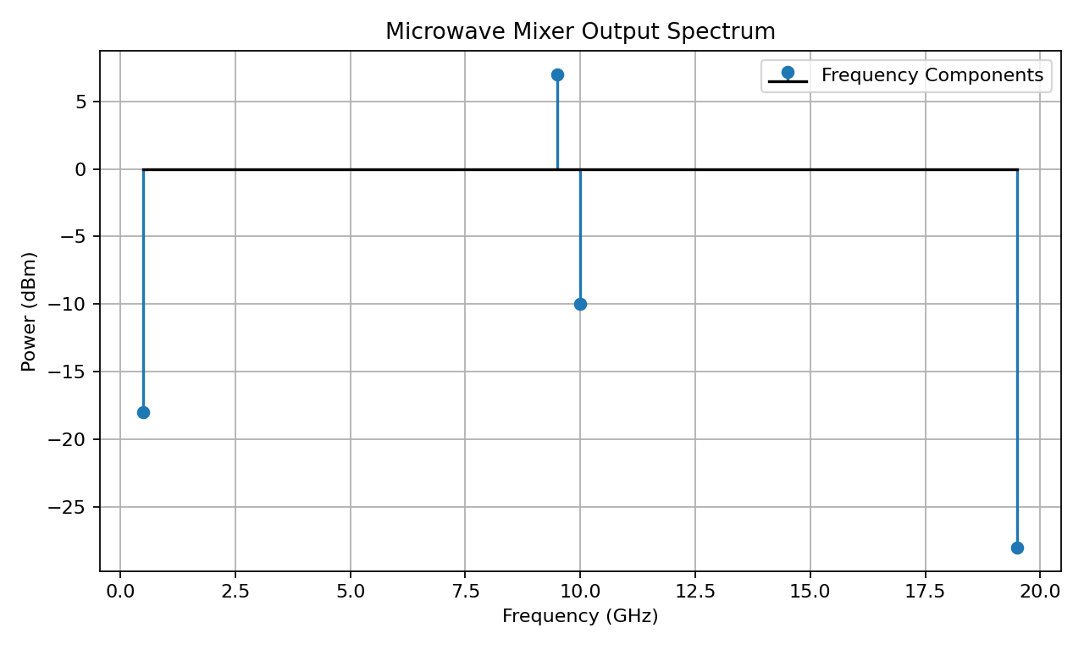
Expected Command Window values for the given inputs:
IF Frequency = 0.50 GHz
Sum Frequency = 19.50 GHz
RF Input Power = -10.00 dBm
LO Power = 7.00 dBm
IF Output Power = -18.00 dBm
Conversion Loss = 8.00 dB
IF Frequency Deviation = 0.00 %
Sum Frequency Deviation = 0.00 %

RESULT
The microwave mixer was simulated in MATLAB. For an RF frequency of 10 GHz and an LO frequency of 9.5 GHz, the intermediate frequency was obtained as 0.5 GHz and the sum frequency as 19.5 GHz. With an assumed conversion loss of 8 dB, the IF output power was calculated as -18 dBm. The frequency components and their power levels were displayed in the output spectrum, demonstrating the basic frequency-conversion characteristics of a microwave mixer.

