Simulation-Based Electromagnetic Analysis of TEM, TE and TM Propagation Modes in Microwave Transmission Structures

1. AIM
To simulate and visualize the electromagnetic propagation modes TEM, TE₁₀, and TM₁₁ using MATLAB and compare their normalized field distributions.

2. PROCEDURE
- Open MATLAB and create a new script.
- Clear the command window, workspace variables, and previously opened figures.
- Define normalized x and y coordinate vectors from 0 to 1 using 100 sample points.
- Use meshgrid to create a two-dimensional coordinate grid.
- Represent the TEM mode using a constant field distribution.
- Represent the TE₁₀ mode using the function sin(πx).
- Represent the TM₁₁ mode using the function sin(πx)sin(πy).
- Create one figure and divide it into three side-by-side subplots.
- Display each mode using imagesc, add axis labels and titles, and include color bars.
- Run the script and compare the three plotted field distributions.

3. MATLAB PROGRAM
clc; clear; close all;

x = linspace(0,1,100);
y = linspace(0,1,100);
[X,Y] = meshgrid(x,y);
TEM = ones(size(X));
TE = sin(pi*X);
TM = sin(pi*X).*sin(pi*Y);

figure;

subplot(1,3,1)
imagesc(x,y,TEM);
title('TEM Mode');
xlabel('x'); ylabel('y');
colorbar;

subplot(1,3,2)
imagesc(x,y,TE);
title('TE_{10} Mode');
xlabel('x'); ylabel('y');
colorbar;

subplot(1,3,3)
imagesc(x,y,TM);
title('TM_{11} Mode');
xlabel('x'); ylabel('y');
colorbar;

sgtitle('Electromagnetic Propagation Modes');

4. OUTPUT
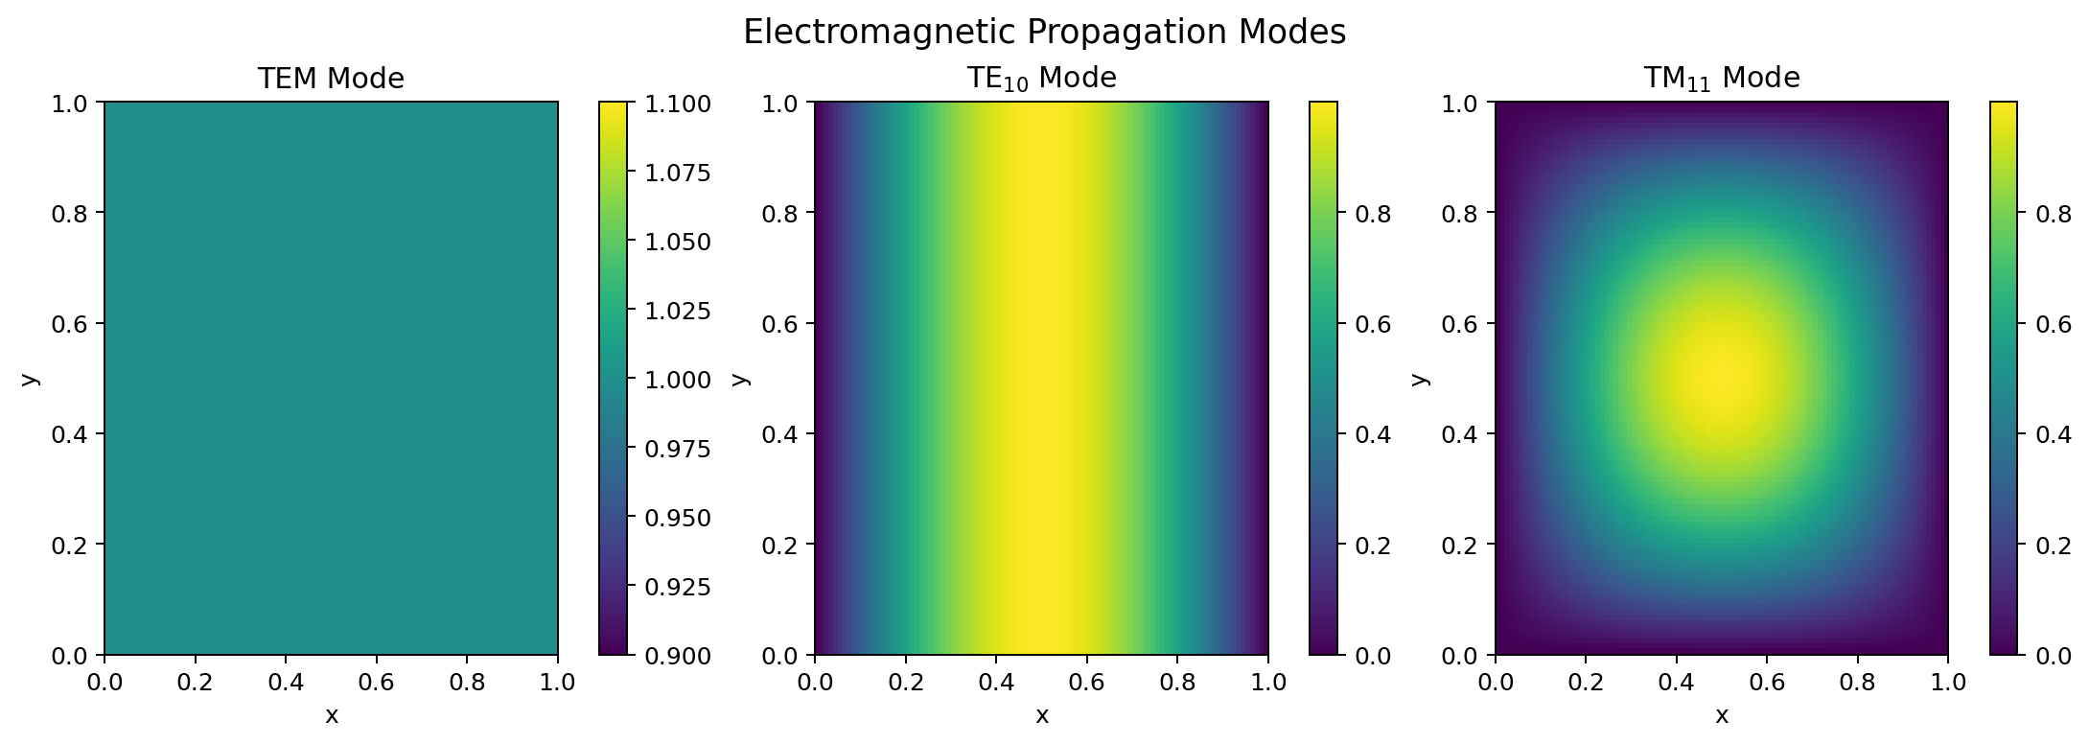

5. RESULT
The MATLAB program was used to visualize the normalized field distributions of the TEM, TE₁₀, and TM₁₁ modes. The TEM distribution remains constant, the TE₁₀ distribution varies with x, and the TM₁₁ distribution varies with both x and y. Thus, the three mode patterns were generated and compared successfully.
Note: These are illustrative normalized mode distributions defined by the supplied script, not a full-wave electromagnetic field solution for a specified physical waveguide.

