1. **Docker Daemon:** The daemon (dockerd) is a process that keeps running in the background and waits for commands from the client. The daemon is capable of managing various Docker objects.
2. **Docker Client:** The client  (docker) is a command-line interface program mostly responsible for transporting commands issued by users.
3. **REST API:** The REST API acts as a bridge between the daemon and the client. Any command issued using the client passes through the API to finally reach the daemon.

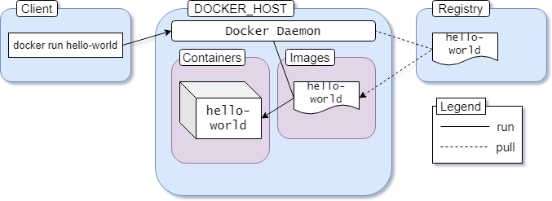

1. You execute docker run hello-world command where hello-world is the name of an image.
2. Docker client reaches out to the daemon, tells it to get the hello-world image and run a container from that.
3. Docker daemon looks for the image within your local repository and realizes that it's not there, resulting in the Unable to find image 'hello-world:latest' locally that's printed on your terminal.
4. The daemon then reaches out to the default public registry which is Docker Hub and pulls in the latest copy of the hello-world image, indicated by the latest: Pulling from library/hello-world line in your terminal.
5. Docker daemon then creates a new container from the freshly pulled image.
6. Finally Docker daemon runs the container created using the hello-world image outputting the wall of text on your terminal.