Miscellaneous Topics

When we want to know the probability of the point to be one the classes then we use the calibration.

In case on Naive Bayes:

In case of naive bayes:

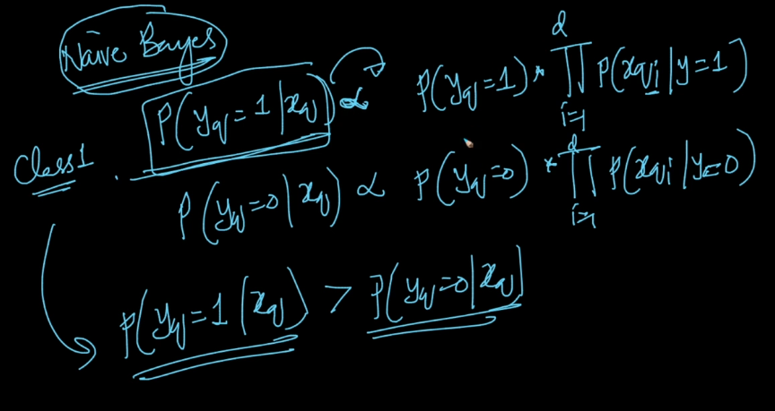
Given a trained model, we want to know the actual probability. We do calibration.
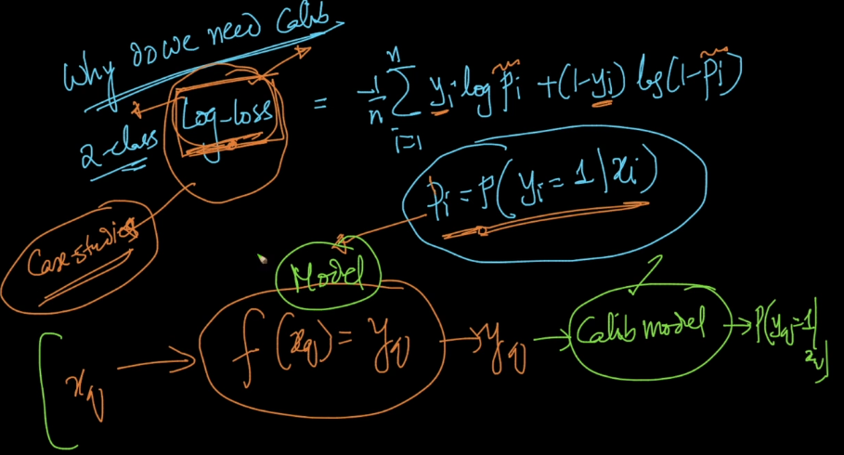

We will train a model, and predict the probability.

Calibration Plots:

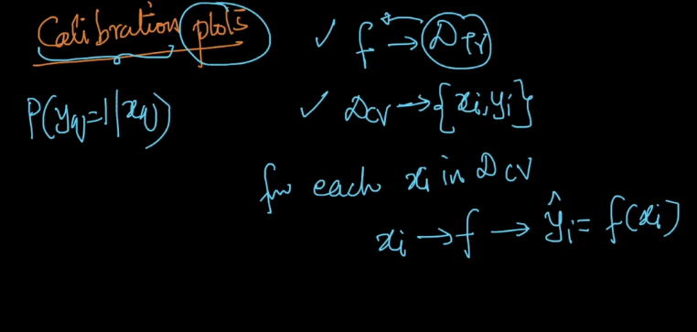
Building a table.
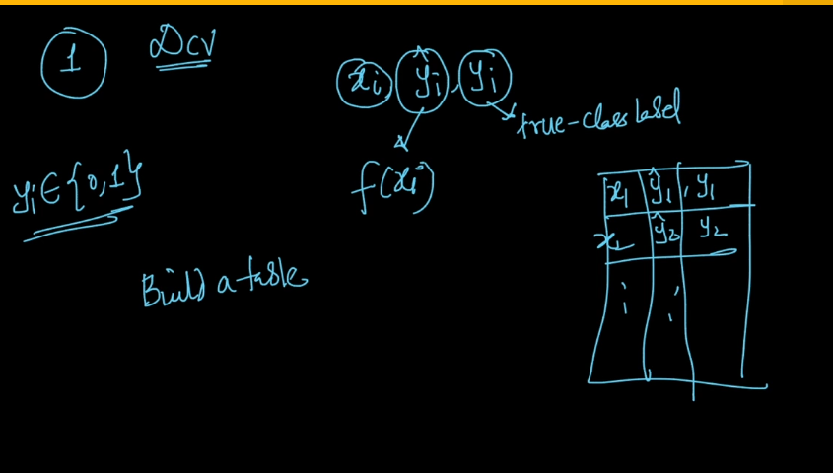
Step - 1

Sort the table in increasing order of y(hat)

Step – 2

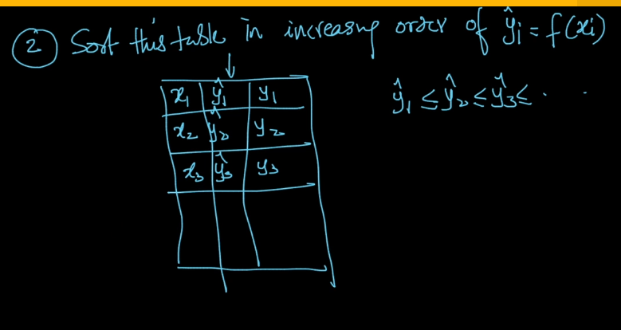
Step – 3:
We will brake my table into chunks of size ‘m’.
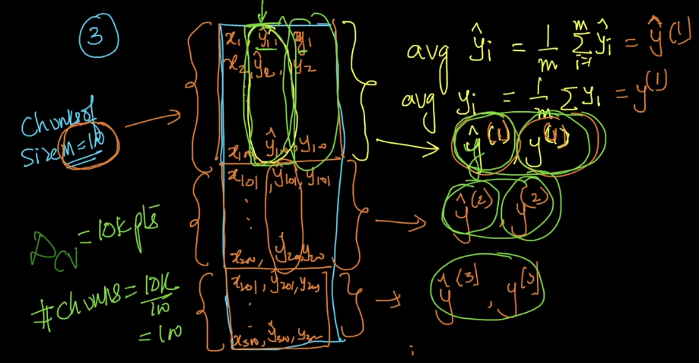

Now, the data for calibration is as follows:

Isotonic regression / Calibration:

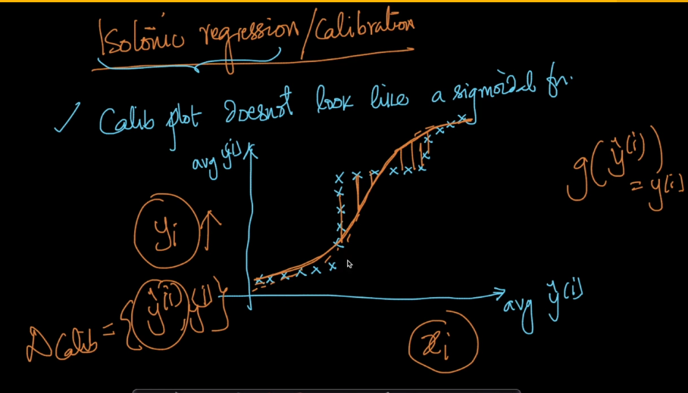
These are called piece wise line fitting is called iso-tonic regression.

