Microwave Engineering- ECA1308
Student Name: M.Raveendra Reddy
Reg no: 192312469, Date (13/10/26)

Experiment 2A: Transmission-Line/TN-Port S-Parameters: Model a 50 2 microwave two-port network of length 50 mm and operate it from 8 to 12 GHz with a 10 GHz center frequency. Set both ports to 50 and obtain $11, S12, S21 and S22. At 10 GHz calculate return loss RL-20log10/S11, insertion loss IL--20log10 S21 and transmission efficiency |S21F×100%. Compare the simulated values with the ideal 500 matched reference.

Aim: To model a 50 Ω microwave two-port transmission line of length 50 mm in MATLAB, obtain the S-parameters S_{11}, S_{12}, S_{21}, S_{22}\) over 8–12 GHz, and calculate the return loss, insertion loss, and transmission efficiency at 10 GHz.
Software Required:MATLAB
Procedure — MATLAB Process
- Open MATLAB and create a new script using Home → New Script.
- Define the input parameters: center frequency \(f_0=10\) GHz, reference impedance \(Z_0=50\ \Omega\), and transmission-line length \(L=50\) mm.
- Define the frequency sweep from 8 GHz to 12 GHz using the MATLAB linspace() function.
- Calculate the phase constant \(\beta=2\pi f/c\), assuming an ideal lossless transmission line with propagation velocity equal to the speed of light.
- Calculate the transmission-line ABCD parameters \(A,B,C,D\) using the line length and characteristic impedance.
- Convert the ABCD parameters into the four S-parameters \(S_{11},S_{12},S_{21},S_{22}\).
- Find the S-parameter values specifically at 10 GHz from the frequency sweep.
- Calculate the return loss, insertion loss, and transmission efficiency using
\(RL=-20\log_{10}|S_{11}|\),
\(IL=-20\log_{10}|S_{21}|\), and
\(\eta=|S_{21}|^2\times100\%\).
- Run the MATLAB program, observe the numerical results, and plot the S-parameters versus frequency to analyze the transmission-line performance.
OUTPUT:
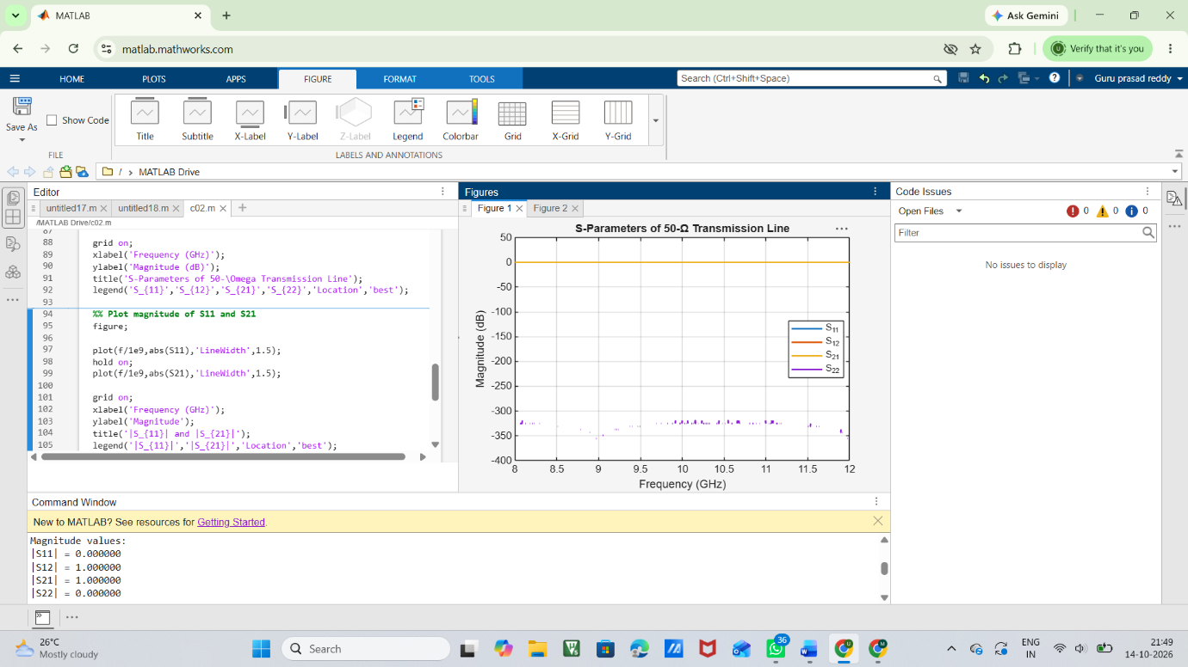
FIG:1

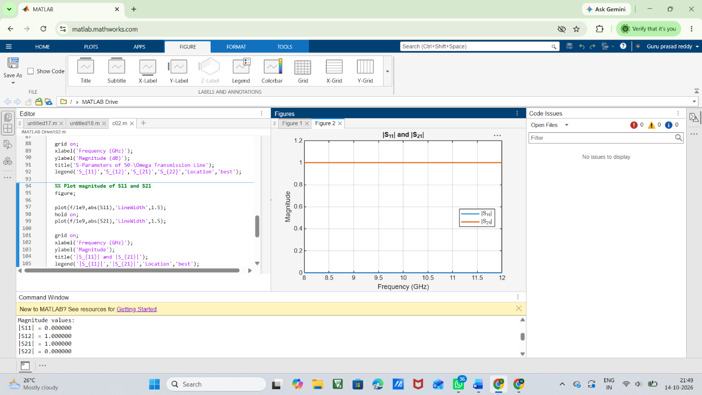
FIG:B

Result —
- The S-parameters \(S_{11}, S_{12}, S_{21}\), and \(S_{22}\) were successfully obtained for the 8–12 GHz frequency range.
- At 10 GHz, the ideal 50 Ω line gives \(|S_{11}|\approx0\) and \(|S_{21}|\approx1\).
- The return loss is theoretically very high (infinite for an ideal match), indicating excellent matching.
- The insertion loss is theoretically 0 dB, indicating lossless transmission.
- The transmission efficiency is approximately 100%, confirming ideal power transfer.

