Curriculum Vitae

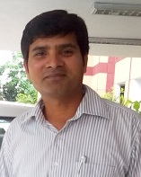
- Name: ANKUR SAXENA
E-mail ID: ankurcabm@gmail.com Contact No.: 9412034289
- Father’s/Husband’s Name: Mr. S.K.Saxena
- Department: Department of Management
- Date of Birth: 23-01-1983
- Correspondence Address: IIM, Lucknow
- Academic Achievements (+2 onwards)
Degree | Institution/ University | Year of  Passing | Division | % of Marks | Subjects/Topic/Specialization
High School | U.P.Board | 1998 | II | 54.5 | P.C.M.E.S
Intermediate | U.P.Board | 2000 | II | 45.8 | P.C.M
BCA | C.C.S.University, Meerut | 2004 | II | 58.7 | Computer Application
M.Sc (C.S) | B.U.Jhansi | 2006 | I | 62.8 | Computer Science
MBA | G.G.S.I.P.U,Delhi | 2008 | I | 63.7 | Marketing

- Employment Record
Name of University/ Institution/Organization | Post Held | Duration |  | Assignments  (Teaching/Reaearch/ Admin./ Sports/ etc.)
Name of University/ Institution/Organization | Post Held | From | To | Assignments  (Teaching/Reaearch/ Admin./ Sports/ etc.)
Droan College of Education and Technology, Rudrapur | Assistant Professor | Aug 2008 | Dec 2010 | Teaching
ICAR- Indian Veterinary Research Institute, Izatnagar | Business Manager/ RA | July 2010 | July 2014 | Business Development
ICAR-Central Avian Research Institute, Izatnagar | Business Manager | Aug 2014 | June 2020 | Business Development
Indian Institute of Management, Lucknow | State Resource Associate | Sep 2021 | Till  Date | Skill Development

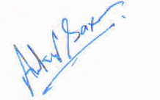

Date: 07-02-2022 Signature of Candidate

