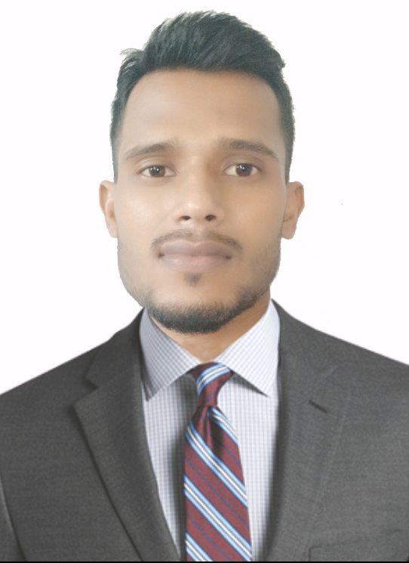
CURRICULUM VITAE

JASIMUDDIN AHMED
ABU SAZID AHMED
S/o- Sirazuddin Ahmed
Vill-Balikuchi
P.O-Balikuchi Ph. No: +917002107673
Dist-Nalbari-781126, Assam E-mail: mail2sazid@gmail.com
DOB: 01/01/1988. Marital status: Unmarried

CAREER OBJECTIVE
To excel my abilities and skills while working as a Telecommunication Engineer in a leading corporate and hence utilizing my astute nature of learning towards the profit of the organization and act as the strengthening bond for the growth of my career.
QUALIFICATION
- B.Tech in Electronics And Telecommunication Engineering passed out in 2013 with 1st division from IETE (Institution of Electronics & Telecommunication Engineers), New Delhi
- 10+2 Science passed out from R.N.C.H.S, Assam in 2007 with 1st division
- 10th passed out from P.B.H.S, Assam in 2005 with 2nd division

EMPLOYMENT SUMMARY
PREVIOUS EXPERIENCE:
ORGANIZATION : Ericsson India Pvt. Ltd.
DURATION : Feb, 2017 to Oct, 2017
DESIGNATION : FIELD MAINTENACE ENGINEER(FME)
Role And Responsibilities
- Installing and Commissioning of Ceragon IP-10/IP-20 Microwave Modules.
- Troubleshooting different microwave links and achieving desired Rx/Tx level.
- Installing and commissioning different Ericsson RBS systems like DUG, DUW and Basebands.
- Performing Drive Test for 2G, 3G and 4G Networks.

PREVIOUS EXPERIENCE:
ORGANIZATION : Arden Telecom Pvt. Ltd.
DURATION : Sep, 2015 to Jan, 2017
DESIGNATION. : SITE ENGINEER
. Role And Responsibilities
- Installing and Commissioning of UBR Equipment.
- Performing LOS, RF, EMF and different telecom surveys.
- Installing and commissioning of indoor and outdoor small-cells and Wi-Fi routers.

PREVIOUS EXPERIENCE:
ORGANIZATION : Infotech Solution
DURATION : Jan 2013 to March, 2015
DESIGNATION : SURVEY ENGINEER
Role And Responsibilities
- Performing RF survey for installing Telecom Towers.
- Performing LOS survey for installing Microwave radio Equipment.
- Performing EMF survey for various Telecom vendors.
TECHNICAL SKILLS
- 1. MSWord 2.MS Excel 3.MS Power Point
PROGRAMING LANGUAGE:
- 1. HTML 2.CSS 3.Javascript

TRAINING PROFILE
- Undergone training on BTS installation and commissioning with S.I.T.E., Noida.
PERSONAL DETAILS
- MOTHER’S NAME : Sahera Bibi
- NATIONALITY : Indian
- CASTE : General
- GENDER : Male
- MOTHER TONGUE : Assamese
- PASSPORT NUMBER : M4273665
- HOBBY : Listening Music, Watching Tech videos
- LANGUAGES KNOWN : Assamese, Hindi, English, Bengali,
DECLARATION
I do hereby declare that all the details furnished above are true to the best of my knowledge and belief.
Name: Abu Sazid Ahmed

