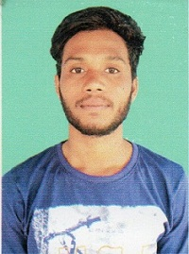
RESUME
Name : Akshya Kumbhar
Father Name : Sampati Kumbhar
Email-id : akshyakumbhar77@gmail.com
Contact No : 7978330331

CAREER OBJECTIVE:-
I Thrive on Challengers & ambitious goals, My Greatest strength is the ability to combine my analytical skill with interpersonal skill. I can Build & maintain business relationship. I am a committed & enthusiastic candidate.
EXPERIENCE:-
- I have 5 year experience in Computer Cecter And Finance Cecter work

PRESENT ADDRESS:-
At-Tora Tangarpada, Po-Tora
Dist/Ps-Bargarh, Pin-768040(Odisha)

PERMANET ADDRESS:-
At-Tora Tangarpada, Po-Tora
Dist/Ps-Bargarh, Pin-768040(Odisha)

PERSONAL PROFILE:-

- Date of Birth : 18 May 1996
- Language Known : English, Hindi & Odia
- Nationality : Indian
- Marital Status : Unmarried
- Category : SC
- Domicile State : Odisha

EDUCATION QUALIFICATION:-

Name of the Examination | Name of the Board/University | Year of Passing | %/Grade
10th | BSE,Odisha | 2011 | 40%
DIPLOMA IN COMPUTER SCIENCE ENGG) | SCTE&VT ODISHA | 2021 | 80%
BTECH IN COMPUTER SCIENCE ENGG | VIJU PATNAIK INSTITUTE OF TECHNOLOGY ROURKELA ODISHA | 2024 | 80%

DECLARATION
I am Akshya Kumbhar by declare that the above stated facts are true to the best of my knowledge and belief.

Date:- Akshya Kumbhar
Place:-Bargarh Signature

