Aman Kumar Mishra
Ofcrman.aw1998@gmail.com

+91- 8839503099
in/aman-kumar-mishra-91b307186

A dynamic, resourceful professional targeting Consultant roles in Mobility Cloud Engineering in a large enterprise-level organization to leverage and grow current skill sets in line with the organization’s objectives.
Location preference: Delhi NCR, Bangalore, Pune, USA & UK

 PROFILE SUMMARY
- An accomplished professional and a people’s leader with a diverse work experience of 5 years in Mobility Cloud Engineering & Consultancy.
- Proven acumen in Cloud platforms for iOS/Android/Windows 10, Mobile Device Management in Intune, Autopilot, Hybrid Autopilot and on premise to cloud as well as Cloud to on premise migrations

Expertise in Intune, Air-watch, Autopilot, Hybrid Autopilot, HTML, CSS, Python, Power Apps & SharePoint.
- An enterprising leader with exemplary capability to build and maintain high performing teams; currently leading a team size of 15 Engineers.
- Merit of defining, leading and developing the product and IT roadmaps to highlight key milestones while creating project deliverables and defining requirements, scope, duration and cost of projects.
- A dependable resource; appreciated several times across the career; felicitated with the Performer of the Month in Apr’19 at HCL Technologies and lots of internal badges in the Infosys Technologies Ltd.
- Extraordinary relationship-building skills; developed trusting and professional relationships across the career.


- Possess credibility & personal integrity that leaves lasting impression with corporate decision makers, motivates employees, and generates loyalty.

CORE COMPETENCIES

Intune  AirWatch  Autopilot
 Mobile Device Management  Hybrid Autopilot  SharePoint



PowerApps HTML Python

 SOFT SKILLS
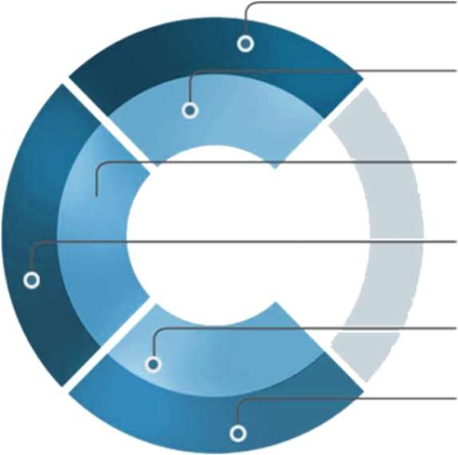
 TECHNICAL SKILLS

Change Agent Collaborator
Communicator Problem Solver
Planner Multi-tasking

CERTIFICATIONS

  - MS 100 Certification in 2023
  - MS 101 Certification in 2023
  - Modern Endpoint Management Certification in 2023

 TRAININGS
  - AirWatch by VMware in 2019
  - Samsung EMM in 2019
  - Microsoft Intune in 2021
  - AFW - Android for Work - MDM implementation in 2022
  - iOS Devices and MDM Management in 2022
  - WP8.1 and W10Mobile - Enterprise Management in 2022
  - Samsung Knox - Android for Enterprise in 2022

    - Languages: HTML, CSS, Python, R
- MAM - Mobile App Management in 2019
- MCM - Mobile Content Management in 2019
- BYOD and Enterprise in 2020
- BYOD - Bring Your Own Device in 2020


CAREER TIMELINE
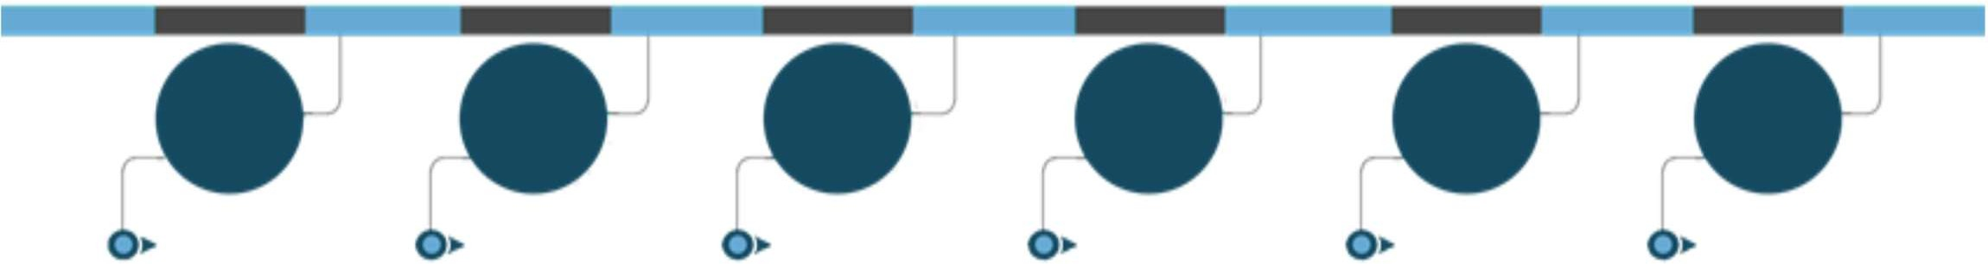

2019-21 2021-
Present 2020-21

2019-21
2021-
Present

HCL
Technologies, Noida as Sr. Specialist

InfosysTechnologies, Bengaluru as Technology Analyst (Team Lead)


WORK EXPERIENCE

Jul’21-Present: Infosys, Bangalore | [Technology Analyst] Team Lead |LRQA |Elevate |Refresco |Ricoh Key Result Areas:
  - Implementing Intune mobile device management
  - Developing, deploying, and managing mobile applications with Intune.
  - Led a team of 15 engineers in resolving complex issues, quality, escalations, KB submission & documentation, and continued training.
  - Acting as a Subject Matter Expert in Apple iOS APN certificates, device enrollment programs (DEP), Configuration Manager and the integration of cloud services (including KIOSK devices iOS/Android, Windows 10 enterprise)
  - Handling the hurdles call and resolving conflicts.
  - Changes apply in the tenant for better updates of Intune as per the latest update by Microsoft.
  - Introducing to the Team about latest updates of Intune whatever I’m aware of.
  - Majorly handle the P-1 Issues
  - Making Shift Roster and Auditing the Ticket and matching with the KPI
  - Providing the approval for any new changes in the production.
  - Migration from SCCM to Intune via Autopilot.

Highlights:
  - Worked explicitly on Windows, Androids, and Mac OS environments.
  - Managed IT software, hardware, and network setup
  - Assisted the documenting processes and monitoring performance metrics.
  - Skilled on premise to cloud as well as cloud to on premise migrations

Sep.’19-Dec’21: HCL Technologies, Noida | GET Senior Software Analyst | Client – Stanley Black & Decker Highlights:
  - Accomplished server-based installations, patches, and upgrades of the mobile device management solution (AirWatch & Microsoft Intune 60,000 devices) as an Intune Administrator
  - Operated directly with the clients’ technical teams and supported staff to ensure mobile infrastructure functionality.
  - Supported clients via telephone, e-mail with a wide range of questions, problems and requests with their iOS and other mobile connectivity needs.
  - Monitoring the SLA of Incidents and SCTASK.
  - Resolve the Escalate issue in a timely manner according to the Standard Operating Procedures.
  - Leverage internal technical expertise including peers, mentors, knowledge base to provide the most effective solution to the client issue.
  - Tackle the client hurdle with the timely recommendation, updates and prons.
  - Troubleshooting and delivering Resolution for any issue Intune.
  - Add users to specific AD Groups and verify the Mobile Exchange Access.
  - APNS Certification Renewal (Apple Push Notification Service)
  - Managing Ios and Android Device – DEP Enrollment BYOD, Re-push profile, CYOD with applications.
  - Providing Training and Documentation to the freshers and L1 Team.
  - Enrollment of Users and Device
  - SP Integration, Configuration, Patching, Renewal the expire certificates.
  - Migration from one tenant to another (SP 2013 0365)
  - Using the Sharegate Tool

 EDUCATION


2019: B.E from Shri Ram Institute of Technology, Jabalpur (Madhya Pradesh)



PERSONAL DETAILS
INDIA BOOK OF RECORDS (Pedaling)
Languages Known: English, and Hindi
Date of Birth: 11-07-1998
Address: New Delhi (A-127, New Ashok Nagar, 110096)



