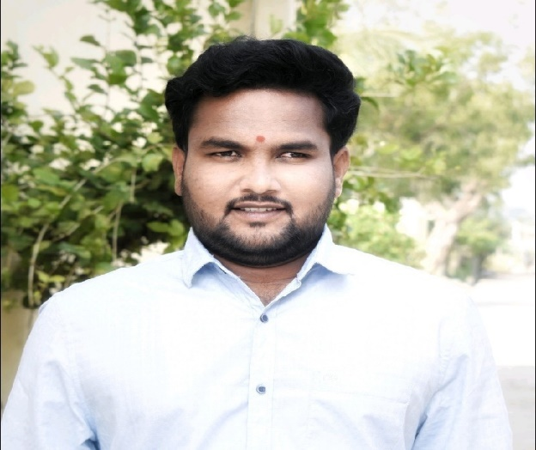
RESUME

Dnyaneshwar Irba Indore
@ indoreds137@gmail.com MO:- 8806363649

O BJECTIVE: To continue my career with an organization that utilize my MANAGEMENT, SUPERVISION &
ADMINISTRATIVE skills to benefit growth and success.

EXPERIENCE: 3.5 + years’ experience.

M & M LTD.
Go-to-Market FaaS Division as a Territory Manager Jan2023 to Till Date

Based at Rajkot & looking Rajkot, Amreli, Jamnagar, Junagadh & Mahuva Territory.

- Business development & brand establishment of Agri inputs & Seeds.
- Handling & leveraging of 50 krish-e marts network for Agri inputs sales.
- Management of Takneek & Digital plot advisory through team .
- Farmer training, demonstration of new products & crop show.
- New Dealer appointment and development.
- Development of sales and marketing channel.
- Market research and order placement and seasonal inventory management.
- Crop Productivity improvement.
- Working with distributors and retailer.

MAHINDRA IBS Ltd
Go-to-Market FaaS Division as a FaaS Centre Manager Jan2021 to Jan2023

Objectives: -
1) Increasing Farmers Prosperity
2)Developing Business Portfolio of dealer.

Responsibilities: -
1)Increasing farmers income with minimizing cost of cultivation through different Krish-e services.
2) Developing Business Portfolio of dealer Ex Mahindra Smmit Agriscience ltd.
3) Farmers training and demonstration of new product & crop show.
4) Takneek & Digital plot management through KP & generating business at ground level.

PUSHPA KRISHI UDYOG Narayangaon as a Manager July2020-Jan2021
1)Campus placement in turmeric & ginger vertical farming project.
2)Overseeing all operation of the project.
3)Crop nutrient & spray management.
4)Mainting controlled environment in Polyhouse.
5)Testing work quality regular basis.

RAWE:
Aim: Building farmers relationship & stage courage.
Result: 6 months on field experience at farmers village, successfully conducted different demonstration in field such as soil sample collection, fertilizer application in fruit crop, seed treatment etc. conducted mini Agri exhibition at village.

ELP:
Aim: Analysis of soil nutrient and fertilizer recommendation.
Result: 2000 soil sample analysis and fertilizer recommendation done as per soil report (30 group member).

Education:
Course | Collage | University/Board | CGPA/%
PGDM in Operation Management | MIT , PUNE | MIT School of distance education | pursuing
B.Sc. Agriculture | Collage of Agriculture, pune-05 | M.P.K.V., Rahuri | 7.81
H.S.C. | Mahatma Gandhi  Mahavidyalaya, Ahmedpur | Maharashtra State Board | 79.08
S.S.C. | Jantha High School, Kautha | Maharashtra State Board | 84

CERTIFICATION:
1) Change management for organization: drive strategic result-udemy
2)Emotional Intelligence: How to influence people and business- udemy
3)Stress management: 40+ easy way to deal with stress-udemy.
4)ChatGPT for better business communication-udemy.
5)Advance Excel- Udemy & Shree Academy.

Languages known: - Marathi, Hindi, English

PERSONAL INFORMATION

Date of Birth: - 27 July 1996
Hobbies: - listing book summery, GYM, Internet searching.
Marital Status: - Married
Permanent Address: - At post Kautha , Block:-Kandhar District:- Nanded , Pin code :-431746

REFRENCE:

Mr. Gaurav Vaidya Dr. Ashish Ganpule
State Head -MH Manager – Digital & Content Agronomy at Syngenta
M0:-88666529810 Mo: - 9158889373

