Curriculum vitae
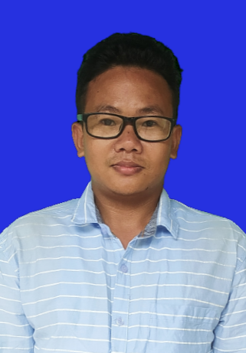
Name : ISSAC MOSAHARY
Email ID : issacmosahary112@gmail.com
Mobile No : 8472843080

________________________________________________________________
CARRIER OBJECTIVE
To seek challenging assignment and responsibility with an opportunity for growth and carrier advancement as a successfully achievement .
PERSONAL DETAILS
Date of Birth : 11 Feb 1998
Gender : Male
Blood group : B (+) ve
Nationality : Indian
Religion : Christian
Marital Status : Unmarried
Father’s Name : Pronay Mosahary
Mother’s Name : Bijuli Mosahary

PERMANENT & PRESENT ADDRESS
Vill: Sashipur P.O: Darranga Mela
P.S: Tamulpur Dist.: Tamulpur Pin: 781360 BTR Assam
ACADEMIC QUALIFICATION
2019 – 2022 : BCA (Bachelor in Computer Application)
From Guwahati University
2016- 2018 : H.S (Science) AHSEC From Bhawanipur H.S School with 67%
2016 : Matriculation (ICSE Board) From Don Bosco School Sashipur with 60.2 %
COMPUTER EDUCATION : PGDCA ( MS-Office : MS-Word, MS-Excel, MS-Powerpoint, MS-Access) DTP, Corel DRAW, Photoshop, Tally, HTML ,Programming Language C ,C++,Java, Visual Basic, Internet, Virus-Antivirus& Basic overview of Hardware ,Networking. From (Edutech Institute of Technology)
WORKING EXPERIENCE: NO
LANGUAGE KNOWN : Assemese, Bodo, English and Hindi.
DECLARATION: I hereby declare that all the above information is true best of my knowledge.
Date:
Place: Signature

