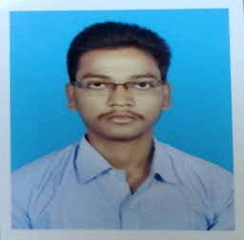
JITENDRA KUMAR SETHI
Jitendrasethi37@gmail.com
9776582905
9583380710

Career Objective:

I want to work for an organization, which will provide me the opportunity to improve my skill and knowledge to growth along with the organization objective. To secure a challenging position in a reputable organization is my goal in this pandemic situation of our country.

Educational Qualification:

Qualification | Specialization | Institution &place | Year of passing | Board/university | Percentage (%)
MBA | Finance and marketing | Aryan school of business and management |  | Bput | continue
B. Com | Finance | S.S mahavidyalaya,anatapur,  Balasore | 2020 | Fakir mohan university | 55%
12th std. | Commerce | S.M College, Barapur | 2017 | Odisha state board | 37%
10th std. | CBSE | M.P high school,uhad,bhadrak | 2014 | Board of secondary, odisha | 57%

Skills:
- Managerial
- Hard working
- Communication
- Leadership

Certificate Programs:
- PGDCA Office excel 2017 certified by Microsoft office specialist.
- Tally ERP 9

Hobbies and interest:
- Travelling
- Photoshoot
- Watching webinar
- Playing video game

Strengths:
- Team leader.
- Quick learner.
- Talkative
- Goal oriented
- Problem solving

Experience:
- Marketing in admission sector
- Work in private finance sector
- Computer sector

Personal Details:
Date of Birth :13/08/1998
Gander : Male
Language Known :Odia, Hindi, English
Permanent Address :Brahmangan,Basudevpur,Bhadrak,756165
Present Address :Nuagan, Eram, Bhadrak, 756162
Marital Status : Single

Declaration:
I, Jitendra kumar sethi, hereby declare that the information contained here is true and correct to the best of my knowledge and belief.

