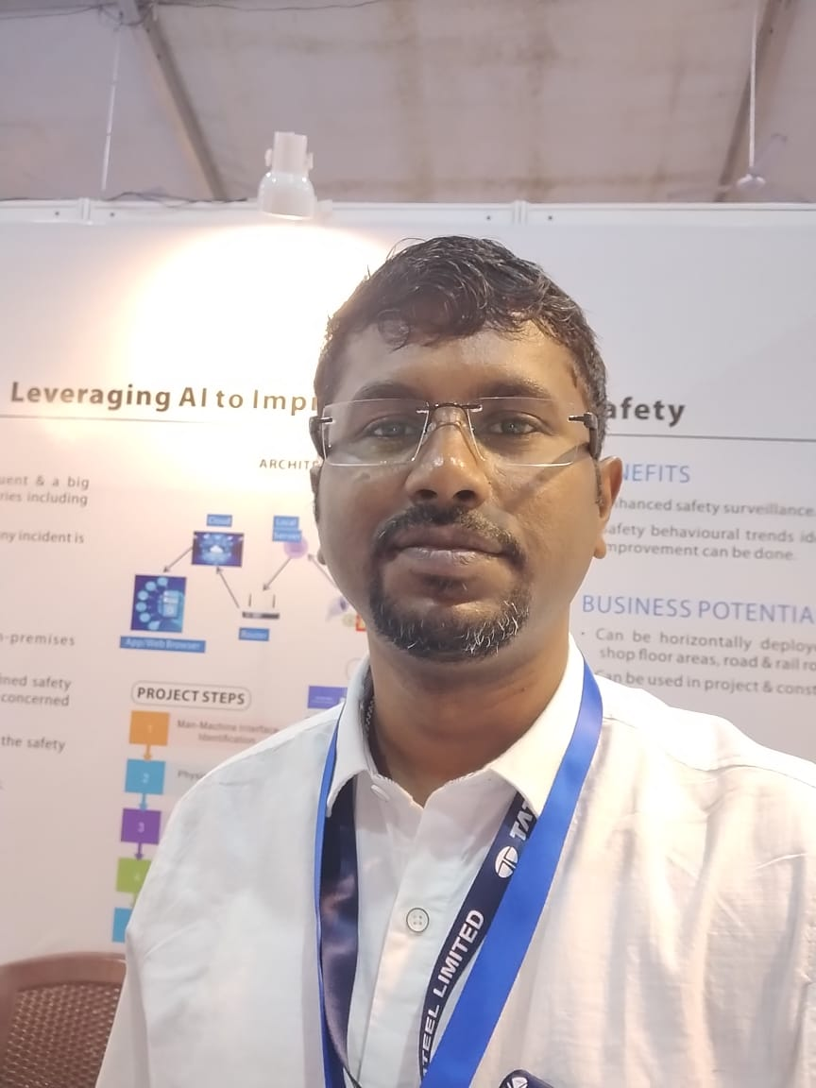
JOY MOHADANI
Date of Birth : 20-10-1992
Contact : +91 7854847226
Email : jmohadani@gmail.com / joymoha7@gmail.com

Job Objective

I want to be a part of a future technologies-MES,OT,Data_integration,Cybersecurity,IIOT want to confront with all the challenges that the job has to offer. Passionate about Control & Automation technology & want to active member of OT technology.

Professional Overview (10 Yrs)

Organisation : TATA Steel_Tinplate Division (Oct’22__present)

Position : Manager Electrical & Automation
Electrolyting Coating Finishing line Maintenane & Upgradation project

a) Past Organisation : Barry Callebaut India Pvt Ltd (Jan’22-Oct’22)
Position : Assistant Manager under Electrical & Automation

b)Past Organisation : EXIDE INDUSTRIES LTD(2019-2021)
Position. : Electrical & Instrumentation –Senior Officer
Working Division : Industrial & Traction Battery-Electrical & Instrumentation

c)Past organisation: HIMADRI SPECIALITY CHEMICAL LIMITED(2017-2019)
Working Division : Oil & Tar Based Chemical Plant Electrical Maintenance
Position : Electrical -Executive

d) Past Organization : BHUSHAN POWER & STEEL LTD(2014-2017)
Working Division : 2015 Cu.M BLAST FURNACE COMMISSIONING -Paul Wurth
(Blast Furnace Proper, BLT, Under Hearth, In & Above Burden Probe)
Designation : Assistant Engineer (Electrical& Instrumentation)

Core Skill Overview
- Instrument & Automation- a) Basic Knowledge of Mitsubishi, Honeywell, ABB & Schneider PLC, DCS Hardware, Software systems.

b) Siemens S-7 200, 300, 1200 & 1500 PLC & Programming knowledge with software Microwin, Scalance, Simatic manager & TIA Portal-13,14,16.
c)Trained & having certificate on different communication protocols like TCP/IP, Modbus RS485, Profibus.
d)TIA Master Advance programing knowledge & Certification.
e) P&ID, Cause Effect Diagram, FAT-SAT, SIL, HAZOP etc knowledge.
- Inventory & Material Management- SAP HANA- PM & MM Module, Critical Spare Maintain, Vendor Handling, Indent (PR, MR) , Budget Planning & Controlling, Capex & Revex Maintain & Planning, Techno commercial comparative preparation, Material Inspection & OPI for Project job.

- Drawings & Standards- i) Instrumentation Related Drawings & their Coded Abbreviations-P&ID, Detailed Engineering. ii)Basic Knowledge of Instrument Datasheet.
- Knowledge of TPM Maintenance- 5’S, Kaizen, CLIT, Root Cause analysis.
- Project & Pre-Commission- Planning, Execution, Installation of different Field instruments, Cable Scheduling, BOQ, BOM, Technical Product Comparison, Detail Engineering, OPI, HAZOP Study, PSSR,Time & Cost Cycle Analysis, Master equipments list prepare for plant operation, Cold Trial, Hot Trial.

KEY SKILLS

- Automation:

- SIEMENS S7-200, 300,1200 & 1500 PLC Programming Basic- Upload/Download, Logic Online, Modification of Channels Input/Output, FB & FC Blocks, Basic Programming of PLC & HMI, Calibration via Micro win, SIMATIC Manager, TIA Portal -13,14,15 & 16 & WinCC for HMI development & troubleshooting.

- Basic Online & Troubleshooting of System fault & fault diagnostic.

- Protocol like-Profinet, Profibus, Modbus, TCP-IP & Hart for connecting devices.

- Basic Programming language & functions like LAD, FBD, SCL, STL, UDT, S-7 Graph, Automatic Sequential, VFD commissioning with Profinet mode, GSD file of different hardware, Distributed Modules Troubleshooting etc.

- Explore different logic & philosophy to control servo modules in motion application.

- Explore OPC-UA data fetching to .xls & UA expert server for dashboard creation & analysis.

- Setron PAC4200 energy meter data fetching to S-7 1500 CPU for Energy monitoring pilot project

- Knowledge of the Siemens product & lifecycle, product group to proactively upgrade them before phase out, likely OP/TP 177 series HMI to KTP 400 comfort, ET 200S series module.

Projects/Modifications :

- Tank Level with Level transmitter logic modification in acid dilution system & Slurry Mixing System with Automatic conveyor start-stop based on sequence.

- S-7 200 Program up gradation to S-7 300 Logic with upgraded HMI for Automated plate generation machine.

- Basic troubleshooting & Programming of Honeywell DCS(C-300 Controller) & Experion studio. Hands On programming foe Co-Gen Fuel Feeding System, Cooling Tower & Water Plant Project.

- Honeywell Graphics Builder & Control builder knowledge for Process automation in High performance pigment section include Trend, Alarm, Interlock & User settings.

- VFD Project commissioning of ABB ACS 880 & Schneider Altivar 630, 930 & Danfoss FC commisioning upto 120 HP motor with different interlock.

- Upgradation of WinCC flexible project of MP 277 10” touch to TP 1200 comfort panel via migration & eliminate all warning & alarms in the projects.

- Instrumentation:

- Cable scheduling of Interconnecting control panel & I/O panel- interfacing with SCADA, Faceplate design, Tag assign, Unit configuration, Controller & I/O assign in new systems.

- JB Schedule, Hook up drawing for the field installed instruments like Pressure, Flow, Temperature & Level monitoring instruments.

- Proper loop Testing likely Cold & Hot Loop Trial before commissioning as a pre-startup procedure.

- Knowledge about Pneumatic & Hydraulic system likely 3/2,5/2 way valves, Hydraulic valves, Valve stand, Accumulator, Proportional valve etc.

- Knowledge of Encoder panel, Servo motor, Weighing Balance, vibration switch different types of special type of instruments.

- Pressure Switch & Transmitter, Flow Transmitter(Magnetic, Vortex, Orifice), Level Transmitter(Radar,Ultrasonic, Float, DP type), Thermocouple, RTD, ZSS, Proximity, RPM Controller, Optical sensor, Load Cell, Pneumatic valve, Proportional Valve, Signal Converter, SCR, Firing Card, Battery charger, Temp Controller, Timer, Air Leakage Tester, Short Circuit Tester, Inter Cell Welding Machine, Heat Sealing Machine, Fully Automation Controlled Machine(Burner Controller for Gas fired Oven(Siemens, Riello), Purging System-Sequential, Thyristor Controlled Heater Station, Servo Motor-Siemens, Encoder Panel- Siemens.

Education

Executive MBA | Operation & Finance | IISWBM | 2019-2020
GATE-2014 | Electrical | All India | Rank-8810
B.Tech | Electrical & Electronics | WBUT(CIT) | 2014 (8.37 CGPA)
Higher Secondary | Science | WBCHSE | 2010 (73 %)
Madhyamik | General | WBBSE | 2008 (77%)

Special Skills & Certifications
- Kepserver Advance Topics from Udemy
- TIA Portal_Master certification from Udemy
- TCP/IP Communication Protocols certification from Udemy.
- Modbus Communication protocols certification from Udemy.
- Cybersecurity Fundamentals certifications from Udemy.
- Electrical Govt License for L.T Work.(West Bengal Govt Certified).
- Having Knowledge of SAP HANA version 750.
- IMS(9001,14001,45001) Internal Auditor certification from BSI.
- RSO Certification from AERB,BARC-Mumbai.

Industrial Training, Projects

- Switchgear & Power Plant Training from Durgapur Projects Ltd fromDecember, 2012 to January, 2013.
- Interpersonal Skills Training in EXIDE INDUSTRIES LMITED.

Declarations
I hereby declare that the above-mentioned information is correct up to my knowledge and I bear the responsibility for the correctness of the above-mentioned particulars.

Place : Jamshedpur Joy Mohadani

