RESUME 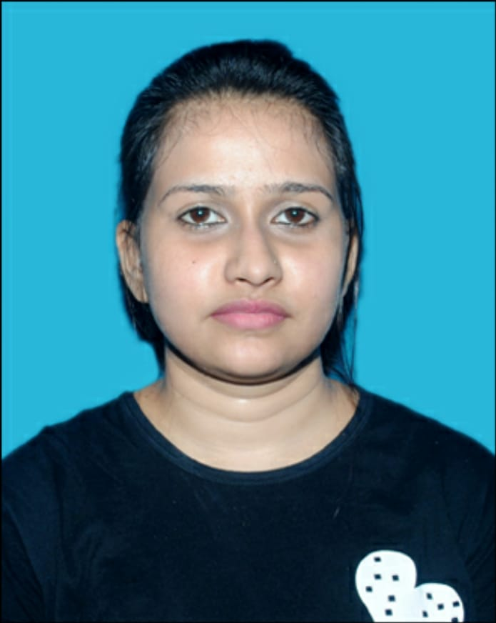

Name : Jyoti Tiwari

Father’s Name : SurendraTiwari

Address : Near RajBhawan Bonkour Nagar Kharghuli,

GHY- 781001

Date of Birth : 10-03-1995

Language Known : Assamese, Hindi, English.

Marital Status : Single

Nationality : Indian

Phone No. : 8399937364

E-mail- : jyotitiwari42414@gmail.com

Gendar : Female

CAREER OBJECTIVE

To curve out a special place in the field of computer that helps me to attain greater of my career. I want to be a successful person in my life with leadership qualities and to be honest toward myself with hardworking skill.

SKILLS

- Enthusiastic, adaptable, patient and friendly.
- Willingness to learn.
- Effective communication skills.
- Good time management.

EDUCATIONAL QUALIFICATION

- H.S. from Kamrup academy higher secondary school in the year of 2014

under AHSEC Guwahati (Assam)
- B.A From KKHSOU in the year of 2019 Guwahati (assam)

OTHER QUALIFICATION

- Diploma in Computer Application (DCA).

EXPERIENCE

- Worked as a Gionee service centre from 1st February 2015 to 31stMarch

2016
- Worked as a Jio Executive 1st May 2016 to 30th November 2018

- Worked as a Sales Person in FMCG Sector Jabson Company from 26th

November 2019 to 30th December 2020.

- Currently I am working in FMCG Sector Dilbahar Company as a

Sales Person from 1st January 2022 till date .

AREAS OF INTEREST
- Making new friends.
- Traveling.
- Surfing the internet.company
- Playing games.

I, the undersigned certify that to the best of best of my knowledge and belief, the resume correctly describes my qualification and myself.

Date

Place: Guwahati. Signature

