MANMEET SINGH

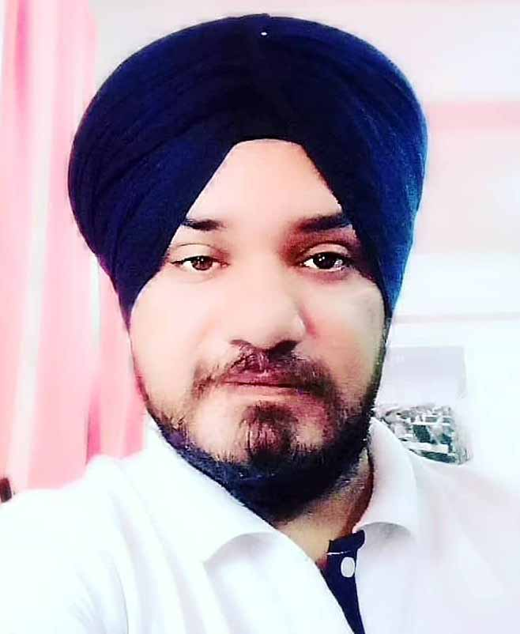
Address: Railway Patri, Talli Morh,
Miran Sahib, Rs Pura, Jammu.
Contact: 9149932446, 9596860911.
Fatehsingh01001@gmail.com.

OBJECTIVE
Ability to do work which helps in growth of my organization as well as mine in key aspect areas, dealing with software works in IT sector while being resourceful, innovative and flexible.
ACADEMIC RECORD
X from Pragmatic Institution Of Education J&K Board
XII from Pragmatic Institution Of Education J&K Board
PROFESSIONAL QUALIFICATION
Graduation : Bsc-IT from Karnataka State Open University
POST Graduation: MCA from Karnataka State Open University
Hardware and Networking From in Jetking
EXPERIENCE
JOB RESPONSIBILITIES

2 year  Vr3 Privated Limited. | Ms office, word ,Excel, PowerPoint,  Acess,Pagemaker,coraldraw,  Tally, Busy. | 2015 to2017
1 year.  MANPOWER GROUP INDIA SERVICE PRIVATE LIMITED. | Assembly Dessembling,color coding,  Ping,ipconfig,Dhcp,Dns,Printer,Troubleshooting,  Window 7 Installation lab maintain,  Software.  . | 2017 to 2018

.

STRENGTH
- Dedication for what I indulge in and proving myself to the extent possible
- Adaptability to changed environment
- Punctual and hard worker

HOBBIES
- Playing & Watching Cricket
PERSONAL DETAILS

- Father’s Name : Raghbir Singh

- Date of birth : 31st March. 1988

- Sex : Male

- Marital status : Single

- Languages known : English, Hindi, Punjabi

- Nationality : Indian

Place:
Dated : MANMEET SINGH

