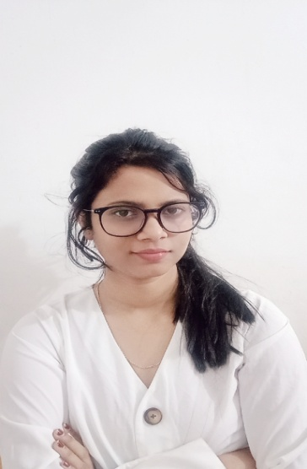

Graduated from Gauhati University at mathematics honours. My studies have given me a detailed understanding of conceptual knowledge, an array of skills which tackle the process of organization and taking in information. A Highly organized and hard working individual looking forward to work for a responsible position to gain practical experiences.
- Microsoft office,power point, ms excel, ms word, C++ etc
- Good communication.
- Strong attention to details and accuracy.
- Creative thinking, time management.

- English
- Hindi
- Bengali

LANGUAGES
03/10/1997

9101076488
8761807947

Peyalichakraborty163@gmail.com

Lachit Nagar, beside bylane 5, Guwahati, Assam, 781007

PERSONAL DETAILS
SKILLS
Masters of Science in Mathematics – [2023]
Arya Vidyapith College, Gauhati University

Bachelor of Science in Mathematics Honours – [2020]
Handique Girls’ College, Gauhati University
Higher Secondary – [2016]
Lumding College

HSLC – [2013]
Don Bosco High School

Listening Music
Travelling
Learning Languages
Sports

INTERESTS
EDUCATION
PEYALI CHAKRABORTY

ABOUT ME

