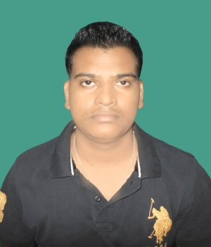
SANJEET KUMAR
58A peerwali gali ashok nagar mayur vihar phase 1
110092
+91- 9006436370
E-mail – sanjeetkumaryadav30@gmail.com

SUMMARY
Sincere and hardworking individual BCA from Bengal college of engineering and technology , Durgapur; accented with the latest trends & techniques of the field & determined to carve a niche in the industry.
COMPUTER-PROFICIENCY

. Operating System : Windows XP/7/8/10 , MS-DOS, Vista.
· Basic : MS OFFICE , Internet.
· Programming Languages : C and C++ , Visual Basic, Core Java
· Web Programming : HTML, Java Script, ASP.NET .
· Database : MS Access, DBMS .

EDUCATION

2016 BCA MAULANA ABUL KALAM AZAD UNIVERSITY OF DGPA- 7.30
T ECHNOLOGY , WEST BENGAL
(Formerly known as West Bengal University of Technology)

SEMESTER | 1 | 2 | 3 | 4 | 5 | 6
S.G.P.A | 7.29 | 7.00 | 7.14 | 6.85 | 7.97 | 7.53

2012 CLASS XII NATIONAL INSTITUTE OF OPEN SCHOOLING 61.40 %

2010 CLASS X CENTRAL BOARD OF SECONDARY EDUCATION CGPA – 6.0

STRENGHTS
- Belief in God, Self Confidence, Convincing Power, Comprehensive problem solving abilities, Excellent verbal and written communication skills, Passion for developing and managing people relations, Good Leadership and Team Building.

AREAS OF IMPROVEMENT
- Obsession with Success :My zeal for coming out winner at all times must be balanced by the appreciation that winning is not the end all. There may be times when winning stops growth and there may be times when failure starts learning. And so the point of worry is the point of no learning.

SPECIAL INTERESTS
Computers & taking part in group discussions & love to take challenges

TRAINING&WORKSHOP
- Undergone 1 month training on ASP.NET from CMC ACADEMY , DURGAPUR

Date of Birth: 15-08-1995| Language Known: English & Hindi| References: Available on Request
Hobbies: Browsing, Travelling, Making friends &Calligraphy.

____________________________
SANJEET KUMAR

