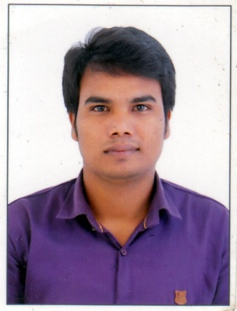

CAREER OBJECTIVE
SHAHIDUL ISLAM
E-mail:islamshahidul000786@gmail.com
Mobile No.: 6300038256 / 9010671902

To pursue a challenging position in multinational company that offers room for professional growth, as this provides me ample opportunities to exhibit my skills which can even increase the standard of the company.

PERSONAL DETAILS

Address : - Vill: - Chukabahi Post Office: - Daipam PS:-Dalgaon
District: - Darrang, State: - Assam Pin:-784514
Date of birth : - 10-09-1995
Gender : - Male
Nationality : - India
Marital Status : - Unmarried
Languages known : - Advanced (1. English 2. Hindi 3. Assamese 4.Bengali )

PROJECT DETAILS

Project Title : - Solar Electrical Bike
Project Duration : - 03 Month
Project Role : - Team Leader
Project Detail : - A bike which will be run by solar and electric energy to overcome
The fuel crisis.
Project Member : - 06

EDUCATION

Course | Year of Passing | Division | Institute | University
HSLC | 2013 | 1st Division | Daipam High School | Board of secondary education Assam.
ahsec | 2015 | 1st Division | Kharupetia H.S. School. | Assam Higher Secondary Education Council.
B.Tech  (Mechanical) | 2019 | 1st Division | Chaitanya institute of technology& science. | Kakatiya university.
PGDCA | 2019 | Distinction | RSETS | RSETS
M. Tech | 2021 | 1st Division | Vaagdevi college of Engineer | Jawaharlal Nehru Technology University Hydrabad.

EXPERIENCE
- Assistant Professor: - Lecturer at 10/05/2019 to 01/01/2020.
- Quality Engineer :- Tecno Company Private Ltd at 0 1/02/2021 to 05/05/2021.
- Consultancy : - Educraft Consultancy at 01/06/2021 to 20/12/2021.

SKILL

COMPUTER SKILL : - Basic computer (MS Office, MS PowerPoint, MS Excel,MS Word).
Technical Computer Skill:- AutoCAD, Java, Pro E, C++, Windows, iOs, Android.

ACHIEVEMENTS

Operation and maintenance of CNC machines with grade Exp:- Course on maintenance and operation of
CNC machine.

HOBBIES

- Developing of Skill 2. Playing Cricket

DECLARATION

I solemnly declare that all the above furnished information is free from error to the best of my knowledge and belief. I bear the responsibilities for the correctness of the above mentioned particular.

Date Signature

