Sougata Banerjee

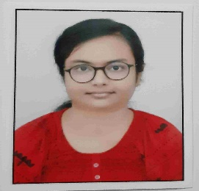

Quick Learner with passion for executing challenging and cutting-edge duties.

Capable enough to work for a team, and lead a team.

EDUCATION

Master of Computer Applications, Jadavpur University

September 2019 - July 2021

- GPA 8.28 out of 10

Bachelor of science, J.K College, Purulia

August 2015 - June 2018

- Honours in Mathematics

- Good background in Mathematics

- 60.25 percent marks in aggregate

WBCHSE ( Science )

- 85.2 % achieved

WBBSE

- 87.57% achieved

Achievements :-

- Recipient Of DST INSPIRE scholarship for being top 1% in 12th

Chakraborty Cottage, Lower Beniasol,Adra
P.O & P.S :- Adra
Purulia, PIN 723121
West Bengal

+91 8116462985

Gmail :-

sougatab217@gmail.com

LinkedIn : -

https://www.linkedin.com/in/sougata-banerjee-9b588b212

TECHNICAL SKILLS

Programming languages

C, C++, Java, JavaScript
Domain knowledge

Data Structures and Algorithms, DBMS. OOP

Skills

HTML5, CSS3

Database management system

Oracle, MySQL

Operating Systems

Windows.

LANGUAGES

English, Bengali, Hindi

Interests

Gardening

Reading

Music

Cricket

Football

