Contact No:  +91-8908646121  +91-7978531427  +91-9776270124  E-Mail:  nsoumya93ranjan@  gmail.com  DOB: 1st Dec,1993  Gender: Male  Blood group: A +ve  Nationality: Indian  Marital Status: Unmarried  Specialization  - Computer fundamental  - JAVA  - .NET(C#& Vb)  - Sql server 2008  Platforms:  Windows NT/2000/2003/2008,Windows XP/Vista/7 | SOUMYA RANJAN NAYAK  PERMANENT ADDRESS : C/o-Mr. Kelu Charan Nayak At – Bichana,Po-Nuapada Dist –Kendarapara, Odisha - 754213 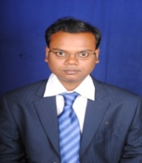 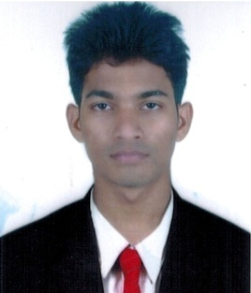   Career Objective  To work in an organization as a key player in challenging and creative environment with 100% efforts where I can learn and enhance my skills for long term stabilization and contribute towards organizational goal and thus ensuring professional and personal growth for the development of the organization…  ACADEMIA  Qualification Inst. / College Board/ University Yr. of Passing % secured  B.Ed Yaswanth College of Education Acharya Nagarjuna University,A.P 2021 77  D.EL.ED NIOS NIOS 2019 72%  M.Sc comp.Sc U.N Autonomous College Of Science And Technology Utkal University 2017 68 %  B.Sc –IST (Information Science and Telecommunication) Ravenshaw University Ravenshaw University 2015 77  +2 (Science) N.S.M city college, Cuttack CHSE, Odisha 2011 46  10th Bethany Convent School,Paradip ICSE,NewDelhi 2009 63  Seminar/Project Report  Seminar on topic.  Gender Sensitivity, Cyber Security ,E-Commerce  Project on topic.  Right to Education. Child Educational System. School CRM System.  Training  - NSDC– CCE (Relationship Centre)  - Gender sensitivity program organized by CBSE.  - Capacity building program organized by CBSE.  Achievements  - Won 1st Prize in English Debatecompetition organized by Inter College in the year 2009.  - Won 2nd Prize in Inter college G.K competition in the year 2009.  - Won 3rd Prize in English Debate competition organized by in the year 2009.  - Won a Prize in Poster exhibition competition on “WIRLESS-ELECTRICTY IN EVERYDAY LIFE” by Bigyana Chetana Mancha ,Odisha
Languages known  English[s,r,w]  Hindi[s,r,w]  Oriya[s,r,w]  s-speak,w-write,r-read  Interests & Hobbies  - Listening Music  - Surfing net.  PRESENT ADDRESS :  C/o-Mr. Sankar Prasad Senapati  At :Bania Sahi,  Po:Buxibazaar  Ps:Mangalabag  Dist –Cuttack,  Odisha - 753001  WORK EFICENCY :  - IT MANAGER  - COMPUTER TEACHER | COMPETENCIES  - Creative & work effectively with teams.  - Quick Learner, Hard-working  - Sincerity and Self Confidence  - Self-motivated, Listen to the subject  SOFT SKILL  Analytical Skills Coordination Skills Time Management Monitoring Skills Interpersonal  Skills Problem detecting & solving Skills Leadership Qualities Managerial Attitude  Work-Experience  - One year experience in First Source Solution Private limited as a Customer Trainer.  - Four months experience as a guest Faculty in Aryan Institute of science and technology.  - A year of experience in St.Xavier’s High School, Brahamanjharilo as Computer Teacher as well as IT manager.  - Presently working in St.Xavier’s High School,ICSE Since from 2016 as a computer teacher cum I.T Manager.(Xavier group of School,Barabati Campus,Cuttack).  - Three years of experience as a Olympiad Trainer in My Aim Academy ,CTC  Declaration  I hereby declare that the above-furnished details are true to the best of my  Knowledge & belief.  Place: CUTTACK SIGNATURE…  Date:

