Sreenu Sannidi
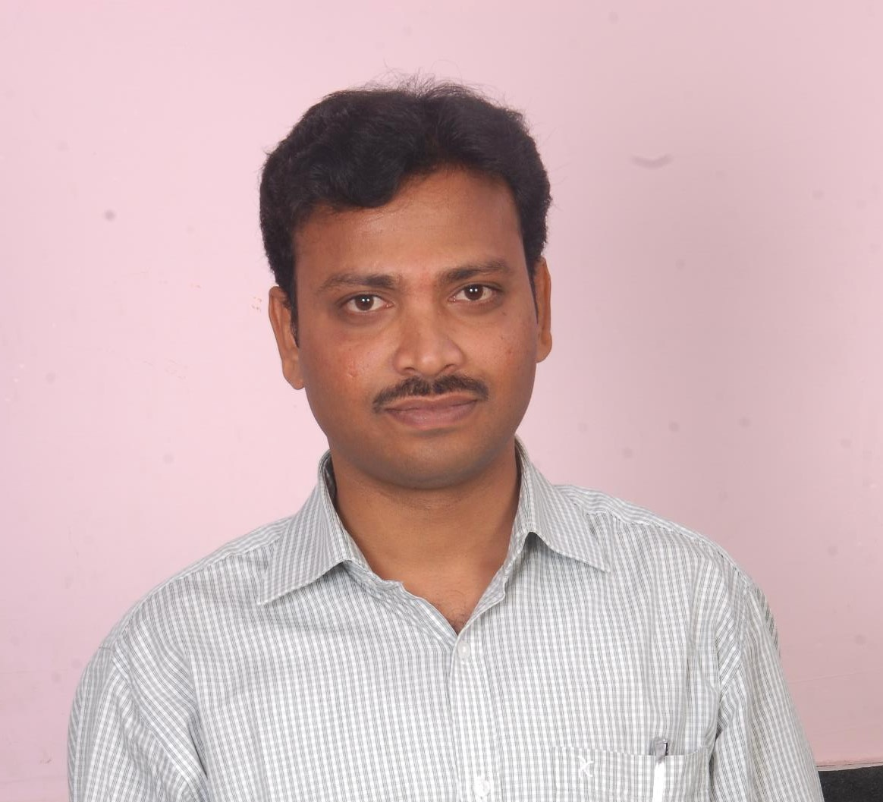
Title: | Senior Consultant
Location: | Hyderabad, Telangana
Languages: | English, Telugu (native)  Mobile No : 8688403605

Experience Summary
- Accomplished professional with 14 years of experience includes 5 years of experience in Java development and Spring framework development.
- Experience on spring modules Spring Boot and Spring MVC.
- Experienced in developing and implementation of REST web services.
- Experience with major databases such as Oracle, MS SQL Server and MYSQL.
- Experience on Servers WebLogic and Tomcat.
- Experience on Control versioning systems like SVN, CVS and Git.
- Experience on using IDEs Eclipse, STS and IntelliJ.
- Certified Querying Microsoft SQL Server 2012/2014 from Microsoft.
- Certified Scrum Master from Scrum Alliance
- Lead a team of 10 members.
- Developed stage plans, highlight reports, risk logs and requests for change
- Project Coordination for Design, Development, Testing, Deployment and Warranty.
- End –to-End Project Management activities like Project Planning, scoping, Mapping Resources as per the Resource Loading Plan, and applied various methods to handle huge volume of data.
- Take an active role in the day to day management of the development/QA team.
KEY SKILLS:
- Functional:
- Lead a team of 10 members.
- Developed stage plans, highlight reports, risk logs and requests for change
- Project Coordination for Design, Development, Testing, Deployment and Warranty.
- End –to-End Project Management activities like Project Planning, scoping, Mapping Resources as per the Resource Loading Plan, and applied various methods to handle huge volume of data.
- Take an active role in the day to day management of the development/QA team.
- Technical:
  - Hands on experience in Java & Java frameworks and MS SQL Server & Oracle

Experience
- Currently working as Senior Consultant in Capgemini India Pvt. Ltd, Hyderabad since 07 May 2021
- Worked as Senior Software Developer in IBM, Hyderabad from Apr 2015 to 30 November 2021
- Worked as Software Developer Lead in IBM, Hyderabad from July 2013 to Mar 2015.
- Worked as Software Engineer Lead in Kenexa, Hyderabad from May 2012 to Jun 2013
- Worked as Software Engineer in Kenexa, Hyderabad from Dec 2009 to Apr 2012

1.Type of Industry: |  | Banking
Project Description: |  | The project involves providing global technology solutions for the merchants for the below facilities.  - Creating and managing of Payees (individual and bulk)  - Managing and approving transactions (individual and bulk) for merchants  - Supporting transaction management for different clients across different counties.
Role/Title: |  | Analyst Development
Project Duration: |  | May 2021– Aug 2022
Responsibilities: |  | - Involved in developing/ modifying the appication features as per client requirement.  - Gave KT to newly joined team members on project/ modules setup, Database setup and internal tools that we use day to day activities.  - Participating actively in all agile ceremonies (Sprint Planning, Daily Stand-Up, Sprint Review, Sprint Retrospective and product backlog grooming)  - Redesigned the application by writing the code from scratch and writing SQL scripts.  - Involved in Configuration and Usage of GraphQL and ActiveMQ for logging and debugging process.  - Being a Sr Consultant in Capgemini involved in weekend/ weekday interviews as interview panel.
Operating Systems: |  | Windows 10
Technology Used: |  | JDK 1.8, Rest API, Spring Boot, Fuse, Microservices, IntelliJ, Oracle SQL Developer, Git Repositary, Maven and GraphQL
2.Type of Industry: |  | Employee Engagement Surveys (Human Resource)
Project Description: |  | Viewpoint (part of Survey Solutions)  Kenexa's (now IBM) Survey Solutions include employee engagement surveys, 360⁰ multi-rater feedback solutions, exit interviews, compliance surveys, and action planning. These solutions help clients understand and act on unique drivers of employee engagement and improve business processes.  Viewpoint is a single application with different gadgets to create reports, view reports, action planning and view resources for client end users (Administrators, Managers and Managers of Managers) based on their role and access group.
Role/Title: |  | Sr Software Developer
Project Duration: |  | Jan 2018 to Nov 2019
Responsibilities: |  | - Implemented Spring MVC controllers like Controller, Simple Form Controller and Multi Action Controller.  - Connected to Data Sources and performed operations using Spring Data framework features like Spring JDBC and Spring ORM.  - Configured the POJOs with backend tables in Hibernate to achive the associations.  - Integrated Spring DAO for data access using Hibernate to fetch data from database and avoid redundant database access statements.
Technology Used: |  | JDK 1.8, Rest API, Spring Boot, Intellij, Apache Maven, Oracle, SQL Developer, Jira and GIT
3. | Type of Industry |  | Employee Engagement Surveys (Human Resource)
 | Project Description: |  | Modules 14 (New generation of Survey Solutions)
 | Role/Title: |  | Sr Software Developer
 | Project Duration: |  | Apr 2015 to Dec 2017
 | Responsibilities: |  | - Implemented Spring MVC controllers like Controller, Simple Form Controller and Multi Action Controller.  - Connected to Data Sources and performed operations using Spring Data framework features like Spring JDBC and Spring ORM.  - Configured the POJOs with backend tables in Hibernate to achive the associations.  - Integrated Spring DAO for data access using Hibernate to fetch data from database and avoid redundant database access statements.
 | Technology Used: |  | Java, J2EE, CSS, JavaScirpt, HTML, JDK 1.8, Rest API, Spring Boot, Intellij, Apache Maven, Oracle, SQL Developer, Jira and GIT
 | 4. Type of Industry |  | Employee Engagement Surveys (Human Resource)
 | Project Description: |  | Survey Solutions (Production Environment)
 | Role/Title: |  | Lead Software Engineer
 | Project Duration: |  | Dec 2006 to Mar 2015
 | Responsibilities: |  | - Collaborated with application developers, production teams, and across functional units to identify business needs and develop solutions.  - Created stored procedures and views as per business requirements.  - Built and maintained SQL scripts and complex queries for data analysis and extraction.  - Identified data issues in production data and provided recommendations for resolution of issues.  - Spearheaded efforts for implementation of best practices for projects deliverables, and ensured integrity of data was maintained through documentation and change management.  - Trained and mentored team members on upgraded version of product to newly joined Engineers.  - Involved in interviewing and onboarding new team.  - Involved in People management, Performance reviews, Appraisals and Escalation handling
 | Technology Used: |  | MS SQL Server, Microsoft .Net and IIS
Achievements: |  |  | - IBM 1-3-9 Award – “Put the Client First” – Q3 2016  - IBM 1-3-9 Award – “Put the Client First” – Q2 2015  - Kenexa Extreme Service Award for “Accuracy” – Q3 2011  - Kenexa Extreme Service Award for “Timeliness” – Q4 2011  - Kenexa Extreme Service Award for “Accuracy” – Q3 2008  - Kenexa Extreme Service Award for “Timeliness” – Q2 2007

Certifications
- Certified Scrum Master at IBM, Scrum Alliance.
- Edge (Essential Diploma for Graduate Engineers), CMC-ATC.
- Querying Microsoft SQL Server 2012/2014, Microsoft.
- AWS Cloud Computing Training Excellence, Collabera TACT.

Higher Education

Masters in Comp. Sciences Osmania University

