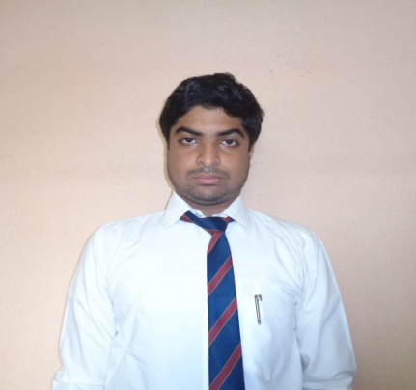
Suranjan Halder
Address: Dhuluk , Bardhaman(713166)
Mob: 7797263007
Email: suranjanhalder2001@gmail.com
Linkedin: https://www.linkedin.com/in/suranjan-halder-a06a93167
Career Objective :
To obtain a position that will allow me to utilize my technical skills, Experience and willingness to learn in making an organization successful .
Profile Snapshot:
An enthusiastic fresher with highly motivated and leadership skills with Bachelors degree in Electronics and Communication Engineering.
Academic Record:
Level | Subject/ Department | Institute | Board / University | % Of Marks
X | Eng, Beng, Psc,Lsc,Math,Geo, Hist. | Nabagram Mayna P.B. High School (H.S) | WBCSE | 72%
XI | Physics, Chemistry, Math, Biology, Eng, Beng. | N.M.P.B.H.S | WBCHSE | 67%
Graduation | Electronics And Communication Enginnering | Dr.B.C.Roy Enginnering College | MAKAUT | 74.75 CGPA upto 6th sem

Skills: Languages: C, Python

Packages and Tools: Cisco Packet Tracer, MATLAB

Projects:

Health Monitoring System -(1may 2021-till now)
Health Monitoring System can help people by providing healthcare Services such as , Medical monitoring Medical data access , Communication with the healthcare provider, emergency case situations through the SMS or GPRS.
Ultrasonic Cap -( 10dec- 4april)
Third eye for the blind is an innovation with the help of the multidiscipline subjects like computer science, electronics engineering and health science which helps the blind people to navigate with speed and confidence by detecting the nearby obstacles using the help of ultrasonic waves and notify them with a buzzer sound or vibration.

Training:
- “Advance Communication System with Cisco Telephony Service” – 6weeks training
from All India Applied Information Technology Development Association.
- “Internet Of Thing(IOT) And Embedded Systems” – 3weeks training
from Central Mechanical Engineering Research Institute(CMERI),Durgapur.

Extra-Curricular Activities:
- NPTEL MOOCs Learner
- Campus Ambassadors at Internbug
- Executive Member Of a NGO foundation “Voice For The Voiceless”
- Photographer ,Won 2nd prize in school inter-house competition.

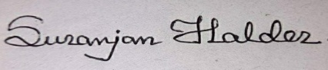 (___________________________) Signature

