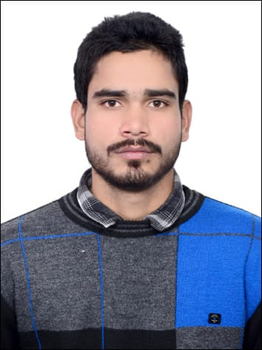
Curriculum Vitae

ZEESHAN KHAN
School Of Sciences , Maulana Azad National Urdu University,
Gachibowli, Hyderabad, Telangana, India (500032)
Email: zk082803@gmail.com |
Phone: +91-; 6396583675 +91-8791686434 (Whatsapp)

Profile
I Zeeshan Khan from Maulana Azad National Urdu University, Gachibowli, Hyderabad, Telangana, India. I am pursuing my Bachelor Of Science (Life Science) . I am highly ambitious, hardworking and socially oriented person since my school days. I always wanted to be in the Science field and so choose Bsc ( Life Science) for my graduation studies.

Career Objectives
My primary aim at this juncture looking for opportunity that will allow me give quality assistance of those in need; and to use strength in communication and psychology as an effective science. As an active science my main goal is to contribute for advancement of society as well as needy peoples.

Educational Qualifications

Bachelor of Science (Pursuing)

School Of Science | Maulana Azad National Urdu University, Gachibowli, Hyderabad, India – 500032.

First Division with 8.64 CGPA (2nd Semester)

Intermediate (2018)
Board of High School and Intermediate Education | UP, India.

First Division with 72.4%
High School (2016)
Board of High School and Intermediate Education | UP, India.

First Division with 77.83%

Hobbies

- Reading Books
- Listen Motivational Poetry
- Volleyball

Personal Information

Name | : | Zeeshan Khan
Father Name | : | Ishraque Ali
Date of Birth | : | 01/July/2001
Gender | : | Male
Nationality | : | Indian
Marital Status | : | Single
Language | : | English, Hindi, Urdu
Address | : | Ward No 17 Mohalla Kira Kakrala Distt Budaun Pin code  243637 (UP)
Declaration

I hereby declare that the above mentioned information is correct up to the best of my knowledge and I bear the responsibility for the correctness of the above mentioned particulars, qualification and achievements.

References

Prof. Salman Ahmad Khan | Dean , School Of Sciences , Maulana Azad National Urdu University, Hyderabad- 500032 (India)  Email:-sahmad_phd@yahoo.co.in  Phone: +91-9598066258
Dr. Maqbool Ahmed | Head Of The Department  School Of Sciences , Maulana Azad National Urdu University,  Hyderabad- 500032 (India)  E-mail: maqboolahmedbotany@gmail.com  Phone: +91-9440366442

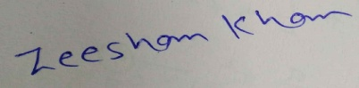
Place: Kakrala, Budaun (UP) (Zeeshan Khan)

