Journal: Nature Methods

Title: 10 words or 90 Characters
speciateIT: Novel, fast and accurate per sequence 16S rRNA gene taxonomic classification
(76 characters)

Authors:

Johanna B. Holm, Pawel Gajer, Jacques Ravel

Affiliations:
Institute for Genome Sciences, University of Maryland School of Medicine, Baltimore, MD, 21201 USA.

To be submitted as a Brief Communication:
A Brief Communication is a more concise format used typically to report a significant improvement to a tried-and-tested method, its modification and adaptation to an important original application, or an important new tool or resource of broad interest for the scientific community. This format typically does not exceed 3 printed pages. Brief Communications begin with a brief unreferenced abstract (3 sentences, no more than 70 words), which will appear on Medline. The title is limited to 10 words (or 90 characters). The main text is typically 1,000-1,500 words, including the abstract and contains no headings with the exception of a single heading for Methods to point readers to the online Methods section providing all technical details necessary for the independent reproduction of the methodology. Brief Communications normally have no more than 2 display items, although this may be flexible at the discretion of the editor, provided the page limit is observed. As a guideline, Brief Communications allow up to 20 references, and article titles are omitted from the reference list.
Brief Communications include received/accepted dates. They may be accompanied by supplementary information. Brief Communications are peer reviewed, and authors must provide a competing financial interests statement before publication.

Brief Communication 1,000-1,500 Words, including Abstract (Currently 733 words)

Abstract (3 sentences, no more than 70 words, currently 68 words): Clustering of sequences into operational taxonomic units (OTUs) has become a mainstream stopgap to taxonomically classifying large numbers of 16S rRNA gene sequences. We developed speciateIT and speciateDB, a novel taxonomic classification tool which rapidly and accurately classifies individual amplicon sequences (https://github.com/Ravel-Laboratory/speciateIT). We show that this method requires minimal computational resources relative to other algorithms and affords accurate species level classification.

Main Text
High-throughput next generation sequencing has revolutionized the field of metataxonomics by producing millions of sequences at an affordable cost, increasing the depth at which microbial communities are characterized. However, large sequence datasets have led to new challenges such as high computational costs associated with data analyses and accurate taxonomic classification. Bioinformaticists have developed novel sequence clustering algorithms which either produce, for a given similarity threshold, groups of sequences known as operational taxonomic units (OTUs)[1-3], or reduce sequencing errors and minimize noise in the data [4-7]. These approaches have proven useful, though noise reduction/error correction may artificially remove or produce diversity [6] and the process of OTU clustering simply shifts the computational cost from taxonomic classification assignment to clustering and is not without problems. Most significantly, the transitive taxonomic assignments obtained from an OTU representative sequence are often flawed as 10-30% of sequences within the OTU, if processed separately, are assigned different taxonomy, thus challenging the ecological value of an OTU [8]. Further, output from clustering-based analyses are dataset specific and when data is added to a study, clustering has to be run again and at increasing computational cost. A solution is to rapidly provide taxonomic classification to every sequence in a dataset.
To alleviate these issues, we present speciateIT, an algorithm capable of fast, accurate individual sequence taxonomic classification. Using a newly curated model guide tree and 7th order Markov Chain models to represent microbial species trained on taxonomy-adjusted amplicon specific regions sequences, speciateIT requires little computational resources, and can quickly process large sequence datasets. speciateIT models correctly classified at the species and genus levels 98, 97, and 94% of known V1-V3, V3-V4, and V4 region’s sequences (Figure 1). This is a major improvement over the RDP Naïve Bayesian Classifier [9], the last innovative taxonomic classifier released in 2007 which was capable of >90% classification accuracy of known sequences to the genus-level only [10, 11].
Estimates of classification accuracy for novel sequences were obtained using repeated 10-fold cross validation. To ensure confidence in assignments, speciateIT imposes model-specific classification error thresholds: when the posterior probability of a query sequence does not exceed this threshold, the query sequence is classified as the next highest taxonomic level at which this threshold requirement is met. In the case of novel taxa, speciateIT is expected to assign higher-level classifications. In our 10-fold cross-validation testing of species groups comprising 10 sequences or more, the overall accuracy (correctness at any taxonomic level) was 92, 86, and 80% for the V1-V3, V3-V4, and V4 regions, respectively, with the majority of correct assignments at the species or genus level (Figure 1). Comparatively, in a 5-fold cross-validation test using the RDP Naïve Bayesian Classifier and 100, 250, and 500 bp reads of the RDP training set (variable regions were not defined), classification accuracy was 48, 55, and 64% accuracy (sensitivity) at the genus level, respectively [10].
Additionally, the speed of speciateIT is incomparable because of its novel model tree-based approach which directs query sequence classification from the root of the tree to the node of its final classification (Figure 2). Classification speed was measured on a 2015 Macbook Pro using each amplicon reference training set sampled to 10¹-10⁷ sequences and processed on one core. Classification speed ranged from ~2 million sequences/hour to ~6 million sequences/hour, respectively, depending on the size of the test set and the number of models in the reference dataset (Figure S1).
The performance of any classifier is entirely dependent on the quality of the sequence training set used to build it. speciateIT models have been built from full length 16S rRNA gene sequences curated from three public databases [12-14] for the taxonomy-adjusted V1-V3, V3-V4, and V4 amplicon sequence regions, and are publically availble (https://github.com/Ravel-Laboratory/speciateIT). The full-length database comprises 15,977 species, 2,917 genera, 515 families, 228 orders, 103 classes, and 43 phyla. Importantly, taxonomy is adjusted in each V1-V3, V3-V4 and V4 database to reflect the loss of taxonomic information associated with sequence truncation, a known problem when using amplicon sequences [15].
We anticipate speciateDB will continue to grow as more species are described, and more 16S rRNA gene variable region speciateIT models will be produced. The classification algorithm script and reference models are publically available via https://github.com/Ravel-Laboratory/speciateIT.

Methods (All Online - Does not count toward word count)
speciateIT Algorithm:
speciateIT produces a hierarchy of Markov Chain models trained on groups of phylogenetically related sequences. The models are organized in a model tree reflecting the species lineages (buildModelTree, Figure S2). For each node of the model tree (except the root) all reference sequences corresponding to the node's subtree are used to build a Markov Chain model (buildMC, Figure S3). Node-specific classification error threshold is set to the maximum posterior probability over all sibling node's sequences where the posterior probabilities are estimated using the reference node model. All error thresholds are adjusted by adding to them the log of the positive (and less than 1) offset coefficient. The optimal value of the offset coefficient was found using cross-validation procedure [TO BE DONE]. Classification error thresholds use a criterion that the majority of a species’ reference sequences’ posterior probabilities should be above the threshold value (est_err_thld, Figure S4). Classification of a query sequence begins at the phylum level of the model tree. The model producing the highest posterior probability is chosen, and the assignment is given to the sequence given that the posterior probability is greater than the classification error threshold for that model. Model comparisons at the next and lower taxonomic levels commence until either a terminal node (species-level) classification is reached, or the classification error threshold criterion is not met (Figure 2).

speciateIT database curation:
Building Reference Sequence Database
To build the speciateIT reference database, 324,167 full length 16S rRNA gene sequences from 30 archaeal and bacterial phyla including 55 classes, 119 orders, 286 families, 1671 genera, and 10,454 species from RDP r11.5 were candidates for a base set of Markov Chain models and guide trees. Sequences chosen contained no ambiguous bases and were 700-1600 bp long. RDP-formatted lineages were re-formatted for speciateIT compatibility (reversed and tab-delimited), and a taxonomy file was created connecting sequence IDs to species annotation. From these sequences, a model tree and 7th order Markov Chain models were built, and classification error thresholds were estimated. These models will be referred to as the base models.
The SILVA r132 NR99 database was next integrated into the above subset of RDP sequences. First, Eukaryotic sequences, sequences without a specific species name (for example, “endosymbiont_eubacteria”), and those containing ambiguous bases were removed from the SILVA dataset. The remaining 154,813 sequences were classified using the base models. From the speciateIT classification file, each SILVA sequence was considered for integration using a custom script add_new_or_to_existing_models.pl. A total of 119,512 sequences were integrated into the training dataset as an existing or “new” (not present in base models) species (a total of 3,123 new species were added). The new training set was dereplicated using a combination of buildModelTree (to get species-specific fasta files), USEARCH cluster_fast algorithm with identity threshold of 1.0 [16], and the custom script concatenate_fasta.pl.
Because 35,301 SILVA sequences were not initially integrated, we repeated the above steps with models built as described previously using the expanded training set (RDP + partial SILVA). In addition, 1,194,492 sequences lacking ambiguous bases from the Greengenes database (5/2013) were also integrated as described using the expanded models. In summary, a total of 1,083,123 full length sequences comprising 15,977 species, 2,917 genera, 515 families, 228 orders, 103 classes, and 43 phyla are represented in the full-length 16S rRNA gene sequence training dataset.
The final full-length training set was de-replicated by species reducing the database to 823,931 non-redundant sequences. Of these, nearly half belonged to “_sp” species, meaning that the sequences were labeled in the source database (RDP, SILVA, or Greengenes) with a genus followed by “_sp”. Annotations of this sort most commonly originated from the RDP (1,567 species) and SILVA (421 species) databases. Because multiple source databases were integrated, “_sp” sequences were re-classified using 7th order Markov Chain models built from full-length sequences of all non-“_sp” species. When a sequence classified to a species (as opposed to a genus, family, etc.), the annotation of that sequence was altered using add_to_existing_models.pl. This process was repeated three times which reduced the number of “_sp” sequences to 212,491, and the number of “_sp” species to 1,844.

Production of 16S rRNA gene sequence region-specific datasets
The final, de-replicated full-length dataset was used to produce datasets for each of the following most commonly used 16S rRNA gene amplicon regions: V1-V3, V3-V4, and V4. Datasets were trimmed using individual primer sequences and mothur v.1.39.5 pcr.seqs (with pdiffs and rdiffs = 5) [2, 17], in combination with visual inspection and manual curation of post-truncated sequences via Geneious v9.1.8 [17] and the E. coli reference 16S rRNA gene sequence (NR_102804). Sequences were removed only when they did not fully span the variable region(s) of interest. Species-specific de-replication of each dataset was performed using buildModelTree and the USEARCH cluster_fast algorithm with identity threshold of 1.0 [16]. To ensure that sequences comprising a species’ model were pure (i.e. correctly clustered within that species), the de-replicated sequences for each species were aligned and analyzed for positional entropy using MAFFT v7.394 [18] and Entropy Analysis (v2.1) from the Oligotyping package (http://merenlab.org/2014/08/16/installing-the-oligotyping-pipeline/)[7], and the mean entropy was calculated for each species. Sequences of species with mean entropy > 0.4 were removed and re-classified using models lacking these sequences. A tail of species was observed above entropy of 0.4 where species tended to have a low number of sequences with very high entropy relative to the rest of the dataset, indicating unusually high diversity. This was a consequence of poor taxonomic annotations from source databases, as evidenced by the many “_sp” species with entropy > 0.4 (Figure S5). Sequences associated with these taxa were removed. Table 1 summarizes the contents of each database.

Table 1. Summary of sequence information comprising each speciateIT 16S rRNA gene sequence region-specific database.
Amplicon Region | Full length | V1-V3 | V3-V4 | V4
No. Sequences | 1,083,123 | 712,573 | 823,685 | 823,705
Mean Length (bp) | 1398 | 482.6 | 420.4 | 252.9
No. NR Sequences | 823,931 | 389,801 | 348,304 | 244,468
No. Species Pre-Merge¹ | 15,977 | 13,899 | 15,929 | 15,938
No. Species Post-Merge² | N/A | 12,009 | 11,872 | 10,371
No. Species Clusters | N/A | 87 | 287 | 433
¹Number of species prior to taxonomic adjustment due to sequence truncation to indicated variable region(s)
²Number of species after taxonomic adjustment due to sequence truncation to indicated variable region(s)

Adjusting taxonomic resolution for 16S rRNA gene sequence region-specific datasets
A loss in taxonomic resolution is expected when trimming full-length 16S rRNA gene sequences to any variable region. If species can no longer be distinguished due to truncation, then sequence misclassification or ambiguity is unavoidable. We captured this misclassification by self-classifying each databases’ sequence (using models built from those sequences with 10% error thresholds). Species annotations were updated using custom scripts merge_models.pl & merging.pl. Here, misclassified sequences were evaluated based on their reference species, their classified species, and the total number of sequences from the reference species that were misclassified to the classified species. If >5% of a reference species sequences were misclassified to another species in the same genus, all of the sequences from both species were re-annotated as Species1_Species2, resulting in a single model. Often, multiple species were not distinguishable using particular variable regions. When these concatenated species names exceeded 100 characters, the names were replaced with a cluster number, and a cluster table is provided for each database which indicates the species comprising that cluster.

Testing classification accuracy of known and novel sequences
To determine the accuracy of classification of known sequences, the sequences from the V1-V3, V3-V4, and V4 databases were classified using their own models without classification error thresholds, which forced all sequences to obtain a species-level classification. Classifications were given a score from 0-1 where 0 is an incorrect classification, 1 is a correct classification at the species level, and scores between 0 and 1 were given to correct classifications at higher taxonomic levels. The sum of these scores divided by the total number of sequences classified gave the overall classification accuracy, and the sum of the 1’s divided by the total number of sequences classified gave the species-level classification accuracy. To estimate the capability of models to classify novel sequences, ten-fold cross-validations were performed on each of the pre-merged speciateIT databases. Species that did not have an “_sp” annotation and had >10 sequences were candidates for the test set: these species were split into 10 parts of which 9 contributed to a training set, and the remaining part contributed to the test set. All remaining species were included in the training set. The cross-validation loop included self-classification and subsequent species merging as described in the production of each database. Classification error thresholds of 70% were used when classifying test sequences.

Rate of Classification
Random test sets of 10¹-10⁷ sequences were produced from the reference sequences used to build models. Classification for each set was performed on a 2015 Macbook Pro using 1 thread. To increase speed, query datasets can be split, run in parallel on different threads, and the results combined.

REFERENCES

1. Schloss PD, Handelsman J: Introducing DOTUR, a computer program for defining operational taxonomic units and estimating species richness. Appl Environ Microbiol 2005, 71(3):1501-1506.
2. Schloss PD, Westcott SL, Ryabin T, Hall JR, Hartmann M, Hollister EB, Lesniewski RA, Oakley BB, Parks DH, Robinson CJ et al: Introducing mothur: Open-Source, Platform-Independent, Community-Supported Software for Describing and Comparing Microbial Communities. In: Applied and Environmental Microbiology. vol. 75; 2009: 7537-7541.
3. Caporaso JG, Kuczynski J, Stombaugh J, Bittinger K, Bushman FD, Costello EK, Fierer N, Peña AG, Goodrich JK, Gordon JI et al: QIIME allows analysis of high-throughput community sequencing data. In: Nat Meth. vol. 7; 2010: 335-336.
4. Callahan BJ, McMurdie PJ, Rosen MJ, Han AW, Johnson AJA, Holmes SP: DADA2: High-resolution sample inference from Illumina amplicon data. In: Nat Meth. vol. 13; 2016: 581-583.
5. Edgar RC: UNOISE2: improved error-correction for Illumina 16S and ITS amplicon sequencing. In: bioRxiv. Cold Spring Harbor Laboratory; 2016: 081257.
6. Amir A, McDonald D, Navas-Molina JA, Kopylova E, Morton JT, Zech Xu Z, Kightley EP, Thompson LR, Hyde ER, Gonzalez A et al: Deblur Rapidly Resolves Single-Nucleotide Community Sequence Patterns. In: mSystems. vol. 2: American Society for Microbiology Journals; 2017: e00191-00116.
7. Eren AM, Morrison HG, Lescault PJ, Reveillaud J, Vineis JH, Sogin ML: Minimum entropy decomposition: Unsupervised oligotyping for sensitive partitioning of high- throughput marker gene sequences. In., vol. 9: Nature Publishing Group; 2014: 968-979.
8. Nguyen N-P, Warnow T, Pop M, White B: A perspective on 16S rRNA operational taxonomic unit clustering using sequence similarity. In: npj Biofilms Microbiomes. vol. 2; 2016: 2567-2568.
9. Wang Q, Garrity GM, Tiedje JM, Cole JR: Naive Bayesian classifier for rapid assignment of rRNA sequences into the new bacterial taxonomy. Appl Environ Microbiol 2007, 73(16):5261-5267.
10. Lan Y, Wang Q, Cole JR, Rosen GL: Using the RDP classifier to predict taxonomic novelty and reduce the search space for finding novel organisms. PLoS One 2012, 7(3):e32491.
11. Dong CVQ: Evaluation of the RDP Classifier Accuracy Using 16S rRNA Gene Variable Regions. Metagenomics 2012, 1.
12. Cole JR, Chai B, Farris RJ, acids QWN, 2005: The Ribosomal Database Project (RDP-II): sequences and tools for high-throughput rRNA analysis. In: academicoupcom
.
13. Quast C, Pruesse E, Yilmaz P, Gerken J, Schweer T, Yarza P, Peplies J, Glöckner FO: The SILVA ribosomal RNA gene database project: improved data processing and web-based tools. In: Nucleic Acids Res. vol. 41; 2013: D590-596.
14. McDonald D, Price MN, Goodrich J, Nawrocki EP, DeSantis TZ, Probst A, Andersen GL, Knight R, Hugenholtz P: An improved Greengenes taxonomy with explicit ranks for ecological and evolutionary analyses of bacteria and archaea. In: The ISME Journal. vol. 6: Nature Publishing Group; 2011: 610-618.
15. Martinez-Porchas M, Villalpando-Canchola E, Vargas-Albores F: Significant loss of sensitivity and specificity in the taxonomic classification occurs when short 16S rRNA gene sequences are used. Heliyon 2016, 2(9):e00170.
16. Edgar RC: Search and clustering orders of magnitude faster than BLAST. In: Bioinformatics. vol. 26; 2010: 2460-2461.
17. Kearse M, Moir R, Wilson A, Stones-Havas S, Cheung M, Sturrock S, Buxton S, Cooper A, Markowitz S, Duran C et al: Geneious Basic: an integrated and extendable desktop software platform for the organization and analysis of sequence data. In: Bioinformatics. vol. 28: Oxford University Press; 2012: 1647-1649.
18. Katoh K, Misawa K, Kuma K-i, Miyata T: MAFFT: a novel method for rapid multiple sequence alignment based on fast Fourier transform. In: Nucleic Acids Res. vol. 30; 2002: 3059-3066.

FIGURES
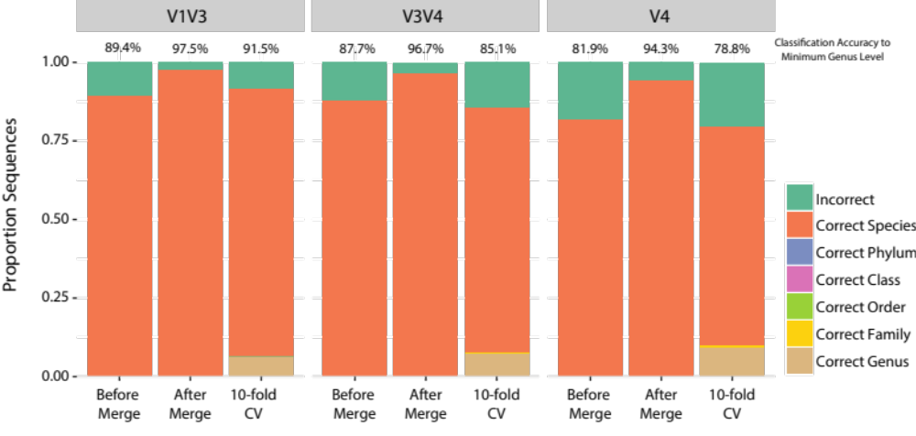
Figure 1. Classification accuracy for each database. Self-classification was performed before and after merging species annotations following truncation to amplicon variable region(s). 10-fold cross validation (10-fold CV) tested the accuracy of classification for novel sequences.
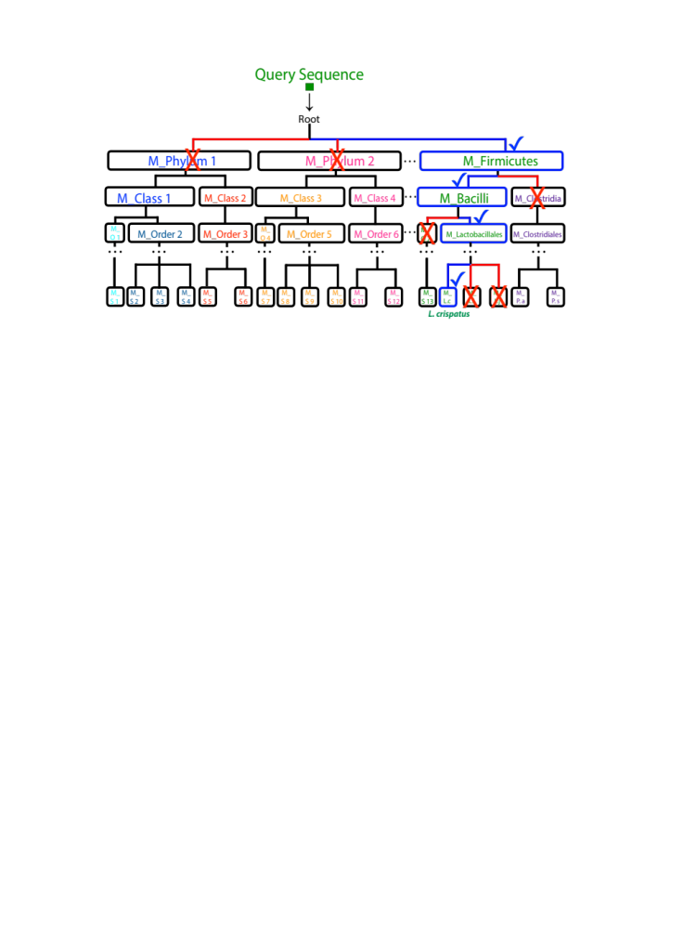
Figure 2. A taxonomy is assigned to a query sequence by traversing a Markov chain model tree associated with the taxonomic tree. First, a phylum level taxonomy is assigned and it corresponds to a phylum with the highest posterior probability of the query sequence coming from the given phylum model. granted that the posterior probability is below the given model’s CETh (as indicated by a blue check mark). The process continues until we reach a leaf of the tree or a classification error threshold condition is violated (posterior probability is above the CETh). In this example, the query sequence is classified as Lactobacillus crispatus (L. cr).

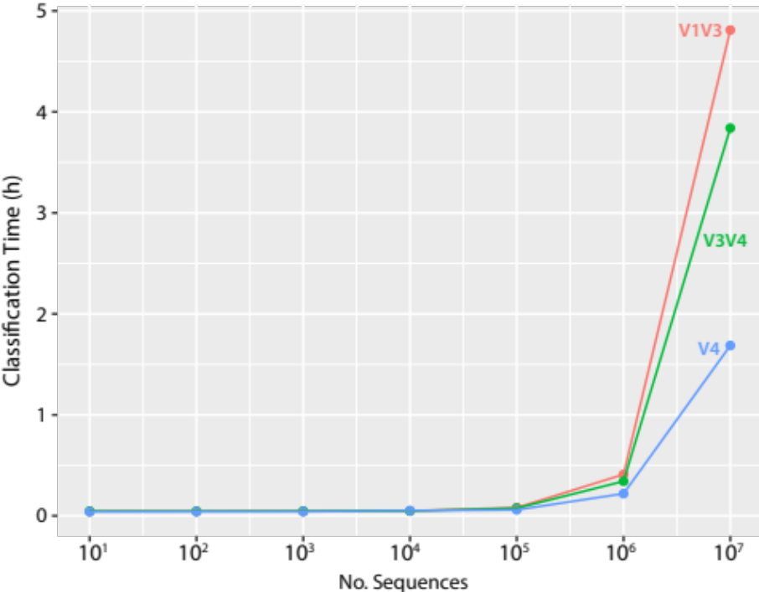
Figure S1. Rate of speciateIT classification of individual sequences using the V1V3, V3V4, and V4 models on a 2015 Macbook Pro.
Figure S2. Sequences are grouped together at each taxonomic level. Each cluster of sequences is used to estimated 0th – 7th Markov chain models. Each dot represents one curated sequence.

 | A | 7mer_{a} | C | 7mer_{a} | G | 7mer_{a} | T | 7mer_{a} | A | 7mer_{b} | C | 7mer_{b}
L. iners | P (A | 7mer_{a}) | P (C | 7mer_{a}) | P (G | 7mer_{a}) | P (T | 7mer_{a}) | P (A | 7mer_{b}) | P (C | 7mer_{b})
L. jensenii | P (A | 7mer_{a}) | P (C | 7mer_{a}) | P (G | 7mer_{a}) | P (T | 7mer_{a}) | P (A | 7mer_{b}) | P (C | 7mer_{b})
L. crispatus | P (A | 7mer_{a}) | P (C | 7mer_{a}) | P (G | 7mer_{a}) | P (T | 7mer_{a}) | P (A | 7mer_{b}) | P (C | 7mer_{b})
… | P (A | 7mer_{a}) | P (C | 7mer_{a}) | P (G | 7mer_{a}) | P (T | 7mer_{a}) | P (A | 7mer_{b}) | P (C | 7mer_{b})
g_Lactobacillus | P (A | 7mer_{a}) | P (C | 7mer_{a}) | P (G | 7mer_{a}) | P (T | 7mer_{a}) | P (A | 7mer_{b}) | P (C | 7mer_{b})
… | … | … | … | … | … | …
f_Lactobacillaceae | P (A | 7mer_{a}) | P (C | 7mer_{a}) | P (G | 7mer_{a}) | P (T | 7mer_{a}) | P (A | 7mer_{b}) | P (C | 7mer_{b})
… | … | … | … | … | … | …
o_Lactobacillales | P (A | 7mer_{a}) | P (C | 7mer_{a}) | P (G | 7mer_{a}) | P (T | 7mer_{a}) | P (A | 7mer_{b}) | P (C | 7mer_{b})
… | … | … | … | … | … | …
c_Bacilli | P (A | 7mer_{a}) | P (C | 7mer_{a}) | P (G | 7mer_{a}) | P (T | 7mer_{a}) | P (A | 7mer_{b}) | P (C | 7mer_{b})
… | … | … | … | … | … | …
p_Firmicutes | P (A | 7mer_{a}) | P (C | 7mer_{a}) | P (G | 7mer_{a}) | P (T | 7mer_{a}) | P (A | 7mer_{b}) | P (C | 7mer_{b})
Figure S3. 7th order Markov chain models are calculated for the sequences grouped at each taxonomic level. Here, Lactobacillus species are used as an example.

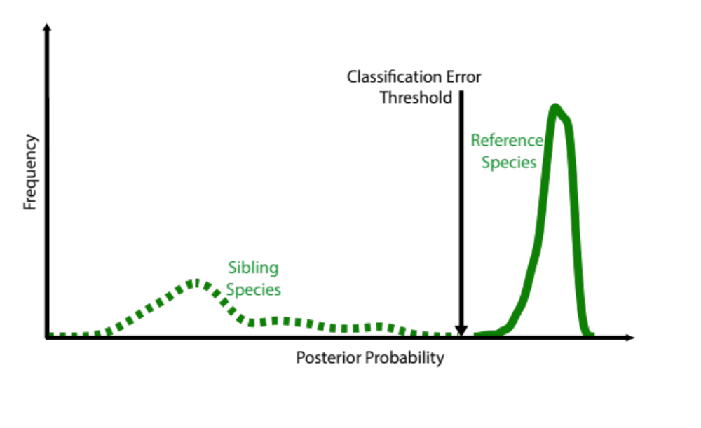
Figure S4. Classification error thresholds are estimated to assign to a query sequence taxonomy at the rank where the assignment has low misclassification error. Here, the classification error threshold is determined for Lactobacillus crispatus. From 1,000 sequences generated by the speciateIT models for L. crispatus, the distributions of the posterior probabilities from the L. crispatus model (dark green) and the siblings of the L. crispatus models (all other Lactobacillus species, light green) are computed. The taxonomic assignment classification error threshold is the intersection of these two distributions (dotted arrow).

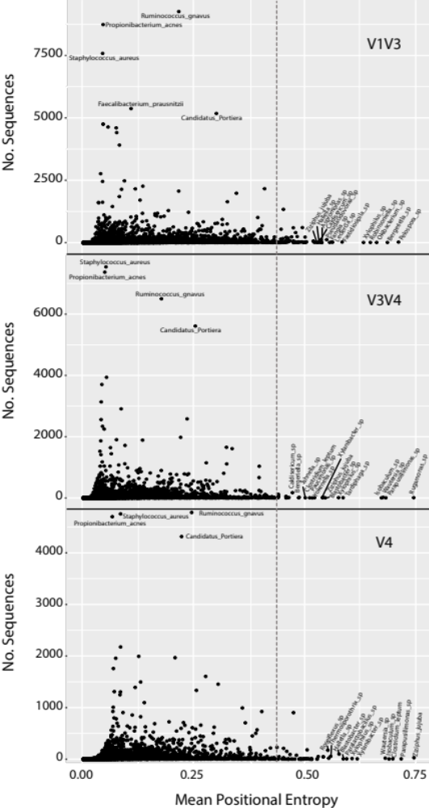
Figure S5. The mean positional entropy values for each species in the 16S rRNA gene V1V3, V3V4, and V4 amplicon speciateDB as a function of the total number of sequences in that species. Species mean entropy values were used to determine if sequences correctly comprised a species model. Species with mean positional entropy > 0.4 (dotted line) were removed from the database.

