**LAB-12 VIEWS**

**TABLES:**

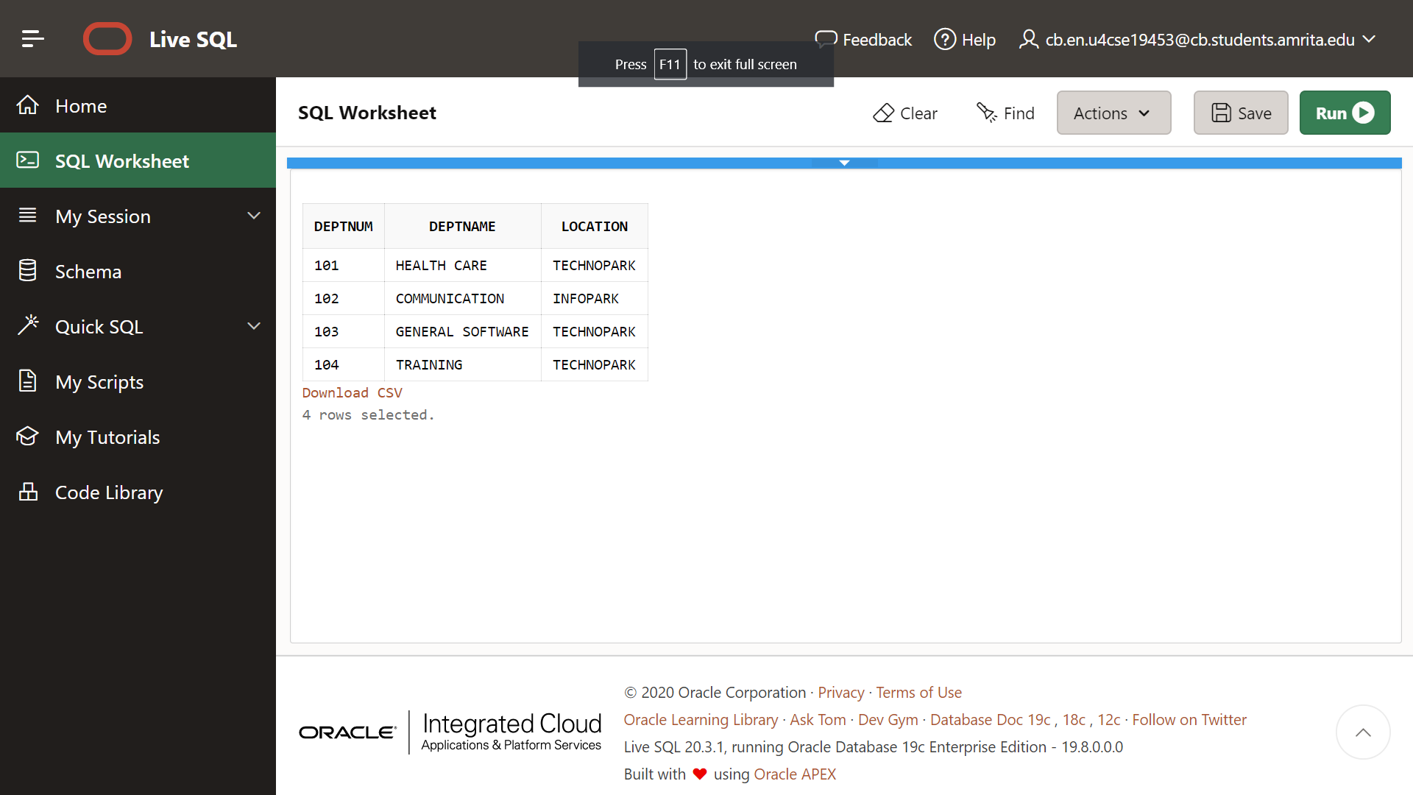

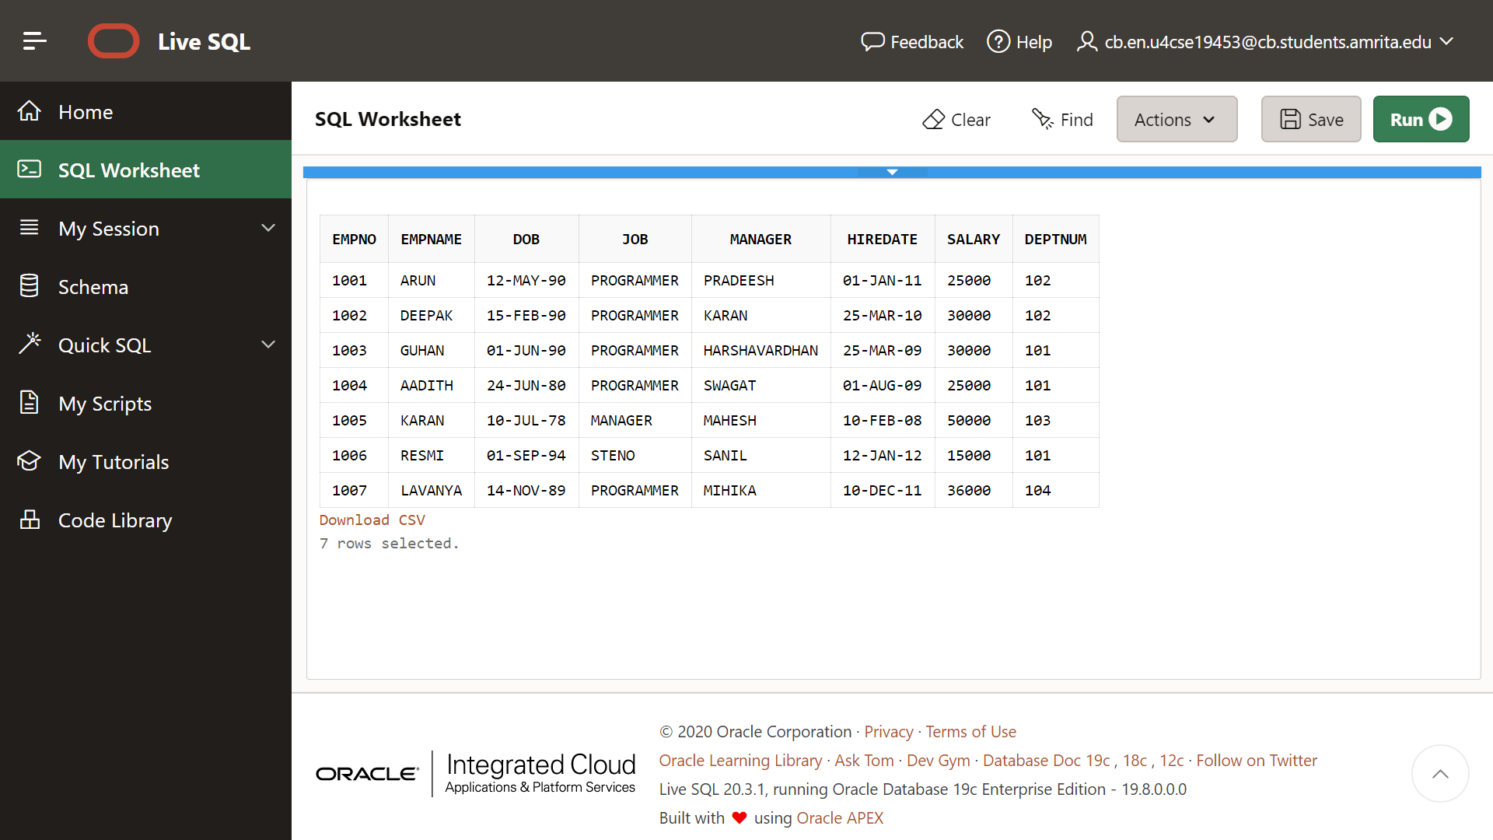

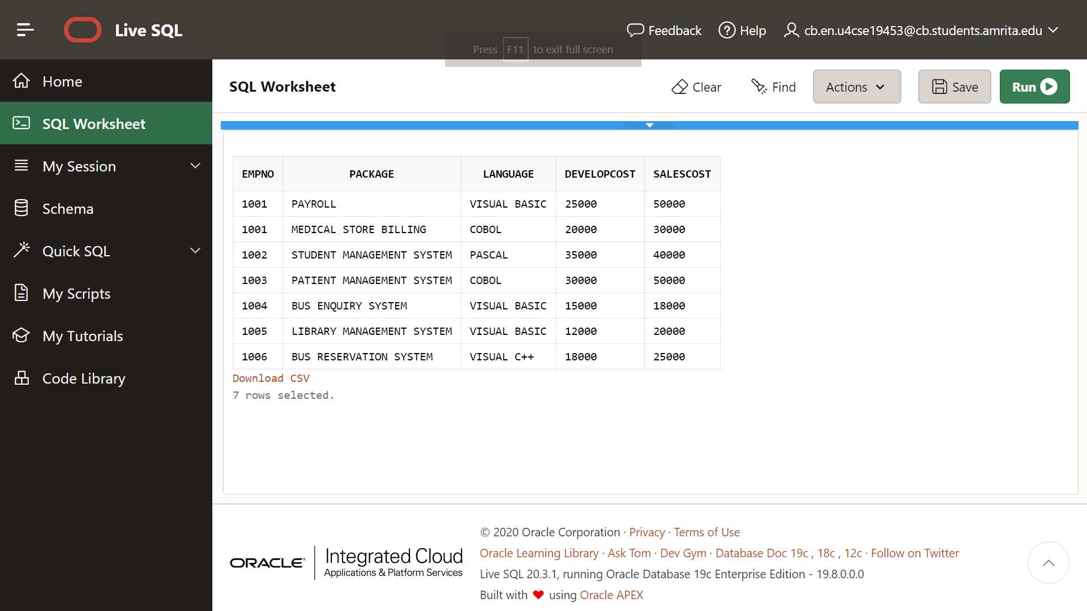

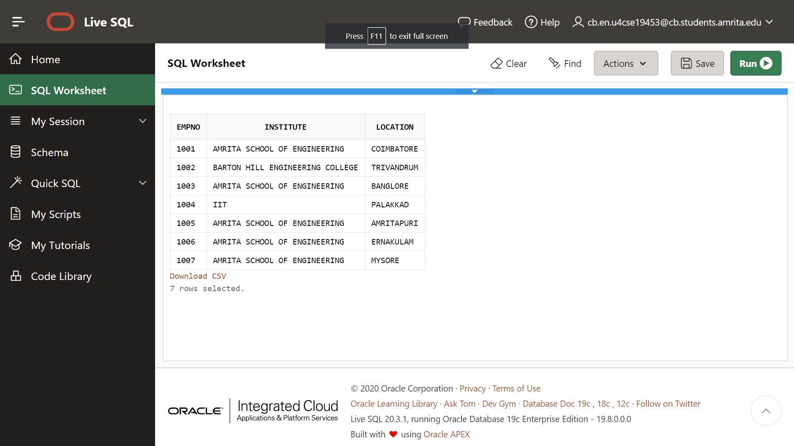

**1.)**

CREATE VIEW employee_info AS (SELECT EMPNO, EMPNAME,JOB,MANAGER,HIREDATE,DEPTNUM FROM EMPLOYEE);

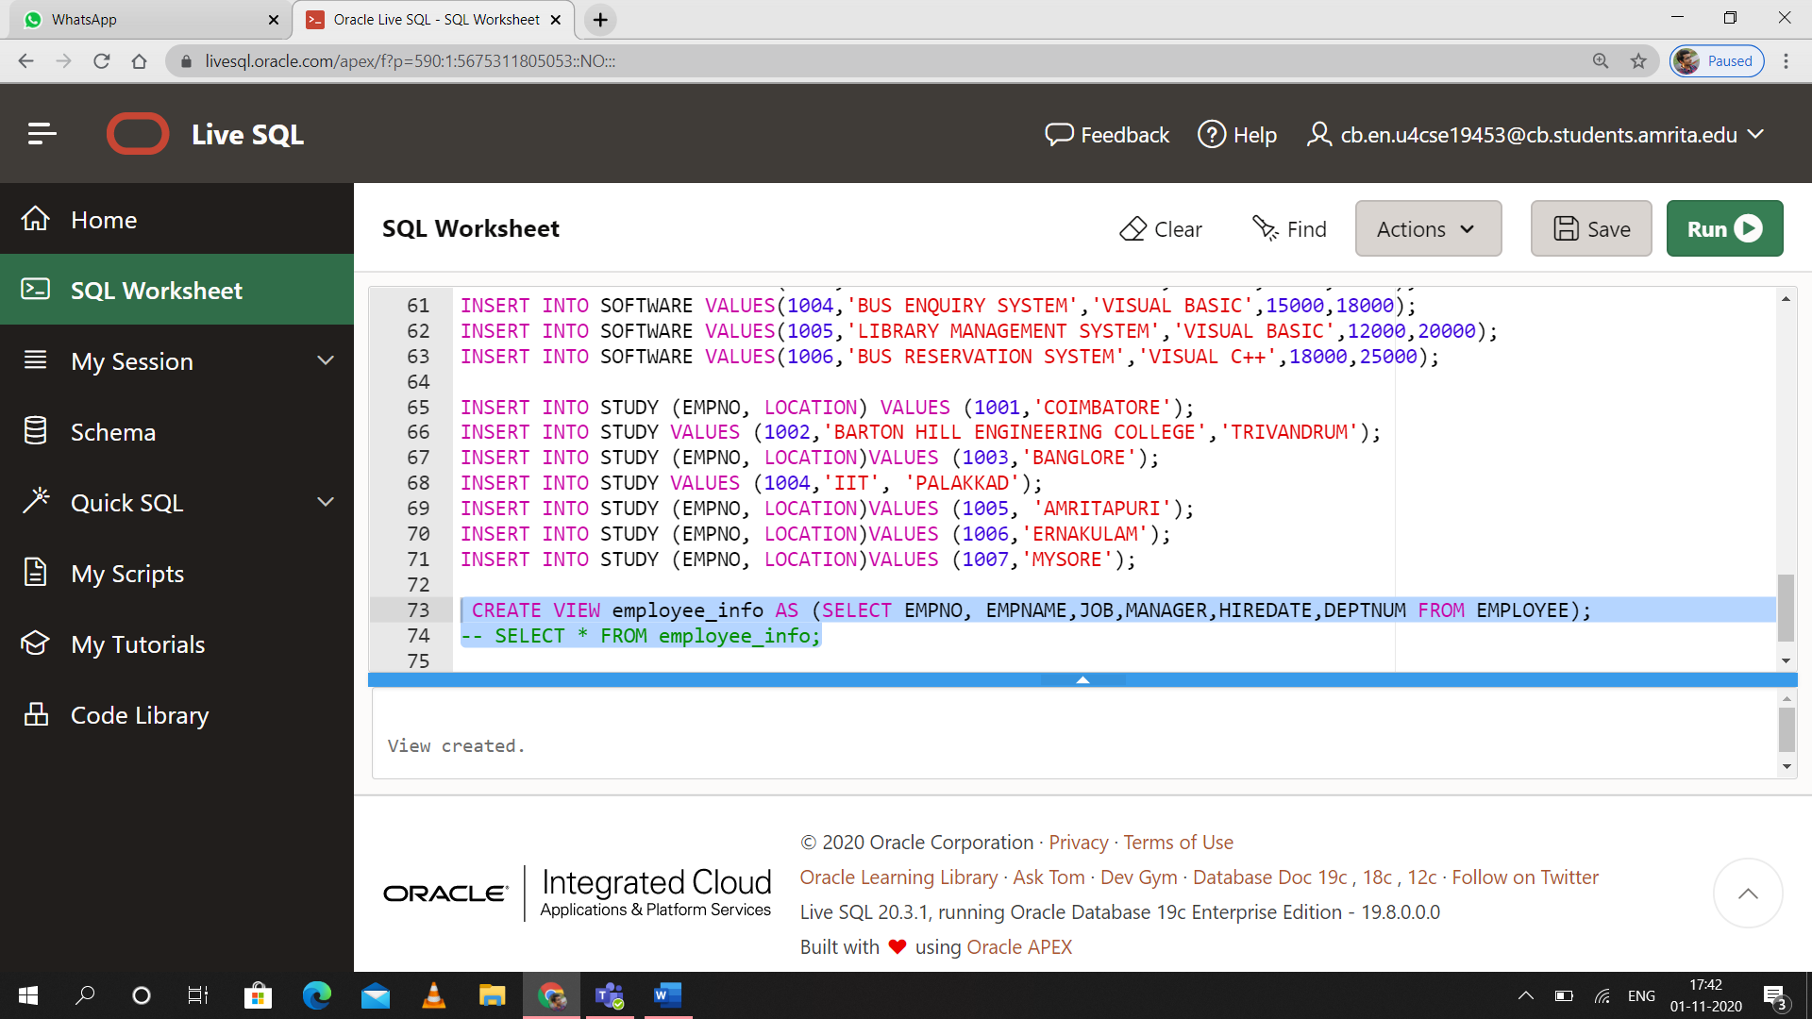

3.)

CREATE VIEW avg_salary AS (SELECT d.DEPTNAME, AVG(e.SALARY) AS AVERAGE

FROM DEPARTMENT d INNER JOIN EMPLOYEE e

ON d.DEPTNUM=e.DEPTNUM GROUP BY d.DEPTNAME);

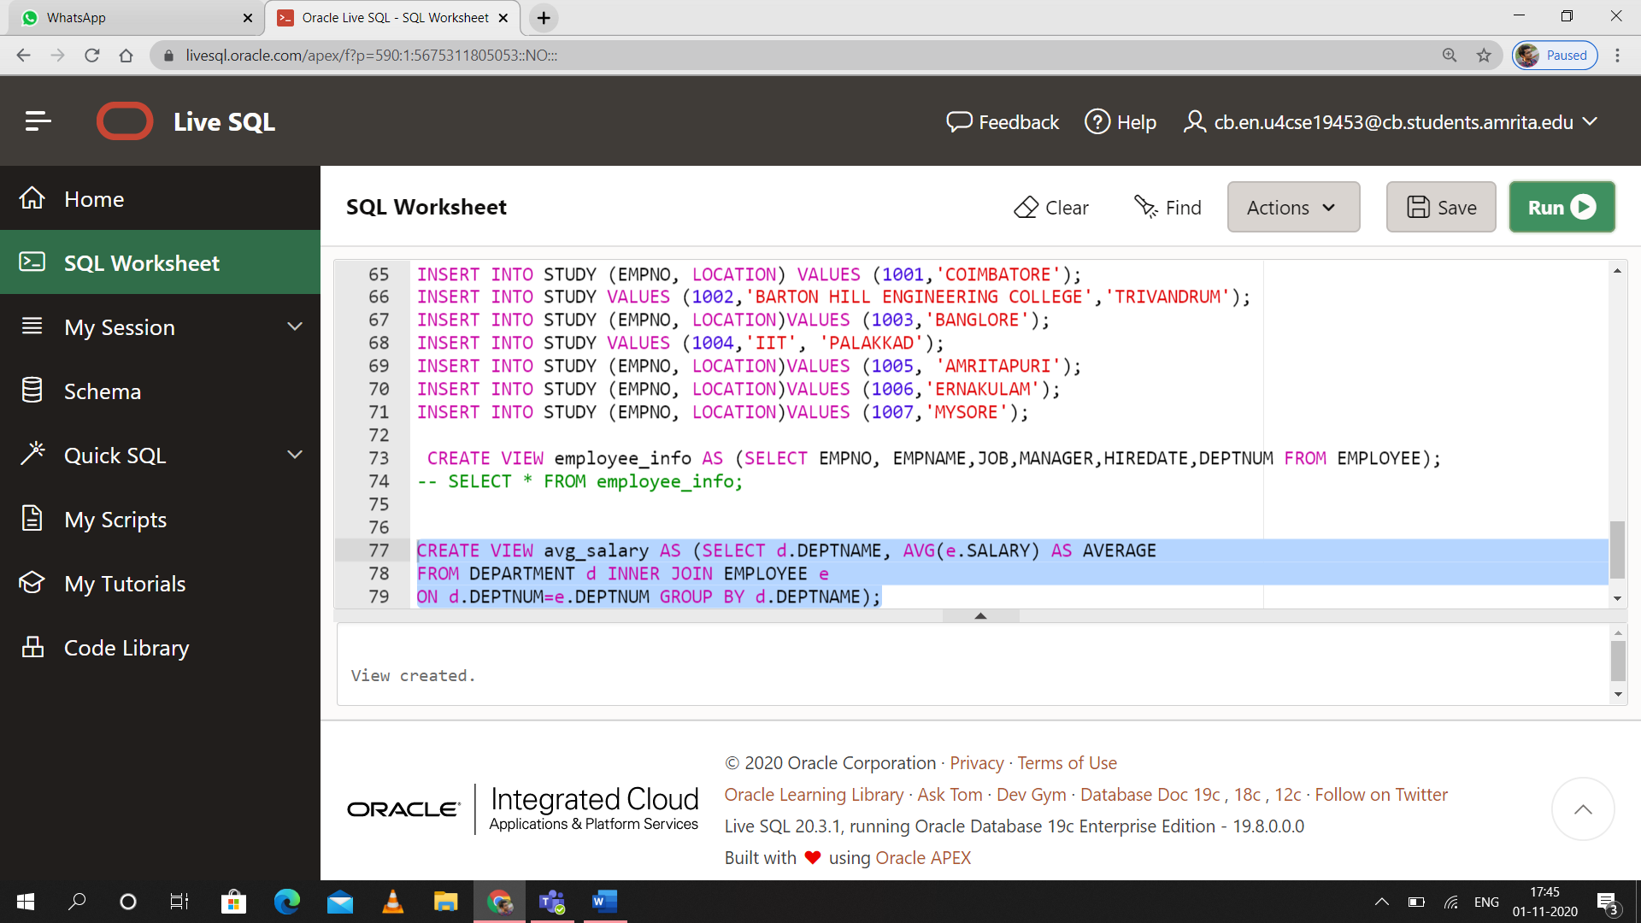

4.)

CREATE VIEW dept_101 AS(SELECT DEPTNUM ,EMPNAME , SALARY FROM EMPLOYEE WHERE DEPTNUM IN (101)) WITH READ ONLY;

SELECT * FROM dept_101;

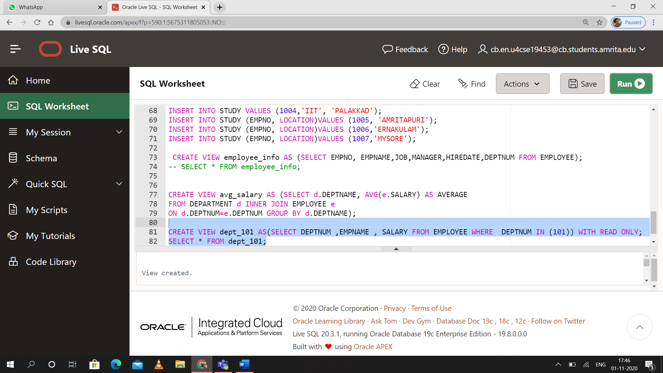

5.)

CREATE VIEW emp AS(

SELECT E1.EMPNAME AS EMPLOYEE , E2.MANAGER FROM

EMPLOYEE E1 , EMPLOYEE E2 WHERE E1.EMPNO = E2.EMPNO);

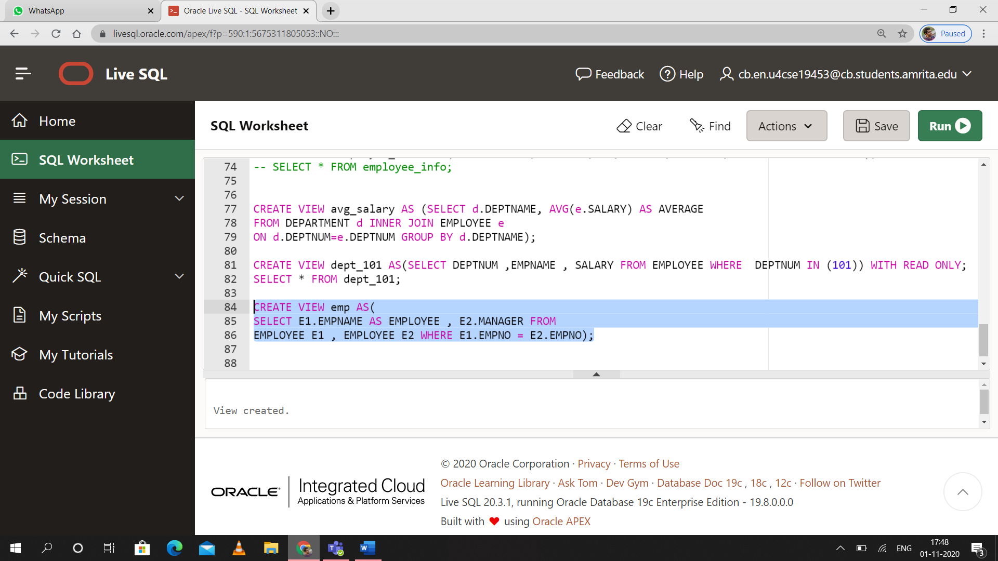

6.)

CREATE VIEW student_amrita AS(SELECT DEPTNAME FROM DEPARTMENT WHERE DEPTNUM IN

(SELECT DEPTNUM FROM EMPLOYEE WHERE EMPNO IN

(SELECT EMPNO FROM STUDY WHERE INSTITUTE = ('AMRITA SCHOOL OF ENGINEERING' ))));

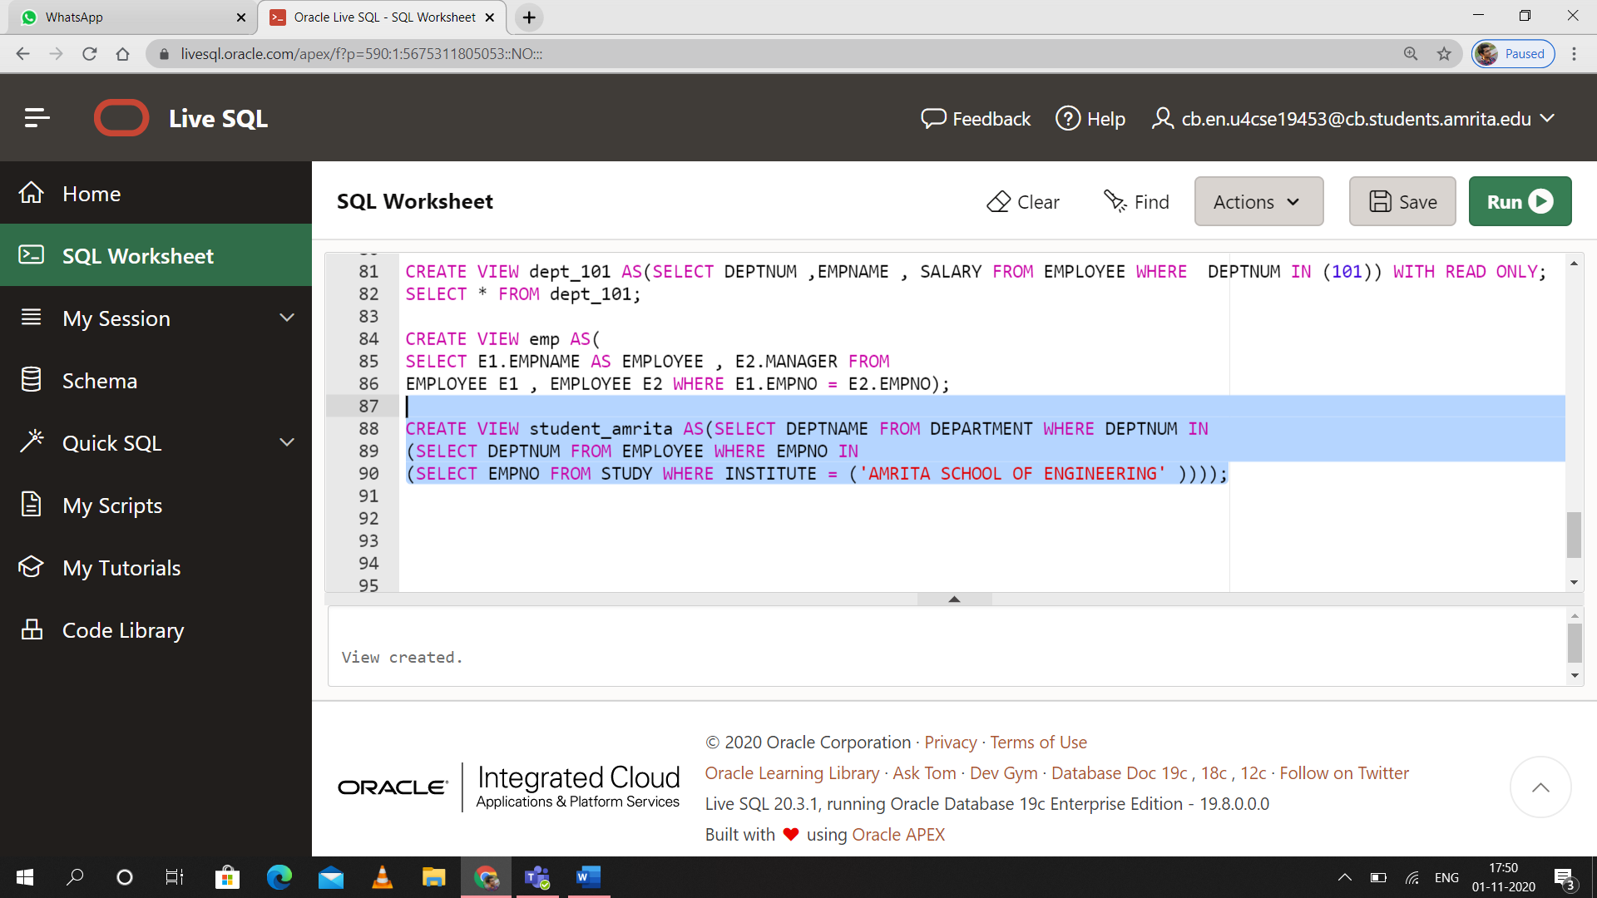

7.)

CREATE VIEW birthdays AS (SELECT * FROM EMPLOYEE WHERE EXTRACT(month from DOB) IN (SELECT EXTRACT(month from current_timestamp) FROM dual));

