**AMRITA VISHWA VIDYAPEETHAM**

**DEPARTMENT OF COMPUTER SCIENCE AND ENGINEERING**

**19CSE204 – OBJECT ORIENTED PARADIGM**

**GROUP PROJECT**

**CAR RENTAL SYSTEM**

# **Overview:**

Car rental system is an online system where customers can rent different kinds of cars of their interest. The main aim of this project is to design and develop a database for the car rental company to maintain the records of different types of information such as customer details, different cars details and it would be easy to keep track of different cars. This system simplifies the assignment of different cars and also increases the efficiency as it attracts many new customers.

This system makes the customers work to search for cars easy as all the details about the availability of different cars are available. This system also helps the car rental company to find the customers easily.

GROUP MEMBERS:

|  |  |  |
| --- | --- | --- |
| **ROLL NO.** | **NAME** | **EMAIL-ID** |
| CB.EN.U4CSE19453 | R.ABHINAV | cb.en.u4cse19453@cb.students.amrita.edu |
| CB.EN.U4CSE19459 | S.SHANTHAN | cb.en.u4cse19459@cb.students.amrita.edu |
| CB.EN.U4CSE19449 | P.KOUSHIK | cb.en.u4cse19449@cb.students.amrita.edu |
| CB.EN.U4CSE19405 | A.HEMANTH | cb.en.u4cse19405@cb.students.amrita.edu |

**TEAM CONTRIBUTION:**

|  |  |  |  |  |
| --- | --- | --- | --- | --- |
| RollNo/Name | Concept | Contribution | Justify your contribution | Program Name |
| CB.EN.U4CSE19459  S.SHANTHAN | Class | Main | Main class calls the login method from login class and display the user menu if the login class validates the login or display the error message when failed. | Main.java |
| CB.EN.U4CSE19459  S.SHANTHAN | Methods | main | Main method this method connects to the database does implement all of the database operations. |  |
| CB.EN.U4CSE19459  S.SHANTHAN | Constructors | main | Initialises the all the variables in this class to null if the datatype is string and zero(0) if the datatype is int or double |  |
| CB.EN.U4CSE19459  S.SHANTHAN | Static Concept | Loginbool,  main | Main method itself is static and the  login_bool is also a static variable which is present in login class and it is used to validate the login here in main method |  |
| CB.EN.U4CSE19459  S.SHANTHAN | Inheritance—Type | Inherited from login | Class main is inherited from login class since it uses the method login which should restrict access to users |  |
| CB.EN.U4CSE19459  S.SHANTHAN | Package | Com.amrita | All the classes present in the project are the part of the package com.amrita |  |
| CB.EN.U4CSE19459  S.SHANTHAN | Exception handling | sqlexceptions | Expected SQLExceptions are mentioned in throws and try block captures the errors that might occur while the SQL statements getting executed. |  |

**PROGRAM :**

package com.amrita;  
  
import com.sun.scenario.effect.impl.sw.sse.SSEBlend_SRC_OUTPeer;  
import java.sql.SQLException;  
import java.util.Scanner;  
import java.lang.String;  
  
  
public class Main extends login {  
 public static void main(String[] args) throws SQLException {  
 login x = new login();  
 x.login();  
 if (login_bool) {  
 Scanner user_input = new Scanner(System.in);  
 DB_OPERATIONS d = new DB_OPERATIONS();  
 String query;  
 System.out.println("==============car rental system console=========================");  
 System.out.println("1. Insert");  
 System.out.println("2. Update");  
 System.out.println("3. Select");  
 System.out.println("4. Delete");  
 System.out.println("===================Please Select an option ======================");  
 int option = user_input.nextInt();  
 System.out.println("(CUSTOMER || CAR || BOOKING || BILLING || PAYMENT)");  
 if (option == 1) {  
 String table_name;  
 System.out.println("Please enter the table name : ");  
 user_input.nextLine();  
 table_name = user_input.nextLine();  
 if (table_name.equals("CUSTOMER")) {  
 System.out.println("Enter ID : ");  
 String CUSTOMER_ID = user_input.nextLine();  
 user_input.nextLine();  
 System.out.println("Enter Phone number : ");  
 String PHONE_NUMBER = user_input.nextLine();  
 user_input.nextLine();  
  
 System.out.println("Enter Email");  
 String EMAIL = user_input.nextLine();  
 user_input.nextLine();  
  
 System.out.println("Enter Street");  
 String STREET = user_input.nextLine();  
  
 System.out.println("Enter City");  
 String CITY = user_input.nextLine();  
  
 System.out.println("Enter Zipcode");  
 String ZIPCODE = user_input.nextLine();  
  
 System.out.println("Enter Aadhaar Id");  
 String AADHAAR = user_input.nextLine();  
  
 query = "INSERT INTO " + table_name + " VALUES('" + CUSTOMER_ID + "','" + PHONE_NUMBER + "','" + EMAIL + "','" + STREET + "','" + CITY + "','" + ZIPCODE + "','" + AADHAAR + "')";  
 d.Insert(query);  
 } else if (table_name.equals("CAR")) {  
  
 System.out.println("Enter CAR_ID : ");  
 String CAR_ID = user_input.nextLine();  
 System.out.println("Enter car model : ");  
 String CAR_MODEL = user_input.nextLine();  
  
  
 System.out.println("Enter customer id");  
 String CUSTOMER_ID = user_input.nextLine();  
  
  
 System.out.println("Enter location");  
 String LOCATION = user_input.nextLine();  
  
 System.out.println("Enter registration number ");  
 String REG_NO = user_input.nextLine();  
  
 query = "insert into " + table_name + " values('" + CAR_ID + "','" + CAR_MODEL + "','" + CUSTOMER_ID + "','" + LOCATION + "','" + REG_NO + "')";  
 d.Insert(query);  
 } else if (table_name.equals("BOOKING")) {  
  
 System.out.println("Enter BOOKING ID : ");  
 String BOOKING_ID = user_input.nextLine();  
  
 System.out.println("Enter car id");  
 String CAR_ID = user_input.nextLine();  
  
 System.out.println("Enter customer id");  
 String CUSTOMER_ID = user_input.nextLine();  
  
 System.out.println("Enter FROM DATE ");  
 String FROM_DATE = user_input.nextLine();  
  
 System.out.println("Enter TO DATE ");  
 String TO_DATE = user_input.nextLine();  
  
 query = "insert into " + table_name + " values('" + BOOKING_ID + "','" + CAR_ID + "','" + CUSTOMER_ID + "','" + FROM_DATE + "','" + TO_DATE + "')";  
 d.Insert(query);  
 } else if (table_name.equals("BILLING")) {  
 System.out.println("Enter BILLING ID : ");  
 String BILLING_ID = user_input.nextLine();  
 System.out.println("Enter BOOKING ID");  
 String BOOKING_ID = user_input.nextLine();  
 System.out.println("Enter customer id");  
 String CUSTOMER_ID = user_input.nextLine();  
 System.out.println("Enter CAR ID ");  
 String CAR_ID = user_input.nextLine();  
  
 System.out.println("Enter BILLING DATE ");  
 String BILL_DATE = user_input.nextLine();  
  
 query = "insert into " + table_name + " values('" + BILLING_ID + "','" + BOOKING_ID + "','" + CUSTOMER_ID + "','" + CAR_ID + "','" + BILL_DATE + "')";  
 d.Insert(query);  
 } else if (table_name.equals("PAYMENT")) {  
 System.out.println("Enter PAYMENT METHOD : ");  
 String PAYMENT_METHOD = user_input.nextLine();  
 System.out.println("Enter PAYMENT STATUS");  
 String PAYMENT_STATUS = user_input.nextLine();  
 System.out.println("Enter BILLING ID");  
 String BILLING_ID = user_input.nextLine();  
 System.out.println("Enter TOTAL AMOUNT ");  
 String TOTAL_AMOUNT = user_input.nextLine();  
 query = "insert into " + table_name + " values('" + PAYMENT_METHOD + "','" + PAYMENT_STATUS + "','" + BILLING_ID + "','" + TOTAL_AMOUNT + "')";  
 d.Insert(query);  
 }  
 } else if (option == 2) {  
 String table_name;  
 System.out.println("Please enter the table name : ");  
 user_input.nextLine();  
 table_name = user_input.nextLine();  
 if (table_name.equals("CUSTOMER")) {  
 System.out.println("enter column ");  
 String UpdateCol = user_input.nextLine();  
 System.out.println("enter value: ");  
 String Value = user_input.nextLine();  
 System.out.println("enter corresponding CUSTOMER_ID: ");  
 int changes = user_input.nextInt();  
 query = "UPDATE " + table_name + " SET " + UpdateCol + "='" + Value + "' WHERE CUSTOMER_ID = " + changes;  
 d.Update(query);  
 } else if (table_name.equals("CAR")) {  
 System.out.println("enter column: ");  
 String UpdateCol = user_input.nextLine();  
 System.out.println("enter value: ");  
 String Value = user_input.nextLine();  
 System.out.println("enter corresponding CAR_ID : ");  
 int changes = user_input.nextInt();  
 query = "UPDATE " + table_name + " SET " + UpdateCol + "='" + Value + "' WHERE CAR_ID = " + changes;  
 d.Update(query);  
 } else if (table_name.equals("BOOKING")) {  
 System.out.println("enter column: ");  
 String UpdateCol = user_input.nextLine();  
 System.out.println("enter value: ");  
 String Value = user_input.nextLine();  
 System.out.println("enter corresponding BOOKING_ID: ");  
 int changes = user_input.nextInt();  
 query = "UPDATE " + table_name + " SET " + UpdateCol + "='" + Value + "' WHERE BOOKING_ID = " + changes;  
 d.Update(query);  
 } else if (table_name.equals("BILLING")) {  
 System.out.println("enter column: ");  
 String UpdateCol = user_input.nextLine();  
 System.out.println("enter value: ");  
 String Value = user_input.nextLine();  
 System.out.println("enter corresponding BILLING_ID: ");  
 int changes = user_input.nextInt();  
 query = "UPDATE " + table_name + " SET " + UpdateCol + "='" + Value + "' WHERE BILLING_ID = " + changes;  
 d.Update(query);  
 } else if (table_name.equals("PAYMENT")) {  
 System.out.println("enter column ");  
 String UpdateCol = user_input.nextLine();  
 System.out.println("enter value: ");  
 String Value = user_input.nextLine();  
 System.out.println("enter corresponding PAYMENT_METHOD : ");  
 String changes = user_input.nextLine();  
 query = "UPDATE " + table_name + " SET " + UpdateCol + "='" + Value + "' WHERE PAYMENT_METHOD = " + changes;  
 d.Update(query);  
 }  
 } else if (option == 3) {  
 String table_name;  
 System.out.println("Please enter the table name : ");  
 user_input.nextLine();  
 table_name = user_input.nextLine();  
 query = "SELECT * FROM " + table_name;  
 d.Select(query);  
 } else if (option == 4) {  
 String table_name;  
 System.out.println("Please enter the table name : ");  
 user_input.nextLine();  
 table_name = user_input.nextLine();  
 System.out.println("enter id to delete : ");  
 int DeleteEntry = user_input.nextInt();  
 query = "DELETE FROM " + table_name + " WHERE BILLING_ID =" + DeleteEntry;  
 d.Delete(query);  
 }  
 }  
 }  
}

|  |  |  |  |  |
| --- | --- | --- | --- | --- |
| Rollo/Name | Concept | Contribution | Justify your contribution | Program Name |
| **CB.EN.U4CSE19453**  R.ABHINAV | Class | signup | Sign up class gets username and password from the users and asks to validate by re-entering the password. If it validates user credentials gets added to the database. | signup.java |
| CB.EN.U4CSE19453  R.ABHINAV | Methods | signup | signup method here all the interactions with the user are done using CLI and validations and data is queried to and froth the Mysql server which is the backend. | signup.java |
| CB.EN.U4CSE19453  R.ABHINAV | Constructor | signup | Default constructor to invoke be invoked on creation of object of signup class. | signup.java |
| CB.EN.U4CSE19453  R.ABHINAV | Inheritance | Inherited from Database Operations | Class signup is inherited from Database Operations class since it uses the method Insert which stores credentials of the user once he signed up | signup.java |
| CB.EN.U4CSE19453  R.ABHINAV | Package | com.amrita | Since to facilitate inheritance all the classes for this project are placed under this package. | signup.java |
| CB.EN.U4CSE19453  R.ABHINAV | Exception handling | try, throws | Expected SQLExceptions are mentioned in throws and try block captures the errors that might occur while the SQL statements getting executed. | signup.java |

**PROGRAM :**

package com.amrita;  
  
import java.sql.*;  
import java.util.Scanner;  
  
public class Signup extends DB_OPERATIONS {  
 //Default constuctor  
 public Signup() {}  
 //connection variables  
 String url = "jdbc:mysql://localhost:3306/CARRENTALSYSTEM";;  
 String pass = "root";  
 String user = "root";  
 public void signup() throws SQLException {  
 try (  
 //establishing connection with the database  
 Connection connection = DriverManager.getConnection(url, user, pass);  
  
 //Creating a statement  
 Statement statement = connection.createStatement();  
 ) {  
 Scanner input = new Scanner(System.in);  
 System.out.println("===========Welcome to the Signup Page==============");  
 System.out.print("Username : ");  
 String username = input.next();  
 System.out.print("\nPassword : ");  
 String password = input.next();  
 System.out.print("\nConfirm Password : ");  
 String Confirm_Password = input.next();  
  
 //checking if the password and the confirm password is same else return  
 if (password.equals(Confirm_Password)) {  
 String query = "select username from credentials";  
  
 //storing the result of the select query in a result set object  
 ResultSet resultset = statement.executeQuery(query);  
  
 //initialzing a count variable to count how many times the username is in the credentials relation  
 int count = 0;  
  
 //here we iterate through the object and check if the user name is already taken  
 while(resultset.next()){  
 String username_db = resultset.getString("username");  
 if(username.equals(username_db)){  
 count = count + 1;  
 }  
 }  
 if(count == 0){  
 String exeQuery = "INSERT INTO credentials VALUES ('"+username+"','"+password+"')";  
 Insert(exeQuery);  
 System.out.println("SignUp Sucessfull!! You can now login");  
 }  
  
  
 } else {  
 return;  
 }

}  
 }  
}

|  |  |  |  |  |
| --- | --- | --- | --- | --- |
| RollNo/Name | Concept | Contribution | Justify your contribution | Program Name |
| CB.EN.U4CSE19449  P.KOUSHIK | Class | login | Login class performs all the operations such as showing the menu and then executing the code based on user’s choice | login.java |
| CB.EN.U4CSE19449  P.KOUSHIK | Methods | login | Login method here displaying the menu and program in favour of user choice is done. If user chooses login it authenticates user using his username and password. If user doesn't have an account, he can choose signup to get signed up | login.java |
| CB.EN.U4CSE19449  P.KOUSHIK | Constructor | login | Default constructor to invoke be invoked on creation of object of login class. | login.java |
| CB.EN.U4CSE19449  P.KOUSHIK | Inheritance | Inherited from signup | Class login is inherited from signup class since it uses the method signup in case if the user isn’t signed up before | login.java |
| CB.EN.U4CSE19449  P.KOUSHIK | Package | com.amrita | Since to facilitate inheritance all the classes for this project are placed under this package. | login.java |
| CB.EN.U4CSE19449  P.KOUSHIK | Exception handling | try, throws | Expected SQLExceptions are mentioned in throws and try block captures the errors that might occur while the SQL statements getting executed. | login.java |

**PROGRAM :**

package com.amrita;  
  
import java.sql.*;  
import java.util.Scanner;  
  
public class login extends Signup{  
 public static boolean login_bool;  
  
 //Default Constructors  
 public login(){ }  
  
 public boolean login() throws SQLException{  
  
 //step-1 : creating a database connection - in the project  
 try (  
 Connection connection = DriverManager.getConnection(url, user, pass);  
  
 //creating a statement and executing a query  
 Statement statement = connection.createStatement();  
  
 ) {  
 //user selects an option here to sign up or login

System.out.println("===========Menu===================");

System.out.println("1. Login");  
 System.out.println("2. Sign Up");  
 System.out.println("============END====================");  
 //creating a scanner object to take the inputs  
 Scanner input = new Scanner(System.in);  
 int option = input.nextInt();  
 if(option == 1){  
 // generating the select query  
 String query = "select * from credentials";  
  
 //executing the query and storing the result set in an object  
 ResultSet resultset = statement.executeQuery(query);  
  
 //using the information that is stored in result set to validate the login  
 String username_input;  
 String password_input;  
 //input username  
 System.out.print("Username : ");  
 username_input = input.next();  
 System.out.print("\n");  
 //input password  
 System.out.print("Password : ");

password_input = input.next();  
 //checking for the user int the database;  
 while(resultset.next()) {  
 String Username = resultset.getString("username");

String Password = resultset.getString("password");  
  
 if(Username.equals(username_input)){  
 if(Password.equals(password_input)){  
 //if username and password both are found in the database then login_bool i set to true  
 login_bool = true;  
 return login_bool;  
 }  
 else{  
 //else set to false  
 login_bool = false;  
 }  
 }  
 }  
 }  
 else if(option == 2){  
 signup();  
 login();  
 }  
 }  
 return login_bool;  
 }  
}

|  |  |  |  |
| --- | --- | --- | --- |
| Rollo/Name | Concept | Contribution | Justify your  contribution |
| CB.EN.U4CSE19405  A.HEMANTH | Class | DB Operations | DB operations helps in connecting frontend with the database |
| CB.EN.U4CSE19405  A.HEMANTH | Methods | Update,  select  insert,  delete | 1.Update:update the database through the query.  2.select:displays the data from database  3.insert:adds data into the database  4.Delete:deletes the data from database |
| CB.EN.U4CSE19405  A.HEMANTH | Constructor | DB operations | Default constructor to invoke be invoked on creation of object of DB operations class. |
| CB.EN.U4CSE19405  A.HEMANTH | Inheritance | Base class for inheritance | It is the base class for inheritance of main class,signup class. |
| CB.EN.U4CSE19405  A.HEMANTH | Package | com.amrita | Since to facilitate inheritance all the classes for this project are placed under this package. |
| CB.EN.U4CSE19405  A.HEMANTH | Exception handling | try, throws | Expected SQLExceptions are mentioned in throws and try block captures the errors that might occur while the SQL statements getting executed. |

**PROGRAM :**

package com.amrita;  
  
import java.sql.*;  
  
public class DB_OPERATIONS {  
 public String username = "root";  
 public String password = "root";  
 public String Dburl = "jdbc:mysql://localhost:3306/CARRENTALSYSTEM";  
  
 public void Insert(String query) throws SQLException {  
 try{  
 int rows_affected = 0;  
 //creating the connection to the database  
 Connection connect = DriverManager.getConnection(Dburl,username,password);  
  
 //creating a statement && executing a query  
 Statement statement = connect.createStatement();  
  
 // excecuting a query  
 rows_affected = statement.executeUpdate(query);  
 //prinring the result  
 System.out.println(rows_affected + " rows have been inserted.");  
 //closing the connection  
 connect.close();  
 } catch (SQLException throwables) {  
 throwables.printStackTrace();  
 }  
 }  
 public void Update(String query) throws SQLException{  
 try{  
 int rows = 0;  
  
 //creating the connection to the database  
 Connection connection = DriverManager.getConnection(Dburl,username,password);  
  
 // creating a statement && executing the query here  
 Statement statement = connection.createStatement();  
 //executing a query  
 rows = statement.executeUpdate(query);  
 //printing the rows affected  
 System.out.println(rows + " rows have been updated.");  
 //closing the connection  
 connection.close();  
 } catch (SQLException throwables) {  
 throwables.printStackTrace();  
 }  
 }  
 public void Delete(String query) throws SQLException{  
 try{  
 int rows_effected = 0;  
 //creating a connection to the database  
 Connection connection = DriverManager.getConnection(Dburl,username,password);  
 //creating a statement  
 Statement statement = connection.createStatement();  
 //executing a query  
 rows_effected = statement.executeUpdate(query);  
 //printing the rows effected statement;  
 System.out.println(rows_effected + " have been updated");  
 connection.close();  
 } catch (SQLException throwables){  
 throwables.printStackTrace();  
 }  
 }  
  
 public void Select(String query) throws SQLException{  
 try{  
 int count = 0;  
 //creating a connection to the database  
 Connection connection = DriverManager.getConnection(Dburl,username,password);  
 //creating a statement  
 Statement statement = connection.createStatement();  
 //storing the result of executed query in a result set object  
 ResultSet set = statement.executeQuery(query);  
 while(set.next()){  
 String id = set.getString("CUSTOMER_ID");  
 String name = ((ResultSet) set).getString("PHONE_NUMBER");  
 String phno = set.getString("EMAIL");  
 String street = ((ResultSet) set).getString("STREET");  
 String city = set.getString("CITY");  
 String zipcode = ((ResultSet) set).getString("ZIPCODE");  
 String aadhaar = set.getString("AADHAAR");  
  
  
 System.out.println(id + " "+ name + " "+ phno + " "+ street + " "+ city + " "+zipcode+ " "+ aadhaar );  
 count++;  
 }  
 System.out.println(count + " rows are Selected");  
 } catch (SQLException throwables) {  
 throwables.printStackTrace();  
 }  
 }  
}

**OUTPUT**

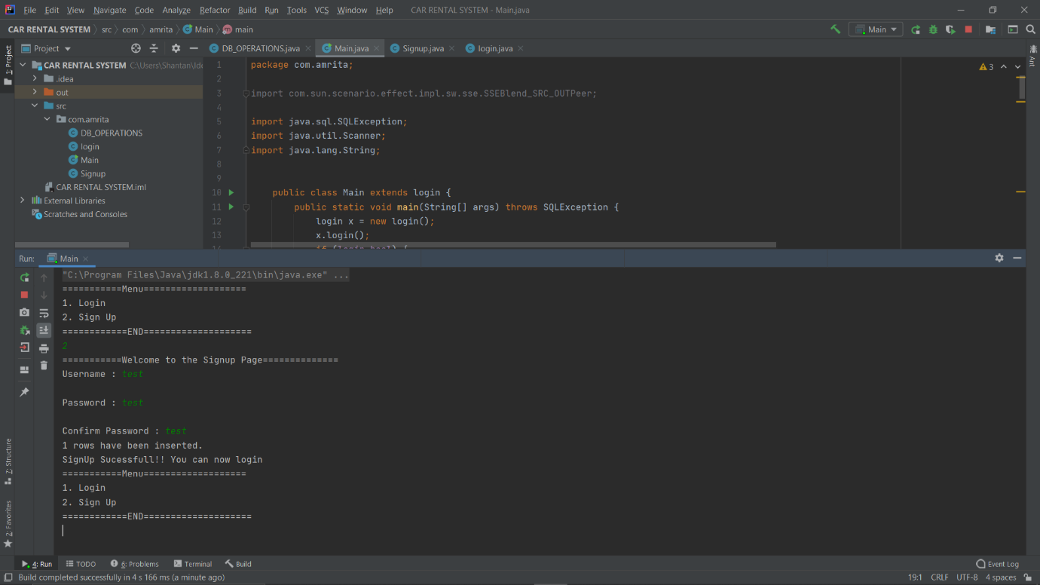

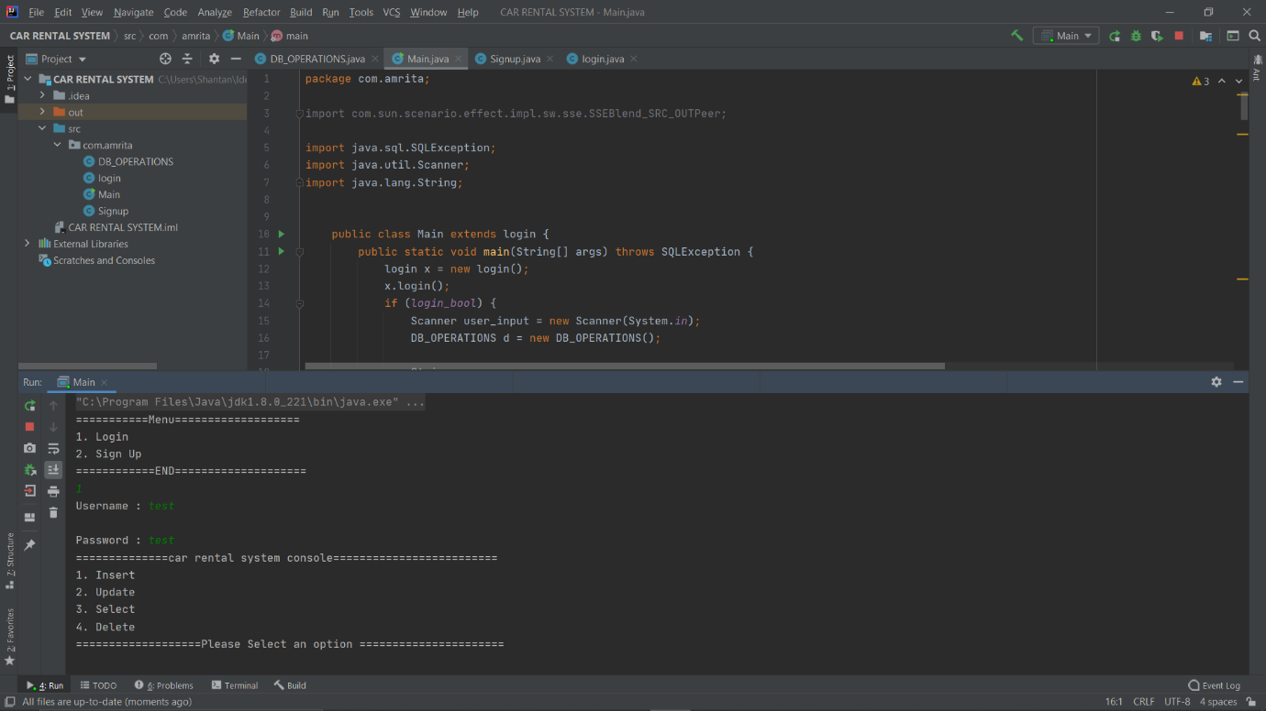

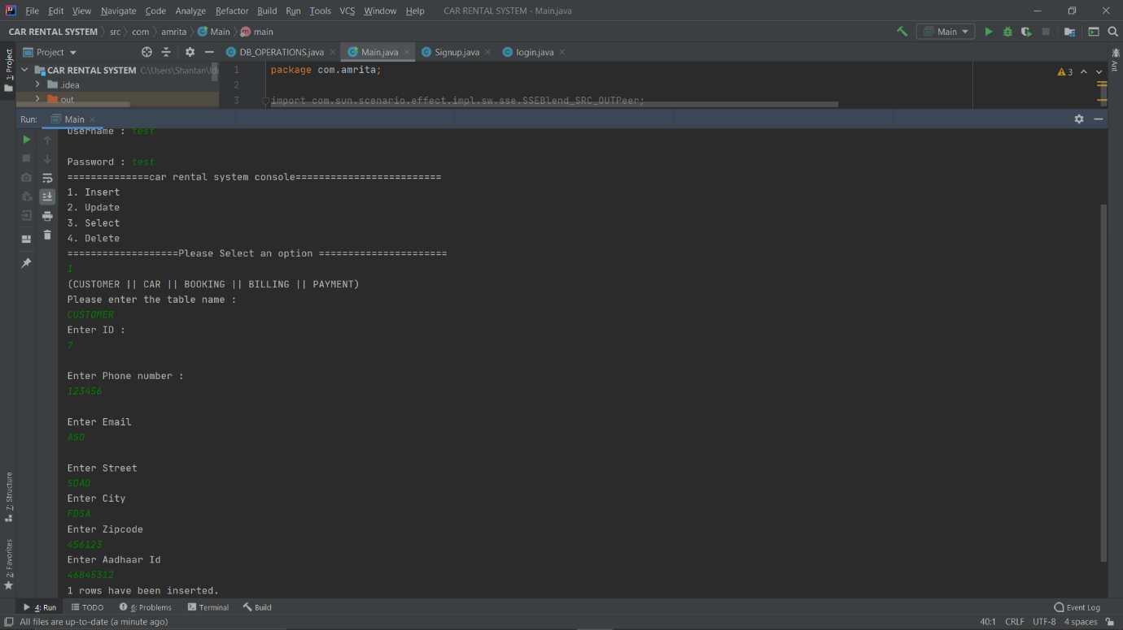

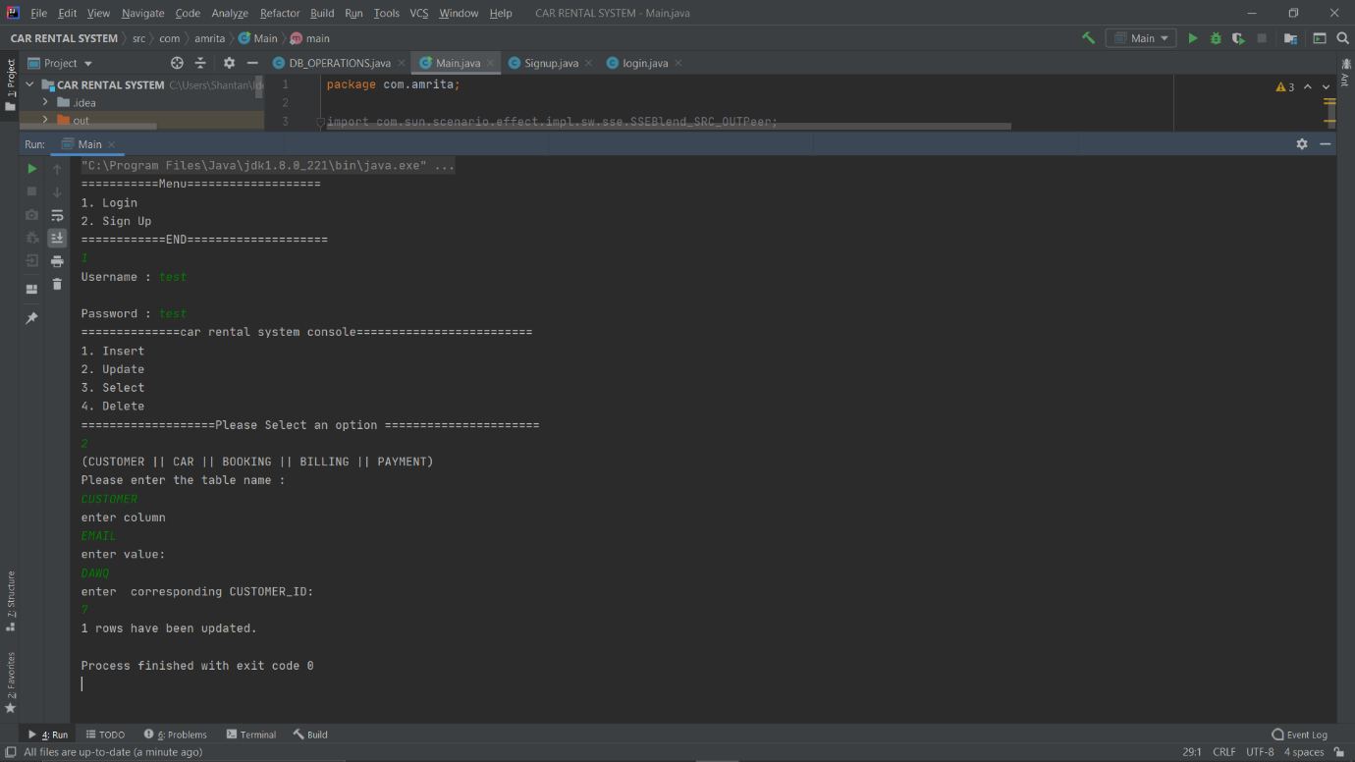

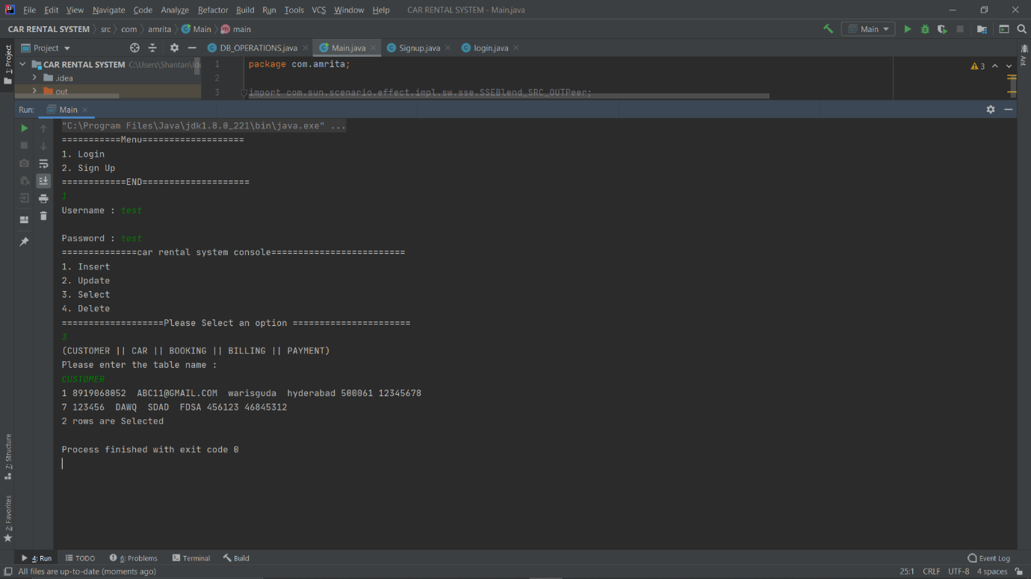

**PROJECT SOURCE CODE:**

**Drive Link :**

[**https://drive.google.com/drive/folders/14PuLks3LWJMAUDDfUaDR9V6E4JhfxVCZ?usp=sharing**](https://drive.google.com/drive/folders/14PuLks3LWJMAUDDfUaDR9V6E4JhfxVCZ?usp=sharing)

**--------------------------------THANK YOU---------------------------------**