**AMRITA VISHWA VIDYAPEETHAM**

**DEPARTMENT OF COMPUTER SCIENCE AND ENGINEERING**

**19CSE204 – OBJECT ORIENTED PARADIGM**

**GROUP PROJECT**

**CAR RENTAL SYSTEM**

Car rental system is an online system where customers can rent different kinds of cars of their interest. The main aim of this project is to design and develop a database for the car rental company to maintain the records of different types of information such as customer details, different cars details and it would be easy to keep track of different cars. This system simplifies the assignment of different cars and also increases the efficiency as it attracts many new customers.

This system makes the customers work to search for cars easy as all the details about the availability of different cars are available. This system also helps the car rental company to find the customers easily.

**GROUP MEMBERS:**

|  |  |  |  |
| --- | --- | --- | --- |
| S.No | STUDENT NAME | ROLL NO. | DIAGRAM |
| 1. | R.ABHINAV | CB.EN.U4CSE19453 | USE CASE DIAGRAM |
| 2. | S.SHANTHAN | CB.EN.U4CSE19459 | OBJECT MODEL |
| 3. | P.KOUSHIK | CB.EN.U4CSE19449 | CLASS DIAGRAM |
| 4. | A.HEMANTH | CB.EN.U4CSE19405 | SEQUENCE DIAGRAM |

USE CASE DIAGRAM:

**FUNCTIONALITIES OF THE SYSTEM:**

|  |  |  |
| --- | --- | --- |
| **Usecase Name** | **Explaination** | **Actors Involved** |
| Attempt to Sign-in | Searches through the server database to find the user profile for authentication. | Passenger,  Server |
| View Travel History | Displays your past records of travels and transactions | Passenger,  Server |
| Track Customer Location | Uses the phone gps to send your location to the driver for easy pick-up process | Passenger,  Server |
| Check Availability | Checking the availability of the desired vehicle of choice | Passenger |
| Book a Car | Provides all the necessary features that one would expect while booking a car.Like verification of user-id,alerting a nearby driver,cxhoice of desired vehicle,date of rental and cancellation of ticket if needed. | Passenger,  Driver |
| Calculate the Fare Charges | As the name suggests,it calculates the amount to be paid by the customer.In considers various factors such as route taken,traffic density,car used,date of rental,etc. | Driver |
| Driver Allotment | Aparticular customer gets alloted to the nearest driver | Driver |

**USE CASE DIAGRAM**

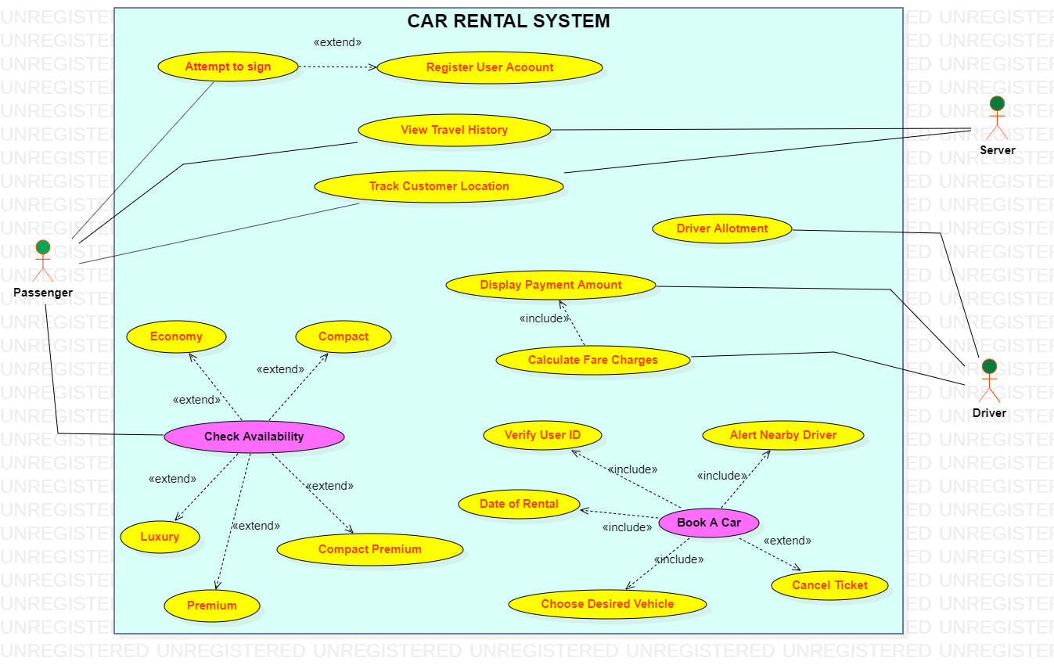

**OBJECT MODEL**

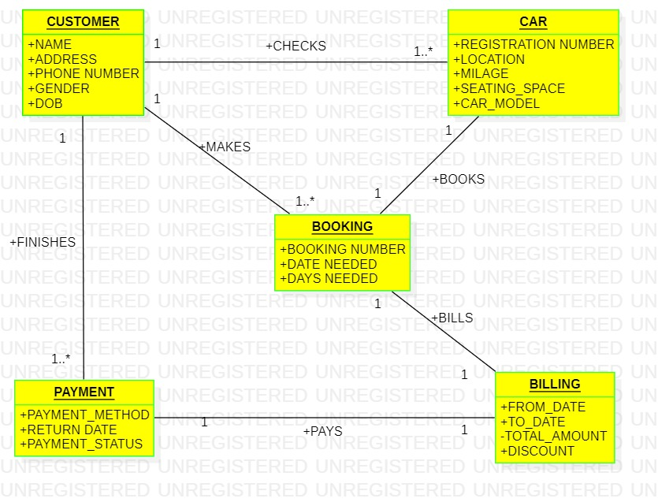

**CLASS DIAGRAM**

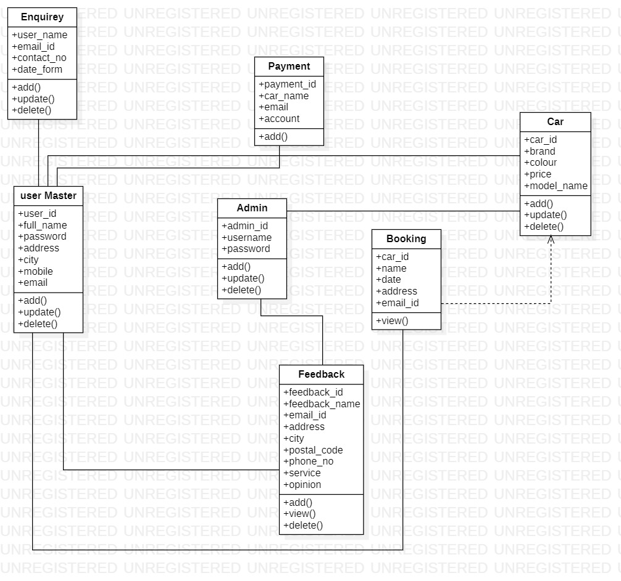

**SEQUENCE DIAGRAM**

