1.Create a class with a **String** that is initialized using instance initialization.

**package** q1;

**public** **class** Instance {

**public** **static** **void** main(String[] args) {

testingclass test1 = **new** testingclass();

}

}

**package** q1;

**public** **class** testingclass {

String sample;

testingclass()

{

System.***out***.println("Constructor invoked");

}

{

sample = "Sample_text";

System.***out***.println("Text with block is: "+sample);

}

}

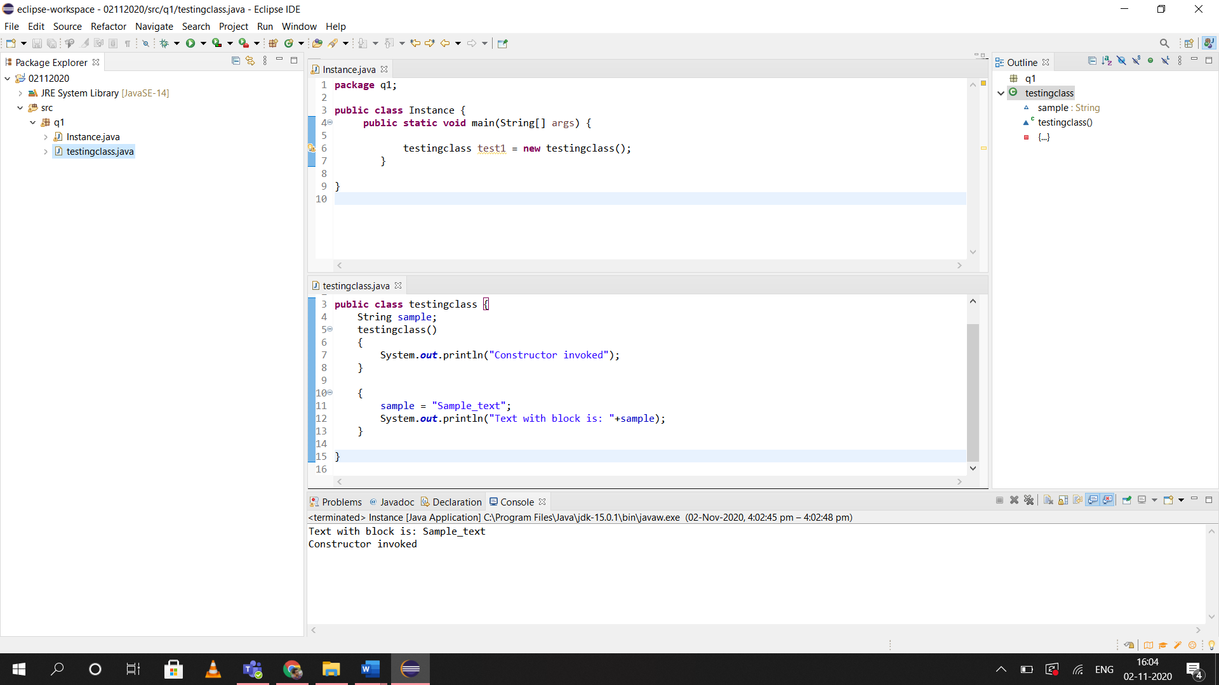

2.

**package** q2;

import java.io.*;

import java.util.Scanner;

**public** **class** ChessPieces {

**public** **int** color, positionX, positionY, forwardMovement, sideMovement;

ChessPieces(**int** x, **int** y){

positionX = x;

positionY = y;

**if**((x+y)%2 == 0){

color = 0;

**else**{

color = 1;

}

}

**public** **void** currentPosition(){

System.***out***.println("Current Position: "+positionX+", "+positionY);

}

}**package** q2;

**public** **class** KnightextendsChessPieces {

Knight(**int** x, **int** y){

**super**(x,y);

forwardMovement = 2;

sideMovement = 1;

}

**public** **void** move(){

**super**.currentPosition();

positionX+=sideMovement;

positionY+=forwardMovement;

System.***out***.println("Knight Moved");

**super**.currentPosition();

}

}

3.)

**import** java.io.*;

**import** java.util.Scanner;

**class** WalkingRobots{

**public** String capability;

WalkingRobots()

{

capability = "Walking";

}

};

**class** TwoLeggedRobots **extends** WalkingRobots{

**public** **int** legs;

**public** String task;

TwoLeggedRobots()

{

task = "Helping Humans";

}

};

**class** ScienceRobots **extends** TwoLeggedRobots{

**public** String specialization;

ScienceRobots()

{

task = "Research";

specialization = "Science";

}

};

**class** MarsRobot **extends** ScienceRobots{

MarsRobot()

{

task = "Mars Research";

specialization = "Space Science";

}

**public** **void** display()

{

System.***out***.println("Capability: "+capability);

System.***out***.println("Task: "+task);

System.***out***.println("Specialization: "+specialization);

}

};

**public** **class** convert{

**public** **static** **void** main(String[] args){

MarsRobot yuri = **new** MarsRobot();

yuri.display();

}

};