**AMRITA SCHOOL OF ENGINEERING**

**19CSE205 - Program Reasoning**

**LAB ASSIGNMENT-6**

**DATE: 15-09-2020**

1. {I}

[initialization]

While(B)

{

i=i+1;

s=s+i;

}

{O: s=n*(n+1)/2}

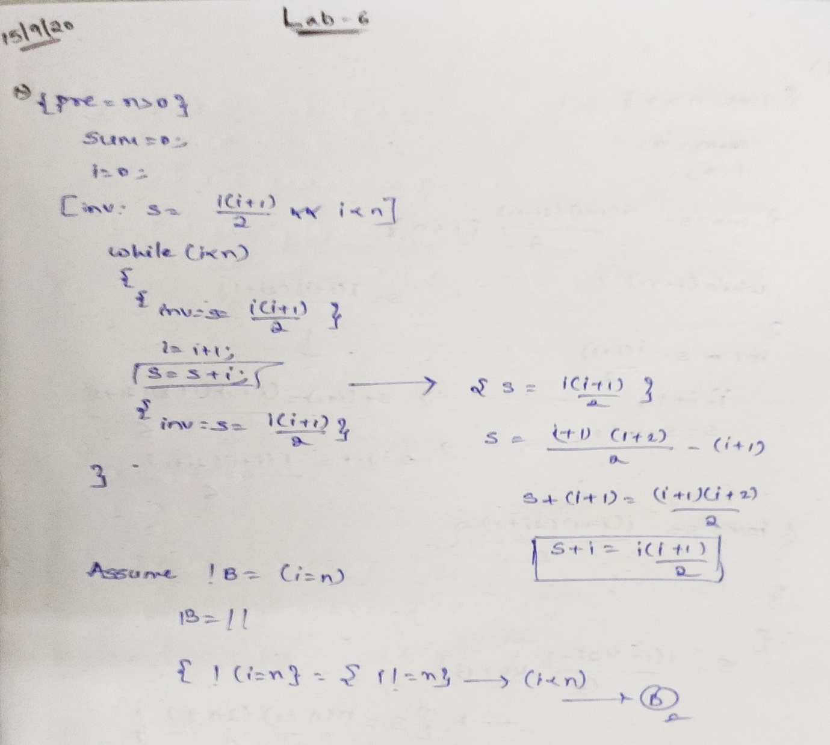

{pre= n>0}

Sum=0;

i=0;

[invariant: s= i(i+1)/2 and I<n] {s=i(i+1)/2

While(i<n) s=(i+1)(i+2)/2-(i+1)

{ s+(i+1)=(i+1)(i+2)/2

[inv =s=i(i+1)/2] s+i=i(i+1)/2

i=i+1;

S=s+i;

{inv =s=i(i+1)/2

}

!B=(i=n)

{ !(i=n)=>{i!=n}->i<n->B

**2.**

{I}

[initialization]

While(B)

{

i=i+1; s=s+i*i;

}

**{O: s=n*(n+1)*(2*n+1)/6}**

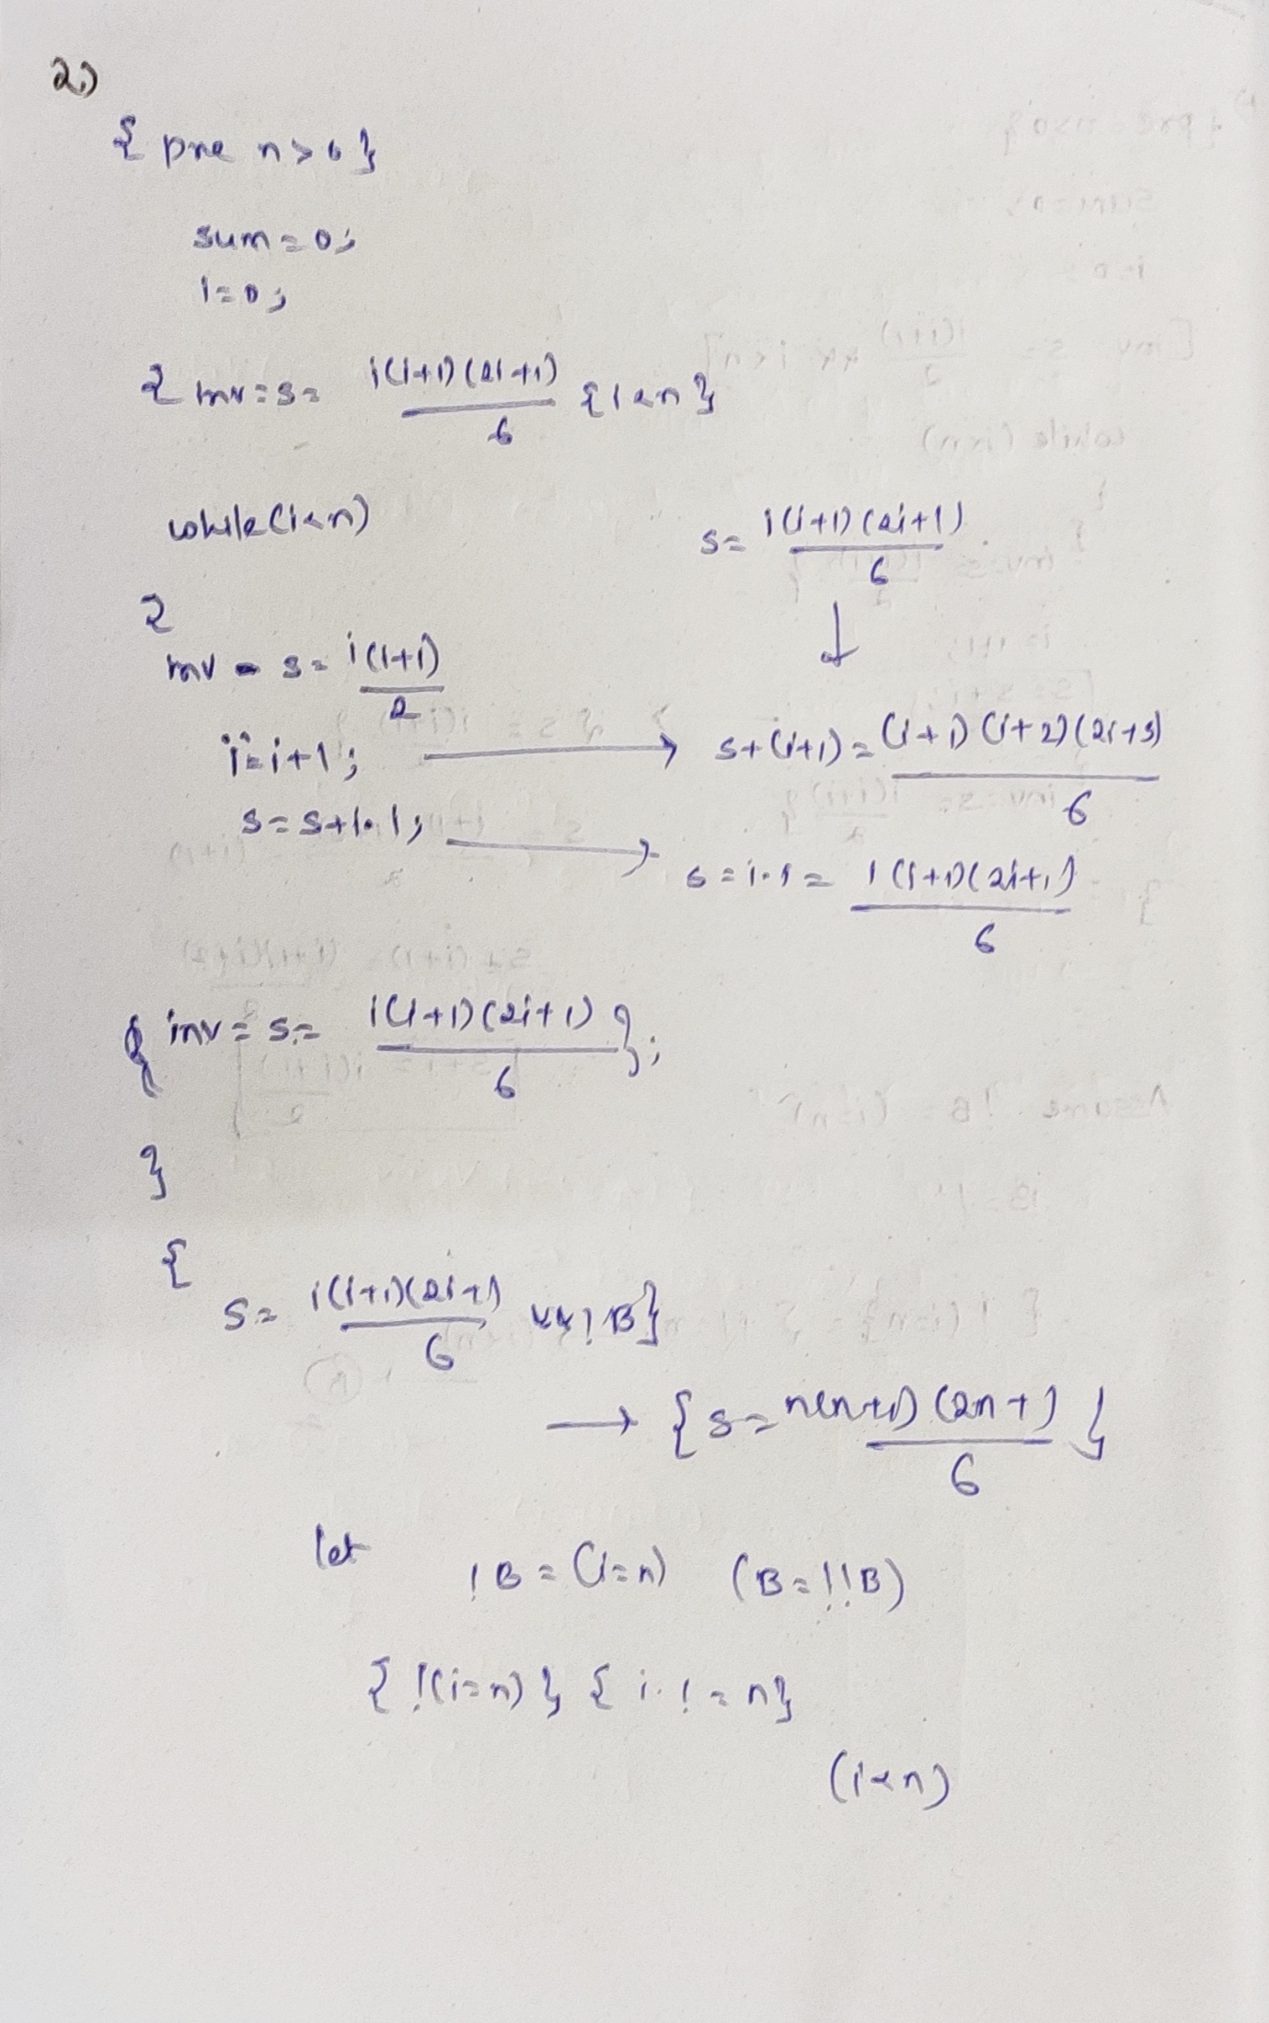

{ pre n>0}

Sum=0;

i=0

{ inv =s= i(i+1)(2i+1)/6 and i<n }

While (i<n)

{ s=i(i+1)(2i+1)/6

{inv s=i(i+1)/2}

i=i+1; s+(i+1)=(i+1)(i+2)(2i+3)/6

S=s+i*i; s+i*i=i(i+1)(2i+1)

Inv s=i(i+1)(2i+1)/6;

}

{ s=i(i+1)(2i+1)/6 and !B } s=n(n+1)(2n+1)/6

Let !B = (i=n)

(i!=n)-> i<n

**3.**

{I}

[initialization]

While(B) {

i=i+1; s=s+i*i;

}

**{O: s=(1*1)+(2*2)+…+(n*n)}**

**Solution:**

{ pre : n>=0 }

i=1;

{ inv : s =(1*1)+(2*2)+…..+(i-1)(i-1) }

While (i !=n+1) s =(1*1)+(2*2)+…..+(i-1)(i-1)

{ s +(i+1)(i+1)=(1*1)+(2*2)+…..+(i)*(i)

{ inv : s=(1*1)+(2*2)+…..+(i-1)(i-1) s+(i*i)= (1*1)+(2*2)+…..+(i-1)(i-1)

I=I+1;

s=s+(i-1);  
{ inv : s= (1*1)+(2*2)+….+(i-1)*(i-1) }

}

{ s= (1*1)+(2*2)+….+(i-1)*(i-1) and !B }

B -> i-1 != n -> i!=n+1

{ s=i(i+1)(2i+1)/6 and !B } s=n(n+1)(2n+1)/6

Let !B = (i=n)

(i!=n)-> i<n

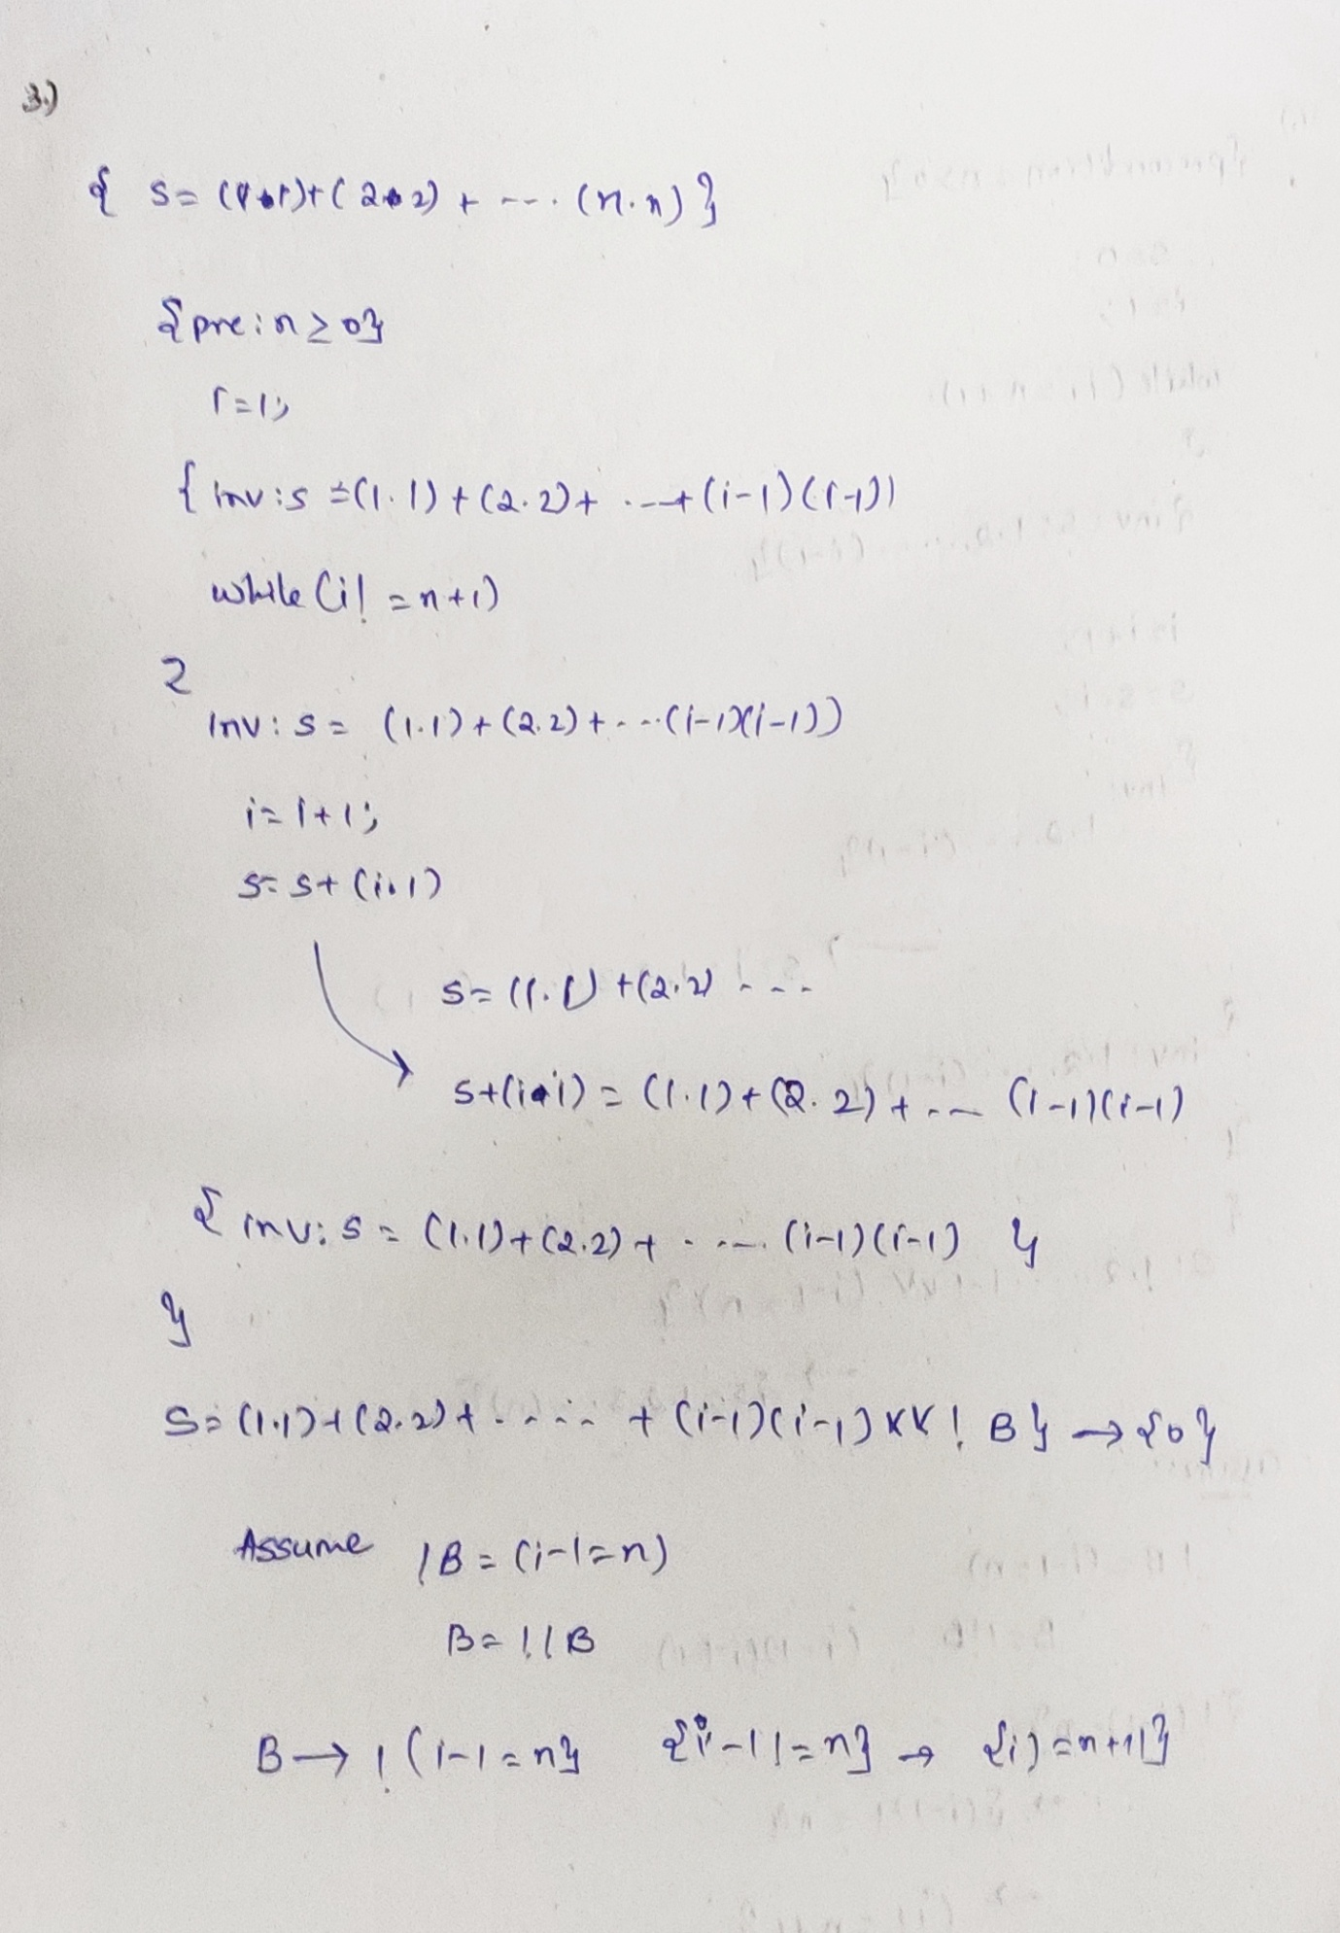

**4.**

{I}

[initialization]

While(B)

{

i=i+1; s=s*i;

}

**{O: s=1*2*…*n}**

{ pre n>0 }

S=0;

i=1;

While (i!=n+1)

{

{ inv : s: 1*2*….*(i-1) }

i=i+1; s*(i+1)= 1*2*….*(i)

S=s*i; s*i= 1*2*….*(i-1)

{ inv : s: 1*2*….*(i-1) }

}

S: 1*2*…..*(i-1) and i-1=n {1*2*3*…..*n}

i-1!=n

i!=n+1;

