**Lab Test 2 : 19CSE205: Program Reasoning**

**DATE:10.11.2020**

**Department of Computer Science and Engineering**

**Amrita School of Engineering, Coimbatore**

**1.)**

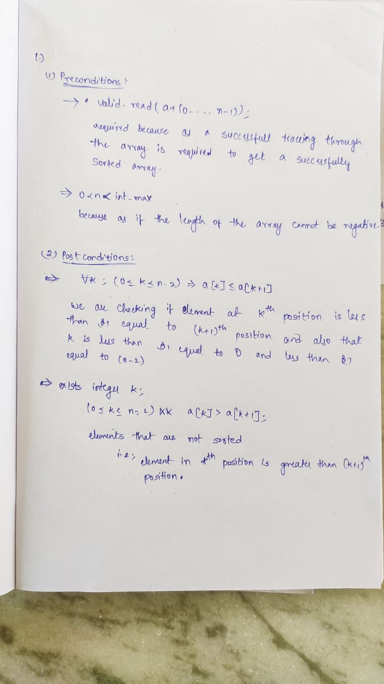

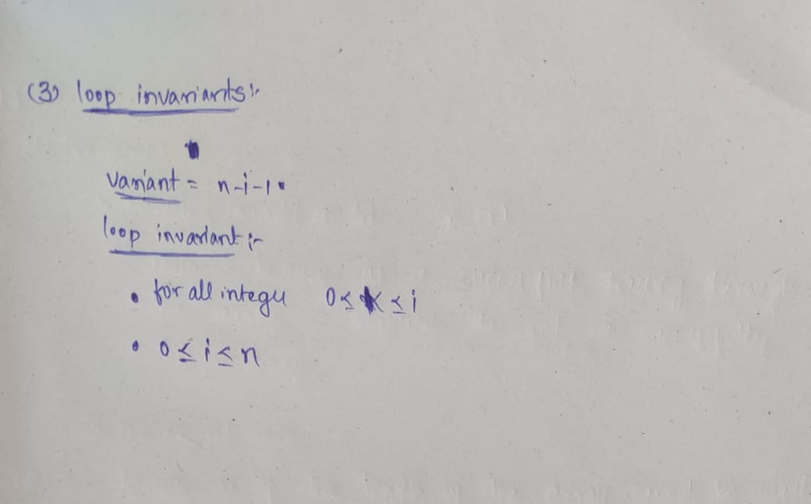

/*@

requires n>=0;

requires \valid_read(a + (0..n-1));

assigns \nothing;

behavior sorted:

assumes \exists integer k; 0 <= k < n && a[k]< a[k+1];

ensures \result==1;

behavior not_sorted:

assumes \forall integer k; 0 <= k < n && a[k]>a[k+1];

ensures \result==0;

disjoint behaviors;

complete behaviors;

*/

int arraySorted(int a[], int n)

{

int i=0;

while (i<n-1){

/*@

loop invariant \forall interger k;(0<=k<=i) && a[k]<a[k+1];

loop invariant 0 <= i <= n;

loop assigns i;

loop variant n-i-1;

*/

if a[i]>a[i+1]

return 0;

i=i+1;

}

return 1;

}

2.)

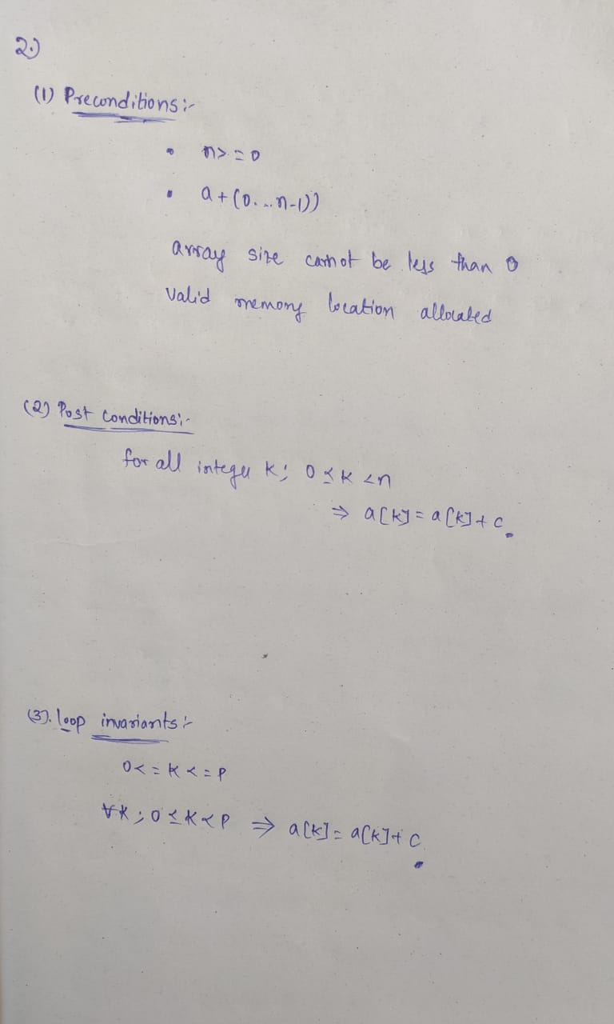

/*@

requires \valid_read(a + (0..n-1));

assigns \nothing;

behavior sorted:

assumes \exists integer k; 0<=k<n-1 && a[k]>a[k+1];

ensures \result==0;

behavior not_sorted:

assumes \forall integer k; 0<=k<n-1 && a[k]<a[k+1];

ensures \result==1;

disjoint behaviors;

complete behaviors;

*/

int arraySorted(int a[], int n)

{

int i=0;

/*@

loop invariant 0 <= i <n-1;

loop assigns i;

loop variant n-i-1;

*/

while (i<n-1){

if(a[i]>a[i+1])

return 0;

i=i+1;

}

return 1;

}