**R.ABHINAV - CB.EN.U4CSE19453**

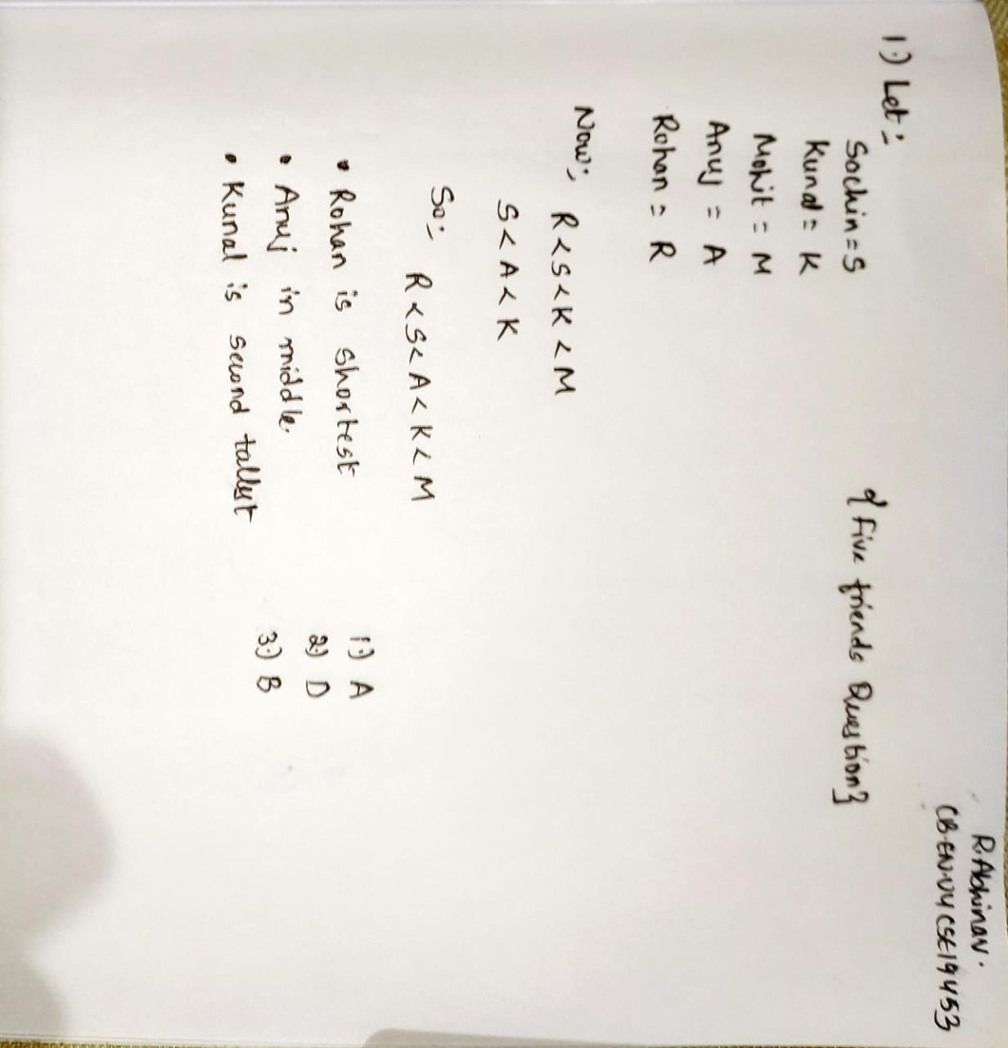

**R.ABHINAV - CB.EN.U4CSE19453**

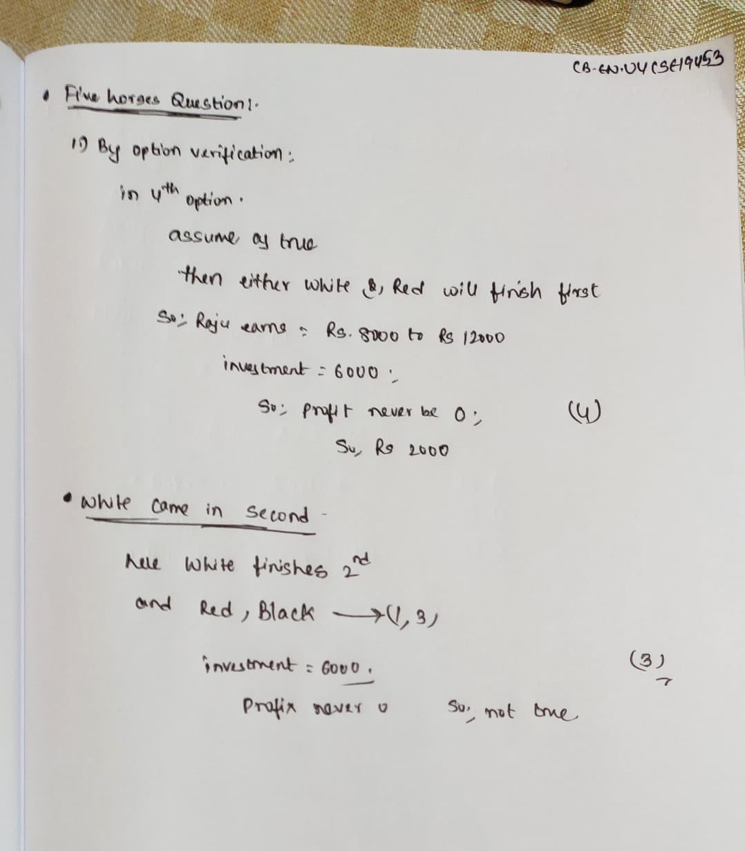

**Thejaswini -CB.EN.U4CSE19462**

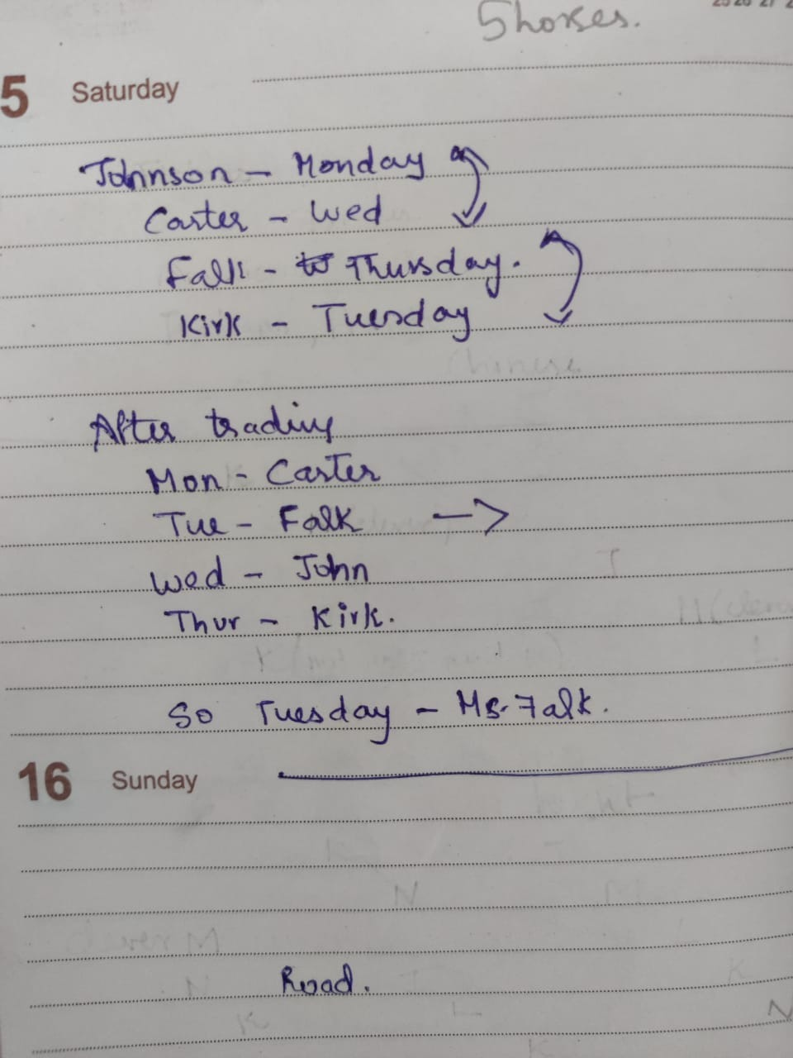

**THEJASWINI -462**

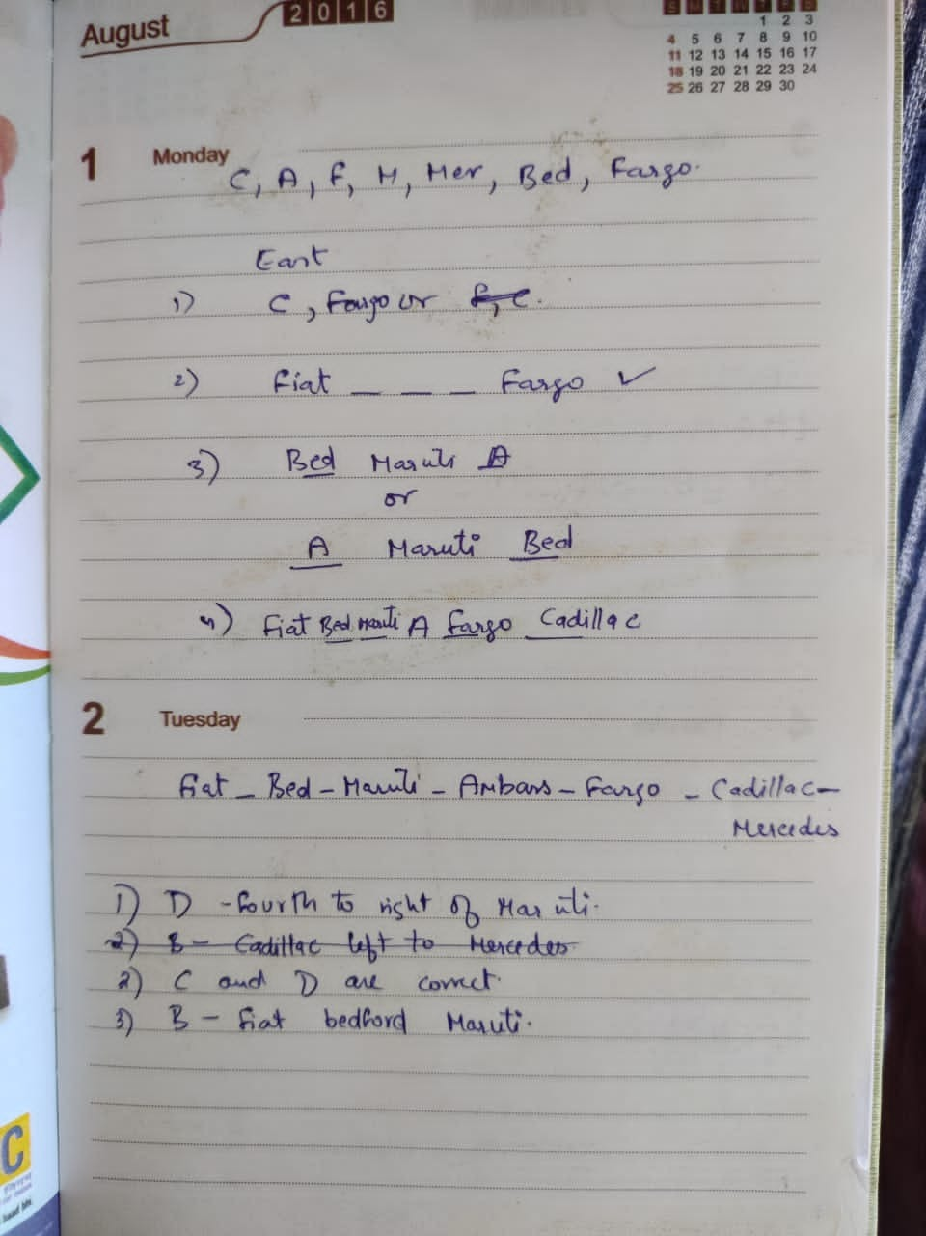

**SATYA HEMANTH – CB.EN.U4CSE19405**

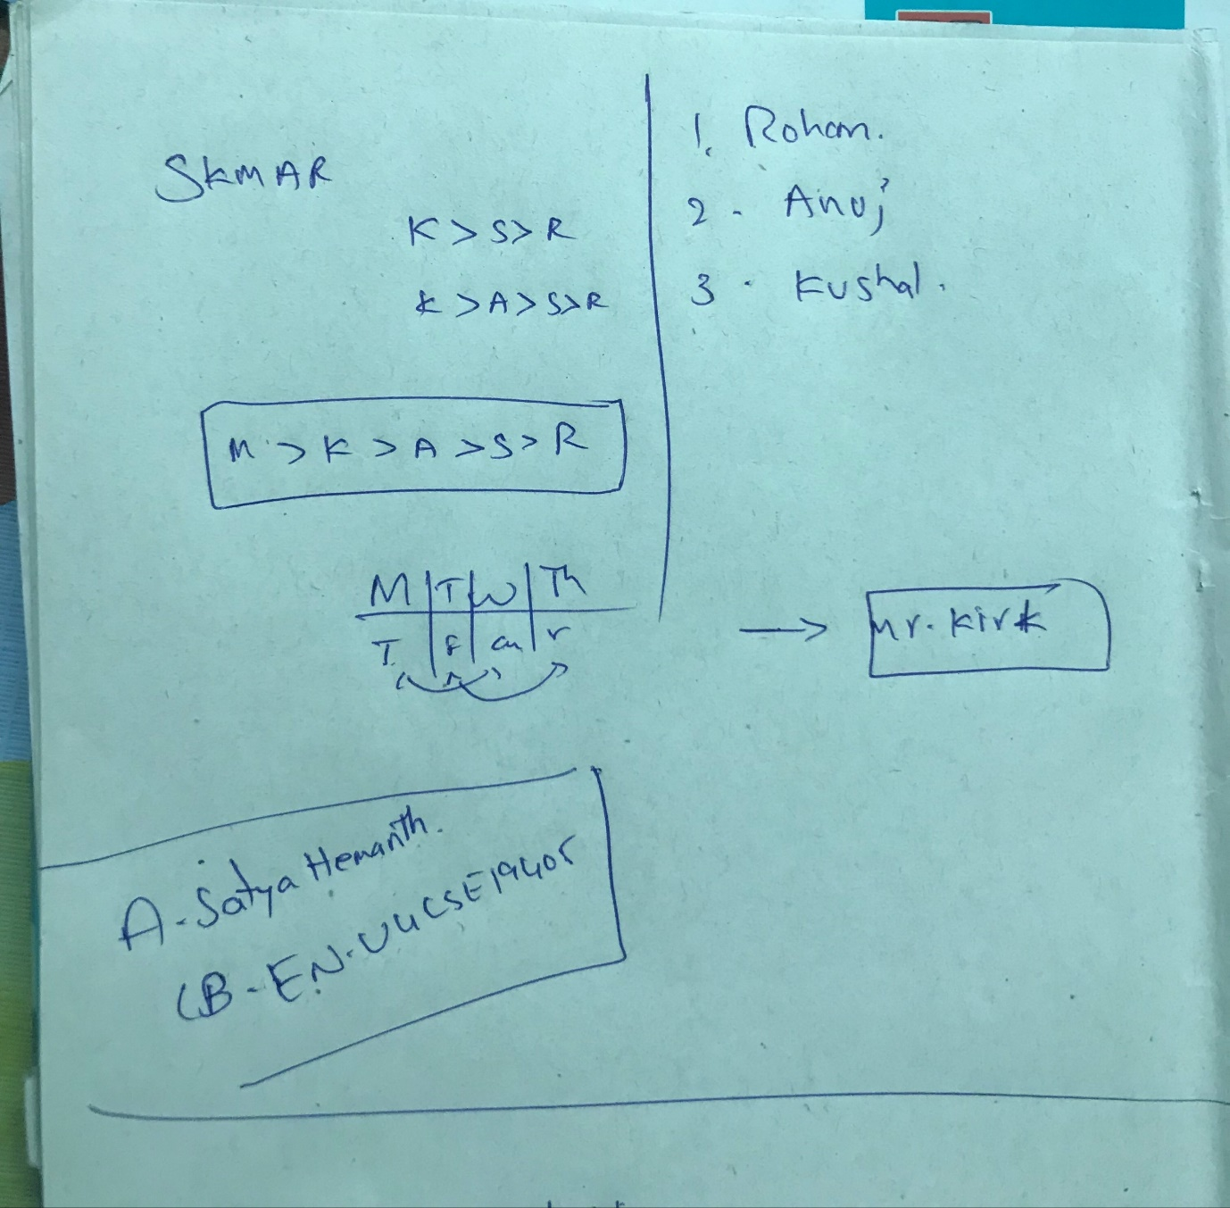

**ROHIT P M – CB.EN.U4CSE19454**

5) Mr.kirk

