

DEPARTMENT OF ENGLISH AND HUMANITIES

**AMRITA VISHWA VIDYAPEETHAM**

COIMBATORE CAMPUS (INDIA)

**BUSINESS PROPOSAL**

**Done by:**

|  |  |  |
| --- | --- | --- |
| S.No | Name of the Student | Roll No. |
| 1. | R.ABHINAV | CB.EN.U4CSE19453 |
| 2. | S.SHANTHAN | CB.EN.U4CSE19459 |

**TITLE PAGE**

**A PROPOSAL ON**

Opening of New branch at Tirupati, Andhra Pradesh

**SUBMITTED TO**

General Manager

State Bank of India, Coimbatore

**SUBMITTED BY**

R.ABHINAV, S.SHANTHAN

Director, Info Computers

Ukkadam-641112, Coimbatore

**MAY 11, 2021**

**Table of Contents**

|  |  |  |
| --- | --- | --- |
| S. No | Topic | Page No. |
|  | About Us | **4** |
|  | Summary | **5** |
|  | Statement | **6** |
|  | Solution | **6** |
|  | Qualifications | **7** |
|  | Timeline | **8** |
|  | Pricing | **9** |
|  | Terms and Conditions | **10** |
|  | Acceptance & Signature | **11** |

**About Us:**

Info Computers are tailored to our client’s specific needs. We identify your challenges quickly and design impactful strategies to address them. Our strategies are tightly structured and aim for minimal disruption to your business.

Info computer had been established in the year 1998.Info computers are one of the leading computer system providers in the state, Tamil Nadu. Info computers has been busineese grow and succeed for over 22 years, locally and globally. We know the landscape, we know your market, and we understand your industry. Moreover, we have a vast pool of resources, information and experience to draw ideas from.

Our consultants have an advanced degree in their field, and at least ten years of experience actually working in that field. This union of theory and practice is essential to our analyitc, data-driven. That’s a lot of problems solved, and working to draw inspitaration from.

We have achieved as best service provider of the state Tamil Nadu in the year 2012 given the Government of the state. We achieved a lot of milestones in the past 22 years.

Our main goal is to deliver good quality of outcome in any aspect. Our main aim is to expand our reputed company all over the country.

**Summary:**

Info Computers is a recognized brand and has a universally expected level of service from its patrons. You have the services people want, and the experiences they crave, but there’s gap between your level of sales and where you want to be.

Growing your business means identifying and building on your strenghts to improve the experiences you offer. It also means understanding the different types of patrons you cater to, and how to connect them to the specific services and experiences they’re looking for effectively

**Problem Statement:**

We have established our company in 1998 and it has been 21 years and the motive of our company was to provide companies to people at very feasible rate.

We have been successful in providing computers in the state and we want to further establish a company in the neighbouring state to provide benefit to the people of that state.

Since the people of this state already have some belief in us and we have been serving them honestly, we have great belief that we would be successful in fulfilling the dreams of the people of the neighbouring state.

Since we do not have enough money to expand our company and since people have demand for our products, we are not able to provide them with what they need. If we establish the new company then all the needs are met and we can be able to clear off the loan easily.

**Proposed Solution:**

We want a loan of 70 lakhs. We are ready to pay the loan with 6% interest with a time period of 5 years. With establishing the second branch we will be having enough profit from the 2 branches to pay the loan back.

We have earned the reputation all over the state so we can be trusted on that part.

**Qualifications:**

We, Info computer has earned reputation all over the state for good, quality and top-notch service for the customers. We know the landscape, we know your market, and we understand your industry. Moreover, we have a vast pool of resources, information and experience to draw ideas from.

Our consultants have an advanced degree in their field, and at least ten years of experience actually working in that field. This union of theory and practice is essential to our analyitc, data-driven. That’s a lot of problems solved, and working to draw inspitaration from.

**Acheviments:**

We have achieved as best service provider of the state Tamil Nadu in the year 2012 given the Government of the state. We achieved a lot of milestones in the past 22 years.

**Timeline:**

|  |  |
| --- | --- |
| Year | Acheivement or Milestone |
| 1998 | Info technologies journey begins with a clear vision to provide best computers to the people at feasible rates. |
| 1999 | people started to believe in the company and buy products. |
| 2000 | crossed the total sales of 500 |
| 2003 | best sales company |
| 2007 | company turn around profit of 20% |
| 2012 | Best service provider by government of Tamil Nadu |
| 2015 | Number of employees reached 500 |
| 2018 | sales rate increased by 16% |
| 2020 | covid relief fund |

**Pricing and Allocation of Loan:**

**Purpose of Loan:**

|  |  |
| --- | --- |
| Budget of new office | RS.10,000,000 |
| Our investment | RS.30,00,000 |
| Loan amount | RS.70,00,000 |

**The money we are requesting for loan as divided:**

|  |  |  |  |
| --- | --- | --- | --- |
| Infrastucture | Equipment | Human Capital | Operational Expenses |
| RS.25,00,000 | RS 17,50,000 | RS.17,50,000 | RS.10,00,000 |

**Flow-Chart of Fund allocation:**

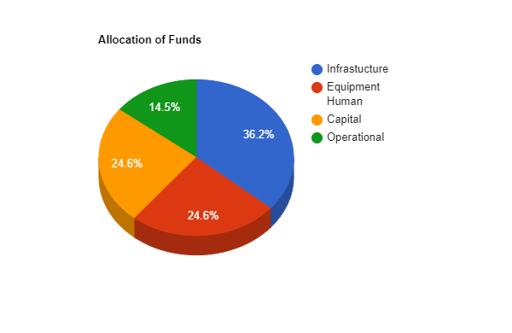

* We expect to launch the office in next eight months

**Repayment of loan:**

* The loan amount we are seeking is RS.70,00,00 is to be repaid over five years at a rate of 6% of interest.
* The monthly installments will be of RS.1,20,000 monthly.
* The revenues are estimated to be RS.17,25,000 in a month for 22 operational days per month.
* **Staff costs –** RS.1,20,000 per month
* **Operational costs –** RS.10,00,000
* **We are left with sufficient amount of money to repay the loan**

**Terms and Conditions:**

We are requesting you the final amount of 70 lakhs and we are having a deadline of payment of 5 years from here with a 6% interest rate. Infrastructure, equipment human capital operational expenses these are all the things which are to be covered with the loan amount. If we are not given the asked amount then we won't be able to properly maintain the branch.

We will not disclose the agreement policy. We will protect all the information of the privacy and terms and conditions.

If we are unable to clear out the loan in the stipulated time then we are ready to face all the consequences.

**SIGNATURE:**

1. Please read the contract on the previous pricing page to make sure you understand all the details involved with us working together. It’s important to us that everything is transparent and understood from the beginning so that we lay a solid foundation for a great working relationship.
2. If you have any questions at all, please let us know. We’re happy to clarify any points and there may be some items that we can sort out togrther. We’re committed to finding the best way to work together. My direct line is (0422) 2685 000/053.
3. Below are the details of our company:

|  |  |
| --- | --- |
| Name of the Company | Info computers |
| Head-office Address | 5012 Townhall, Coimbatore-641001 |
| Phone: | 0422-2685 000/053 |
| Email: | [help.infocomputers@gmail.com](mailto:Help.info@gmail.com) |
| Website: | <infocomputers.com> |