1. Install eclipse from the link: <https://www.eclipse.org/downloads/download.php?file=/oomph/epp/2022-06/R/eclipse-inst-jre-win64.exe>
2. Download the ANTLR complete jar file on clicking the link: [Complete ANTLR 4.10.1 Java binaries jar](https://www.antlr.org/download/antlr-4.10.1-complete.jar)
3. Open Eclipse and install ANTLR plugin: Go to help > Eclipse Marketplace, now type “ANTLR” in search bar. Now Install ANTLR 4 0.3.6. Restart the Eclipse once done.
4. Create Class path for ANTLR as follows: Select Windows > Preferences, you will see ANTLR on left pane, expand it and click on “Tool” you will get

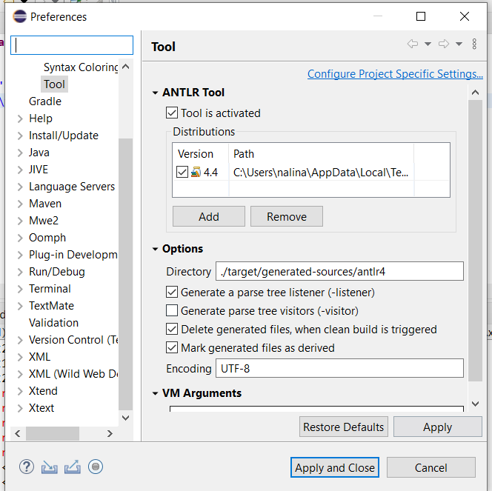

1. Now change the version of the ANTLR: add the 4.10.1 jar file you have downloaded.
2. Change the options: directory to ./src instead of ./target/generated-sources/antlr4
3. Apply changes

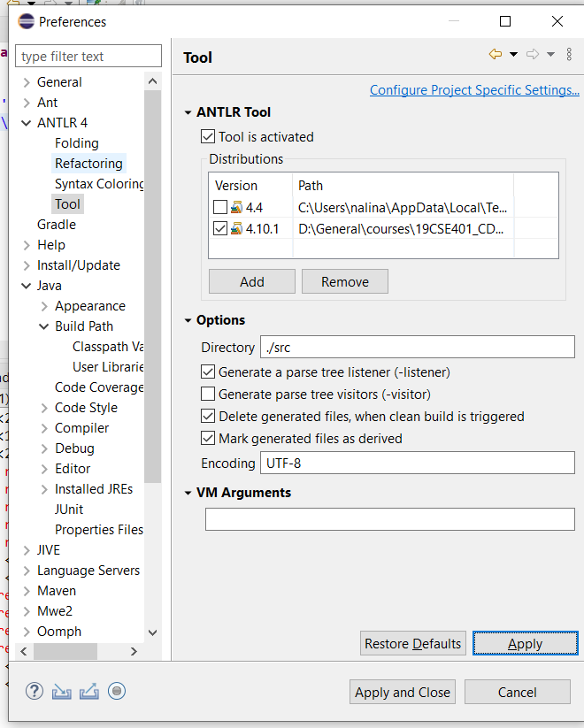

1. Click on Java >buildpath > classpath variables> new you will get

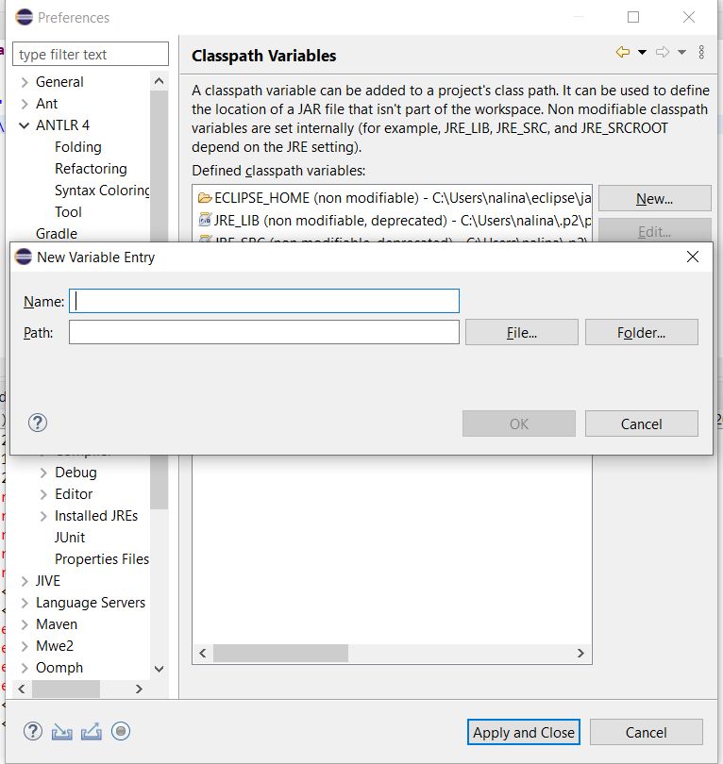

1. Now type Name: ANTLR, Select the path of antlr-complet-4.10.1.jar file.
2. Apply and Close.
3. Create a new Java project:
   1. Add the hello.g4, Main.g4 and input file into the project src folder
   2. The following error should be seen

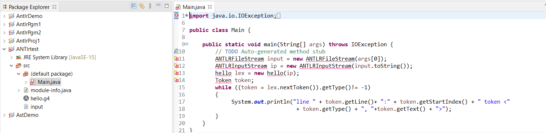

* 1. Now right click on your project name on eclipse explorer and select properties, you will see

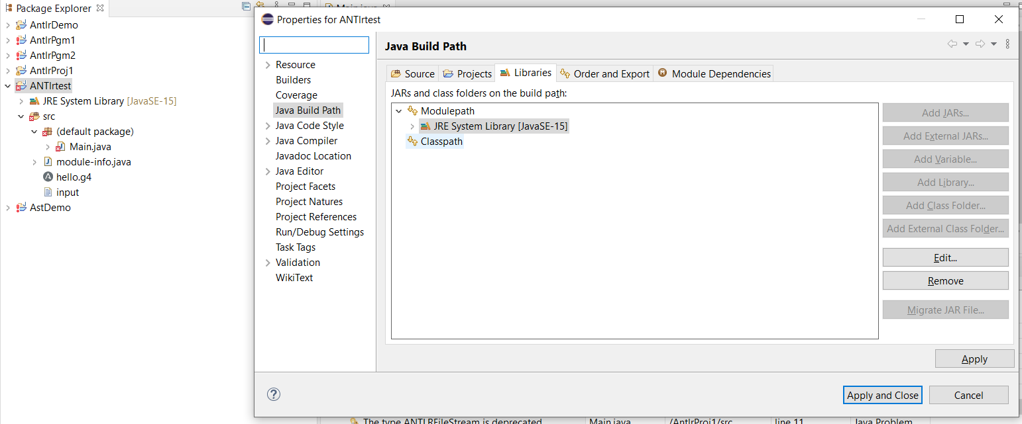

* 1. Select classpath and add external jar : antlr-complete-4.10.1.jar that you have downloaded.

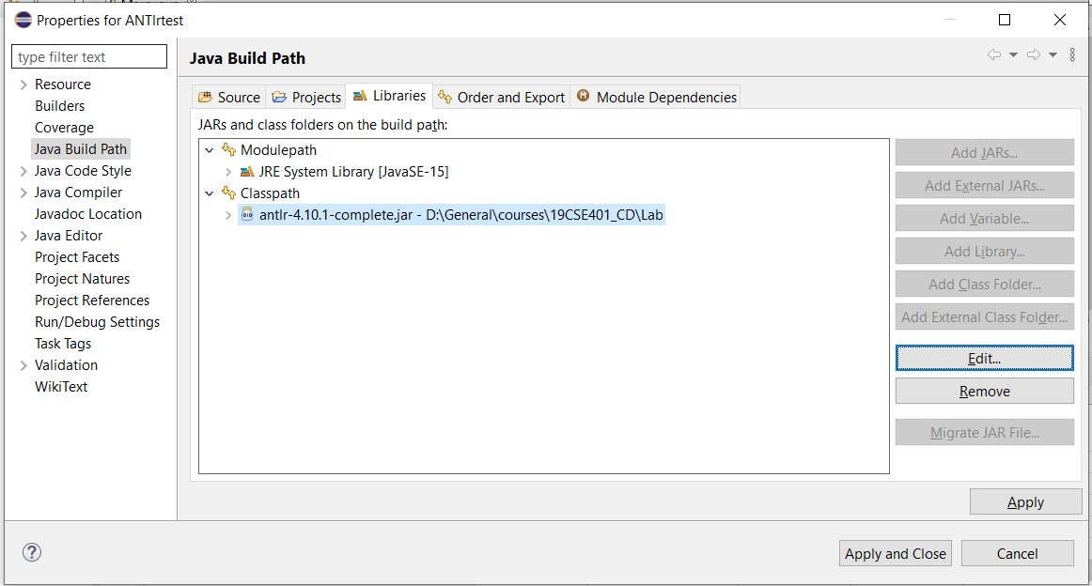

* 1. Apply changes
  2. Now select Run/Debug Settings > New, select “Java Application”, you will get:

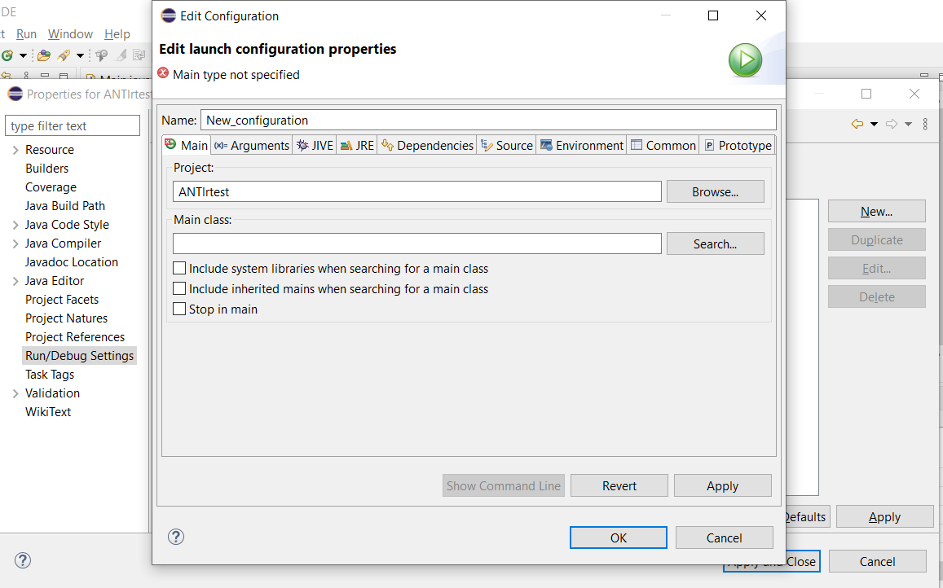

* 1. Fill Main Class, as *Main* by searching for *Main(default package)*, Apply changes
  2. Next select the tab: Arguments > Program Arguments and type “input”
  3. Now change the working directory >Other on selecting the src folder of the working directory.

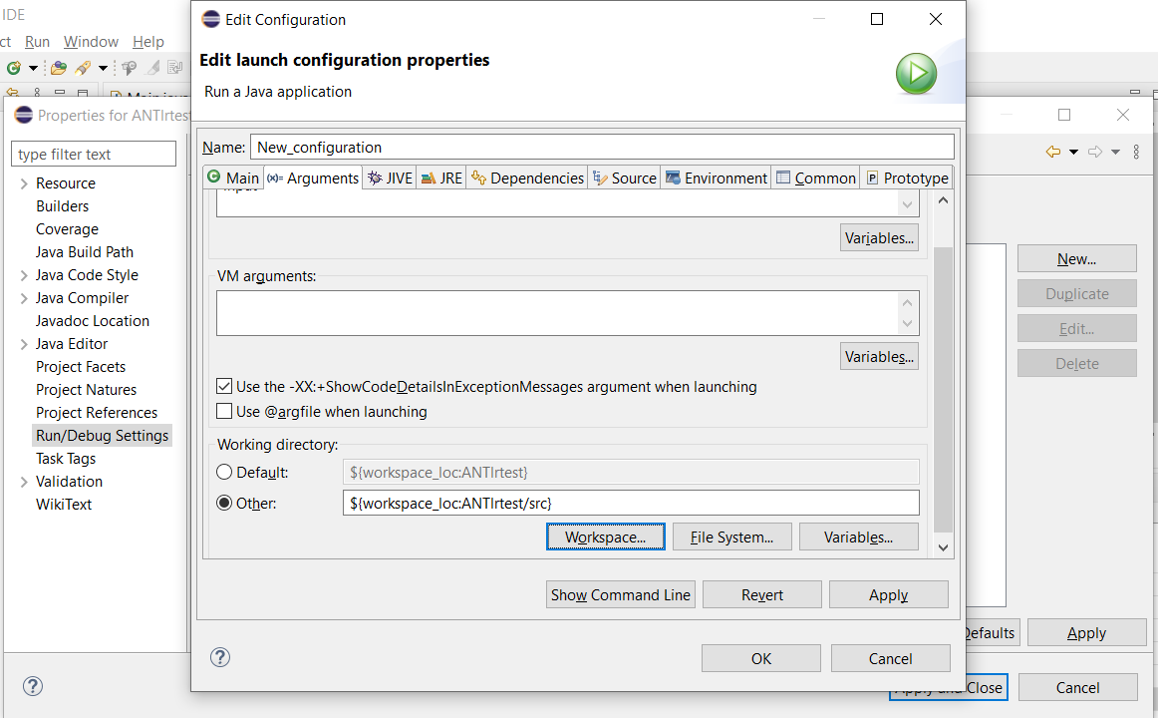

* 1. Delete the module-info.java for reference library to come to effect.
  2. Run the main.java, you will get the output as follows:

