**CSC-PROJECT**

**NAME:R.SRILATHA**

**REG-NO:2000031685**

**AIM**: BUILD A WEBSITE USING AMAZON LIGHTSAIL

**LIGHTSAIL:-** With Amazon Lightsail, you can launch a WordPress site on a virtual server with a few, simple clicks. Your virtual server will launch in minutes, with WordPress installed and all the benefits of running a server on AWS, including reliability and security.

Services Required:-VPS

Architecture diagram:-

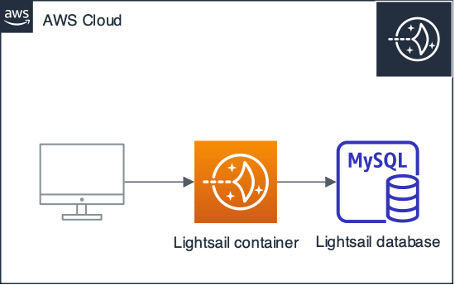

## Step 1: Sign up for AWS

## Step 2: Create a Website instance in Lightsail

1. Sign in to the LightSail console.
2. On the Instances tab of the Lightsail home page, choose Create instance.
3. Choose the AWS Region and Availability Zone for your instance.

Choose your instance image.

1. Choose Linux/Unix as the platform.
2. Choose Website as the blueprint.

Choose an instance plan.

A plan includes a low, predictable cost, machine configuration (RAM, SSD, vCPU), and data transfer allowance

Enter a name for your instance.

Resource names:

* Must be unique within each AWS Region in your Lightsail account.
* Must contain 2 to 255 characters.
* Must start and end with an alphanumeric character or number.
* Can include alphanumeric characters, numbers, periods, dashes, and underscores

## Step 3: Connect to your instance via SSH and get the password for your WordPress website

On the Instances tab of the [Lightsail home page](https://lightsail.aws.amazon.com/), choose the SSH quick-connect icon for your WordPress instance.

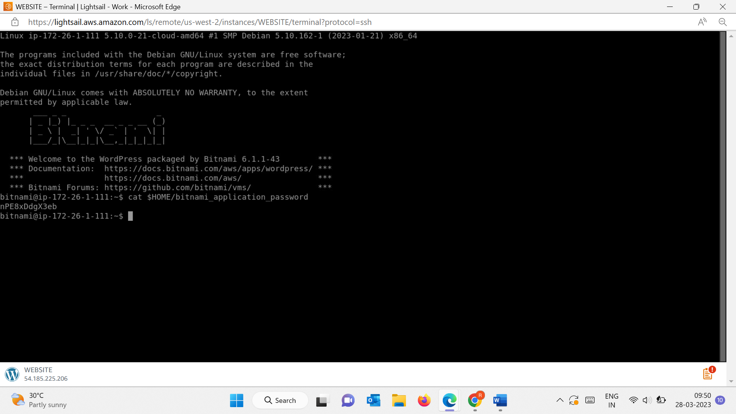

## Step 4: Sign in to the administration dashboard of your WordPress website

1. In the Username or Email Address box, enter user.
2. In the Password box, enter the default password obtained earlier in this tutorial.
3. Choose Log in.

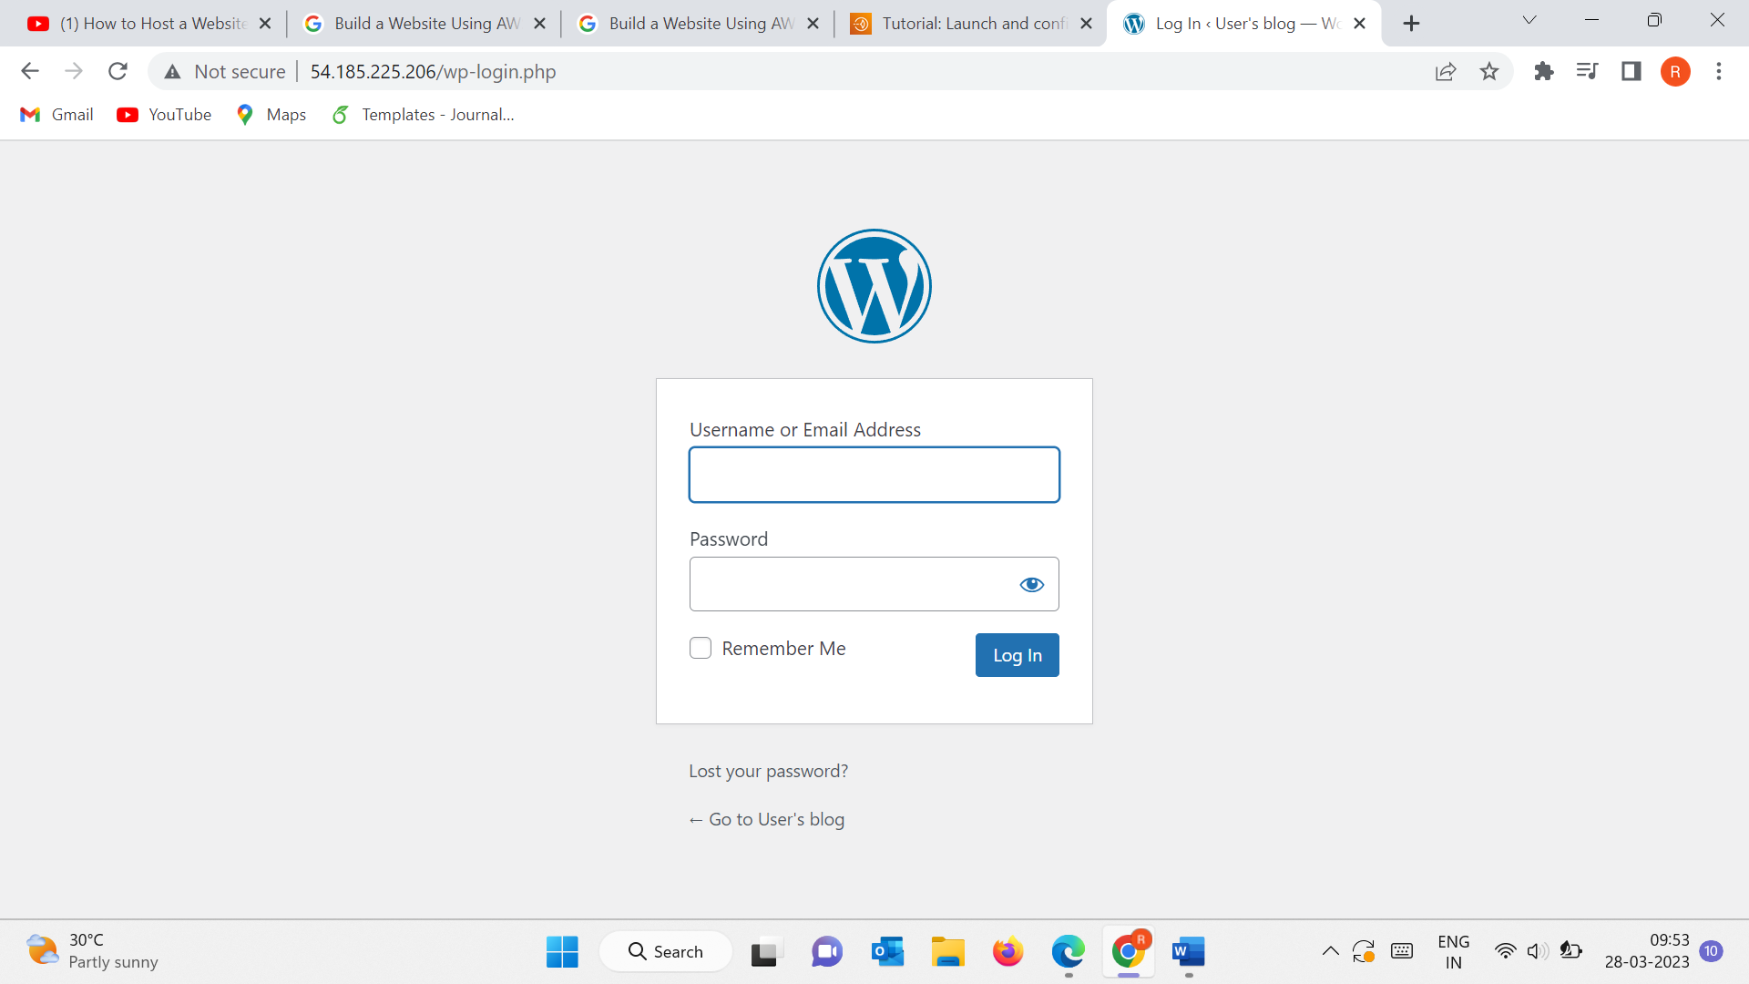

You are now signed in to the administration dashboard of your WordPress website

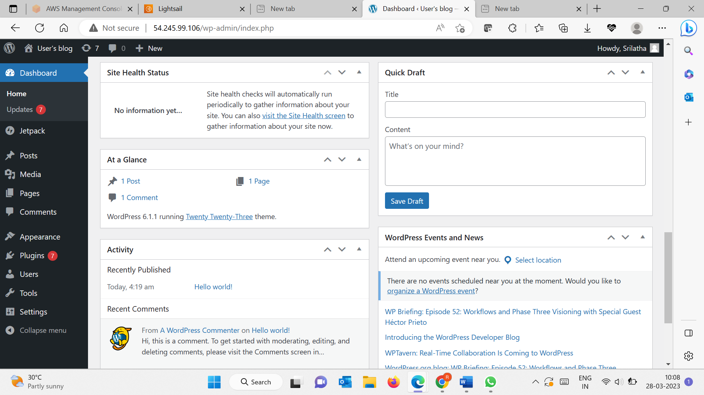

## Step 5: Create a Lightsail static IP address and attach it to your WordPress instance

## On the Instances tab of the [Lightsail home page](https://lightsail.aws.amazon.com/), choose your running WordPress instance.

## Choose the Networking tab, then choose Create static IP.

## Name your static IP, then choose Create.

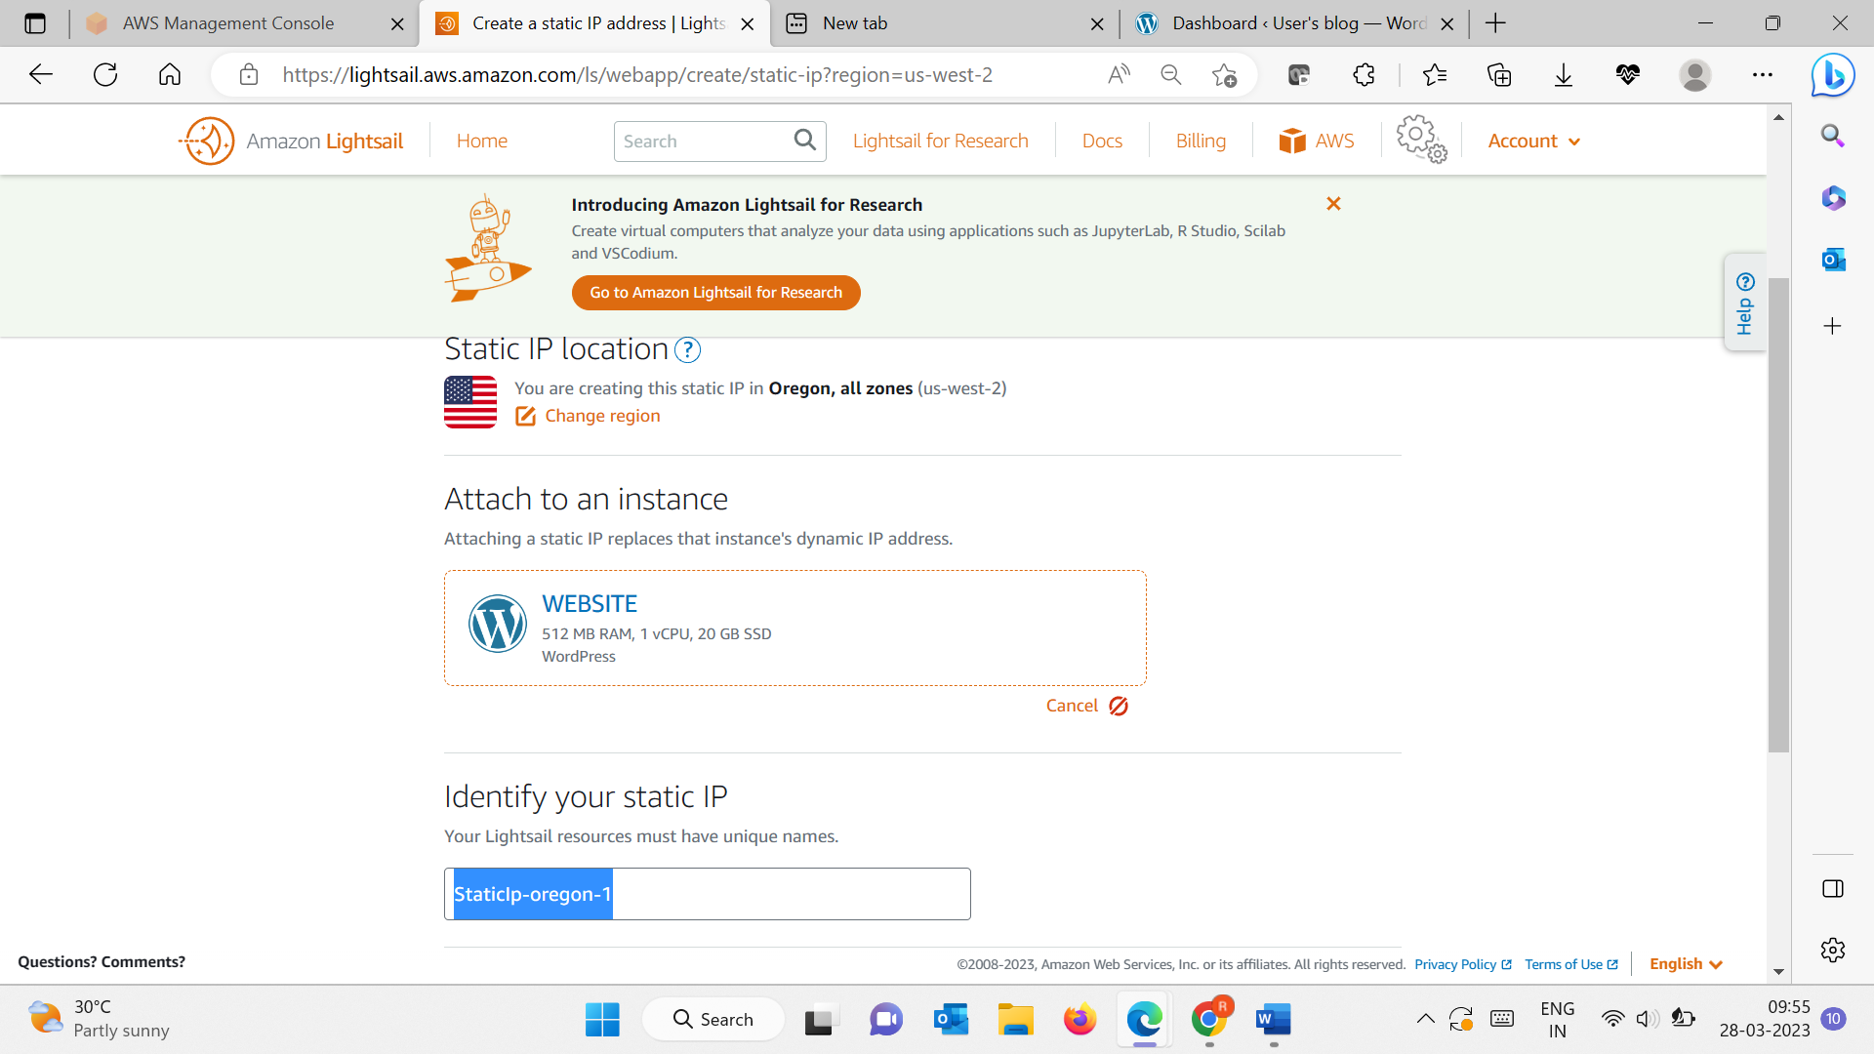

Name your static IP, then choose Create.

