- Statistical Test
  - I used the Mann-Whitney U statistical test. The Mann-Whitney U test is a one-tailed test.
  - The Mann-Whitney U test is applicable to this dataset because unlike the t-test, it doesn't assume a particular distribution in the data.
  - I got the following results:
    - Mean with Rain: 2028.19603547
    - Mean without Rain: 1845.53943866
    - U value: 153,635,120.5
    - p value: 2.7413530677e-06 (Calculated by substituting 1 for the inappropriate number generated by the Mann-Whitney u method.
  - The means are significant because they show the average entries per hour on both rainy and non-rainy days. The rather large difference in the means shows that rain does impact subway ridership. The P value is significant because it shows the probability that the two datasets differ. The very small value of p shows that it is incredibly unlikely that the variance in the two samples is due to random sampling alone.

- Linear Regression
  - I used the Ordinary Least Squares method using Statsmodels.
  - I used datetime, weekday, station, conds, fog, meanprecipi, meanpressuri, meantempi, meanwspdi, and hour.
  - I used weekday because I know that the workday commute contributes to ridership. I included station because certain stations are likely to be higher traffic than others. I included meanprecipi, meanpressurei, meantempi, and meanwspdi because they are all features that describe weather conditions in a given time period. So while the rain feature might tell you whether it was raining or not in a given location in a given time period; Meanprecipi will tell you how severe the rainfall was. People may be willing to walk to work in a drizzle, but would rather be in the subway during a downpour. Conds, and fog I added to my model because they too describe the weather, in a more general way. I added hour to the model because I know that transit ridership, in general, fluctuates by time of day. Lastly, I added datetime because when I was experimenting with adding in other features it significantly increased my R² value.
  - My R² value is 0.52335062157
  - This R² value means that approximately 52.33% of the variance between both samples is accounted for by my model. While this value is significantly higher than the R² value that was achieved by the gradient descent model used in the classroom exercise; I am unsure if this is a high enough value (for this particular type of dataset) to be considered a good fit.

- Visualizations

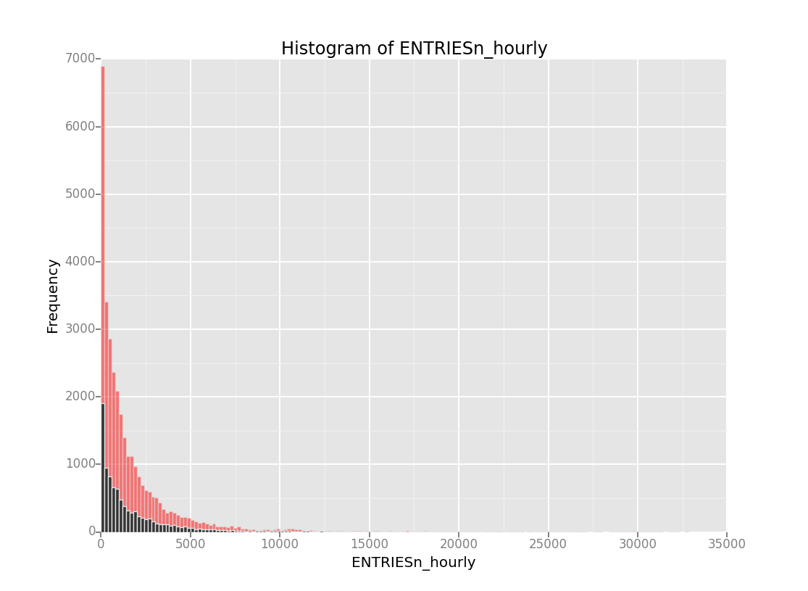
The above histogram contains a frequency distribution for ENTRIESn_hourly on both rainy(black) and non-rainy days (red). This shows that while there is significantly more data for the non-rainy days, both samples show very similar distributions.
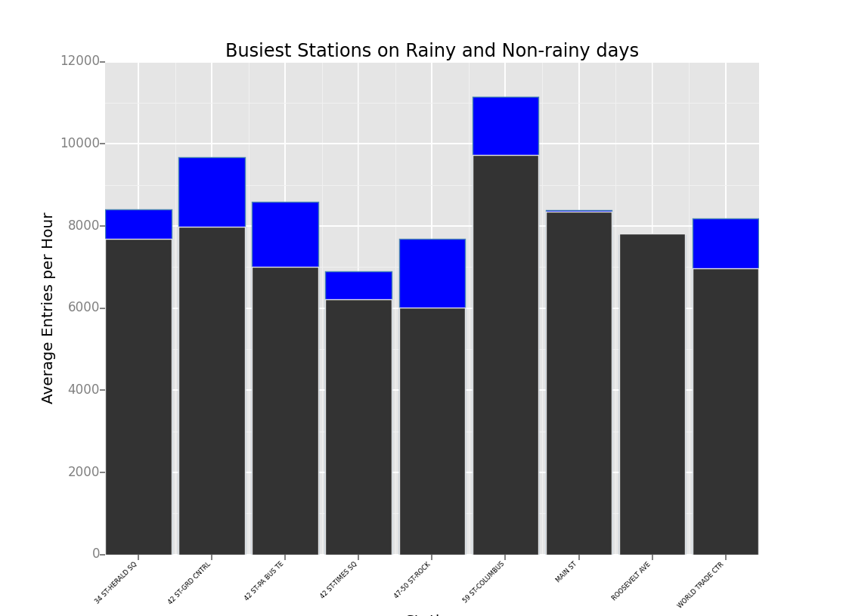

The above plot shows the nine busiest stations in the data set, with their average number of entries per hour displayed for both rainy and non-rainy days. The blue bars show the rainy days, and clearly in all of the busiest stations but one, rainfall leads to increased entries per hour. Interestingly enough the Roosevelt Ave station is only behind on rainy days by 32 entries per hour on average.

- Conclusion
  - Over the last several weeks, I have been looking in depth at a data set that combines New York City Subway data, and weather data for the area covered by the New York City Subway. I have been trying to determine whether rain impacts subway ridership. My analysis of this data set has lead me to the conclusion that more people do ride the subway on rainy days than non-rainy days.

  - The analyses that lead me to this conclusion are as follows. I compared the average number of entries per hour, which showed an increase on rainy days of 183 entries per hour on average. The second analysis that showed me the impact of rain on subway ridership was plotting the bar graph above. Seeing the difference between in ridership at the busiest subway stations under both conditions was very telling for me.

- Reflection
  - In discussing potential shortcomings, I will start with the shortcomings of my analysis. I am unsure that Linear Regression is the best option for developing a predictive model for this data set. I don't know what a better option would be, but I think the complexity of human behaviour makes predicting by linear regression difficult. Further, I don't think that my understanding of feature selection is quite as good as I would like it to be. I am sure that there is a way to get the R² value higher, but I couldn't think of anything else to add, and everything that I removed or changed dropped the value.

As far as shortcomings in the data, I would think that more data would help develop a more solid predictive model. The improved data set was a lot easier to work with and had a lot of the things that I would say were shortcomings in the original data set. For instance, the inclusion of the stations column. As far as shortcomings that are in the improved data set, the time between samples makes it difficult to see changes in ridership throughout the day. While trying to get a picture of what was going on by just looking at the data, I found the number of units made making sense of the numbers (without code) really difficult. Outside of these things the only other problems that I had with the data set were almost purely aesthetic. The column names, and the number of date/time related columns were things that I would have done differently, but like I said those are purely aesthetic.

Resources Used:

While I did not directly use code from any particular place, I did often refer to the various documentation pages for the packages that we used.

http://ggplot.yhathq.com/docs/index.html
As well as ggplot's github issues pages
http://pandas.pydata.org/pandas-docs/stable/
http://matplotlib.org/users/pyplot_tutorial.html
http://statsmodels.sourceforge.net/devel/examples/notebooks/generated/ols.html

When trying to figure out the structure of how statmodels ols method worked I took the basic structure from the following piazza question. Then looked at statsmodels docs to understand why it was put together that way. I actually cannot find the original question that I used, but while looking I stumbled on the following discussion. The last post of which includes essentially the same information:

https://piazza.com/class/i23uptiifb6194?cid=235

When I was trying to figure out if my R² value was inappropriate I read the following blog:
http://blog.minitab.com/blog/adventures-in-statistics/how-high-should-r-squared-be-in-regression-analysis

“I hereby confirm that this submission is my work. I have cited above the origins of any parts of the submission that were taken from Websites, books, forums, blog posts, github repositories, etc. By including this in my email, I understand that I will be expected to explain my work in a video call with a Udacity coach before I can receive my verified certificate.”

Additional Code:

import pandas
from ggplot import *
import numpy as np
import scipy
import scipy.stats
import statsmodels.api as sm
import statsmodels.formula.api as smf
import datetime
import time
pandas.options.mode.chained_assignment = None

f1 = "C:/Users/Evan/Downloads/turnstile_weather_v2.csv"
f2 = "C:/Users/Evan/Downloads/turnstile_data_master_with_weather.csv"

def subway_data_analysis(filename):
subway_data = pandas.read_csv(filename)
with_rain = subway_data['ENTRIESn_hourly'][subway_data['rain'] == 1]
without_rain = subway_data['ENTRIESn_hourly'][subway_data['rain'] == 0]
mean_with_rain = np.mean(with_rain)
mean_without_rain = np.mean(without_rain)
U, p = scipy.stats.mannwhitneyu(with_rain, without_rain)
print("Mean with Rain: ", mean_with_rain)
print("Mean without Rain: ", mean_without_rain)
print("U value: ", U, "and p value: ", p)

prediction = predictions(subway_data)
r_squared = compute_r_squared(subway_data['ENTRIESn_hourly'], prediction)
subway_data['prediction'] = prediction
print("R^2 value: ", r_squared)

def compute_r_squared(data, predictions):

mean = np.mean(data)
numerator = ((data - predictions)**2).sum()
denominator = ((data - mean)**2).sum()
r_squared = 1 - numerator/denominator

return r_squared

def predictions(turnstile_weather):

ols_regression = smf.ols(data = turnstile_weather, formula = "ENTRIESn_hourly ~ datetime+weekday+station+conds+fog+meanprecipi+meanpressurei+meantempi+meanwspdi+hour").fit()
prediction = ols_regression.predict()

return prediction

The code used for visualizations (I used ipython notebook):

import pandas
from ggplot import *
import numpy as np
import scipy
import scipy.stats
import statsmodels.api as sm
import statsmodels.formula.api as smf
import datetime
import time
pandas.options.mode.chained_assignment = None
f1 = "C:/Users/Evan/Downloads/turnstile_weather_v2.csv"
subway_data = pandas.read_csv(f1)

with_rain = subway_data[subway_data['rain'] == 1].reset_index(drop = True)
without_rain = subway_data[subway_data['rain'] == 0].reset_index(drop = True)

ggplot(without_rain, aes(x = 'ENTRIESn_hourly'))\
+ geom_histogram(aes(fill = "red", alpha = 0.5), binwidth = 200)\
+ geom_histogram(aes(x = 'ENTRIESn_hourly'), data = with_rain, binwidth = 200) \
+ ggtitle("Histogram of ENTRIESn_hourly")+ xlab("ENTRIESn_hourly") + ylab("Frequency")
sd_with_rain = subway_data[subway_data['rain']==1].groupby(['station'], as_index = False).mean()
sd_with_rain = sd_with_rain.sort(['ENTRIESn_hourly'], ascending = False)
sd_with_rain = sd_with_rain[sd_with_rain['ENTRIESn_hourly'] >= 6000]
sd_with_rain = sd_with_rain.reset_index(drop = True)
sd_with_rain
sd_without_rain = subway_data[subway_data['rain']==0].groupby(['station'], as_index = False).mean()
sd_without_rain = sd_without_rain.sort(['ENTRIESn_hourly'], ascending = False)
sd_without_rain = sd_without_rain[sd_without_rain['ENTRIESn_hourly'] >= 6000]
sd_without_rain = sd_without_rain.reset_index(drop = True)
sd_without_rain
ggplot(sd_with_rain, aes(x = 'station', y = 'ENTRIESn_hourly'))\
+ geom_bar(aes(weight = 'ENTRIESn_hourly', fill = "blue", color = "steelblue"), stat = "bar")\
+ geom_bar(aes(weight = 'ENTRIESn_hourly'), data = sd_without_rain, stat = "bar")\
+ theme(axis_text_x = element_text(angle = 45, hjust = 1, size = 6, color = "black", vjust = 1))\
+ ggtitle("Busiest Stations on Rainy and Non-rainy days") + xlab("Station") + ylab("Average Entries per Hour")

