http://studentfolders.student.cascadia.edu/bit112/ravennanderson/
Overall Formatting
Alright. I revamped my colors, and added some subtle flare. I went for a darker tone. The previous colors were very in your face, so I wanted to balance it out more. The navigation bar and the weekly lessons section are closely related in color now. There’s an association with those two. Overall I have cooler tones, mixed in with complimentary vibrant warm colors.
- After the navigation bar we have a content section that displays a welcome div, and a button with a link. The h2 Welcome text has a position: absolute value while the button has a position: relative. Both have top: %’s.
- Below that section we just have a plain div banner that is used to separated the sections.
- Below the banner we have actual content. Inside one div is too smaller divs. “aboutme” and “lessons”. The about me div just has a paragraph with information. The lessons tab, has an image that when you click it has a link directed to the lesson’s url for that week.
- The aboutme, and lessons section have the positions “float: left” applied to them. The text inside those divs also have a position: relative applied to them. With a top: % applied.
- The footer just displays my email and Instagram. The div in the footer also as a float: left” applied to it.
All of these contents have a styling “parallax” applied to them. It makes it feel like the content is floating above the background image.
#4a0056 | #272e72 | #009588 | #73c1af | #f0f25d | #522480 | #d86995 | #cf9d9d | #34a5b4 | #22272b

Mood: Relaxing and calming. Some excitement as well.
Site Header / Branding
The header section has a Font-family Caveat Brush, cursive. Color is white. The button is a light green - #179589. And now when you hover over the button, it will turn a shade darker #008779. The background image are mainly the blues of the palette, but they are kind of bright so I just brought the exposer on them down.

Navigation Links
Font-style used: Chakra Petch, sans-serif. Text is the yellow. The dropdown menu background color is purple, with text being white. Now if you hover of the links, the background turns yellow.

Cursor – went a little overboard and decided to try out the sparkling trail cursor effect. Picked deeper yellow for that.
Content Section
Font-family: 'Bai Jamjuree', sans-serif; Background color is a deep purple #4a0056, and a dark blue #283070. The header text is white, but to make it less harsh on the eyes, I changed the text font to a softer pink. #cf9d9d.

Site Footer
Background is the same as the body background. The text is white. I added a dark purple line, that when you hover over the link the line wiggles.

Updates – 10/30/18
- Button below welcome has fade effect when you hover over it.
- Computer image also has a fade effect when you hover over it. It is a link to the assignment
- On the contact section. Both my email and Instagram have a squiggle line wiggling when you hover over it.
- The cursor now emits sparkles (may be too much but I thought why not for this week)
- Added audio player
- Navbar drop down menu changes color when you hover over the options
Before and after shot. I think it looks better. There’s more contrast, it’s not really blinding you like before.
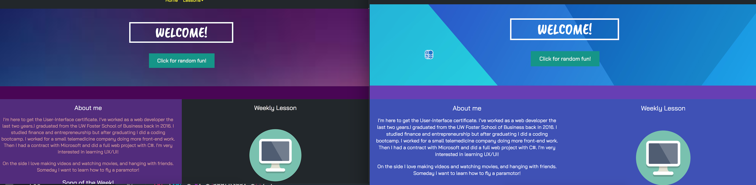

Links for the squiggle: https://css-tricks.com/having-fun-with-link-hover-effects/
Links for the cursor: http://www.snazzyspace.com/tumblr/mouse-sparkles.php

