Raven Browning  
Anthony Pilla

Dr.Eaglin

Cen 3722

Assignment 4

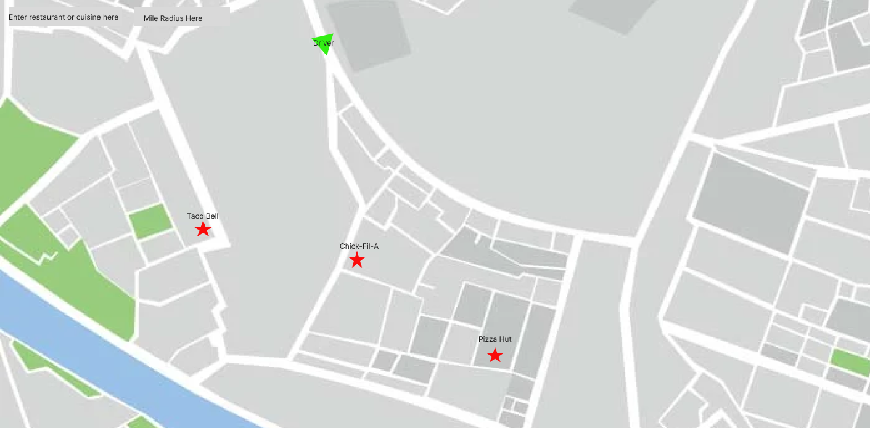

**1. GPS Map Screen:**

* This screen displays a GPS map with the driver's current location.
* The driver is prompted to use voice activation to search for restaurants in the vicinity.

**- User Operation:**

* Driver activates voice search by tapping on the microphone icon or using a voice command.
* Driver says the name of the desired restaurant (e.g., "Chick-fil-A").
* The app processes the voice command and displays the search results on the map.

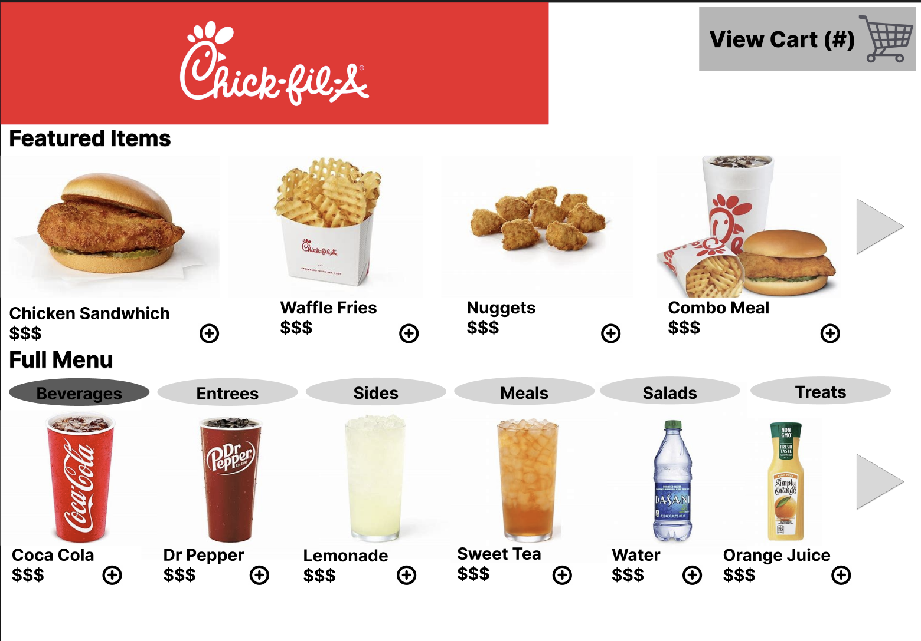

**2. Chick-fil-A Menu Screen:**

* This screen shows the menu items available at Chick-fil-A.

**- User Operation:**

* Driver selects items from the menu by using voice activation or tapping on them.
* Each item may have options for customization (e.g., size, toppings), which the driver can select.
* Driver can add items to their order by tapping on an "Add to Order" button or voice action.

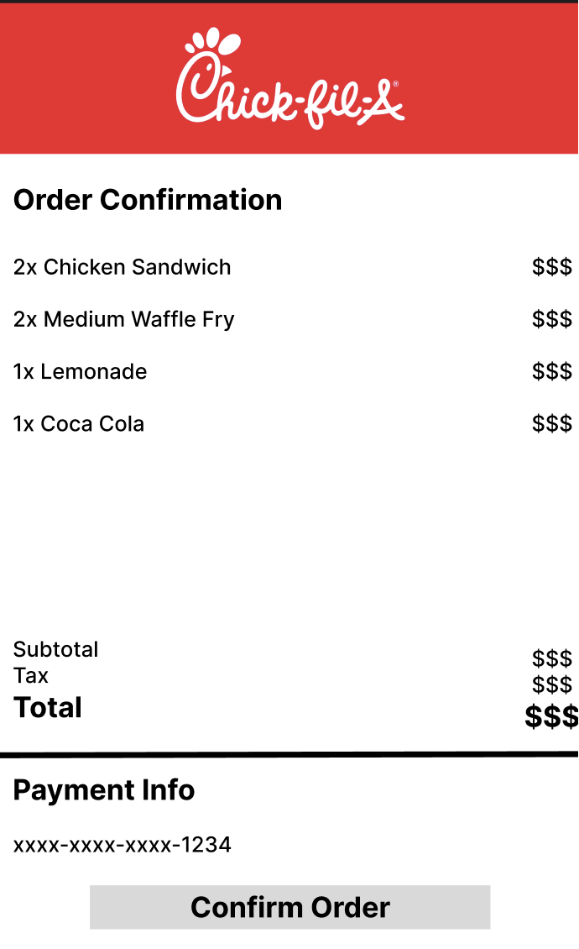

**3. Checkout Screen:**

* This screen displays the items selected by the driver and allows them to review their order.

**- User Operation:**

* Driver can review the selected items and make any necessary modifications (e.g., quantity adjustments, removing items).
* Driver proceeds to checkout by tapping on a "Checkout" or "Place Order" button.
* The app may prompt the driver to confirm their order and provide payment information (if not already saved).

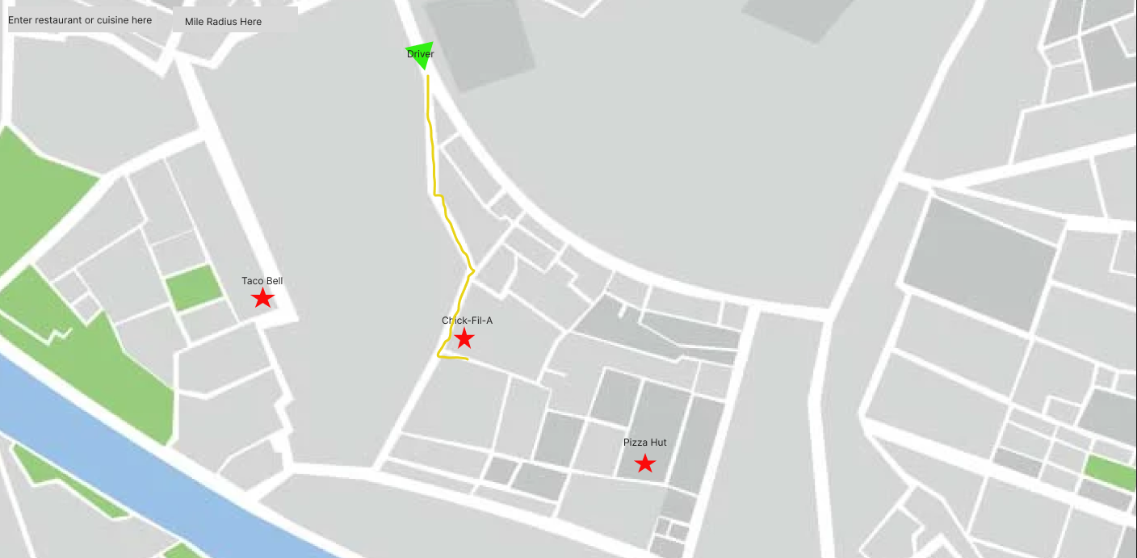

**4. GPS Route to Chick-fil-A Screen:**

* This screen shows the GPS route from the driver's current location to the selected Chick-fil-A restaurant.

**- User Operation:**

* Driver initiates navigation by tapping on a "Start Navigation" or similar button.
* The app launches turn-by-turn directions using the selected navigation app (e.g., Google Maps, Waze).
* Driver follows the route to reach the Chick-fil-A location.

**Flow of the Application:**

- The driver starts on the GPS Map screen, where they use voice activation to search for Chick-fil-A.

- After selecting Chick-fil-A from the search results, the driver is taken to the menu screen to browse and select items.

- Once the driver has finished selecting items, they proceed to the checkout screen to review and confirm their order.

- After confirming the order, the driver is provided with GPS navigation directions to the selected Chick-fil-A location.

- The driver follows the navigation instructions to arrive at Chick-fil-A and complete their order.