**Project Synopsis**

ON

**“DAILY EARN”**



*Department of Computer Science & Application*

### Institute of Engineering & Technology

#### Submitted to :- Submitted by : -

***Mr. Akash Kumar Choudhary*  Anshuman Srivastava** (201500117)

# DECLARATION

We hereby declare that the work presented in this dissertation entitled “**DAILY EARN”** has been done by me under the guidance of our mentor **Mr. Akash Kumar Chaudhary**, and this dissertation embodies our work.

#### *By*:

#### ***Anshuman Srivastava*** *(201500117)*

# ACKNOWLEDGMENT

#### It gives us a great sense of pleasure to present the synopsis of the B.Tech full stack project **Daily Earn** undertaken during B. Tech III Year. This project is going to be an acknowledgment of the inspiration, drive, and technical assistance that will be contributed to it by many individuals.

We owe a special debt of gratitude to **Mr. Akash Kumar Chaudhary (Technical Trainer, Department of CEA),** for providing us with an encouraging platform to develop this project, which thus helped in shaping my abilities towards a constructive goal, through his constant support and guidance to our work.

#### We also do not like to miss the opportunity to acknowledge the contribution of all department faculty members for their kind guidance and cooperation.

*By:*

**Anshuman Srivastava** (201500117)

**TABLE OF CONTENT**

1. Introduction of the Project
2. About the Project
   1. Java Script, Html, Bootstrap, MongoDB and Node JS
   2. Visual Code Studio
3. Software Requirement
4. Hardware Requirement
5. Future Prospects
6. References
   1. Referred books.
   2. Online GitHub Repository

**INTRODUCTION**

#### In this, we will build an interesting website that will provide user a portal for freelancing works available nearby. To build this application we will use HTML, CSS, Bootstrap, JavaScript, NodeJS, ExpressJS, MongoDB and ReactJS. This is one of the exciting and thrilling website. While building this website we used various libraries.

In our project one user can post the work and other users can select and connect with them for further details related to the posted work. The user can post the work, set price for that and other user can select the type of work, bid for that, post their previous works and experience.

This project helps users to post works and find the best worker for that in best possible price. And also allow user/worker to find the nearby works and earn on the daily basis.

## TECHNOLOGIES USED

## HTML and CSS:

HTML is an acronym which stands for **Hyper Text Markup Language** which is used for creating web pages and web applications. Let's see what is meant by Hypertext Markup Language, and Web page. HTML is a markup language which is used for creating attractive web pages with the help of styling, and which looks in a nice format on a web browser. An HTML document is made of many HTML tags and each HTML tag contains different content.

CSS stands for Cascading Style Sheets. It is a style sheet language which is used to describe the look and formatting of a document written in markup language. It provides an additional feature to HTML. It is generally used with HTML to change the style of web pages and user interfaces.

**JavaScript:**

JavaScript is a light-weight object-oriented programming language which is used by several websites for scripting webpages. It is an interpreted, full-

fledged programming language that enables dynamic interactivity on websites when applied to an HTML document.

With JavaScript, users can build modern web applications to interact directly without reloading the page every time. The traditional website uses JavaScript to provide several forms of interactivity and simplicity.

1. It is a light-weighted and interpreted language.
2. It is a case-sensitive language.
3. JavaScript is supportable in several operating systems including Windows, macOS, etc.
4. It provides good control to the users over the web browsers.

**Bootstrap**

Bootstrap is a free and open-source CSS framework directed at responsive, mobile-first-front-end web development. It contains, HTML, CSS and JavaScript based design templates for typography, forms, buttons, navigation and other interface components.

**Mongo DB**

MongoDB is a source-available cross-platform document-oriented database program. Classified as a NoSQL database program, MongoDB uses JSON -like documents with optional schemas. MongoDB is developed by MongoDB Inc and licensed under the Server Side Public License (SSPL) which is deemed non-free by several distributions. MongoDB is a member of the MACH Alliance.

**Node JS**

**Node.js** is a cross-platform, open-source server environment that can run on Windows, Linux, Unix, macOS and more. Node.js is a back-end JavaScript runtime environment, runs on the V8 JavaScript Engine, and executes JavaScript code outside a web browser.

**ExpressJS**

Express is a minimal and flexible Node.js web application framework that provides a robust set of features for web and mobile applications.

**ReactJS**

ReactJS is a **declarative, efficient,** and flexible **JavaScript library** for building reusable UI components. It is an open-source, component-based front end library which is responsible only for the view layer of the application. It was initially developed and maintained by Facebook and later used in its products like WhatsApp & Instagram.

# MOTIVATION

The idea behind choosing this project was that nowadays finding best labor or person for any types of work is very difficult and there a too much exploitation also like good workers charges too much and secondly it also increases employment and allow users to earn daily and fulfill their daily needs. The project favors both the users, one who needs workers and one who want to work and earn.

We are trying our best to provide good facilities to the user.

## OBJECTIVE OF THE PROJECT

The project aims and objectives that will be achieved after completion of this project are discussed in this subchapter. The aims and objectives are as follows:

* Post a work and find the best worker for that.

• Available all the works at same place.

• Facility to find the best work nearby with best price possible.

* User can rate the workers/user and can give their feedback.
* User can see their past work done.
* User have their past work experience and feedback which helps them to create a better portfolio for them.

**USE CASE DIAGRAM**

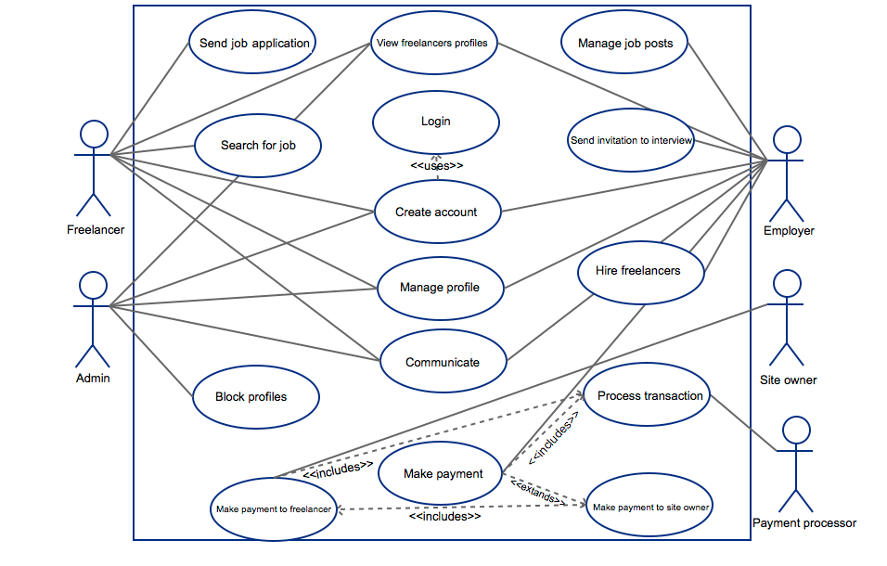

## DATA FLOW DIAGRAMS

User registration/Login

Search Movies and View reviews

USER

Perform CRUD operations on their own reviews

**REVIEW SECTION**

Give rating

Like Reviews

Delete reviews

Post a work

Login Successful

USER

**REQUIREMENTS:**

##### **Software Requirements (Minimum):**

1. Operating Systems: Windows, Linux, mac
2. Editor used: Vs Code Editor
3. Browser
4. Command line interface (CLI)
5. Development tools and Programming language- HTML, CSS, JavaScript, Bootstrap, Node, node package manager, Express, MongoDB, MongoDB compass.

##### **Hardware Requirements (Minimum):**

* + 1. Processor: i3 processor-based computer or further
    2. Storage: 4GB Ram

5 GB Hard Disk Space

* + 1. Device: Laptop, desktop or any smartphone

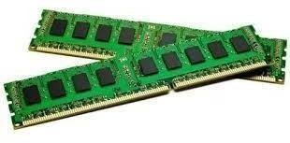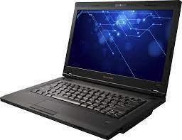

**FUTURE SCOPE**

The project can be further extended and several sections can be incorporated taking in account to the activity of the users

* AI based recommendation for work and workers.
* A section can be added for the artists also like actor, singer, director and many more.
* Introduce the concept of renting the items also like cranes, trolly, trucks and worker equipment also.

***REFERENCES:***

* <https://realpython.com/tutorials/advanced/>
* <https://www.w3schools.com/w3css/w3css_color_libraries.asp>
* <https://www.quackit.com/html/codes/html_code_library.cfm>

### BOOKS:

Learning Web Design: A beginner’s Guide To HTML, CSS, JavaScript, and Web Graphics

Responsive Web Design with HTML5 and CSS3

***ONLINE GITHUB REPOSITORY:***

[GitHub](https://github.com/anancs24/Movies-Zone-Project)

### FACULTY GUIDELINES:

**Mr. Akash Kumar Chaudhary**,

(Technical Trainer at GLA University)



