Robotics Toolbox in MATLAB

Project Report

BY

Amaan Khan

Malay Nagda

Laukik Mujumdar

Ravendra Raghvendra

Tanmay Dhanote

Work Contributions

Amaan Khan – Euler Angles, Manipulator Control

Malay Nagda – Differential Kinematics, Workspace

Laukik Mujumdar – Inverse

Ravendra Raghvendra – Inverse, GUI

Tanmay Dhanote – Homogenous Transformation, GUI

# Description

Homogenous Transformation

# Use of Toolbox

## How to run the Toolbox?

Step 1: Run the main window file (Main_Window.mlapp)

Step 2: The Robotic Toolbox open as seen below:

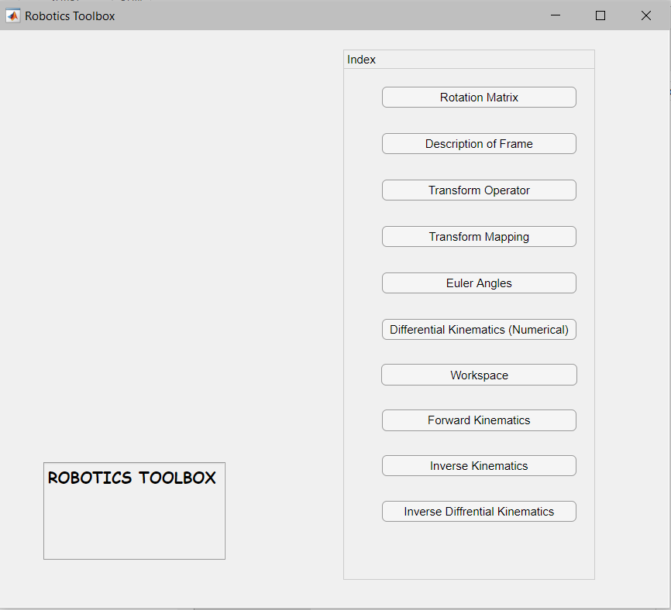

Step 3: Press the button for the problem you want to solve and a new GUI window for each problem will appear. (Example as shown below):

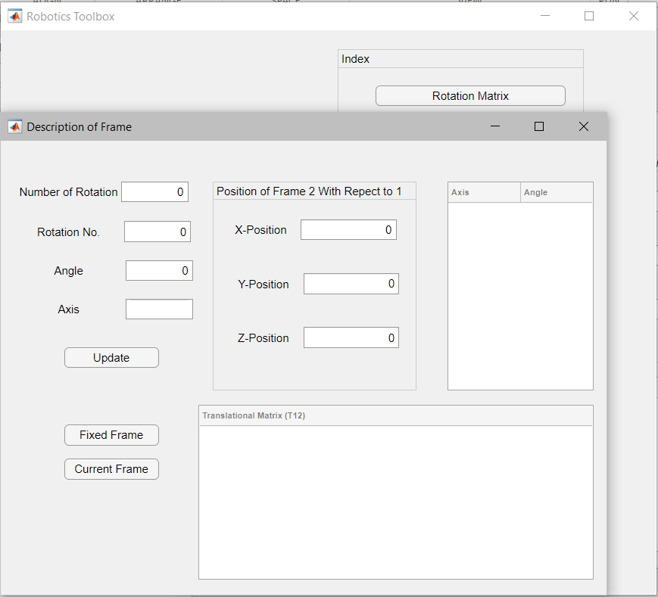

## How to use GUI?

### Rotation Matrix

Instructions