- Add VM to Update Manager
- Modify VM update settings:
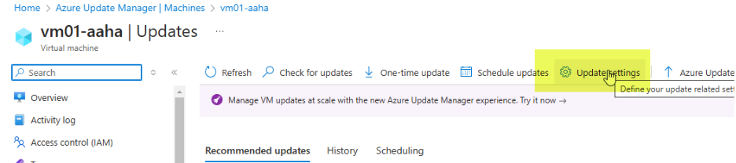
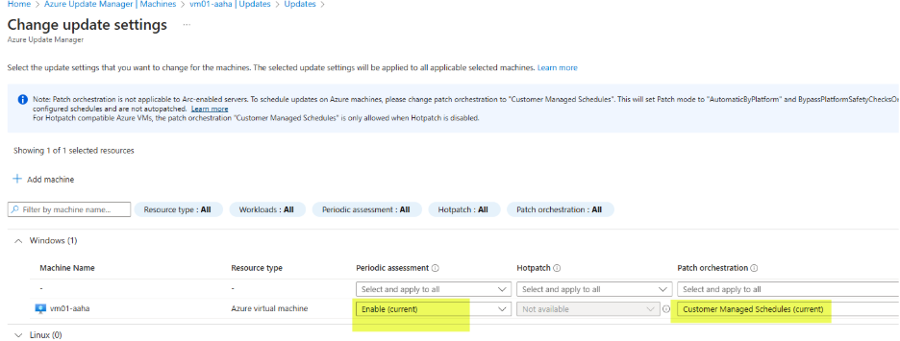
- Go to Update Manager>Resources>Machines>Maintenance configurations
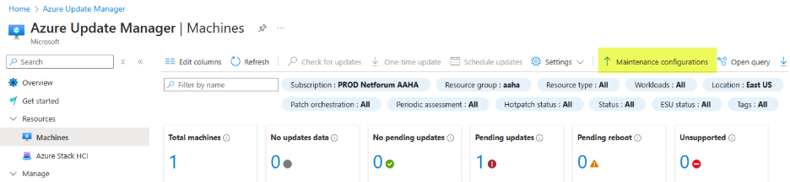
- Go to PROD-Netforum-Patching
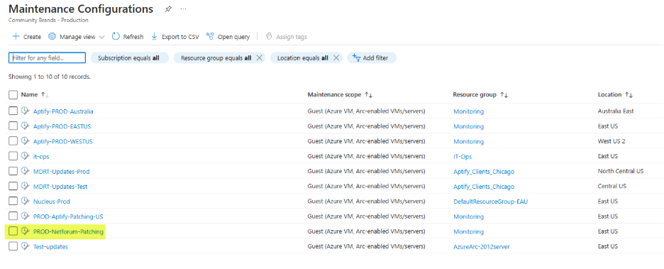
- Go to Resources and click Add
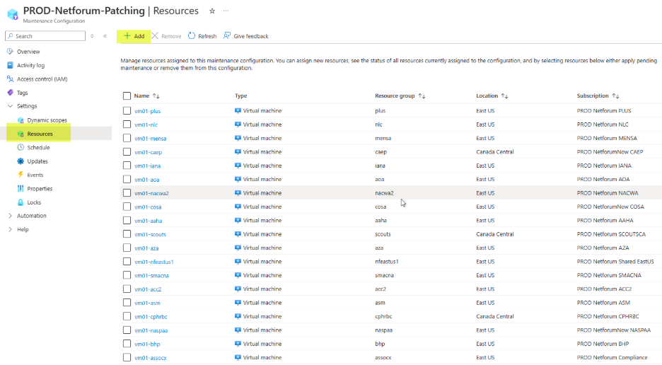
- Search for VM, select it and click Save
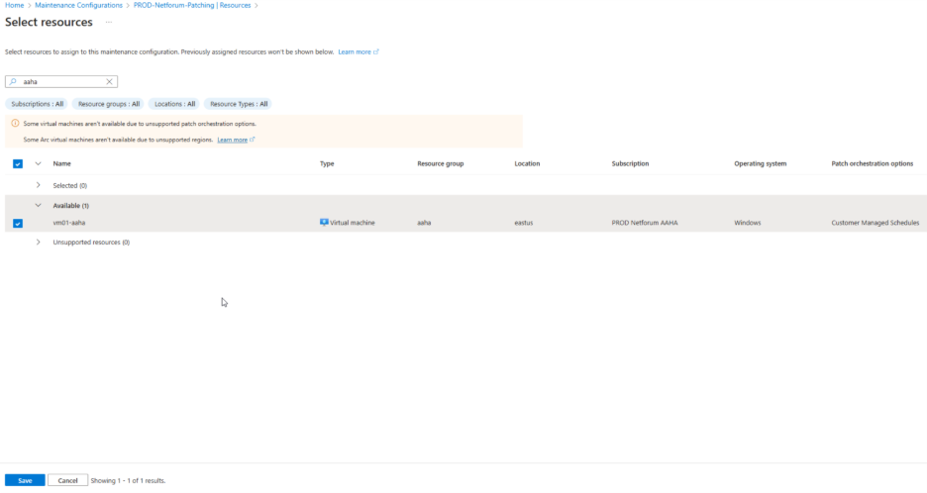

- Configure malware scanning on storage accounts
- Go to Microsoft Defender for Cloud>Environment Settings and click on subscription

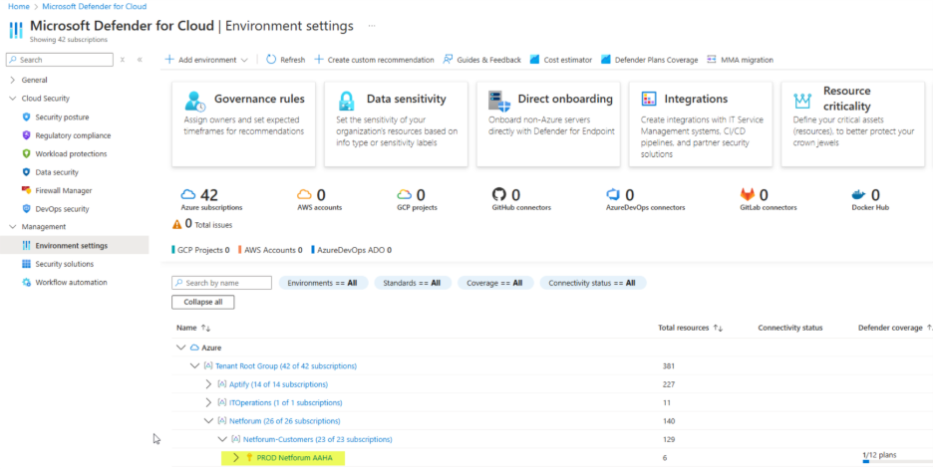
- Ensure storage status is On, and click on Settings link:
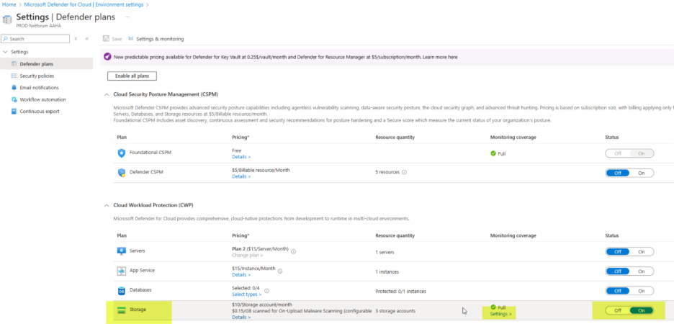
- If ‘Limit of GB scanned’ is not set to 35 GB, click Edit settings to set it:
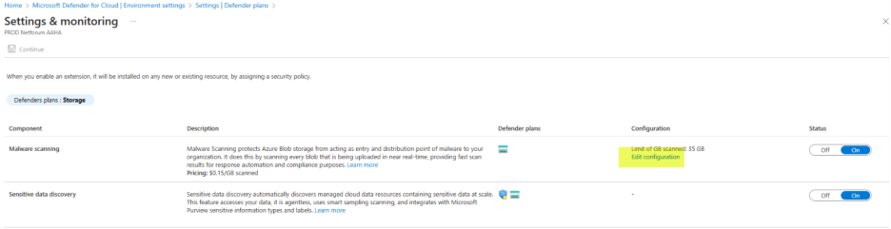
3. Create log analytics workspace. Example:
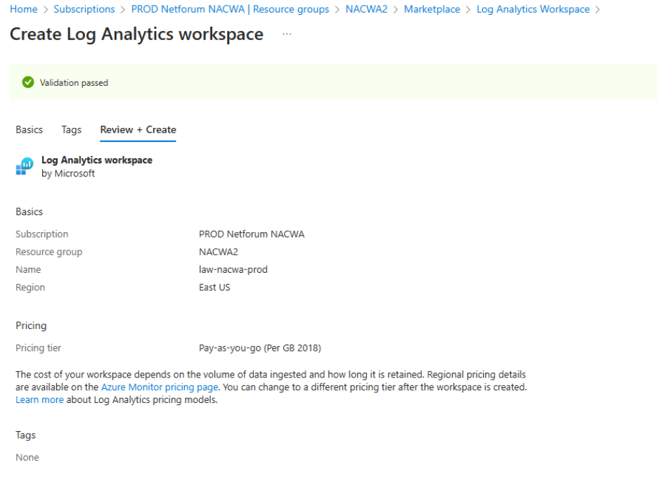

4. Set daily cap on log analytics workspace
- Go to Log Analytics workspaces and select workspace for subscription

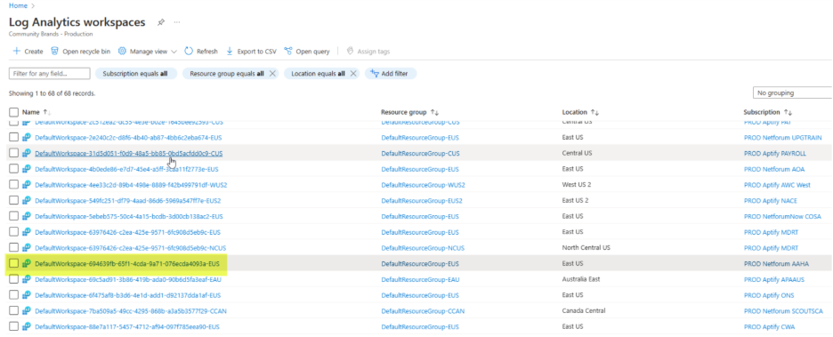
- Click on Usage and estimated costs
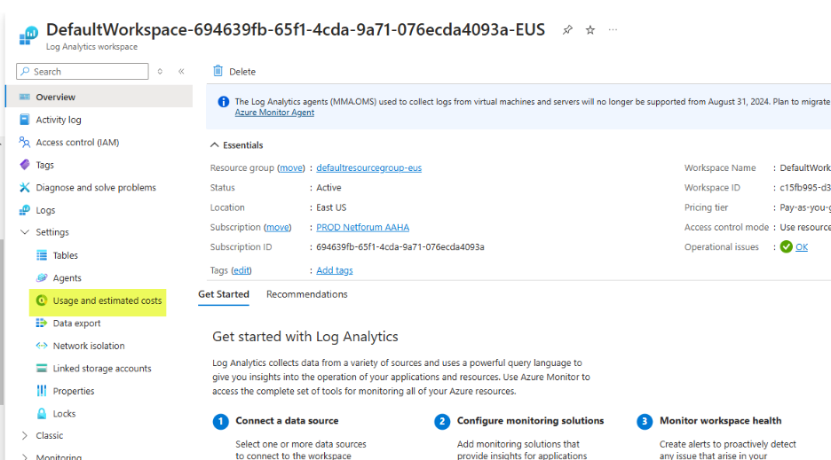
- Click on Daily cap
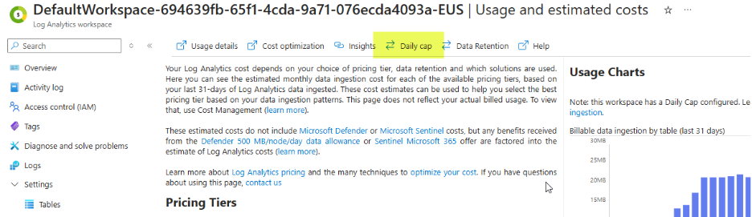
- Turn on and set daily volume cap to .25 GB/day
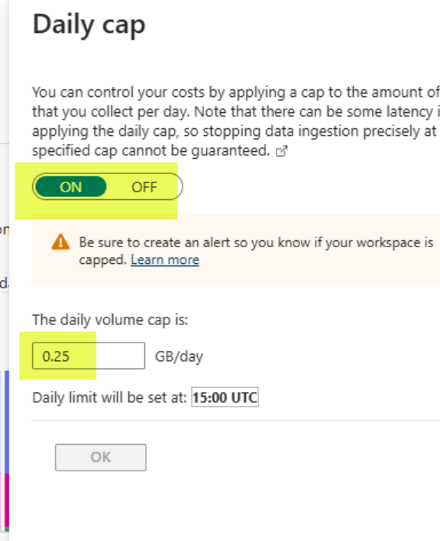

4. Configure resource group security alerts
- Go to Microsoft Defender for Cloud>Management>Workflow automation and click ‘Add workflow automation’

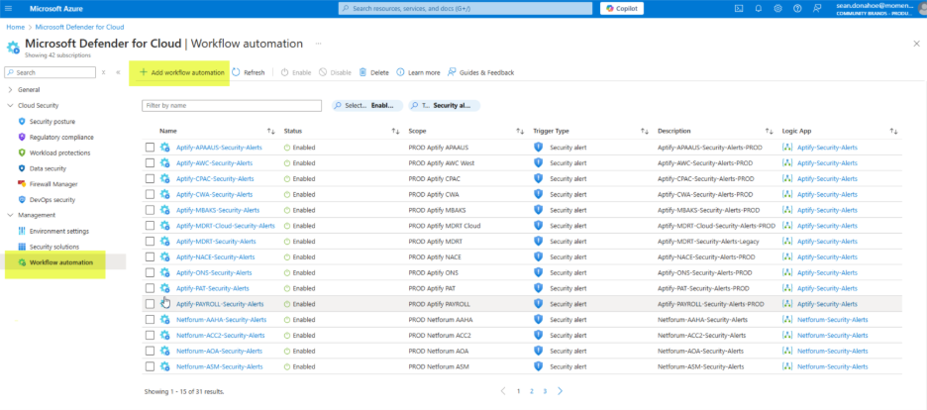
- Name = Netforum-<customer acronym>-Security-Alerts
- Subscription = subscription used for new deployment
- Resource Group = main resource group, ‘SMACNA’ for example
- Defender for Cloud data type = Security alert
- Alert severities = All severities selected
- Actions
- Select PROD IT Operations subscription
- Logic app name = Netforum Security Alerts
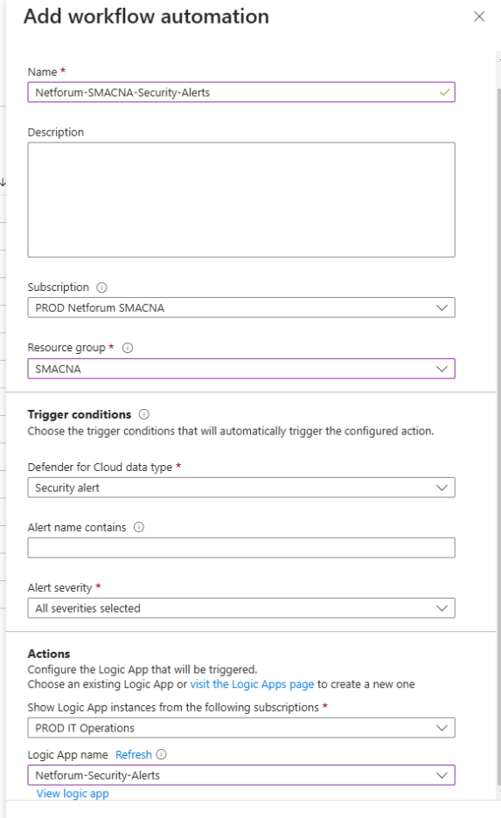
Note: We have to create Logic app for the alert on different subscription or same subscription.
# JSON Schema for manual:
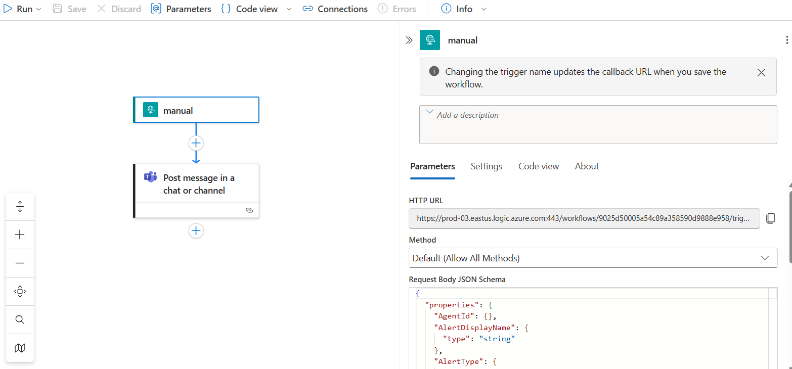
{
"properties": {
"AgentId": {},
"AlertDisplayName": {
"type": "string"
},
"AlertType": {
"type": "string"
},
"AlertUri": {
"type": "string"
},
"AzureResourceId": {
"type": "string"
},
"CompromisedEntity": {
"type": "string"
},
"ConfidenceLevel": {},
"ConfidenceReasons": {},
"ConfidenceScore": {},
"CorrelationKey": {
"type": "string"
},
"Description": {
"type": "string"
},
"EndTimeUtc": {
"type": "string"
},
"Entities": {
"items": {
"properties": {
"$id": {
"type": "string"
},
"$ref": {
"type": "string"
},
"Asset": {
"type": "boolean"
},
"BlobContainer": {
"properties": {
"$ref": {
"type": "string"
}
},
"type": "object"
},
"Category": {
"type": "string"
},
"Etag": {
"type": "string"
},
"FileHashes": {
"items": {
"properties": {
"$ref": {
"type": "string"
}
},
"required": [
"$ref"
],
"type": "object"
},
"type": "array"
},
"Files": {
"items": {
"properties": {
"$id": {
"type": "string"
},
"Asset": {
"type": "boolean"
},
"Directory": {
"type": "string"
},
"FileHashes": {
"items": {
"properties": {
"$id": {
"type": "string"
},
"Algorithm": {
"type": "string"
},
"Asset": {
"type": "boolean"
},
"FriendlyName": {
"type": "string"
},
"Type": {
"type": "string"
},
"Value": {
"type": "string"
}
},
"required": [
"$id",
"Algorithm",
"Value",
"FriendlyName",
"Asset",
"Type"
],
"type": "object"
},
"type": "array"
},
"Name": {
"type": "string"
},
"Type": {
"type": "string"
}
},
"required": [
"$id",
"Directory",
"Name",
"FileHashes",
"Asset",
"Type"
],
"type": "object"
},
"type": "array"
},
"FriendlyName": {
"type": "string"
},
"Metadata": {
"properties": {
"IsGraphCenter": {
"type": "boolean"
}
},
"type": "object"
},
"Name": {
"type": "string"
},
"ResourceId": {
"type": "string"
},
"ResourceName": {
"type": "string"
},
"ResourceType": {
"type": "string"
},
"StorageResource": {
"properties": {
"$ref": {
"type": "string"
}
},
"type": "object"
},
"Type": {
"type": "string"
},
"Url": {
"type": "string"
}
},
"required": [],
"type": "object"
},
"type": "array"
},
"ExtendedLinks": {},
"ExtendedProperties": {
"properties": {
"API type": {
"type": "string"
},
"Alert Id": {
"type": "string"
},
"CompromisedEntity": {
"type": "string"
},
"EffectiveAzureResourceId": {
"type": "string"
},
"EffectiveSubscriptionId": {
"type": "string"
},
"Investigation steps": {
"type": "string"
},
"Malware types detected": {
"type": "string"
},
"Potential causes": {
"type": "string"
},
"ProductComponentName": {
"type": "string"
},
"SHA-256": {
"type": "string"
},
"resourceType": {
"type": "string"
}
},
"type": "object"
},
"Intent": {
"type": "string"
},
"IsIncident": {
"type": "boolean"
},
"ProcessingEndTime": {
"type": "string"
},
"ProductName": {
"type": "string"
},
"ProviderAlertStatus": {},
"RemediationSteps": {
"items": {
"type": "string"
},
"type": "array"
},
"ResourceIdentifiers": {
"items": {
"properties": {
"$id": {
"type": "string"
},
"AadTenantId": {
"type": "string"
},
"AzureResourceId": {
"type": "string"
},
"AzureResourceTenantId": {
"type": "string"
},
"Type": {
"type": "string"
}
},
"required": [
"$id",
"Type"
],
"type": "object"
},
"type": "array"
},
"Severity": {
"type": "string"
},
"StartTimeUtc": {
"type": "string"
},
"Status": {
"type": "string"
},
"SystemAlertId": {
"type": "string"
},
"TimeGenerated": {
"type": "string"
},
"VendorName": {
"type": "string"
},
"WorkspaceId": {},
"WorkspaceResourceGroup": {},
"WorkspaceSubscriptionId": {}
},
"type": "object"
}
# JSON Schema for Post message in a chat or channel:

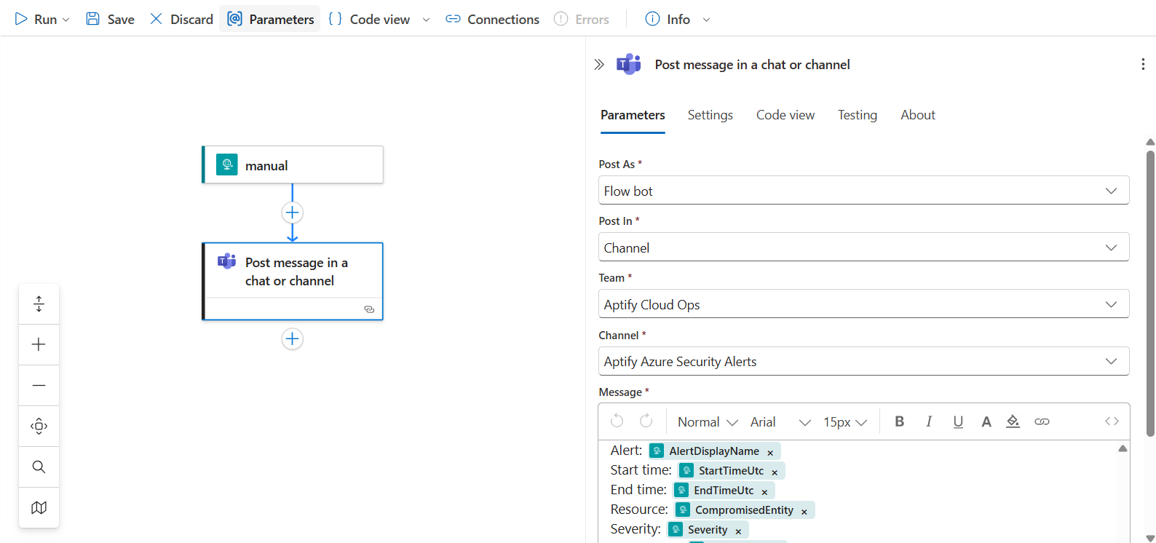
Alert: AlertDisplayName
Start time:StartTimeUtc
End time: EndTimeUtc
Resource:CompromisedEntity
Severity: Severity
Description: Description
# Need to setup connection to send Alert.

