Staircase Edge and Fall-Hazard Analysis Using Custom YOLO Segmentation and Depth Anything V2

Rohith Rajesh
Computer Science
VIT Chennai
Mysuru, India
rohithrajeshindia@gmail.com

Abstract— Descending stairs and ledges are a recognised fall risk for both construction workers and visually impaired people. This paper presents a research prototype that analyses a single staircase image for stair regions, stair edges and potential drop-off hazards. A custom-trained YOLOv8 segmentation model localises two classes, stairs and edges, while Depth Anything V2 Small provides a per-pixel relative depth map. A separate analysis module aligns the two outputs and examines the depth inside an eroded stair mask with three explainable, vectorised checks: depth far beyond a robustly fitted floor baseline, zero or invalid depth, and an abnormal vertical depth gradient. Agreement between independent evidence groups, together with region size and position, decides whether a flagged region is labelled critical or possible. The system runs entirely on CPU behind a Gradio interface and is packaged as a Docker container for deployment on an AWS EC2 instance. We report qualitative results, synthetic tests of the hazard logic and observed failure cases, including a wall detected as a stair edge and a top-down staircase whose depth map shows no discontinuity. Accuracy has not yet been measured on a labelled benchmark, and the prototype is not a validated safety system.
Index Terms—staircase detection, fall hazard, instance segmentation, YOLO, monocular depth estimation, Depth Anything V2, CPU inference, Gradio, Docker, cloud deployment.

Introduction
The system's design goal was to avoid depending on any single sensing modality for both localisation and distance. A purely geometric or purely learned single-model approach risks two different failure modes: an object detector alone has no native sense of physical distance, while a depth model alone has no notion of what a hazardous edge looks like as opposed to an ordinary floor transition. The goal was therefore to combine the two in a deliberately staged fusion: an instance-segmentation network answers 'where is the nearest edge', and a monocular depth network independently answers both 'is this really a drop-off' and 'how far away is it'.
Single-stage detectors such as YOLO [1], available in the Ultralytics framework [2], localise objects and their masks in one forward pass and are light enough for CPU inference. They recognise what a region is, but a mask carries no information about the three-dimensional shape around it. Monocular depth estimators such as Depth Anything V2 [3] supply that missing geometry from a single RGB image, but they do not know what a staircase is. This work combines the two models downstream, at inference time, so that each does the job it is good at.
The pipeline reuses a custom-trained stair and stair-edge segmentation model together with Depth Anything V2 Small, aligned at pixel level. The hazard analysis module comprises three vectorised checks, a two-tier labelling rule and explicit uncertainty states. A Gradio interface, packaged in a Docker container for deployment on AWS, exposes the pipeline. The rest of this paper is organised as follows. Section II reviews related work and Section III describes the tools and algorithms used. Sections IV to VII present the methodology, architecture, workflow and formulas, and Section VIII collects the tables and figures. Section IX reports implementation, results and discussion, and Sections X and XI give the conclusion and future work.

Architecture Diagram
Fig. 6 shows the software architecture. The browser talks to the Gradio interface in app.py. The module inference.py loads the YOLO segmentation model and Depth Anything V2 Small once at start-up and runs them on the same working image. The module hazard_analysis.py aligns the masks with the depth map, computes region statistics and evaluates the hazard checks, and visualize.py renders the overlays. All settings, such as model paths, image-size limits and thresholds, live in config.py, and the weights are kept in the models directory. Everything runs in one Docker container on an EC2 instance.
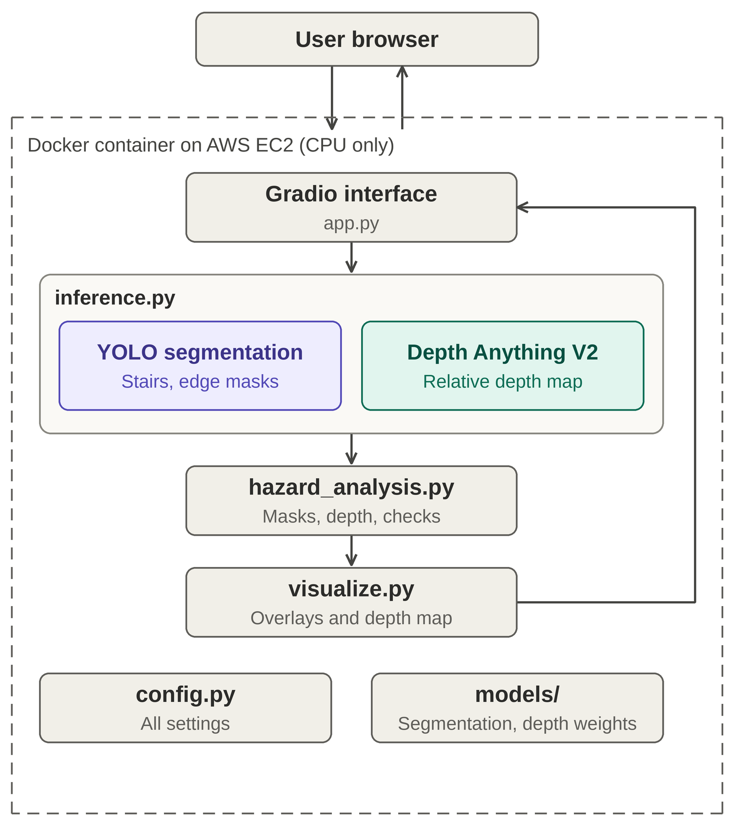
- Software architecture of the application inside the Docker container on AWS EC2.

Related Works

Stair Detection for Assistive Navigation
Pérez-Yus et al. detect and model staircases using a wearable depth sensor [4], and Wang et al. detect stairs, pedestrian crosswalks and traffic signs from RGB-D images [5]. Both rely on active depth sensing, which adds hardware, power draw and cost. An RGB-only pipeline lowers the hardware burden, at the price of having to infer geometry.

Instance Segmentation
Two-stage methods such as Mask R-CNN [6] produce accurate masks but are heavier at inference. Single-stage detectors in the YOLO family [1] with segmentation heads, as implemented in Ultralytics [2], trade a little accuracy for speed, which suits CPU deployment.

Monocular Depth Estimation
Early convolutional approaches predicted depth from one image with multi-scale networks [7]. MiDaS mixed several datasets to achieve zero-shot transfer across scenes [8], and Depth Anything scaled training with large amounts of unlabelled images [9]. Depth Anything V2 [3] improves fine detail by training on synthetic labels and distilling a large teacher into smaller students. The standard checkpoints predict relative depth, not metric distance, so thresholds in metres cannot be derived from them directly.

Gap Addressed
Detection-only systems know what a region is but not its shape, and depth-only systems know shape but not meaning. This work fuses a task-specific segmenter with a general depth prior using simple, inspectable rules, and reports where that fusion fails.

Tools and Algorithms Used

YOLO Instance Segmentation
YOLO [1] is a fast single-stage framework built on convolutional neural networks. In this project a YOLOv8 segmentation network, run through the Ultralytics framework [2], returns for every detected region a polygon mask, a class label (stairs or edges) and a confidence score. These masks are the input to the depth and hazard analysis.

Depth Anything V2 Small
Depth Anything V2 [3] Small is a monocular depth estimator that predicts a depth value for every pixel of a single RGB image. It pairs a ViT-S (DINOv2) encoder with a DPT decoder, has about 24.8 M parameters, and uses a 94.6 MB checkpoint released under the Apache-2.0 licence [10]. The V2 version was trained mainly on synthetic labels and then distilled using pseudo-labelled real images, which gives sharper fine detail than V1. Its output is relative inverse depth: larger values are nearer, and the scale differs from image to image. The values are not distances in metres.

Gradio Web Interface
Gradio [11] is a Python library for building web interfaces for machine learning models. In this project it provides a page where the user uploads a JPG or PNG staircase image and sets the confidence threshold. After processing, the page shows the original image, the segmentation overlay, the stair-edge view, the depth map, the combined output, a table of detected regions and the hazard report (Fig. 8).

Proposed Methodology

Custom Stair and Edge Segmentation Model
The segmentation model is a YOLOv8 segmentation network trained on polygon annotations of two classes, stairs and edges. Training used overlap_mask=False and mask_ratio=1, because the default settings allowed the large stairs class to erode the thin edges class and downsampled thin features. The trained weights are reused unchanged. At inference the confidence threshold is 0.35 and the input size is 640. Class identities are read from the model's name table (edges=0, stairs=1) and looked up by name, because a label-order mismatch previously caused depth to be sampled from the wrong class without any visible error. Mask polygons returned in original-image coordinates are rasterised at the working resolution so that each mask has exactly the same pixel grid as the depth map.
Figs. 1 to 5 show the validation behaviour of the trained model. The normalised confusion matrix (Fig. 1) separates the two classes from the background. The model reaches an mAP@0.5 of 0.917 over both classes, with 0.895 for edges and 0.939 for stairs (Fig. 4), and its F1 score peaks at 0.93 at a confidence of 0.619 (Fig. 2). The edges class scores lower than the stairs class. Table II lists the training configuration.
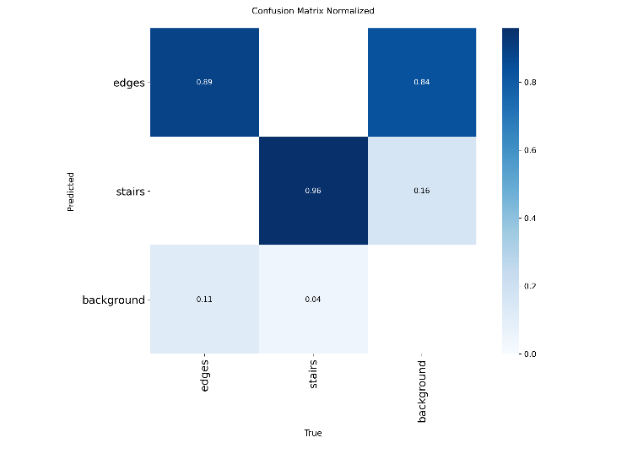
- Normalised confusion matrix of the segmentation model for the edges, stairs and background classes.
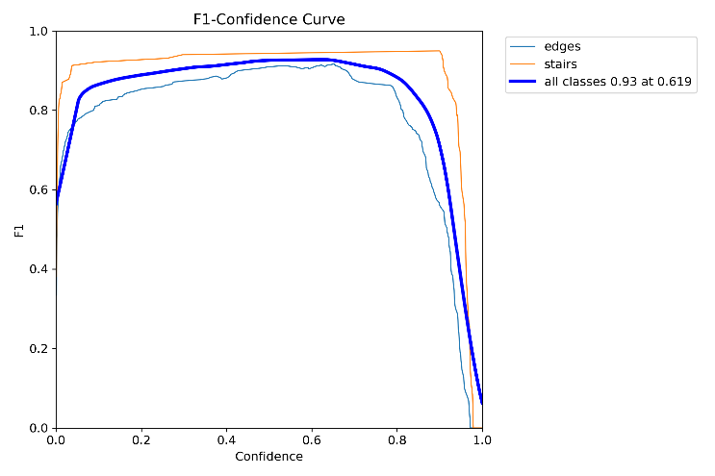
- F1–confidence curve (all classes: 0.93 at a confidence of 0.619).
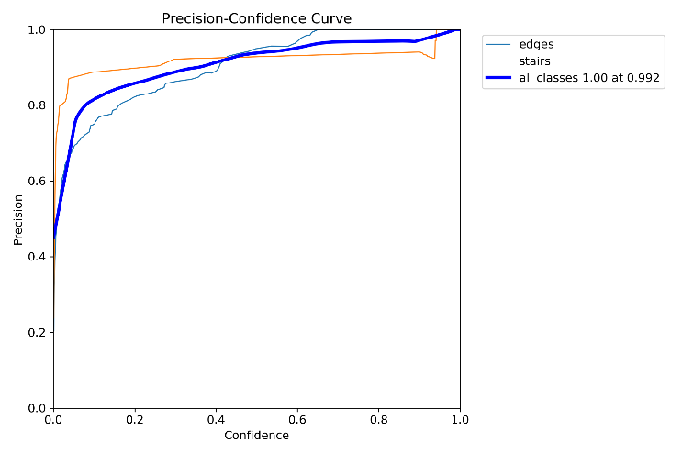
- Precision–confidence curve (all classes: 1.00 at a confidence of 0.992).
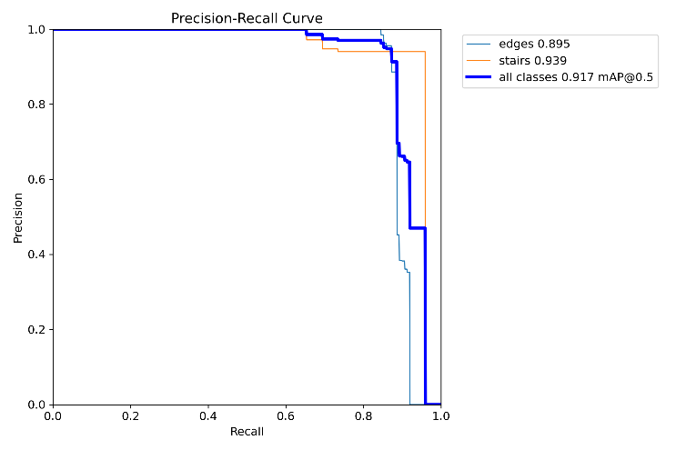
- Precision–recall curve (mAP@0.5: 0.917 for all classes, 0.895 for edges and 0.939 for stairs).
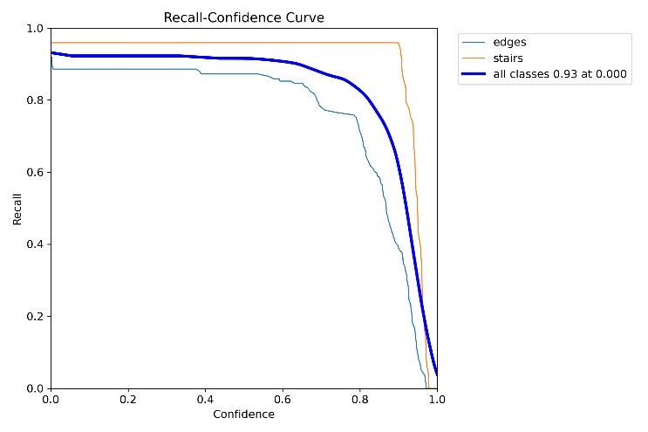
- Recall–confidence curve (all classes: 0.93 at a confidence of 0.000).

Relative Depth Estimation
Depth Anything V2 Small [3] (ViT-S encoder, 24.8 M parameters) is used with the official implementation and its pretrained checkpoint, which is released under the Apache-2.0 licence [10]. The image is resized so that its longest side is 518 px (rounded to a multiple of 14), normalised with ImageNet statistics, and run on CPU. The output is resized back to the working resolution. It is relative inverse depth: larger values are nearer, and the scale differs from image to image. For display and region statistics the map is rescaled to [0, 1] using its 1st and 99th percentiles (Eq. 1); the hazard checks use the raw map.

Hazard Analysis
For every detected region the median, 10th and 90th percentile of the normalised depth are computed inside its mask. Because masks of thin features proved unstable, a second statistic samples the bottom 30% of each bounding box.
The stairs mask is treated as the walkable surface. It is eroded to remove boundary bleed and cropped to the lower part of the frame as a geometric proxy for the near field. Three checks run inside this region of interest. The void check finds depth far beyond a robustly fitted floor baseline. The hole check finds zero or non-finite depth. The step check uses the Sobel operator [12] to find an abnormal downward depth gradient along the image Y axis.
Thresholds are expressed in robust standard deviations of the floor's own statistics, never in metres. Flagged pixels are merged, cleaned and grouped into regions, and each region is labelled CRITICAL FALL HAZARD or POSSIBLE DROP-OFF according to the tier rule in Section VII. Images that are too dark or too blurry, masks that are too small, and depth maps that are invalid over most of the floor produce the result Uncertain — unable to assess reliably instead of a decision.

Interface and Deployment
The application is built with PyTorch [13] for CPU inference, OpenCV [14] for image processing and Gradio [11] for the web interface. Both models are loaded once at start-up and warmed up, a lock allows one inference at a time, and the request queue serves the rest. The application is packaged with Docker [15] using CPU-only PyTorch wheels and is run on an Amazon EC2 instance [16], with the security group restricted to the developer's address and no credentials stored in the code.

Workflow
Fig. 7 shows the processing flow from upload to result. A JPG or PNG image is validated and resized, and an invalid file returns an error message instead of a failure. YOLO segmentation and Depth Anything V2 then run on the same working image, and their outputs are aligned so that every mask indexes the depth map directly. The hazard module builds a floor region of interest from the eroded stairs mask. If this region is too small, or the depth is invalid over most of it, the result is Uncertain.
Otherwise the void, hole and step checks run, and their results are merged and cleaned into candidate regions. The evidence level then decides the label. Nothing flagged gives No anomaly, which becomes Uncertain if the image is too dark or blurry. Weak evidence, meaning a single kind of evidence or a small region far from the camera, gives Possible. Agreement between a depth-level anomaly and a vertical step in a large or near region gives Critical. The overlays and the report are then rendered.
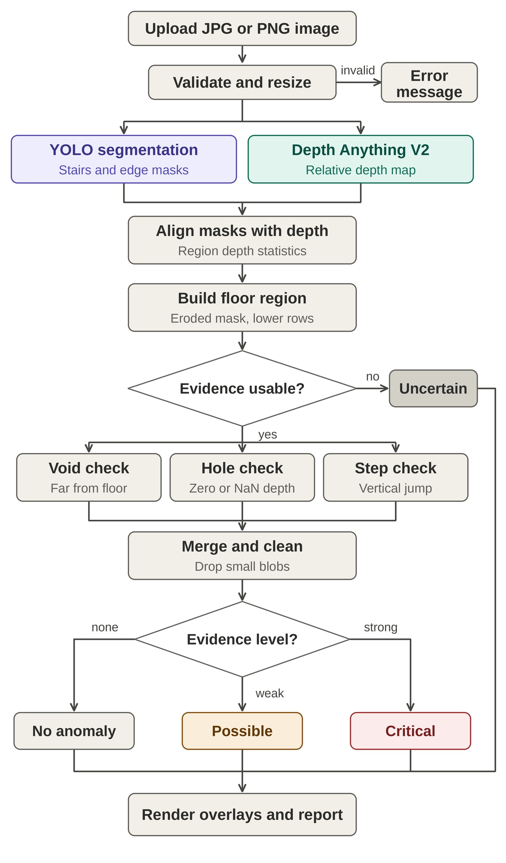
- Processing flow chart. Amber marks the possible tier, red the critical tier and gray the Uncertain outcome.

Algorithms and Formulas
Let D be the raw depth map (larger = nearer), M the stairs mask, and H and W the image height and width in pixels. P₁ and P₉₉ are the 1st and 99th percentiles of D. The normalised depth used for display and statistics is
D̃ = clip( (D − P₁) / (P₉₉ − P₁), 0, 1 ) (1)
The region of interest R is the stairs mask eroded by k pixels, restricted to rows below a fraction ρ of the image height:
R = erode(M, k) ∧ [ y ≥ ρ·H ] (2)
Floor baseline. For each image row y, the row profile m(y) is the median of D over R, and a polynomial of degree 2 is fitted to it by iteratively reweighted least squares with Tukey bisquare weights [17]:
m(y) = median{ D(x, y) : R(x, y) = 1 } (3)
b(y) = c₀ + c₁(y/H) + c₂(y/H)² (4)
The weights depend on the scaled residuals u of the fit, with σ̂ the robust scale of the residuals r:
w = (1 − u²)² for |u| < 1, otherwise 0 (5)
u = r / (4.685·σ̂), σ̂ = 1.4826·MAD(r) (6)
A robust fit lets a drop-off that covers a minority of rows stand out as an outlier. A per-row median would absorb a ledge that spans a whole row.
Check 1, unbounded void. The far residual f is the amount by which the depth lies beyond the baseline (for inverse depth, farther means smaller). Pixels whose far residual exceeds k_{v} robust standard deviations σ_{v} are flagged:
f(x, y) = b(y) − D(x, y) (7)
V = R ∧ [ f > k_{v}·σ_{v} ] (8)
σ_{v} = max( 1.4826·MAD(f | R), α_{v}·(P₉₉ − P₁) ) (9)
Check 2, data hole (ε is a near-zero tolerance):
Hl = R ∧ [ ¬finite(D) ∨ D ≤ ε ] (10)
Check 3, downward step. With D_{f} the 5×5 median-filtered depth and the Sobel kernel S_{y} = (1/8)·[[−1, −2, −1], [0, 0, 0], [1, 2, 1]], the vertical gradient is
G = S_{y} ∗ D_{f} (11)
A pixel is flagged when its gradient exceeds the median gradient of the floor by more than k_{s} robust standard deviations σ_{s}:
S = R ∧ [ G − median(G | R) > k_{s}·σ_{s} ] (12)
σ_{s} = max( 1.4826·MAD(G | R), α_{s}·(P₉₉ − P₁) ) (13)
Merge and clean. The three maps are merged, and connected components smaller than a fraction β of |R| are discarded:
A = V ∪ Hl ∪ S (14)
keep component c if |c| ≥ β·|R| (15)
Tier rule. Void and hole are correlated on Depth Anything V2 (its final ReLU turns very far surfaces into exact zeros), so agreement is counted between two evidence groups, level (V or Hl) and gradient (S). For a component c:
g(c) = 1[ c ∩ (V ∪ Hl) ≠ ∅ ] + 1[ c ∩ S ≠ ∅ ] (16)
A component is labelled critical if
g(c) ≥ g_{min} (17)
and it is large or near, that is
|c| ≥ a_{min}·H·W or y_{max}(c) ≥ b_{min}·H (18)
Otherwise it is labelled possible. The signs in Eqs. 7 and 11 are for inverse depth; for true-depth maps they are reversed.
Algorithm 1: Hazard analysis
- Align the mask and depth map to the frame; downscale to at most 640 px for speed.
- Compute quality warnings (brightness, sharpness). Build R (Eq. 2); if R is too small or the depth is invalid over most of R, return Uncertain.
- Fit the baseline (Eqs. 3 to 6) and evaluate the three checks (Eqs. 7 to 13).
- Merge and clean (Eqs. 14 and 15); label connected components.
- Assign a tier to each component (Eqs. 16 to 18).
- Render red (critical) and orange (possible) overlays with labels; if nothing is flagged and quality warnings exist, return Uncertain, otherwise return no anomaly found. This is not a safety guarantee.

Tables and Figures
This section collects the tables that describe the software, the training configuration and the hazard-analysis settings (Tables I to IV) and lists all figures. The result tables appear in Section IX.
- Software stack
Component | Version or choice
Language | Python 3.11
Segmentation | Ultralytics 8.4.138, custom YOLOv8 segmentation weights
Depth | Depth Anything V2 Small (vendored official code, ViT-S checkpoint, 94.6 MB)
Deep learning | PyTorch 2.5.1 (CPU wheels in the container)
Image processing | OpenCV, NumPy, Pillow
Interface | Gradio
Packaging and cloud | Docker; AWS EC2 (Ubuntu LTS)
Version control | Git

- YOLO segmentation training configuration and validation results
Item | Value
Architecture | YOLOv8 segmentation (Ultralytics)
Classes | edges (0), stairs (1)
Annotation | Roboflow polygon annotation
Epochs / batch size / image size | 120 / 12 / 640
overlap_mask / mask_ratio | False / 1
Hardware | Google Colab (Tesla T4), local RTX 3050 (4 GB)
mAP@0.5, all classes | 0.917
mAP@0.5, edges / stairs | 0.895 / 0.939
Peak F1, all classes | 0.93 at confidence 0.619

- Initial hazard-analysis parameters (untested starting values)
Parameter | Symbol | Value
Erosion radius (analysis pixels) | k | 5
Near-field start fraction | ρ | 0.30
Baseline polynomial degree | – | 2
Void threshold / scale floor | k_{v} / α_{v} | 6 / 0.02
Hole tolerance | ε | 1e−6
Step threshold / scale floor | k_{s} / α_{s} | 8 / 0.004
Minimum component area | β | 0.002
Groups required for critical | g_{min} | 2
Large / near fractions | a_{min} / b_{min} | 0.01 / 0.60
Analysis size (longest side) | – | 640 px

- Tier assignment
Evidence groups agreeing | Large or near | Label
Level and gradient | Yes | Critical fall hazard
Level and gradient | No | Possible drop-off
One group only | Any | Possible drop-off
None, image-quality warning | n/a | Uncertain
None, no warning | n/a | No anomaly found (not a safety guarantee)

List of figures. Fig. 1 confusion matrix; Fig. 2 F1–confidence curve; Fig. 3 precision–confidence curve; Fig. 4 precision–recall curve; Fig. 5 recall–confidence curve; Fig. 6 software architecture; Fig. 7 flow chart; Fig. 8 Gradio interface; Fig. 9 segmentation overlay; Fig. 10 stair-edge view; Fig. 11 wall detected as an edge; Fig. 12 top-down view without edges; Fig. 13 depth map; Fig. 14 combined output; Fig. 15 depth of the top-down view; Fig. 16 hazard overlay.

Implementation, Results and Discussion

Implementation
The prototype was developed on Windows in a Python 3.11 virtual environment and consists of app.py, config.py, inference.py, visualize.py and hazard_analysis.py, the vendored depth_anything_v2 package, and a models directory with the YOLO weights and the Depth Anything V2 Small checkpoint. GPUs are hidden from PyTorch so that local behaviour matches the CPU-only cloud target. The application was built and tested stage by stage: YOLO only, then depth, then mask and depth alignment, then the hazard module, then packaging. The resulting interface is shown in Fig. 8.
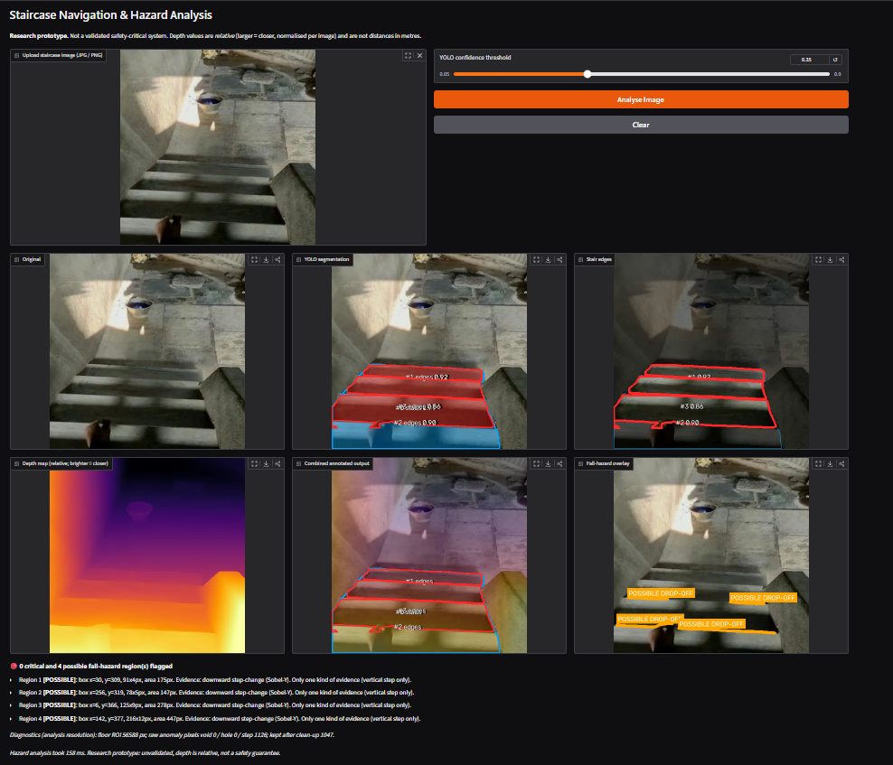
- Gradio interface with the upload panel, confidence slider, result panels, region table and hazard report.

Test Procedure
Testing so far is qualitative, on staircase photographs taken by the author, plus synthetic depth maps for the hazard logic. No labelled benchmark has been evaluated, so no accuracy, false-positive or miss rates are claimed.

Segmentation Results
On the test staircase the model finds the stairs region and the three step edges with confidences between 0.86 and 0.92 (Figs. 9 and 10). The confidence threshold matters for thin edges. On a second test image, seven candidate regions were returned at the default Ultralytics threshold of 0.25; raising the threshold to the chosen 0.35 removed three edge candidates with confidences between 0.26 and 0.32 and kept four regions.
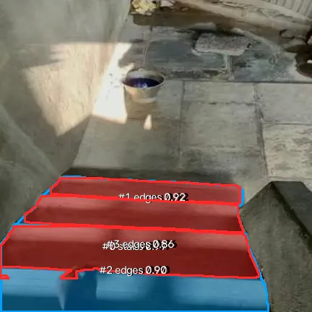  - Segmentation overlay: stairs (blue) and edge regions (red) with class and confidence labels. | 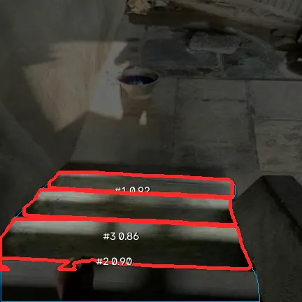  - Stair-edge view: the detected edge regions highlighted on the dimmed image.

Two failure cases were observed. In one image a wall panel was detected as an edge with a confidence of 0.36, just above the threshold, and as a stairs region (Fig. 11). In a top-down view of a plain granite staircase no edge passed the 0.35 threshold (Fig. 12). The training set contains no ascending-stair negatives.
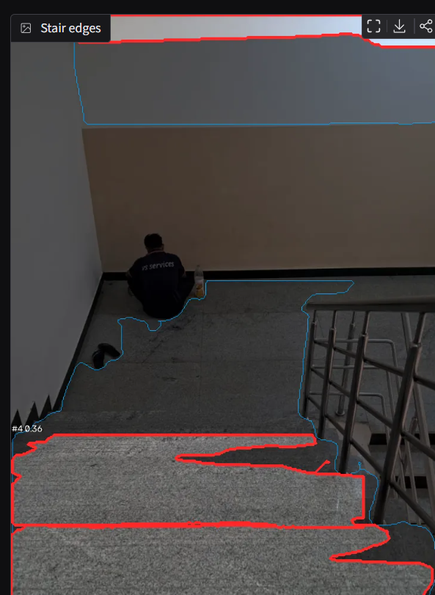  - Failure case: a wall region detected as an edge (confidence 0.36). | 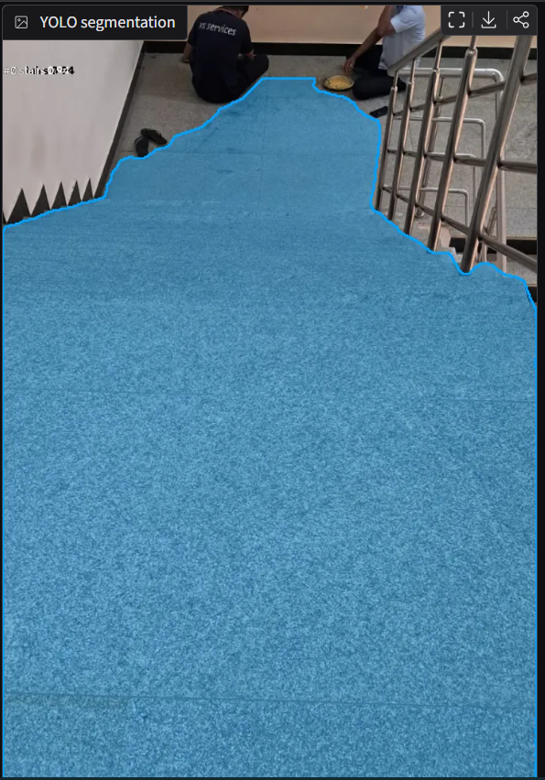  - Failure case: top-down view in which no edge is detected at a threshold of 0.35.

Depth Results
Masks and depth map are aligned because both are produced at the same working resolution (Fig. 13). The combined output overlays the segmentation on the depth map (Fig. 14). Depth Anything V2 does not always expose the steps. For the top-down staircase of Fig. 12 the depth map is a smooth gradient from far (top) to near (bottom) and shows no discontinuity at the stair edges, even though the segmentation model finds them (Fig. 15).
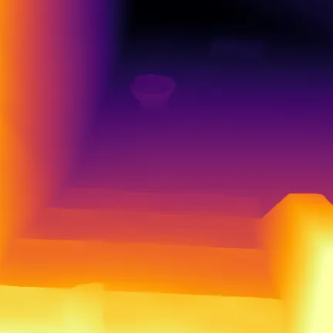  - Relative depth map (brighter is nearer). | 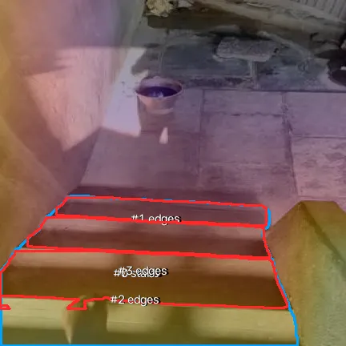  - Combined annotated output: segmentation over the depth map.

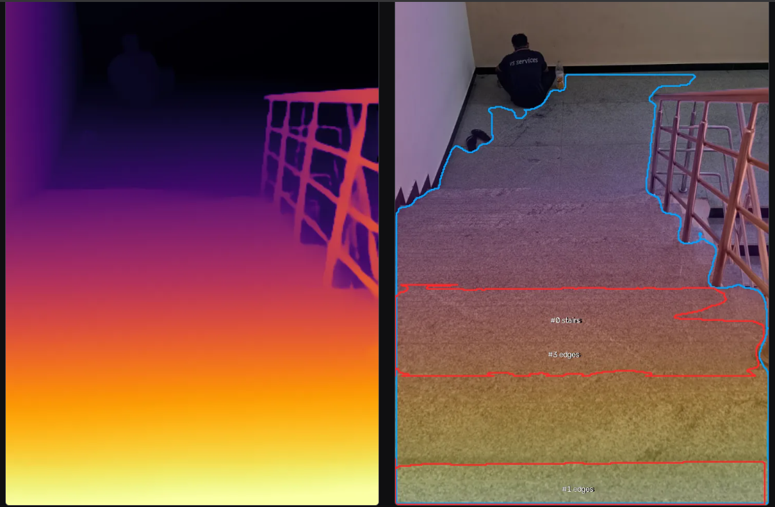
- Depth map (left) and combined output (right) for the staircase of Fig. 12: the depth is a smooth gradient with no jump at the stair edges.

CPU Performance
Table V lists the processing time for one 720×1280 image on a laptop CPU. The depth model takes slightly longer than segmentation. The cold-start figure shows why both models are loaded once at start-up and warmed up. These are single measurements, not averages over many images.
- Processing time for one image on a laptop CPU (single run)
Stage | Time (s)
YOLO segmentation | 0.299
Depth Anything V2 Small | 0.416
Depth normalisation | 0.015
Model total | 0.730
End-to-end request, before the hazard module was added | 0.78
First YOLO call without warm-up (cold start) | 8.63

Hazard Analysis Results
Fig. 16 shows the hazard overlay for the test staircase. In this example the flagged regions are labelled possible drop-off (orange) and none is labelled critical. The hazard logic was also tested on synthetic 720×1280 depth maps over a stairs mask (Table VI). These tests check that the code behaves as designed; they are not evidence of accuracy on real staircases.
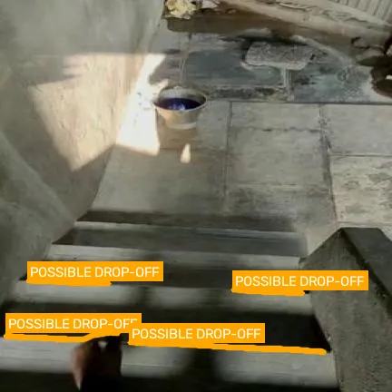
- Fall-hazard overlay: flagged regions are labelled possible drop-off.
- Synthetic tests of the hazard module (not real model output)
Case | Expected | Result
Smooth depth ramps, with and without noise | No anomaly | No anomaly
Hard ledge across the frame | Flag | Critical (void + step)
Blurred ledge | Flag | Critical (void + step)
Zero-depth patch | Flag | Critical (void + hole + step)
NaN patch | Flag | Critical (hole + step)
Void over part of the width | Flag | Possible (void only)
Three blurred risers | Flag | Possible (step only)

These tests exposed two defects in the first version. A per-row median baseline made a full-width ledge invisible, so a robust polynomial baseline was adopted (Eqs. 3 to 6). A morphological opening removed thin step responses, so it was disabled and the minimum-area filter was kept. A diagnostics line with the raw pixel counts of each check was also added to the report. On the real top-down staircase the first version produced an empty overlay: because the depth map has no discontinuity at the stair edges, none of the three checks fired.

Cloud Deployment
The container was built and run on an AWS EC2 t3.small instance (Table VII). Both models load and warm up in about 2.5 s according to the container log. Peak memory during an analysis and the warm per-image latency on the instance have not yet been measured.
- Measurements on the AWS EC2 instance
Item | Value
Instance type | t3.small (2 vCPUs, 2 GiB RAM)
Operating system | Ubuntu 26.04 LTS
Model start-up and warm-up | about 2.5 s (container log)
Memory in use, models loaded and idle | 50% of 2 GiB (login banner)
Root volume | 6.61 GB, 82.6% used (login banner)
Peak memory during an analysis | not yet measured
Warm per-image latency on the instance | not yet measured

Discussion
The two models complement each other. YOLO supplies meaning and location, and depth supplies relative geometry, and combining them is cheap enough for CPU use. The results also show clear limits. First, the depth-based checks can only fire when the depth map actually contains a discontinuity, and Depth Anything V2 smoothed the stair edges in the top-down image, so this evidence was invisible to the checks even though YOLO found the edges. Second, the stairs mask is used as the floor mask because the model has no floor class, and on a genuine staircase the step check will fire on ordinary risers, so the module behaves as a descending-step detector rather than a general floor-hole detector. Third, erosion removes the mask boundary, where a ledge often lies, so the radius is a trade-off between false alarms and missed edges. Fourth, the segmentation model produced false positives on walls and missed edges in a top-down view, which post-processing cannot fully repair.
Finally, relative depth cannot support distances in metres, so the 1 to 3 m walking range is approximated by a row-based near-field crop that must be calibrated for each camera mounting. The thresholds are untested defaults, and the label No anomaly found must never be read as a statement that the stairs are safe.

Conclusion
This work demonstrates a CPU-only pipeline that fuses a custom stair and stair-edge segmentation model with Depth Anything V2 Small, exposes the result through a Gradio interface, and packages it for AWS deployment. An explainable hazard module evaluates three depth anomalies, assigns two tiers and declines to decide when the evidence is poor. A laptop CPU processed one image through the two models in about 0.73 s. The hazard logic behaves as designed on synthetic data, but its behaviour on real staircases is unvalidated, and the observed failure cases show where the current evidence is insufficient. The system is a research prototype, not a validated safety device.

Future Work
- Add a rule that uses the YOLO edge detections directly, so that stair edges raise a flag even when the depth map is smooth.
- Build a labelled evaluation set and measure false positives, missed hazards and uncertain cases, then tune the thresholds against it.
- Add hard negatives to the training data: walls, top-down views and ascending stairs.
- Evaluate a validated metric-depth model, with its licence checked, together with calibration against measured stair dimensions.
- Benchmark ONNX Runtime against PyTorch on CPU.
- Move to real-time video on a vest-mounted camera.
- Add authentication and HTTPS and evaluate a managed container service for deployment.

References
- J. Redmon, S. Divvala, R. Girshick, and A. Farhadi, “You only look once: Unified, real-time object detection,” in Proc. IEEE Conf. Comput. Vis. Pattern Recognit. (CVPR), Las Vegas, NV, USA, 2016, pp. 779–788.
- G. Jocher, A. Chaurasia, and J. Qiu, “Ultralytics YOLOv8,” version 8.0.0, 2023. [Online]. Available: https://github.com/ultralytics/ultralytics
- L. Yang, B. Kang, Z. Huang, Z. Zhao, X. Xu, J. Feng, and H. Zhao, “Depth Anything V2,” in Adv. Neural Inf. Process. Syst. (NeurIPS), vol. 37, 2024, arXiv:2406.09414.
- A. Pérez-Yus, G. López-Nicolás, and J. J. Guerrero, “Detection and modelling of staircases using a wearable depth sensor,” in Proc. Eur. Conf. Comput. Vis. (ECCV) Workshops, 2014, pp. 449–463.
- S. Wang, H. Pan, C. Zhang, and Y. Tian, “RGB-D image-based detection of stairs, pedestrian crosswalks and traffic signs,” J. Vis. Commun. Image Represent., vol. 25, no. 2, pp. 263–272, Feb. 2014.
- K. He, G. Gkioxari, P. Dollár, and R. Girshick, “Mask R-CNN,” in Proc. IEEE Int. Conf. Comput. Vis. (ICCV), Venice, Italy, 2017, pp. 2961–2969.
- D. Eigen, C. Puhrsch, and R. Fergus, “Depth map prediction from a single image using a multi-scale deep network,” in Adv. Neural Inf. Process. Syst. (NIPS), vol. 27, 2014, pp. 2366–2374.
- R. Ranftl, K. Lasinger, D. Hafner, K. Schindler, and V. Koltun, “Towards robust monocular depth estimation: Mixing datasets for zero-shot cross-dataset transfer,” IEEE Trans. Pattern Anal. Mach. Intell., vol. 44, no. 3, pp. 1623–1637, Mar. 2022.
- L. Yang, B. Kang, Z. Huang, X. Xu, J. Feng, and H. Zhao, “Depth Anything: Unleashing the power of large-scale unlabeled data,” in Proc. IEEE/CVF Conf. Comput. Vis. Pattern Recognit. (CVPR), 2024, arXiv:2401.10891.
- “Depth-Anything-V2-Small,” Hugging Face model card. [Online]. Available: https://huggingface.co/depth-anything/Depth-Anything-V2-Small (accessed Oct. 13, 2026).

- A. Abid, A. Abdalla, A. Abid, D. Khan, A. Alfozan, and J. Zou, “Gradio: Hassle-free sharing and testing of ML models in the wild,” arXiv:1906.02569, 2019.
- I. Sobel and G. Feldman, “A 3×3 isotropic gradient operator for image processing,” presented at the Stanford Artificial Intelligence Project (SAIL), 1968.
- A. Paszke et al., “PyTorch: An imperative style, high-performance deep learning library,” in Adv. Neural Inf. Process. Syst., vol. 32, 2019, pp. 8024–8035.
- G. Bradski, “The OpenCV library,” Dr. Dobb’s J. Softw. Tools, 2000.
- D. Merkel, “Docker: Lightweight Linux containers for consistent development and deployment,” Linux J., vol. 2014, no. 239, Mar. 2014.
- Amazon Web Services, “Amazon EC2 documentation.” [Online]. Available: https://docs.aws.amazon.com/ec2/ (accessed Oct. 13, 2026).
- R. A. Maronna, R. D. Martin, and V. J. Yohai, Robust Statistics: Theory and Methods. Chichester, U.K.: Wiley, 2006.

Screenshots

