EduCapsules
Teach safely · Learn in order · Monitor with confidence
MASTER SOFTWARE REQUIREMENTS SPECIFICATION
Version 1.1 · Audited & Reconciled Baseline
11 September 2026 (v1.1 audit pass; supersedes v1.0 of 8 September 2026)
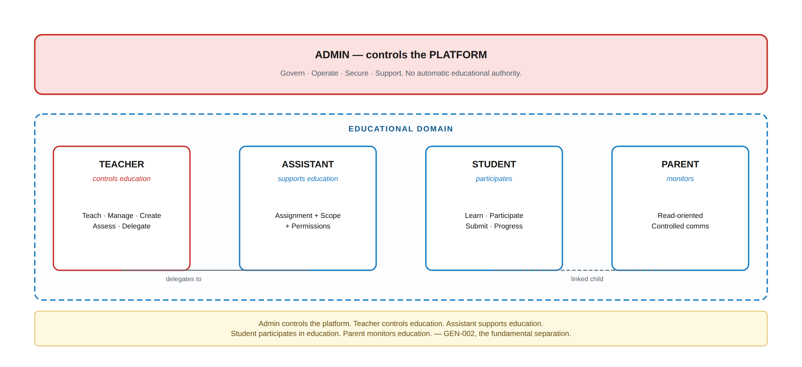
Figure 0.1 — The fundamental role separation. Every requirement in this document is consistent with it.
Project Owner | Miss Selvia
Project Manager · Software Engineer · Developer | Moustafa Mahgoub
Testing & Quality Assurance | Ramzy Mohamed
Consolidates | 16 source specifications: roles, dashboards, activities, question bank, storage, import/export, content protection, session security, data security, legal framework, payments, capability matrices
Supersedes | All prior EduCapsules SRS drafts and the individual specification documents listed above

This document is the single source of truth for EduCapsules. Where it conflicts with an earlier document, this document wins; every such conflict is recorded in §1.4.

1. Document Control

1.1 Identification
Field | Value
Product | EduCapsules
Document | Master Software Requirements Specification
Version | 1.1 — Audited & Reconciled Baseline (supersedes 1.0)
Date | 11 September 2026
Status | Draft for Project Owner acceptance. This revision is a systematic audit pass over v1.0: every change is itemised in the change log (§52.5); no confirmed decision was reversed.
Authority | Single source of truth (GEN-001). Supersedes all prior EduCapsules specification documents.
Change control | A requirement changes only through §1.5: identify → explain → trace dependencies → update all affected sections → update business rules, permissions and acceptance criteria → record in the change log.

1.2 How this document is organised
Sections 2–9 establish the product, its vocabulary and its authorization model — read these first, because everything else depends on them. Sections 10–23 specify the domain. Sections 24–33 specify the role experiences and cross-cutting services. Sections 34–43 specify architecture, data, API and quality. Sections 44–51 cover verification, traceability and open items.

1.3 Requirement conventions
Convention | Rule
Identifier | PREFIX-NNN, permanent, never reused, never renumbered. §51 lists every prefix.
Priority | MUST (V1 required) · SHOULD (important, not V1-blocking) · COULD (optional) · WON'T (excluded from this release)
Status | CONFIRMED (decided) · PROPOSED (this document's recommendation, binding on acceptance) · ASSUMPTION (working position) · OPEN (needs a decision) · FUTURE (post-V1)
Wording | “shall” = binding requirement. “should” = strong recommendation. Anything not stated as a requirement is not one.
Testability | Every MUST is written so that it can be objectively verified. Where a numeric target is not yet decided it is marked TBD rather than invented.

1.4 Conflicts found in the source material, and how they were resolved
The source specifications were written at different times. Six genuine conflicts were found. Each is resolved below in favour of the latest, most explicit decision, preserving the core architectural principles. No conflict was resolved by silently introducing a different architecture.
# | Conflict | Resolution | Where
C-1 | “Session” means a teaching occurrence in the academic material and an authenticated access period in the security material. | Both concepts are kept and renamed. *Teaching Session* (academic, prefix SES) and *Login Session* (security, prefix AUTH). The word “session” is never used unqualified in this document. | §3.2, §14, §32
C-2 | Security material numbered login-session requirements SES-001…020; the agreed prefix table assigns SES to the academic Session. | SES = Teaching Session. Former SES-001…020 are remapped to AUTH-101…120; the mapping table is in §51.2 so no source requirement is lost. | §51.2
C-3 | Question Bank requirements used prefix QB; the agreed prefix table specifies QBN. | QBN adopted. QB-nnn → QBN-nnn, numbering preserved. | §51.2
C-4 | Import/export material contains two requirements numbered STR-IMP-008. | The version-preservation rule keeps STR-IMP-008; the package-import rule is renumbered STR-IMP-013. | §17.6
C-5 | Role material lists four roles in the capability matrices; Admin is specified separately as a fifth. | Five roles: Teacher, Assistant, Student, Parent, Admin. The four-role matrices are educational-domain matrices; Admin is added to every matrix in this document. | §8
C-6 | Storage material offers Option A (students immediately get new file versions) and Option B (published content keeps its version) without deciding. | Option B is adopted and made binding — published content is version-stable (GEN-015). Option A would silently change assessments students had already started. | §17.5, §18.3

Table 1.1 — Source conflicts and their resolutions. Nothing was dropped; everything was reconciled.

1.5 Change control
GEN-005 · No requirement changes silently
identify affected requirement(s)
→ explain the change and its reason
→ trace dependencies: DB · API · permissions · UI · security
analytics · notifications · testing · business rules
→ update every affected section
→ update business rules and the permission matrix
→ update acceptance criteria and traceability
→ record in the change log (§51.4)

1.6 Approval
Role | Name | Decision required | Signed
Project Owner | Miss Selvia | Accept the scope, the PROPOSED decisions (§50) and the V1 boundary (§49)
PM / Engineer | Moustafa Mahgoub | Confirm §34–§42 are buildable as specified
Testing / QA | Ramzy Mohamed | Confirm every MUST maps to a verifiable acceptance criterion

1.7 What changed in v1.1
v1.0 was audited section by section against its own stated decisions, its data model, its permission catalogue and its traceability chain. This pass did not reverse any decision marked CONFIRMED. It corrected internal contradictions, filled gaps the document’s own structure already implied, and repaired broken cross-references. Every change is one of four kinds:
Kind | Example | Count
Contradiction resolved | Group/Classroom cardinality (§9.2 vs §37.3.2); cross-tenant storage deduplication (§14.4 vs §37.3.4); duplicate ID BR-014 (§9.2 vs §30.1) | 3 | —
Broken cross-reference repaired | Citations that pointed at the wrong requirement or the wrong open-decision entry — full list in Appendix E | 14 | —
Gap closed with a new requirement | SEC-012...015, ACT-009, STR-023, LDB-009, AUTH-127, ORG-009/010, CRS-009/010, GEN-029, BR-021, and an Academic Period subsection (§8.1) | 12 | —
Editorial correction | Figure/illustration count in §24.4; duplicated retention table (§32.3 now references §44.3 instead of repeating it) | 2 | —
Table 1.2 — Amendment summary. The full itemised list, with rationale and affected sections for every change, is Appendix E (§52.5).

2. Introduction, Purpose & Scope

2.1 Purpose of the product
GEN-001 · THE EDUCAPSULES PURPOSE
EduCapsules exists to let teachers teach their students in a safe environment, students learn in an organised environment, and parents monitor their children. Every requirement in this document serves education, organisation, safety, privacy, security, controlled access, teacher authority, student learning, parent monitoring, delegated assistant support, protected educational content, and strong auditability.

2.2 Purpose of this document
This SRS is written to be built from. It defines what EduCapsules must do and the constraints under which it must operate, in enough detail that architects, backend, frontend, mobile/desktop, database, DevOps, security and QA engineers, designers and product managers can work from it without relying on undocumented assumptions.

2.3 Scope
In scope | Out of scope
The EduCapsules platform: web application and the backend services behind it; the academic domain; activities and assessment; question bank; teacher storage and content protection; the five role experiences; communication; achievements and leaderboards; the early-release payment model; security, privacy, audit and legal-support requirements. | Native desktop and mobile applications (architecture must permit them — §41); AI-generated content and AI tutoring; enterprise SSO; marketplace; external LMS/SIS integration; proctoring; advanced analytics. See §49.

2.4 Product goals
# | Goal | How this document serves it
G-1 | A teacher can run real classes end to end inside the platform | §10–§20 specify the full teaching chain; §22 the teacher experience
G-2 | No user can reach data they are not entitled to | §9 authorization model; §31 security; §33 audit; §45 acceptance
G-3 | Course content is hard to steal, and theft is traceable | §19 content protection; §17 storage; §33 audit
G-4 | Delegation to assistants is safe and revocable | §23 assistant delegation; §9.6 no amplification
G-5 | Parents see their own children and nothing else | §24 parent experience; §9.5 relationship checks
G-6 | Nothing is stored twice when it can be referenced | §17 storage; §16 question bank
G-7 | Published content never changes underneath a student | GEN-015; §16.5; §18.3
G-8 | Every consequential action is attributable | §33 audit; §12 grade history

3. Definitions & Terminology
Terminology is a security control in this product: most of the source material's ambiguity came from two words used for two things. The vocabulary below is binding across UI, API, database, tests and this document (GEN-029).

3.1 Academic vocabulary
Term | Definition | Answers | Not
Organization | Tenant boundary. A school, institute or independent teaching practice. | Whose platform is this? | A classroom
Classroom | A broad student cohort or category — “Grade 10”, “Advanced Students”, “2026 Intake”, “English B1”. May contain many Groups. | Who are these students? | Not a physical room
Group | A subdivision inside exactly one Classroom. | How do we divide them? | A classroom
Subject | An academic discipline. Contains Courses. | Which discipline? | A course
Course | A structured teaching programme under a Subject. Contains Cycles. | Which programme? | A subject
Cycle | A time period or phase within a Course. Contains Topics. | Which phase? | A term
Topic | The learning concept or unit. | What is being taught? | A lesson time
Teaching Session | A real teaching occurrence — one lesson, delivered to a group at a time (Arabic: *7essa*). Carries attendance. | When is teaching happening? | Not a login session
Activity | Anything a student is expected to do, complete, submit or participate in. Homework, Quiz, Assignment, Exam, Exercise, Project, Discussion and Survey are Activity types, not separate top-level concepts. | What does the student do? | A topic
StudentActivity | One student's state against one Activity: status, attempts, best score. | How is this student doing on it? | The Activity itself
Submission | One attempt by one student at one Activity. | What did they hand in? | A grade

Table 3.1 — Academic vocabulary. Topic / Session / Activity are three different things and are never merged.

3.2 The two meanings of “session” — resolved
C-1 · CONFIRMED · BOTH CONCEPTS EXIST AND ARE NAMED APART
Teaching Session (prefix SES) is an academic entity: a real lesson occurrence with attendance, materials and activities. Login Session (prefix AUTH) is a security entity: an authenticated period during which a user may interact with the platform. The bare word “session” is never used in this document, in the API, in the database, or in the UI. Database tables are teaching_session and auth_session.
This was the single largest source of ambiguity across the source material and it would have reached the schema if left unresolved.

3.3 Access-control vocabulary
Term | Definition
Role | What kind of user this is: Teacher, Assistant, Student, Parent, Admin. Role alone authorises nothing.
Scope | The boundary within which a role or permission applies: Organization, Classroom, Group, Course, Cycle, or a combination.
Permission | An explicit named action, e.g. GRADE_HOMEWORK. The catalogue is closed: an action with no permission code cannot be performed.
Relationship | A verified link that grants access independently of role: Parent↔Student, Teacher↔Classroom, Assistant↔Assignment.
Entitlement | The right to access specific paid or restricted content, derived from a payment, subscription or grant. Separate from role and from permission.
Assistant Assignment | The record that grants an Assistant a scope and a permission set, optionally time-bounded. Assistant access is *always* Assignment + Scope + Permissions.
Object-level authorization | Verifying that the authenticated user may access *this specific object*, not merely objects of this kind.

3.4 Storage & content vocabulary
Term | Definition
StorageObject | The physical stored bytes, identified by content hash (SHA-256). Private, encrypted at rest, never publicly addressable.
File | A Teacher's logical file: owner, organization, filename, type, status. Points at StorageObjects through versions.
FileVersion | One version of a File, bound to one StorageObject.
FileReference | A record of *where a file is used* — attached to a Course, Topic, Teaching Session, or Activity, with its own visibility and purpose.
Teacher Storage | The Teacher's private workspace. Separate from published content.
Published content | Content a Teacher has explicitly attached and published to authorised students. Uploading is not publishing.
Content Gateway | The service that issues short-lived, scoped, revocable access to protected content after all authorization checks pass.
Protection level | 0 Public · 1 Standard · 2 Protected · 3 Premium. Set per content reference, not globally.

3.5 Acronyms
RBAC | Role-Based Access Control | IDOR | Insecure Direct Object Reference
BOLA | Broken Object Level Authorization | MFA | Multi-Factor Authentication
DRM | Digital Rights Management | HLS | HTTP Live Streaming
DASH | Dynamic Adaptive Streaming over HTTP | TLS | Transport Layer Security
WAF | Web Application Firewall | CSP | Content Security Policy
CSRF | Cross-Site Request Forgery | XSS | Cross-Site Scripting
SSRF | Server-Side Request Forgery | RPO | Recovery Point Objective
RTO | Recovery Time Objective | WCAG | Web Content Accessibility Guidelines
SLA | Service Level Agreement | QTI | Question & Test Interoperability

4. Architectural Golden Rules
These are the invariants of EduCapsules. Every requirement in this document is consistent with them, and any future requirement that contradicts one of them is wrong until this section is deliberately changed. They are numbered GEN and are directly testable.
ID | Golden rule | Enforced in
GEN-001 | This SRS is the single source of truth for EduCapsules. | §1
GEN-002 | Admin controls the platform. Teacher controls education. Assistant supports education. Student participates. Parent monitors. | §8, §21–§25
GEN-003 | The frontend is never a security boundary. Hiding a button is not authorization. | §9, §31, §40
GEN-004 | Backend authorization is authoritative and is evaluated on every protected operation. | §9
GEN-005 | No requirement, permission or business rule changes silently. | §1.5
GEN-006 | Assistant access = Assignment + Scope + Permissions. Being an Assistant grants nothing. | §23
GEN-007 | Parent access is based on a verified Parent↔Student relationship, never on knowing an ID. | §24
GEN-008 | Classroom = student cohort/category. Group = subdivision of exactly one Classroom. | §12
GEN-009 | Topic = what is taught. | §13
GEN-010 | Teaching Session = when teaching happens. | §14
GEN-011 | Activity = what the student does. | §15
GEN-012 | The Question Bank stores the question; the Activity stores the use of the question; the Submission stores the student's response. | §16
GEN-013 | Storage stores physical objects; references connect them to educational entities. | §17
GEN-014 | Upload once → store once → reference everywhere → version when changed. | §17
GEN-015 | Published content is version-stable: it never changes underneath a student. | §16.5, §17.5, §18.3
GEN-016 | Access to a course ≠ access to the original course files. | §19
GEN-017 | Protected content is delivered through controlled, short-lived, revocable access. | §19
GEN-018 | Security-sensitive actions are auditable and attributable. | §33
GEN-019 | Tenant isolation is enforced at every layer. | §11, §31
GEN-020 | Payment status never determines a user's educational role. | §27, §28
GEN-021 | Historical records remain attributable after an account is deactivated. | §33, §43
GEN-022 | No control shall claim that screenshots or photography are impossible. | §19.7
GEN-023 | Privacy is enforced by architecture, not only by policy. | §29
GEN-024 | Least privilege is the default; new resources start restrictive. | §9, §31
GEN-025 | No user accesses a resource merely because they know or possess its identifier. | §9.7
GEN-026 | Correct answers, unreleased grades and private metadata never reach a client that is not entitled to them — even if the interface would not display them. | §16.9, §19.10
GEN-027 | Deleting an account never silently destroys educational or audit history. | §43
GEN-028 | Architecture is chosen for security, maintainability and cost — not for novelty. | §35
GEN-029 | The vocabulary of §3 is binding and exclusive: a defined term is used consistently, and a bare "session" never appears, in the UI, the API, the schema, tests or this document. (Added in v1.1.) | §3

Table 4.1 — The twenty-nine golden rules (v1.1 adds GEN-029). GEN-025 alone prevents a large class of serious vulnerabilities.

5. System Overview & Context
EduCapsules is a multi-role educational platform: a responsive web client and the backend services behind it, with private object storage, a protected content delivery path, and a single authorization core that every request passes through.
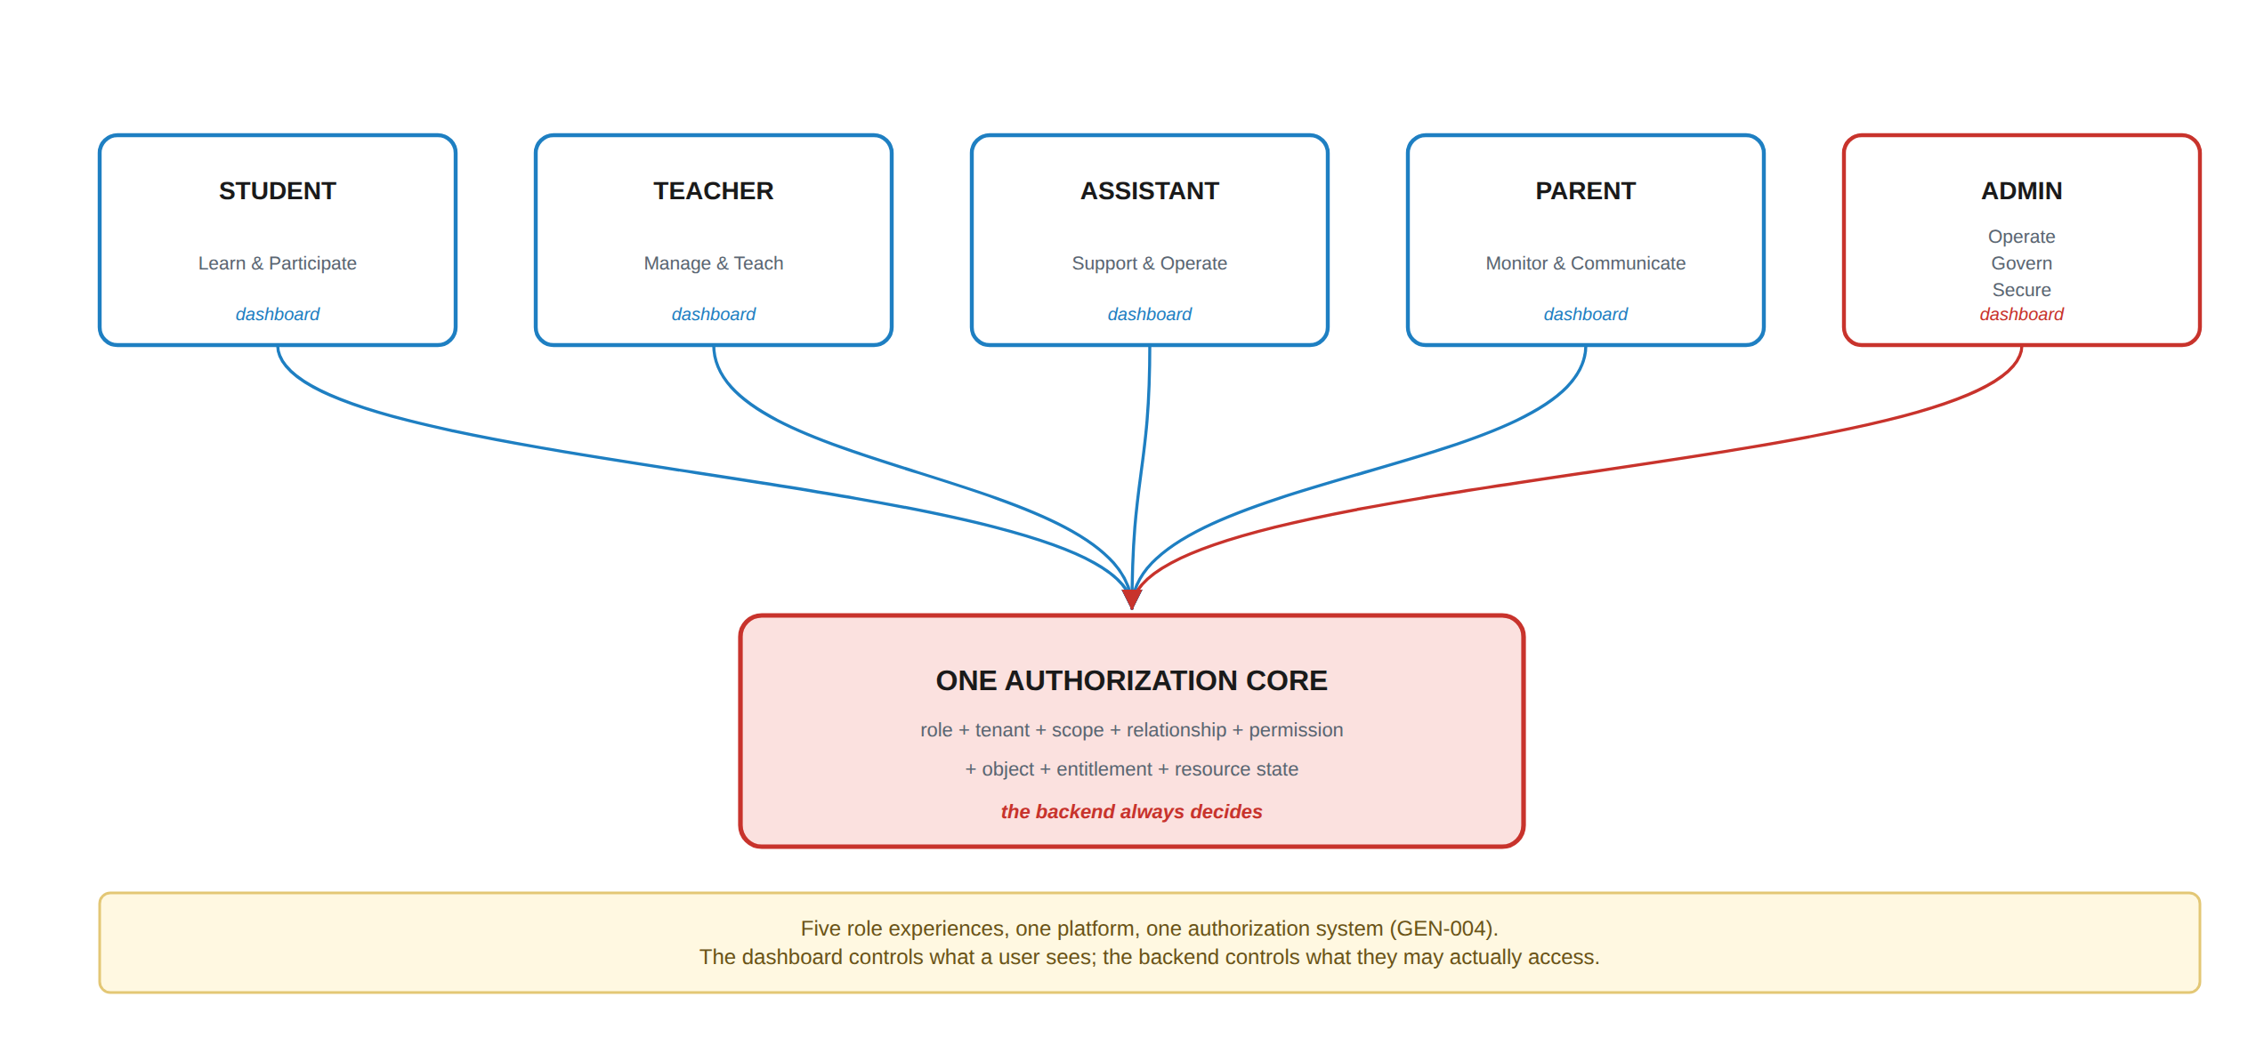
Figure 5.1 — Five role experiences over one authorization core. The dashboards differ; the security decision does not.

5.1 External context
External system | Purpose | V1 | Notes
Email delivery provider | Verification, password reset, notification email | MUST | Failure must not block the originating transaction (NOT-014)
Edge / CDN / WAF provider | DNS, TLS, CDN, WAF, DDoS protection | MUST | Infrastructure, not an integration
Object storage | Private encrypted content storage | MUST | Behind a storage interface (§41)
Video processing / streaming | Transcoding, segmenting, encrypted delivery | SHOULD | Required before Level 3 video protection is claimed
DRM licence service | Widevine · FairPlay · PlayReady | FUTURE | Level 3 premium video
Malware scanning | Upload quarantine and scanning | MUST | §17.9
Payment provider | — | WON'T (V1) | Early release is evidence-based (§27)
SSO / identity provider | — | FUTURE | §49

5.2 Client applications
V1 is a responsive web application. The backend security model shall not be coupled to any one client (GEN-004): every client — web, Windows, macOS, Android, iOS — is an equal consumer of the same authorised API. Native applications may add content protections the web cannot provide (§19.7), but never *replace* server-side decisions.

6. Actors & Roles

6.1 The five roles
Role | Philosophy | Authority derives from | Never has
Teacher | Teach + Manage + Create + Assess + Delegate. The primary educational authority. | Ownership / assigned educational scope + permissions | Admin authority; another Teacher's private storage; platform security or system configuration
Assistant | Support Teacher + perform delegated educational tasks. | Assistant Assignment + Scope + Permissions | Anything not explicitly delegated; self-granted permissions; billing; ownership transfer
Student | Learn + Participate. | Classroom/Group membership + role + permissions | Another student's private data; any academic authority; grading; structure management
Parent | Monitor + Communicate. | Verified Parent↔Student relationship + role | Any write to academic records; unlinked students; child impersonation
Admin | Govern + Operate + Secure + Support the platform. | Admin role + granular permissions + administrative scope | Automatic educational authority; unrestricted private data; silent access; audit-log modification

Table 6.1 — The five roles. The “never has” column is as binding as the rest.

6.2 Cross-role capability matrix — educational domain
Legend: ✔ allowed within own scope · ⚙ permission-dependent · ✖ not allowed · — not applicable.
Capability | Teacher | Assistant | Student | Parent | Admin
Manage academic structure | ✔ | ⚙ | ✖ | ✖ | Oversight ⚙
Create activities | ✔ | ⚙ | ✖ | ✖ | ⚙
Grade activities | ✔ | ✔ ⚙ | ✖ | ✖ | Exceptional ⚙
Complete activities | ✖ | ✖ | ✔ | ✖ | ✖
View own progress | ✔ | ✔ | ✔ | — | ✔
View child's progress | ✖ | ✖ | ✖ | ✔ | ✖
Manage achievements | ✔ | ⚙ | ✖ | ✖ | Oversight ⚙
Earn achievements | — | — | ✔ | ✖ | —
View achievements | ✔ | ✔ | ✔ | ✔ | ⚙
View leaderboard | ✔ | ✔ | ✔ | ⚙ | ⚙
Communicate with students | ✔ | ⚙ | ⚙ | ✖ | ⚙
Communicate with teachers | — | ✔ | ⚙ | ⚙ | ⚙
Monitor child | ✖ | ✖ | ✖ | ✔ | ✖
Manage students | ✔ | ⚙ | ✖ | ✖ | ⚙
Manage billing | ⚙ payer only | ✖ | ✖ | ⚙ payer only | ⚙
Teacher Storage | ✔ own | ⚙ shared only | ✖ | ✖ | Oversight only
Platform administration | ✖ | ✖ | ✖ | ✖ | ✔
Audit logs | Own actions | Own actions | ✖ | ✖ | ⚙
System configuration | ✖ | ✖ | ✖ | ✖ | Elevated ⚙

Table 6.2 — The consolidated capability matrix. §26 gives the authoritative per-permission matrix.

7. Authorization Model
This is the section the rest of the document depends on. Wherever a requirement says “authorised”, “within scope” or “permitted”, it means precisely what is defined here.

7.1 The authorization decision
Every protected operation passes through the same eleven-stage decision. A valid login gets a user past stage 1 only; it decides nothing else.
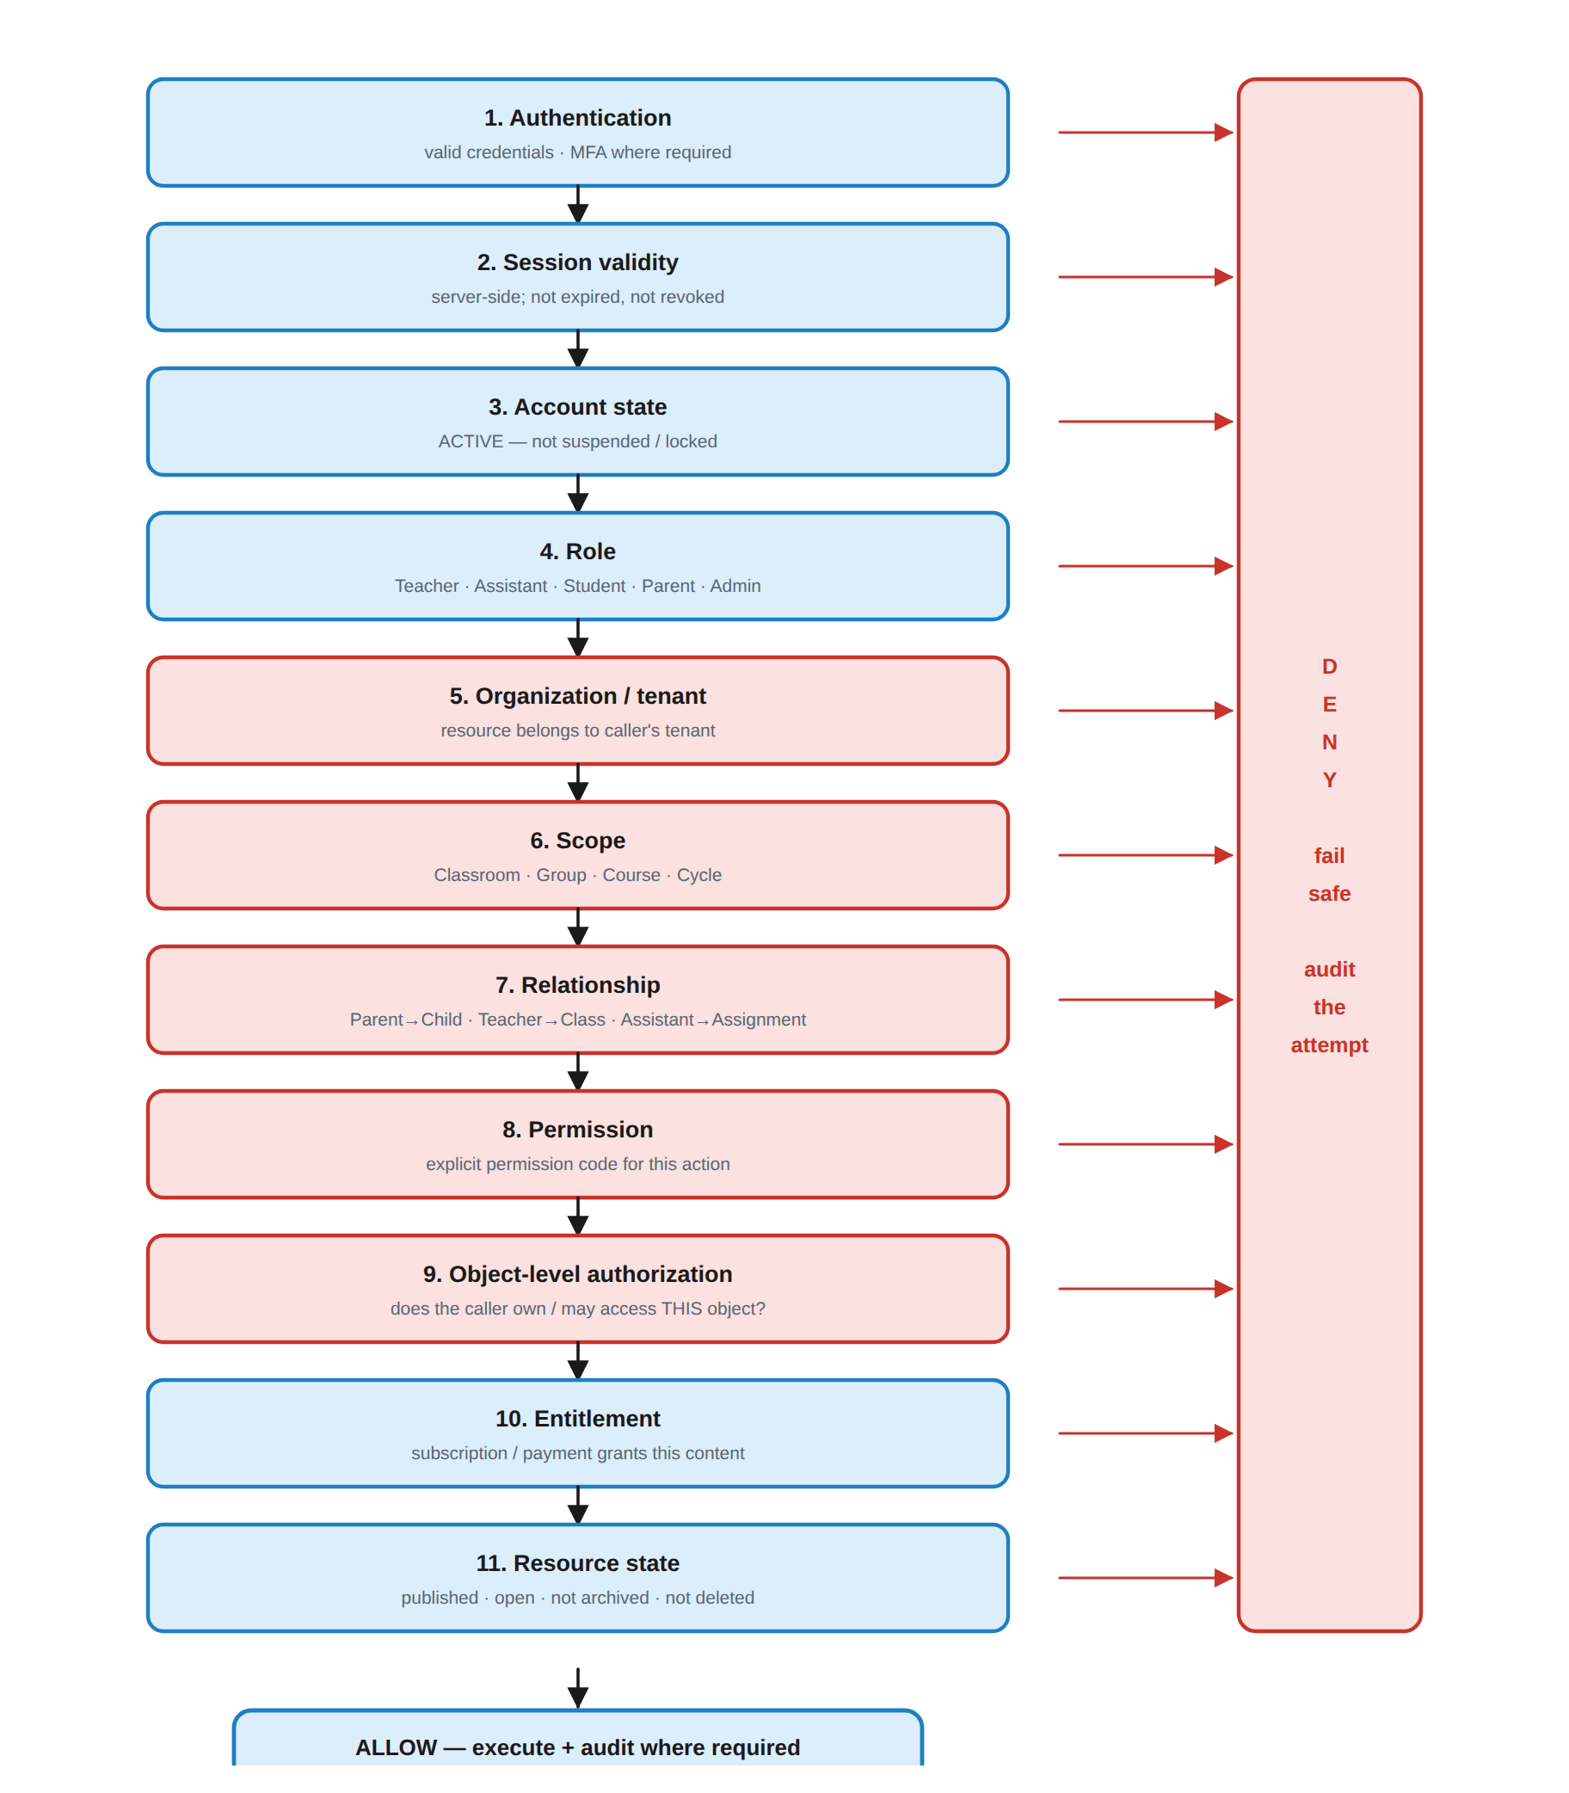
Figure 7.1 — The authorization decision. A failure at any stage denies, fails safe, and is audited (SEC-001, GEN-004).

7.2 Requirements
ID | Requirement | Priority | Actor
SEC-001 | Every protected operation shall evaluate identity, role, organization, scope, relationship, permission, target object, entitlement and resource state before executing. | MUST | System
SEC-002 | Authorization shall be enforced server-side. Client-side checks exist for usability only and carry no authority. | MUST | System
SEC-003 | A valid authenticated Login Session shall not by itself grant access to any resource. | MUST | System
SEC-004 | The system shall never accept a role, permission, scope, organization or user identity supplied by the client as proof of that attribute. | MUST | System
SEC-005 | Object-level authorization shall verify the caller's relationship to the specific target object, not merely to objects of that type. | MUST | System
SEC-006 | A permission grant shall never exceed the granting user's own permissions at that scope. | MUST | System
SEC-007 | Permissions may carry an expiry; an expired grant shall be treated as absent without further action. | MUST | System
SEC-008 | New resources shall default to the most restrictive visibility consistent with their purpose. | MUST | System
SEC-009 | Denials shall not disclose whether the resource exists (§40.3). | MUST | System
SEC-010 | Every grant, modification, expiry and revocation of a role or permission shall be audited. | MUST | System

Table 7.1 — Core authorization requirements.

7.3 Scope model
Scopes nest. A grant at a wider scope applies to everything inside it; a grant at a narrower scope never leaks outward. This is what lets one mechanism describe a head of department, a class teacher and a single-course assistant.
SEC-011 · Scope containment
Organization widest — platform / tenant administration
└── Classroom a cohort
└── Group a subdivision of that Classroom

Subject
└── Course
└── Cycle narrowest educational scope

A grant at scope S applies to S and to every scope contained by S.
It never applies to a parent or a sibling of S.
Cohort scopes (Classroom/Group) and content scopes (Course/Cycle) may be combined
in one Assistant Assignment — the caller must satisfy every scope named on the grant.

7.4 Relationship-based authorization
Relationship | Grants | Verified how | Requirement
Parent → Student | Read access to that child's permitted academic information | ParentLink.status = ACTIVE, checked on every request | PAR-002, SEC-012
Teacher → Classroom / Course | Educational authority within that scope | Ownership or organization assignment | TCH-028, SEC-013
Assistant → Assignment | Exactly the delegated permissions within the assigned scope | AssistantAssignment active and not expired | AST-002, SEC-014
Student → Classroom / Group | Access to content targeted at that membership | ClassroomMembership / GroupMembership active | STU-002, SEC-015

Added in v1.1: SEC-012...015 were cited in Table 7.2 above and in §46/§48 since v1.0, but were never separately stated as requirements. They are defined here.
ID | Requirement | Priority | Actor
SEC-012 | The Parent → Student relationship shall be re-verified as ACTIVE on every request; a REQUESTED or REVOKED ParentLink shall grant nothing. | MUST | System
SEC-013 | The Teacher → Classroom/Course relationship shall be re-verified on every request against ownership or an organization role assignment, never cached client-side. | MUST | System
SEC-014 | The Assistant → Assignment relationship shall be re-verified on every request: the AssistantAssignment must be ACTIVE, unexpired, and the delegating Teacher must still hold the delegated permission in an equal-or-wider scope. | MUST | System
SEC-015 | The Student → Classroom/Group relationship shall be re-verified on every request against an active ClassroomMembership or GroupMembership. | MUST | System

7.5 Entitlement
Entitlement is evaluated after authorization and answers a different question: not “may this user access things of this kind?” but “has this user paid for, or been granted, *this* content?” It is the check that expires when a subscription or session payment lapses (§28).
ID | Requirement | Priority | Actor
SEC-016 | Access to protected content shall require a valid Entitlement in addition to role, scope, relationship and permission. | MUST | System
SEC-017 | An expired or revoked Entitlement shall deny new content access while leaving the student's academic history intact. | MUST | System
SEC-018 | Entitlement shall be evaluated server-side at the point of content delivery, not cached on the client. | MUST | System

7.6 No privilege amplification
SEC-006 · A GRANT CAN NEVER EXCEED THE GRANTER'S OWN AUTHORITY
A Teacher may delegate GRADE_HOMEWORK on Group 1 only if the Teacher holds GRADE_HOMEWORK on Group 1. Permissions marked non-delegatable in §26.3 can never be passed on at all — so an Assistant can never create another Assistant, expand their own scope, or become a Teacher or Admin. Delegation is therefore never an escalation path.

7.7 The single most important security rule
GEN-025 · IDENTIFIER POSSESSION IS NOT AUTHORIZATION
No user shall be able to access or modify a resource solely because they know or possess its identifier. Every protected request shall be authorized according to the authenticated user's role, organizational membership, relationship to the resource, assigned scope and explicit permissions.
This single principle prevents IDOR/BOLA — the most likely serious vulnerability class in a platform of this shape, and the one that would expose student records.

8. Organization & Tenancy
The Organization is the tenant boundary. It may be a school, an institute, or an independent teaching practice operated by a single Teacher — the model is the same in both cases.
ID | Requirement | Priority | Actor
ORG-001 | The system shall support Organizations as the tenant boundary for all scoped data. | MUST | System
ORG-002 | Every scoped record shall carry organization_id, and every query shall filter on it. | MUST | System
ORG-003 | An Organization shall never be able to access another Organization's private data by any request shape. | MUST | System
ORG-004 | Tenant isolation shall be enforced at API authorization, scope validation, object authorization and query layers — not by frontend filtering. | MUST | System
ORG-005 | The system shall support an Organization operated by a single independent Teacher without requiring an institutional structure. | MUST | System
ORG-006 | Organization membership shall be an explicit record; it shall not be inferred from a Login Session. | MUST | System
ORG-007 | Authorized Admins shall manage Organization profile, membership, subscription, usage and settings according to administrative permission. | MUST | Admin
ORG-008 | A user may hold different roles in different Organizations; each request shall be evaluated against the Organization owning the target resource. | SHOULD | System
ORG-009 | Deactivating or closing an Organization shall follow a defined lifecycle (request → confirm → grace period → read-only → archived) and shall never cascade-delete its users, courses, content, grades or audit records; retention and erasure follow §44 exactly as for an individual account. (Added in v1.1.) | MUST | Admin
ORG-010 | Organization closure shall require Platform Owner or Super Admin authorization, a stated reason, and shall be fully audited; it shall not be reachable through an Organization-scoped Admin role alone. (Added in v1.1.) | MUST | Admin

Table 8.1 — Organization and tenancy requirements.
GEN-019 · TENANCY IS A DATA-MODEL PROPERTY, NOT A FILTER
organization_id exists on every scoped table from the first migration and is part of every query predicate. Retrofitting tenancy onto a populated schema means touching every table, every query and every authorization check at once — it is the single most expensive migration this product could face, and it costs almost nothing to avoid now.

8.1 Academic Periods
Added in v1.1. AcademicPeriod (§37.3.2) is load-bearing — Classroom, Enrollment, Course and the leaderboard/progress windows all bind to it, and Table 37.7 states “one active Classroom per student per AcademicPeriod” as an enforced cardinality rule — but v1.0 defined no functional requirement for who creates, manages or closes one. This subsection closes that gap; it does not introduce a new concept, only specifies the one the data model already depended on.
ID | Requirement | Priority | Actor
PER-001 | The system shall support AcademicPeriods scoped to an Organization, each with a name, start date, end date and status. | MUST | Admin
PER-002 | Authorized Admins, and Teachers where the Organization delegates it, shall create and manage AcademicPeriods. | MUST | Admin
PER-003 | A Classroom, Course and Enrollment shall each belong to exactly one AcademicPeriod; a Student shall hold at most one active Classroom membership per AcademicPeriod (BR-015). | MUST | System
PER-004 | AcademicPeriods shall not overlap within the same Organization unless the Organization explicitly supports concurrent periods (e.g. parallel tracks); the default is non-overlapping. | MUST | System
PER-005 | Closing an AcademicPeriod shall not delete or hide any Classroom, Enrollment, grade, submission or attendance record created within it; historical data remains queryable by period. | MUST | System
PER-006 | Creating a new AcademicPeriod shall never modify or move records belonging to a prior one. | MUST | System
Table 8.2 — Academic Period requirements. Prefix PER, registered in Appendix A.

9. Classroom & Group
Classroom answers *who are these students*. Group answers *how do we divide them*. These are different questions and are modelled separately (GEN-008).
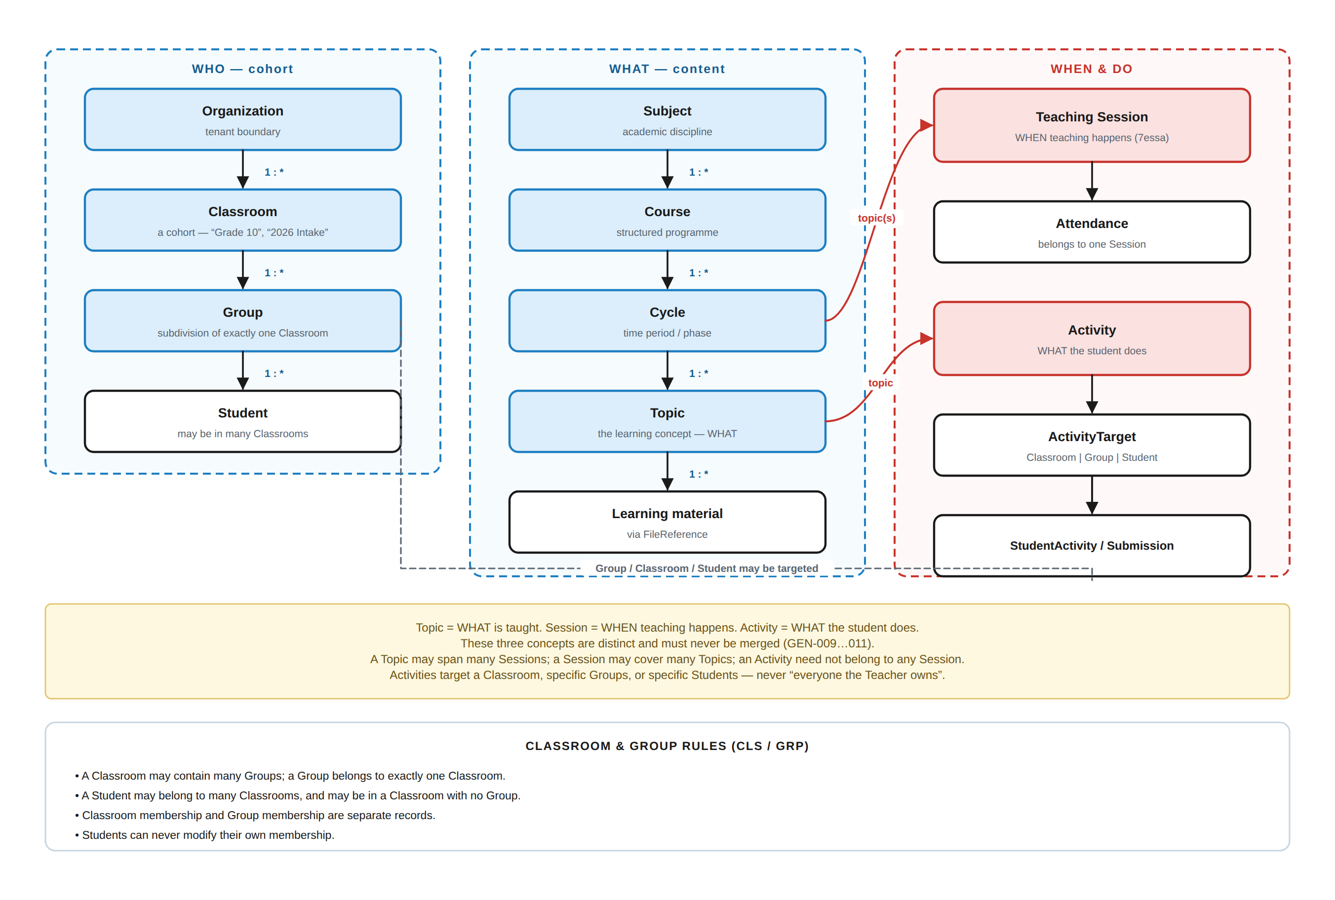
Figure 9.1 — The academic domain model: cohort, content, and time/action as three distinct trees.

9.1 Definitions in force
Concept | Rule | Example
Classroom | A broad student category or cohort. Not necessarily a physical room. | Grade 10 · Advanced Students · Computer Engineering · 2026 Intake · Summer Program · English B1
Group | A subdivision inside exactly one Classroom. | Grade 10 → Group A, Group B, Group C

9.2 Structural rules — CONFIRMED
ID | Rule | Priority
CLS-001 | A Classroom may contain multiple Groups. | MUST
GRP-001 | A Group belongs to exactly one Classroom. | MUST
CLS-002 | A Student may belong to multiple Classrooms. | MUST
CLS-003 | Classroom membership and Group membership are separate records with independent lifecycles. | MUST
GRP-002 | A Student may belong to a Classroom without currently belonging to any Group. | MUST
CLS-004 | Students shall never be able to modify their own Classroom or Group membership. | MUST
CLS-005 | Teachers shall manage Classrooms and Groups within their authorised scope. | MUST
CLS-006 | Assistants shall manage only the Classrooms and Groups explicitly assigned to them. | MUST
CLS-007 | Parents shall see Classroom and Group information only for their linked children. | MUST
CLS-008 | Classroom-wide content shall be targetable to all Classroom members. | MUST
GRP-003 | Group-specific content shall target only that Group's members. | MUST
CLS-009 | Membership records shall be dated (joined_at, left_at) and shall never be deleted; moving a student ends one membership and creates another. | MUST
CLS-010 | Historical grades, submissions, achievements and points shall remain attached to the context in which they were earned when a Student changes Classroom or Group. | MUST

Table 9.1 — Classroom and Group rules. CLS-009/010 are what make a mid-term class change non-destructive.
BR-015 · PROPOSED · WHAT A CLASSROOM OR GROUP CHANGE DOES AND DOES NOT DO (renumbered from BR-014 in v1.1 — BR-014 was already assigned to the payment revenue-share rule in §30.1)
Moving a Student ends the current membership with a left_at date and creates a new one. Grades, submissions, point history and achievements are never moved, recalculated or deleted — they stay attached to the Activity and context in which they were earned. The Student's new Group leaderboard reflects points earned within that scope; the Student's total achievements are unaffected.
Rejected: transferring records to the new Group. It corrupts both Groups' analytics, makes the new Teacher appear to have graded work they never saw, and destroys the audit answer to “who gave this mark”.

10. Subject · Course · Cycle · Topic
This is the content tree. It is deliberately independent of the cohort tree in §9: content is authored once and delivered to whichever Classrooms, Groups or Students the Teacher targets (§15.4).
ID | Requirement | Priority | Actor
SUB-001 | The system shall support Subjects belonging to an Organization. | MUST | Teacher/Admin
SUB-002 | A Subject may contain multiple Courses. | MUST | System
CRS-001 | The system shall support Courses belonging to exactly one Subject. | MUST | Teacher
CRS-002 | Courses shall support draft, published and archived states with defined transitions. | MUST | Teacher
CRS-003 | A Course shall record its authoring Teacher permanently. | MUST | System
CYC-001 | A Course may contain multiple Cycles; a Cycle represents a time period or phase and shall have start and end dates. | MUST | Teacher
CYC-002 | Cycles shall be ordered within their Course. | MUST | Teacher
TOP-001 | A Cycle may contain multiple Topics; a Topic is the learning concept being taught. | MUST | Teacher
TOP-002 | Topics shall be ordered within their Cycle. | MUST | Teacher
TOP-003 | A Topic may be referenced by many Teaching Sessions and by many Activities. | MUST | System
CRS-004 | Learning materials shall attach to Courses, Cycles, Topics, Teaching Sessions and Activities through FileReferences, never by duplicating files. | MUST | System
CRS-005 | Students and Parents shall never modify Teacher-owned content. | MUST | System
CRS-006 | Archiving shall preserve all dependent Activities, submissions, grades and audit records. | MUST | System
CRS-007 | A Course shall not be returned to draft once a Submission exists against any of its Activities; it may only be archived. | MUST | System
CRS-008 | Publishing shall be an explicit action separate from creating or uploading. | MUST | Teacher
CRS-009 | The owning Teacher shall add or remove a co-teacher on a Course via a UserRoleAssignment scoped to that Course; a co-teacher's default permissions equal the owner's educational permissions in that scope but never include ownership transfer, co-teacher management, or Course deletion, which remain owner-only. (Added in v1.1.) | MUST | Teacher
CRS-010 | Every co-teacher grant, modification and removal shall be audited and visible to all current co-teachers of the Course. (Added in v1.1.) | MUST | System

Table 10.1 — Subject, Course, Cycle and Topic requirements.

10.1 Content lifecycle
Course & content lifecycle
DRAFT ──publish──▶ PUBLISHED ──archive──▶ ARCHIVED
▲ │ │
└──unpublish──────────┘ │
(only while no Submission exists — CRS-007) │
▼
readable forever to those who studied it
(GEN-027 · no hard delete of academic history)

11. Teaching Sessions & Attendance
A Teaching Session is a first-class academic entity: a specific teaching occurrence where a Teacher or Assistant teaches a specific group of students during a defined time. It answers when (GEN-010) and it is where attendance lives.
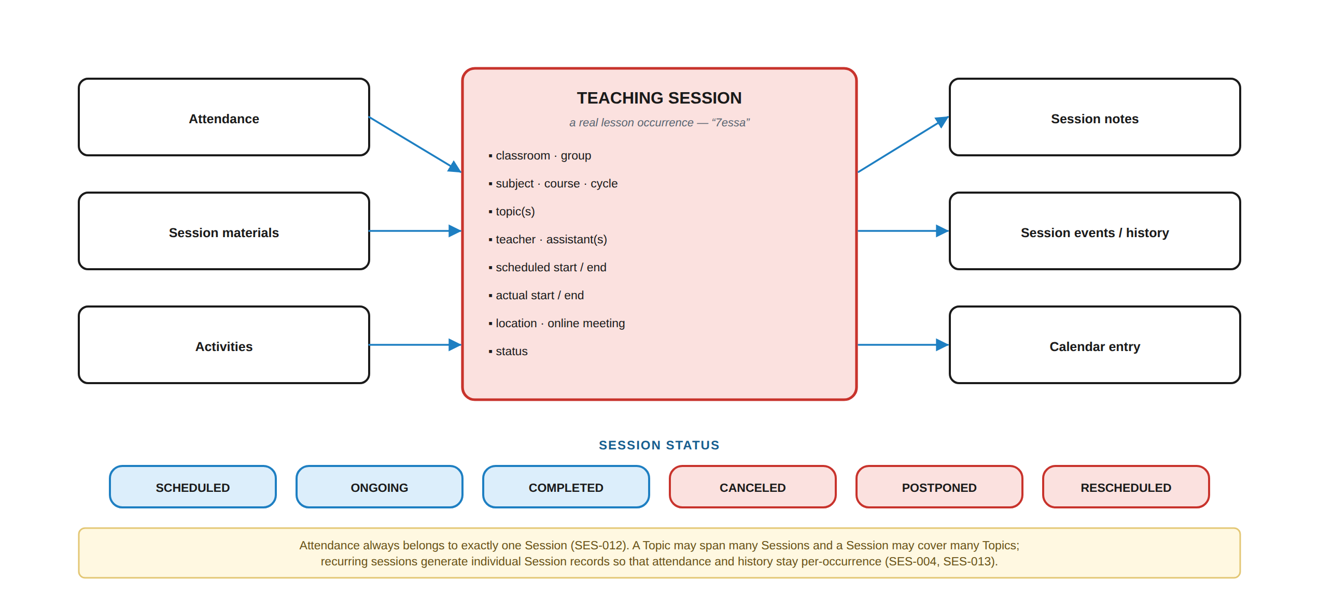
Figure 11.1 — The Teaching Session and what attaches to it.

11.1 Requirements
ID | Requirement | Priority | Actor
SES-001 | The system shall support Teaching Sessions as a distinct academic entity. | MUST | System
SES-002 | A Teaching Session shall record classroom, group, subject, course, cycle, topic(s), teacher, assistant(s), scheduled start/end, actual start/end, status, location and online-meeting information where applicable. | MUST | Teacher
SES-003 | Session status shall be one of SCHEDULED · ONGOING · COMPLETED · CANCELED · POSTPONED · RESCHEDULED. | MUST | System
SES-004 | Recurring sessions shall generate individual Session records rather than a single recurring object. | MUST | System
SES-005 | Authorized users shall schedule, reschedule, cancel, start and end Sessions within their scope. | MUST | Teacher/Assistant ⚙
SES-006 | Sessions shall support attached materials through FileReferences. | MUST | Teacher
SES-007 | Sessions shall support Teacher notes, visible according to configured visibility. | MUST | Teacher
SES-008 | Activities may originate from a Session; Session association shall be optional. | MUST | System
SES-009 | A Topic may span multiple Sessions and a Session may cover multiple Topics. | MUST | System
SES-010 | Sessions shall appear in the Teacher, Assistant, Student and Parent calendars according to scope and relationship. | MUST | System
SES-011 | The system shall maintain a Session event history recording material changes. | MUST | System
SES-012 | Attendance shall belong to exactly one Teaching Session. | MUST | System
SES-013 | Attendance shall record student, state, who recorded it and when. | MUST | System
SES-014 | Attendance shall be recordable only by an authorised Teacher, or an Assistant holding MANAGE_ATTENDANCE in the Session's scope. | MUST | System
SES-015 | Attendance changes shall be auditable. | MUST | System
SES-016 | Students shall never record or modify their own attendance. | MUST | System
SES-017 | Parents shall view attendance for linked children where the Organization enables it. | SHOULD | Parent

Table 11.1 — Teaching Session and attendance requirements.

12. Activities
Activity is the general container for anything a student is expected to do, complete, submit or participate in. Homework, Quiz, Exam and the rest are Activity types, not separate top-level academic concepts (GEN-011). This is what keeps the data model, the permission model and the analytics from fragmenting.

12.1 Activity types
Type | Purpose | V1 | Default grading
Homework | Work completed outside or after a lesson | MUST | Manual / hybrid
Quiz | Short assessment | MUST | Automatic + manual
Assignment | Structured student task | MUST | Manual
Exam | Formal assessment, stricter controls | MUST | Automatic + manual
Exercise | Practice; may be ungraded | MUST | Ungraded / automatic
Project | Larger multi-step task, milestones, optionally group | MUST | Manual + rubric
Discussion | Structured student participation and replies | MUST | Manual / participation
Survey | Collect responses; optionally anonymous | MUST | Ungraded
Reading | Required reading with completion criteria | FUTURE | Completion
Video Activity | Watch with completion tracking and in-video questions | FUTURE | Completion / automatic
Presentation | Student creates and presents | FUTURE | Manual + rubric
Practical Activity | Lab or hands-on work | FUTURE | Manual + rubric
Custom Activity | Teacher-defined type with configurable submission and grading | FUTURE | Configurable

Table 12.1 — Activity types. V1 builds the first eight; the remaining five are additions to the same Activity entity, not new entities.

12.2 Universal activity structure
ACT-001 · Every Activity type shares one base structure
Activity = Identity · Academic context · Target · Schedule · Instructions
Materials · Questions/Tasks · Submission config · Grading
Feedback · Visibility · Attempts · Status · History

Academic context: Subject → Course → Cycle → Topic → [Teaching Session]
(Session association is OPTIONAL — SES-008)

12.3 Lifecycle
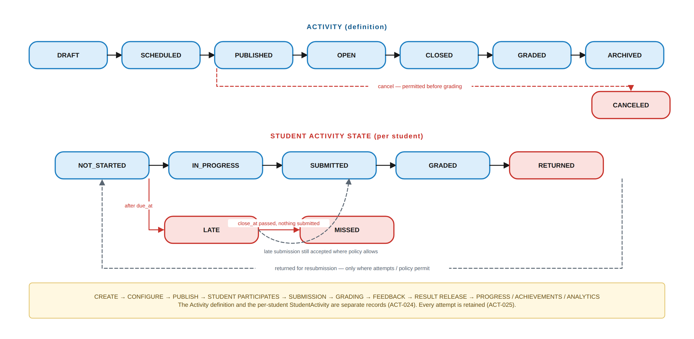
Figure 12.1 — Activity lifecycle and the separate per-student state. The definition and the student's state are different records (ACT-024).

12.4 Targeting — the rule that prevents accidental disclosure
ACT-012 · AN ACTIVITY IS DELIVERED TO AN EXPLICIT TARGET, NEVER TO “EVERYONE”
An Activity shall specify its recipients as one or more of: the entire Classroom, specific Groups, or specific Students. The system shall never assume that every student in a Teacher's account automatically receives an Activity. The resolved recipient set shall be recorded on the Activity so that later membership changes do not silently rewrite history.

12.5 Requirements
ID | Requirement | Priority | Actor
ACT-001 | The system shall provide Activity as a generic educational task entity with a shared base structure across all types. | MUST | System
ACT-002 | The system shall support the Activity types marked V1 in §12.1. | MUST | System
ACT-011 | Activities shall associate with Classroom, Group, Course, Cycle, Topic and Teaching Session as applicable. | MUST | Teacher
ACT-012 | Authorized users shall target Activities to a Classroom, specific Groups, or specific Students. | MUST | Teacher/Assistant ⚙
ACT-013 | Activities shall support publication and visibility controls (PRIVATE · TEACHER_ONLY · SCHEDULED · PUBLISHED · STUDENTS · STUDENTS_AND_PARENTS · ARCHIVED). | MUST | Teacher
ACT-014 | Activities shall support publish, start, due and close dates and a time limit where applicable. | MUST | Teacher
ACT-016 | Activities shall support configurable submission types (TEXT · FILE · MULTIPLE_FILES · LINK · IMAGE · VIDEO). | MUST | Teacher
ACT-017 | Activities shall support configurable attempt limits. | MUST | Teacher
ACT-018 | Activities shall support late-submission policy: allowed, not allowed, allowed until a date, with optional penalty, and manual acceptance. | MUST | Teacher
ACT-019 | The system shall support automatic grading for objectively gradable question types. | MUST | System
ACT-020 | The system shall support manual grading. | MUST | Teacher/Assistant ⚙
ACT-021 | The system shall support hybrid grading within a single Activity. | MUST | System
ACT-022 | The system shall support rubrics where applicable, and shall attach rubric results to the submission. | MUST | Teacher
ACT-023 | Authorized users shall provide written feedback, and file or media feedback where supported. | MUST | Teacher/Assistant ⚙
ACT-024 | Student submissions shall be maintained separately from Activity definitions. | MUST | System
ACT-025 | The system shall retain every submission attempt; a new attempt shall never overwrite a previous one. | MUST | System
ACT-026 | Authorized Teachers and Assistants shall access Activity analytics for their scope. | MUST | Teacher/Assistant ⚙
ACT-027 | The system shall notify relevant users of Activity events per §30. | MUST | System
ACT-028 | Activities shall be able to trigger achievements where configured. | MUST | System
ACT-029 | Students shall access only Activities targeted at them or at a membership they hold. | MUST | System
ACT-030 | Parents shall view only Activity information for linked children and only at the permitted visibility. | MUST | System
ACT-031 | Assistants shall manage Activities only within their delegated permissions and scope. | MUST | System
ACT-032 | Activity history shall be preserved after completion, grading, closure or archival. | MUST | System
ACT-033 | The system shall prevent unauthorized modification of Activity definitions, submissions and grades. | MUST | System
ACT-034 | The system shall record on-time or late status at submission, computed server-side from the server clock — never from a client-supplied timestamp. | MUST | System
ACT-035 | A failed submission shall preserve the student's work; no user action shall result in silently lost work. | MUST | System
ACT-036 | Where multiple attempts are allowed, the Teacher shall configure the final grade as highest, latest, average, or Teacher-selected. | MUST | Teacher

Table 12.2 — Activity requirements.

12.6 Student activity states
Activity status (definition) | StudentActivity status (per student)
DRAFT · SCHEDULED · PUBLISHED · OPEN · CLOSED · GRADED · ARCHIVED · CANCELED | NOT_STARTED · IN_PROGRESS · SUBMITTED · LATE · GRADED · RETURNED · MISSED

13. Question Bank
The Question Bank is a core reusable system for creating, storing, organising, reusing and managing questions across Quizzes, Exams, Homework, Exercises and other Activities.
GEN-012 · THE QUESTION BANK GOLDEN RULE
Create a question once → store it once → reuse it everywhere. The Question Bank stores the question. The Activity stores the *use* of the question. The Submission stores the student's response. These three are separate records, which is what makes reuse, versioning, analytics, import/export and randomised selection all tractable.

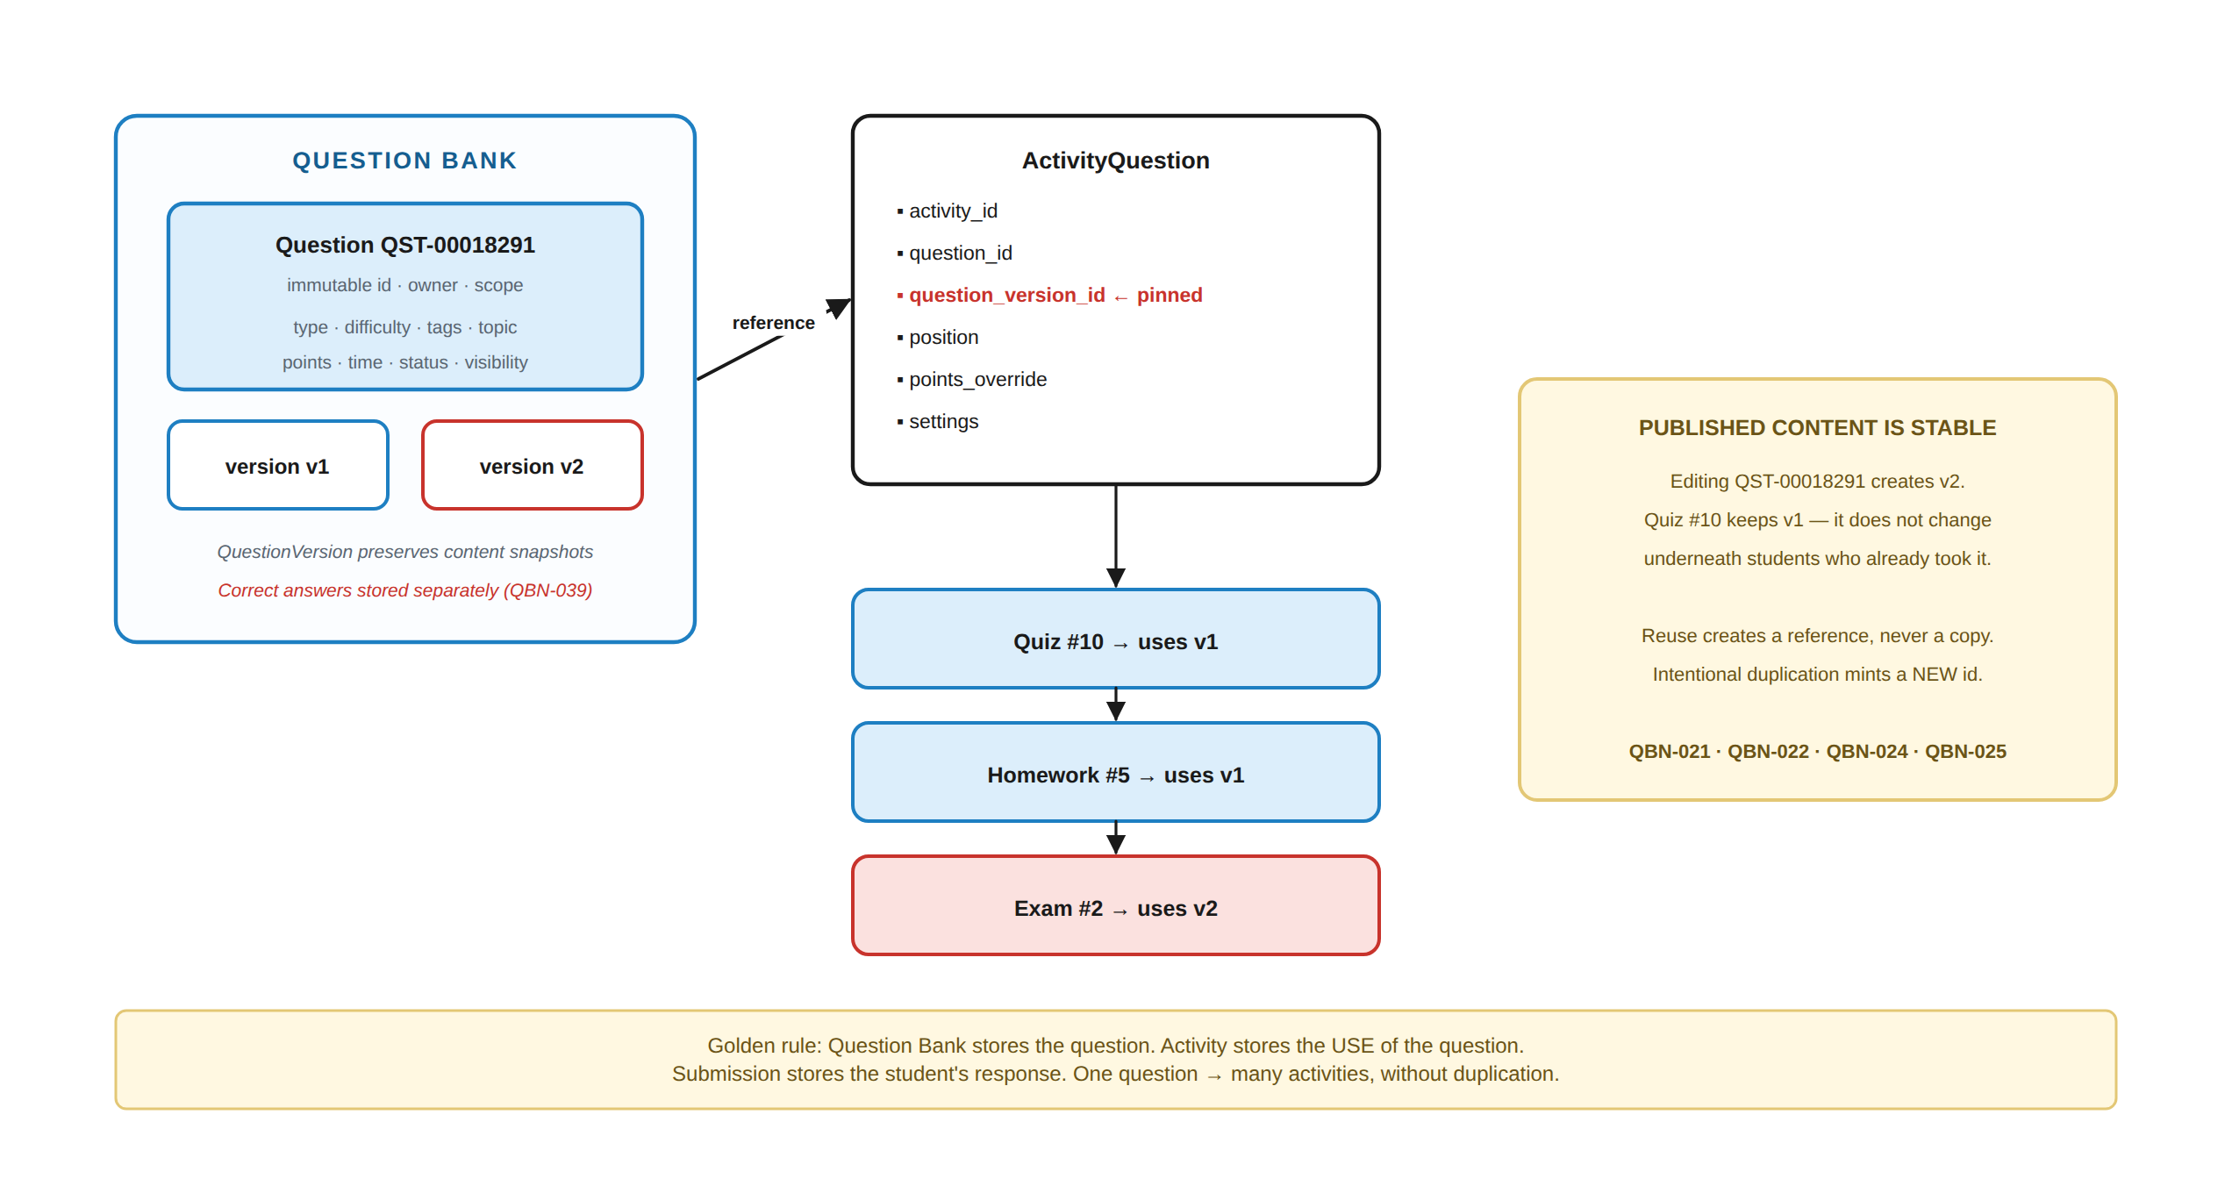
Figure 13.1 — Question reuse and version pinning. Editing a question never changes an activity that has already been published.

13.1 Question types
Type | Grading | V1 | Type | Grading | V1
Multiple choice | Automatic | MUST | Matching | Automatic | SHOULD
Multiple select | Automatic | MUST | Ordering | Automatic | SHOULD
True / False | Automatic | MUST | Image-based | Automatic/manual | SHOULD
Short answer | Automatic | MUST | Audio-based | Automatic/manual | FUTURE
Long answer / essay | Manual | MUST | Video-based | Manual | FUTURE
Numerical (tolerance, units) | Automatic | MUST | Code question | Automatic | FUTURE
Fill in the blank | Automatic | MUST

Table 13.1 — Question types. Code questions require a secure execution environment and are FUTURE.

13.2 Question structure
Group | Fields
Identity | Question ID (unique, immutable, stable across edits), owner, organization
Classification | Type · Subject · Course · Cycle · Topic · learning objective(s) · tags · difficulty
Content | Rich text · mathematics (stored as LaTeX/MathML, not as a screenshot) · images · tables · code · media
Answers | Answer options with position, correctness, per-answer feedback and score value
Assessment | Default points · estimated time · explanation with configurable reveal timing
Governance | Status (DRAFT · READY · PUBLISHED · ARCHIVED) · visibility (PRIVATE · SHARED · ORGANIZATION) · versions · usage history

13.3 Requirements
ID | Requirement | Priority | Actor
QBN-001 | The system shall provide a Question Bank for authorized educational staff. | MUST | Teacher
QBN-002 | Each question shall have a unique immutable identifier that remains stable when the question is edited. | MUST | System
QBN-003 | The system shall support the question types marked V1 in §13.1. | MUST | System
QBN-014 | The system shall support question difficulty classification. | MUST | Teacher
QBN-015 | The system shall support academic classification by Subject, Course, Cycle and Topic. | MUST | Teacher
QBN-016 | The system shall support custom tags. | MUST | Teacher
QBN-017 | The system shall support learning-objective association. | SHOULD | Teacher
QBN-018 | The system shall support question explanations with configurable reveal timing (always hidden · after submission · after grading · after close · teacher only). | MUST | Teacher
QBN-019 | The system shall support default points and estimated completion time. | MUST | Teacher
QBN-020 | The system shall support question collections containing references, not copies. | MUST | Teacher
QBN-021 | The system shall allow a question to be reused across multiple Activities. | MUST | Teacher
QBN-022 | Reusing a question shall not create a duplicate question record. | MUST | System
QBN-023 | The system shall support intentional duplication, which mints a new Question ID. | MUST | Teacher
QBN-024 | The system shall support question versioning. | MUST | System
QBN-025 | A published Activity shall preserve the exact question version used at publication. | MUST | System
QBN-026 | The system shall support Question Pools. | MUST | Teacher
QBN-027 | The system shall support random selection from pools, including per-difficulty quotas. | MUST | Teacher
QBN-028 | The system shall support search and filtering across all classification fields. | MUST | Teacher
QBN-029 | The system shall support question import (EduCapsules package · CSV · Excel · JSON; QTI-compatible formats where supported). | MUST | Teacher ⚙
QBN-030 | The system shall support question export. | MUST | Teacher ⚙
QBN-031 | The system shall perform duplicate detection during import. | MUST | System
QBN-032 | The system shall never automatically merge questions solely because they appear similar. | MUST | System
QBN-033 | The system shall maintain question usage history. | MUST | System
QBN-034 | The system shall provide question-performance analytics to authorized users. | SHOULD | Teacher
QBN-035 | The system shall support Teacher-owned and Organization-owned Question Banks. | MUST | System
QBN-036 | The system shall support controlled sharing of questions with named Teachers or Assistants. | SHOULD | Teacher
QBN-037 | Assistants shall access the Question Bank only per delegated permissions and scope. | MUST | System
QBN-038 | Students shall have no direct access to any Question Bank. | MUST | System
QBN-039 | Correct answers and internal question metadata shall never be transmitted to a student client before the Activity permits their release. | MUST | System
QBN-040 | Parents shall have no direct access to any Question Bank. | MUST | System
QBN-041 | Question Bank authorization shall be enforced server-side. | MUST | System
QBN-042 | Question Bank operations shall be auditable where they affect published assessments. | MUST | System

Table 13.2 — Question Bank requirements.

13.4 What a student never receives
GEN-026 / QBN-039 · THE ANSWER KEY NEVER LEAVES THE SERVER
A student client shall never receive: answer keys, correct-answer flags, teacher notes, internal tags, hidden difficulty metadata, unpublished or future questions, other Teachers' questions, or Question Bank identifiers where unnecessary. It is not sufficient that the interface does not display them — they must not be in the response at all. This is a network-inspection-level requirement and is tested as such (TC-011).

13.5 Duplicate detection
Import and upload duplicate detection may use similarity signals, but the system shall present options (use existing · create new anyway · compare · cancel) and shall never merge automatically (QBN-031, QBN-032). Filename or question text alone is never treated as identity.

14. Teacher Storage
Teacher Storage is a private workspace inside the platform. It is not course content and it is not visible to students. The Teacher owns and manages their educational workspace; EduCapsules controls the infrastructure, security, access and delivery of what is stored there.
GEN-014 · THE STORAGE GOLDEN RULE
Upload once → store once → reference everywhere → version when changed → export without unnecessary duplication → import with deduplication.

14.1 The three-layer model
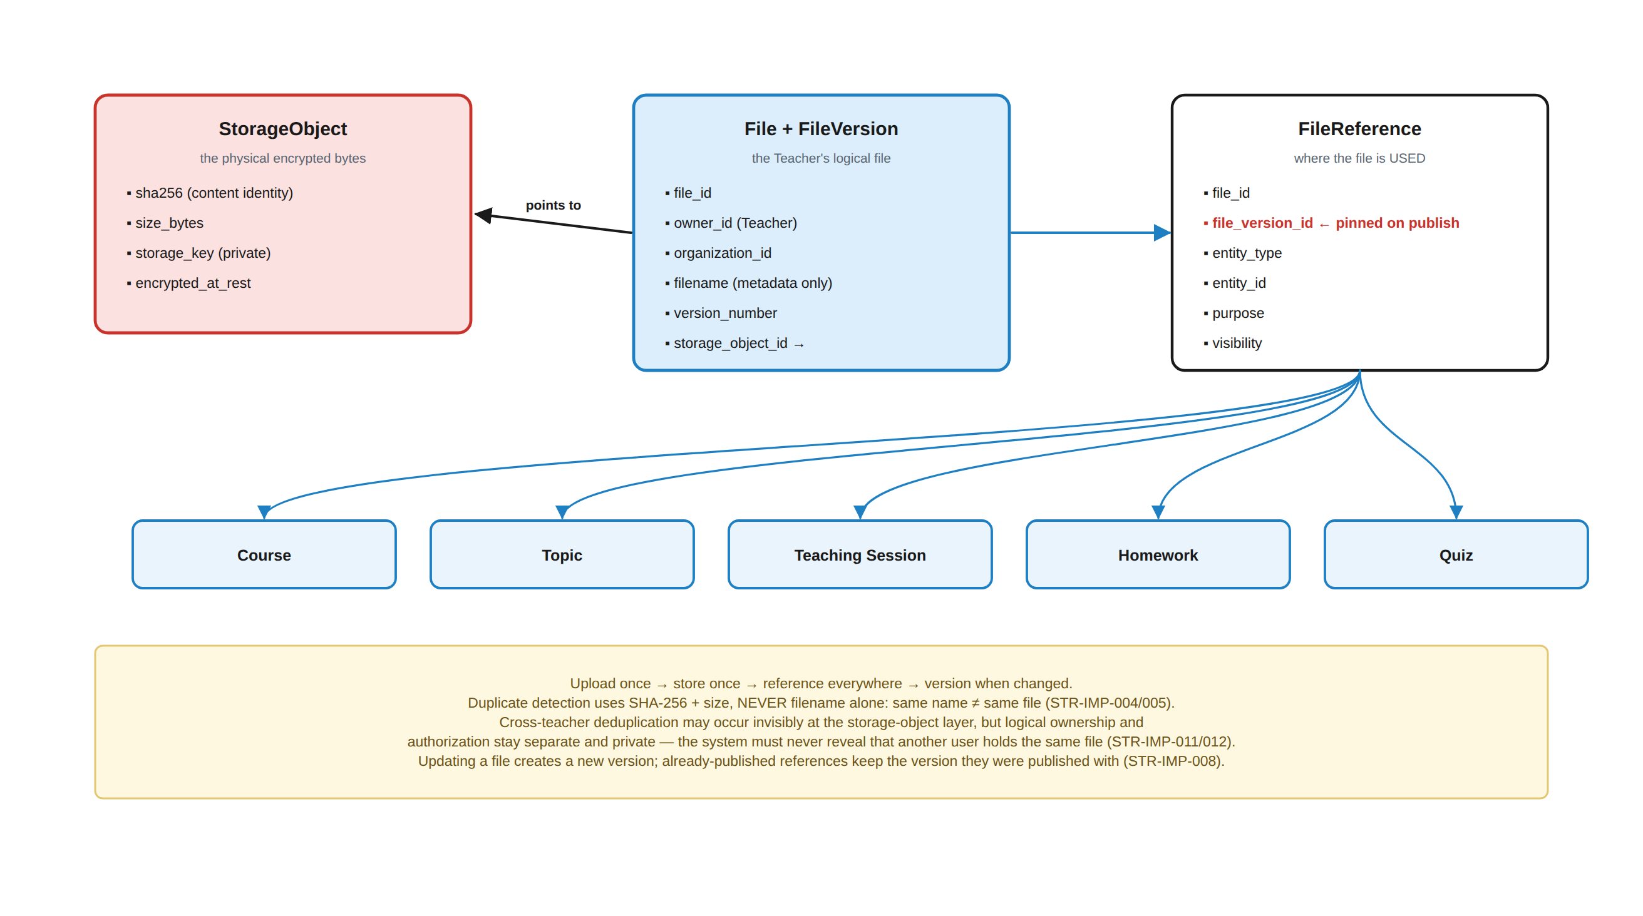
Figure 14.1 — StorageObject (bytes) · File + FileVersion (the Teacher's logical file) · FileReference (where it is used). One physical object serves many educational resources.
Layer | Identity | Owned by | Purpose
StorageObject | SHA-256 content hash | The platform | The physical encrypted bytes. Private, never publicly addressable. May be shared internally between tenants — invisibly.
File / FileVersion | File ID + version number | The Teacher (and Organization) | The logical file the Teacher sees, names, versions, organises and owns.
FileReference | Reference ID | The educational entity | Where the file is *used* — a Course, Topic, Teaching Session, Homework or Quiz — with its own purpose, visibility and content policy.

Table 14.1 — Separating these three is what makes deduplication, versioning and content protection all possible without breaking ownership.

14.2 Storage areas
STR-016 · The Teacher's storage structure
Teacher Storage
├── My Files private personal files
├── Courses organised by Subject → Course → Cycle → Topic
├── Homework Materials
├── Quiz Materials
├── Resources
├── Shared with Assistants explicitly shared, per-permission
├── Archive retained, not offered to students
└── Trash recoverable before purge

14.3 Core storage requirements
ID | Requirement | Priority | Actor
STR-001 | The system shall provide each Teacher with logically isolated private storage. | MUST | System
STR-002 | Teacher Storage shall not be publicly accessible by default. | MUST | System
STR-003 | The system shall enforce server-side authorization for every storage operation. | MUST | System
STR-004 | Students shall have no direct access to Teacher Storage. | MUST | System
STR-005 | Parents shall have no direct access to Teacher Storage. | MUST | System
STR-006 | Assistants shall access Teacher Storage only where explicitly shared, and only with the granted operations (view · upload · edit · delete · share · publish · download). | MUST | System
STR-007 | Uploaded files shall undergo validation of size, declared MIME type, extension and file signature, and shall be malware-scanned before becoming available. | MUST | System
STR-008 | Protected files shall be encrypted at rest. | MUST | System
STR-009 | Protected content shall be delivered through authorized content-delivery mechanisms, never through permanent public URLs. | MUST | System
STR-010 | The system shall maintain file metadata, ownership and content hash. | MUST | System
STR-011 | The system shall support configurable per-plan storage quotas. | MUST | System
STR-012 | Deleted files shall go to Trash and be recoverable for a defined retention period before purge. | MUST | System
STR-013 | The system shall maintain version history where versioning is enabled. | MUST | System
STR-014 | Security-sensitive storage operations shall be logged: upload · download · delete · restore · rename · move · share · permission change · publish · unpublish · version change. | MUST | System
STR-015 | A user shall not be able to access another user's storage by manipulating file identifiers. | MUST | System
STR-016 | Teachers shall organise storage with folders, search, filter, sort, tags, favourites and preview. | MUST | Teacher
STR-017 | The system shall warn before deleting a file that is currently referenced, stating how many educational resources reference it. | MUST | System
STR-018 | Reaching a storage quota shall block new uploads but shall never break students' access to already-published content. | MUST | System
STR-019 | The system shall notify the Teacher at defined quota thresholds. | SHOULD | System
STR-020 | Teachers shall download their own original files; downloads shall be authenticated and logged. | MUST | Teacher
STR-021 | External sharing shall be configurable and, where enabled, shall use expiring, revocable links with optional password and download restrictions. Protected course content shall not be externally shareable. | SHOULD | Teacher
STR-022 | Large files shall be stored in object storage, not in the relational database; the database shall hold metadata and references. | MUST | System
STR-023 | A File with one or more live FileReferences shall not be purged; it may be trashed, but purge is blocked until every reference is removed. STR-017's warning is presentational; this is the enforced guard behind it. (Added in v1.1.) | MUST | System

Table 14.2 — Teacher Storage requirements.

14.4 Import, reference and deduplication
ID | Requirement | Priority | Actor
STR-IMP-001 | Authorized users shall attach existing Storage files to educational entities without creating physical copies. | MUST | Teacher/Assistant ⚙
STR-IMP-002 | The system shall distinguish physical Storage objects from logical file references. | MUST | System
STR-IMP-003 | One Storage file shall be attachable to multiple Courses, Topics, Teaching Sessions and Activities. | MUST | System
STR-IMP-004 | Duplicate detection shall use content-based identification (SHA-256) together with file size. | MUST | System
STR-IMP-005 | Filename shall never be used alone as the duplicate criterion — the same name may be a completely different file. | MUST | System
STR-IMP-006 | When an identical file is uploaded, the system shall offer to reuse the existing accessible file or to store it as a new version. | MUST | System
STR-IMP-007 | Versioning shall not duplicate identical versions. | MUST | System
STR-IMP-008 | Published content shall preserve its published version when the source file is subsequently updated. | MUST | System
STR-IMP-011 | Logical ownership and authorization boundaries shall be preserved when storage objects are deduplicated internally. | MUST | System
STR-IMP-012 | Deduplication shall never reveal the existence or metadata of another user's private file. | MUST | System
STR-IMP-013 | The system shall support importing previously exported EduCapsules content packages. | MUST | Teacher ⚙
STR-IMP-009 | Imported files shall be compared against accessible existing files before creating new physical copies. | MUST | System
STR-IMP-010 | The system shall never automatically overwrite an existing file when an imported file has the same filename but different content. | MUST | System
STR-EXP-001 | Authorized users shall export Storage files. | MUST | Teacher ⚙
STR-EXP-002 | Authorized users shall export folders and supported content collections. | SHOULD | Teacher ⚙
STR-EXP-003 | Course exports shall not include multiple physical copies of the same file when several references point to it. | MUST | System
STR-EXP-004 | Exports shall preserve relationships between educational entities and files. | MUST | System
STR-EXP-005 | Export packages shall include a manifest sufficient to reconstruct file references on import. | MUST | System

Table 14.3 — Import, export, reference and deduplication requirements.
STR-EXP-003 · Reference-preserving export, not naive duplication
Export/
├── files/
│ └── F-10291_Algebra.pdf ONE physical copy
└── manifest.json
Topic 1 → files/F-10291_Algebra.pdf
Topic 2 → files/F-10291_Algebra.pdf
Session 1 → files/F-10291_Algebra.pdf
Homework → files/F-10291_Algebra.pdf

STR-IMP-011/012 · PROPOSED · CROSS-TENANT DEDUPLICATION IS INVISIBLE
Physical deduplication may occur at the storage-object layer across tenants, so that two Teachers holding the same file consume one object. Each Teacher still has their own File record, ownership and references, and deleting one Teacher's File never deletes the object while another reference exists. The system shall never say “this file already exists” when the match is in another user's storage — duplicate checks are performed only within the requesting user's accessible storage.
Rejected: naive per-user physical copies (expensive), and cross-user duplicate messages (leaks the existence of another user's private file).

15. Content Publishing
Uploading is not publishing. The gap between the two is a deliberate security boundary.
CNT-001 · The publishing pipeline
Teacher Storage (private)
↓ select file
Attach to Course / Cycle / Topic / Session / Activity → FileReference
↓ configure visibility and content policy
PUBLISH (explicit action)
↓
Protected content delivery (§16)
↓
Authorized students only

ID | Requirement | Priority | Actor
CNT-001 | Uploading a file shall not make it visible to any student; publication shall be an explicit, separate action. | MUST | System
CNT-002 | Publication shall create or update a FileReference with an explicit visibility and content policy. | MUST | System
CNT-003 | Draft content shall be visible only to its owner and to explicitly authorised staff. | MUST | System
CNT-004 | Published references shall pin the file version published (GEN-015). | MUST | System
CNT-005 | Unpublishing shall remove student access without deleting the file or its history. | MUST | Teacher
CNT-006 | Content policy shall be set per reference, not globally: view · download · print · copy · share. | MUST | Teacher
CNT-007 | Archived content shall remain accessible to its owner and to those who already studied it, and shall not be offered for new assignment. | MUST | System

Table 15.1 — Publishing requirements.

16. Content Protection
This is a major EduCapsules requirement and it is stated honestly. The goal is not to make copying technically impossible — for content a human can see, that is unachievable. The goal is that unauthorized extraction is difficult, detectable, traceable and economically unattractive.
GEN-016 · THE CENTRAL CONTENT-PROTECTION PRINCIPLE
Access to a course ≠ access to the original course files. A student never receives the original stored asset merely because they are logged in and enrolled. They receive a protected rendering or an encrypted stream, delivered through the Content Gateway after every authorization, entitlement, policy and abuse check has passed.

16.1 The delivery pipeline
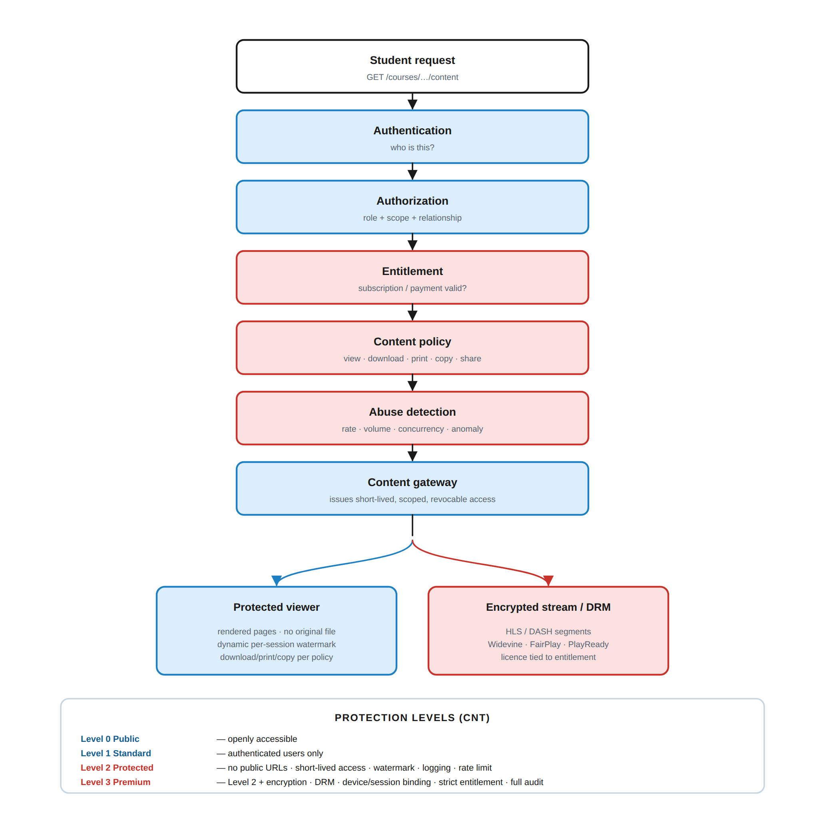
Figure 16.1 — The content protection pipeline and the four protection levels.

16.2 Protection levels
Level | Applies to | Controls | Example content
0 Public | Deliberately public material | None beyond normal web serving | Public course introduction, marketing page
1 Standard | Authenticated users | Login required; no public URL | General course information
2 Protected | Normal course content | No public URLs · short-lived scoped access · dynamic watermark · access logging · rate limiting | Course PDF, worksheet, lesson notes
3 Premium | High-value paid content | Level 2 + encryption · DRM where applicable · strict entitlement · device/session controls · concurrent-playback limits · detailed audit | Paid course PDF, recorded lecture, exam content

Table 16.1 — Protection is set per content reference. A course may mix levels.

16.3 Requirements
ID | Requirement | Priority | Actor
CNT-010 | No course content shall be publicly accessible unless explicitly designated Level 0. | MUST | System
CNT-011 | Every content request shall undergo server-side authentication, authorization, entitlement and content-policy evaluation. | MUST | System
CNT-012 | Students shall never receive permanent unrestricted URLs to protected assets. | MUST | System
CNT-013 | Protected content shall be delivered through short-lived, scoped, cryptographically random, revocable access. | MUST | System
CNT-014 | Protected documents shall be delivered through a protected viewer that renders content rather than serving the original file. | MUST | System
CNT-015 | Protected content shall carry a dynamic watermark identifying user, content, session and time where practical. | MUST | System
CNT-016 | Protected video shall be delivered as encrypted segmented streams (HLS and/or DASH), not as direct file URLs. | MUST | System
CNT-017 | Level 3 video shall use DRM where the client platform supports it. | SHOULD | System
CNT-018 | Protected course content shall never be embedded in client-side code or configuration. | MUST | System
CNT-019 | The system shall rate-limit content requests per user, per resource and per session. | MUST | System
CNT-020 | The system shall detect and respond to bulk-extraction and scraping patterns. | MUST | System
CNT-021 | The system shall support concurrent-session and concurrent-playback limits, configurable per plan and per protection level. | SHOULD | System
CNT-022 | Content access shall be logged with user, content, action, device, session and timestamp. | MUST | System
CNT-023 | A protected content link shared with an unentitled user shall grant no access. | MUST | System
CNT-024 | Detected extraction abuse shall raise a Security Event, and may revoke content tokens, apply rate limits, require re-authentication or restrict content access. | MUST | System
CNT-025 | Automated abuse controls shall use thresholds and multiple signals; a single unusual request shall not block a legitimate user. | MUST | System
CNT-026 | Assistants shall access only the Teacher content explicitly shared with them; an Assistant shall not be able to bulk-download a Teacher's course library. | MUST | System
CNT-027 | Students shall have no native “share course content” function unless the Teacher explicitly enables it for that content. | MUST | System
CNT-028 | Content ownership, organization, protection policy and modification history shall be recorded for every protected asset. | MUST | System

Table 16.2 — Content protection requirements.

16.4 Screenshots and screen recording — stated honestly
GEN-022 · WHAT THE PLATFORM MUST NOT CLAIM
On ordinary web browsers, screenshots and screen recording cannot be reliably prevented, and no EduCapsules requirement, marketing statement or legal document shall claim otherwise. Copy-blocking, context-menu suppression and DevTools-blocking are deterrents, not security boundaries, and shall never be relied on as protection.
The enforceable version of the requirement is CNT-029 below.

ID | Requirement | Priority | Actor
CNT-029 | On supported native platforms the system shall restrict screenshot and screen-recording capability for Level 3 content using operating-system controls where available. On platforms where prevention is not technically possible, the system shall rely on DRM, dynamic watermarking, access control, entitlement and monitoring to deter, trace and limit unauthorized capture. | MUST | System
CNT-030 | Highly protected content may be designated native-application-only where the Organization requires stronger capture protection. | SHOULD | System
CNT-031 | Offline content, where supported, shall use encrypted local storage, device-bound keys, expiring licences and periodic online entitlement checks; protected assets shall never be written to the user's ordinary filesystem as plain files. | FUTURE | System

16.5 Development rules that are requirements
- Never place course content, permanent asset URLs or answer keys in JavaScript, client configuration or client-side state (CNT-018).
- Never trust student_id, role, organization_id or any scope value supplied by the client (SEC-004).
- Never rely on disabling F12, right-click or text selection as protection (GEN-003).
- Assume the student's device is hostile: the client may inspect network traffic, modify JavaScript, replay and automate requests, and record the screen. Every security decision is therefore made server-side (GEN-004).

17. Grading, Feedback & Progress

17.1 Grading requirements
ID | Requirement | Priority | Actor
GRD-001 | Authorized users shall record a score against a Submission. | MUST | Teacher/Assistant ⚙
GRD-002 | The system shall support automatic, manual and hybrid grading within one Activity. | MUST | System
GRD-003 | Authorized users shall provide written feedback, and rubric, file or media feedback where supported. | MUST | Teacher/Assistant ⚙
GRD-004 | Grades shall be released explicitly; an unreleased grade shall not be visible to the Student or Parent. | MUST | Teacher
GRD-005 | Only users holding the relevant permission in the Activity's scope shall create or modify a grade. | MUST | System
GRD-006 | Every grade change shall be recorded in an append-only history capturing old value, new value, actor, timestamp and — after release — a reason. | MUST | System
GRD-007 | Grade history shall be preserved after the grader's account is deactivated, and shall continue to identify the original grader. | MUST | System
GRD-008 | Where multiple attempts exist, the recorded result shall follow the Activity's configured policy (highest · latest · average · teacher-selected). | MUST | System
GRD-009 | Late submissions shall be flagged, and any configured penalty shall be applied transparently, storing both raw and adjusted score. | MUST | System
GRD-010 | Students shall see their own grades and feedback once released; Parents shall see their linked child's; no user shall see another student's. | MUST | System
GRD-011 | Administrative grade override, where it exists, shall require elevated permission, a stated reason and a high-severity audit event. | MUST | Admin
GRD-012 | Grade writes shall be transactional; a partial grade write shall never be observable. | MUST | System

Table 17.1 — Grading and feedback requirements.
GRD-006 · GRADE INTEGRITY IS THE PRODUCT'S CREDIBILITY
A grade modification records: old value, new value, who changed it, when, and why. History is append-only — a correction writes a new row and never edits the previous one. This is what lets the platform answer, months later, the only question that matters in a dispute.

17.2 Progress requirements
ID | Requirement | Priority | Actor
PRG-001 | The system shall track Activity completion per student. | MUST | System
PRG-002 | The system shall present progress at Topic, Cycle and Course level. | MUST | System
PRG-003 | The system shall present an overall progress figure per student. | MUST | System
PRG-004 | Progress shall be derived and reproducible from stored records at any time; a stored progress figure is a cache, not a source of truth. | MUST | System
PRG-005 | Progress shall be recomputed on every event that can change it. | MUST | System
PRG-006 | Teachers and authorized Assistants shall see progress per student and per group within their scope, without averaging across scopes in a way that hides a lagging group. | MUST | Teacher/Assistant ⚙
PRG-007 | Optional or ungraded Activities shall not reduce a student's progress percentage. | MUST | System
PRG-008 | Progress shall measure completion, not attainment; grade and progress shall be reported as separate figures. | MUST | System

Table 17.2 — Progress tracking requirements.
BR-020 · PROPOSED · PROGRESS MEASURES COMPLETION, NEVER ATTAINMENT
A student who submits everything and scores poorly is at 100% progress with a low grade. Conflating the two produces a number that answers neither question. The exact weighting formula per Activity type is OPEN (§50, D-17) and shall be configured centrally once decided — but the completion-not-attainment principle is binding regardless of the formula.

18. Achievements, Points & Leaderboards
Gamification is a major EduCapsules component. It is built to be auditable, because a motivation system that can be quietly manipulated stops motivating.

18.1 Achievements
ID | Requirement | Priority | Actor
ACH-001 | Students shall view earned achievements with details, badge, points and award date. | MUST | Student
ACH-002 | Teachers shall create custom achievements within their authorised scope. | MUST | Teacher
ACH-003 | Achievement categories 1–4 shall be configurable by Teachers, and by Assistants where explicitly permitted within scope. | MUST | Teacher/Assistant ⚙
ACH-004 | Homework and Quiz achievements shall be decidable by Teachers and by authorized Assistants. | MUST | Teacher/Assistant ⚙
ACH-005 | Criteria-based achievements shall be evaluated automatically when a qualifying event occurs. | MUST | System
ACH-006 | Achievement definition, configuration and awarding shall be permission-controlled. | MUST | System
ACH-007 | An achievement shall be awarded at most once per student unless explicitly defined as repeatable. | MUST | System
ACH-008 | Achievements shall be retained permanently, including after Classroom or Group change and after course archival. | MUST | System
ACH-009 | Achievement awards, revocations and definition changes shall be audited. | MUST | System
ACH-010 | Parents shall view their linked child's achievements; no user shall configure achievements they are not permitted to configure. | MUST | System
PTS-001 | The system shall maintain a point balance per student. | MUST | System
PTS-002 | Point-earning events and their values shall be defined centrally and applied consistently. | MUST | System
PTS-003 | Point corrections shall be made by compensating entries; no point record shall be edited or deleted. | MUST | System
PTS-004 | Manual point adjustment shall require permission and a stated reason, and shall be audited. | MUST | Teacher ⚙
PTS-005 | Students, linked Parents and authorized staff shall view relevant point information and history. | MUST | System
PTS-006 | Point values shall be configurable per Organization without a code change. | SHOULD | Admin

Table 18.1 — Achievement and points requirements.

18.2 Leaderboards
ID | Requirement | Priority | Actor
LDB-001 | The system shall support leaderboards at Group, Classroom, Subject and Cycle scope. | MUST | System
LDB-002 | Students shall view leaderboard information subject to privacy rules. | MUST | Student
LDB-003 | Parents shall view only their linked child's leaderboard position. | MUST | Parent
LDB-004 | Leaderboard configuration, including disabling a leaderboard for a Group, shall be permission-controlled. | MUST | Teacher/Admin ⚙
LDB-005 | Ties shall be resolved by a single documented rule applied consistently across every scope. | MUST | System
LDB-006 | A leaderboard shall be computed over a defined scope and period and shall never silently mix periods. | MUST | System
LDB-007 | Assistant leaderboard visibility shall be limited to their assigned scope. | MUST | System
LDB-008 | A student shall be able to opt out of appearing to other students without losing their own view of their position. | SHOULD | Student
LDB-009 | A leaderboard shall default to disabled for a newly created scope; it becomes visible only after a Teacher or authorised Assistant explicitly enables it (LDB-004). (Added in v1.1.) | MUST | System

Table 18.2 — Leaderboard requirements.
LEADERBOARDS ARE THE HIGHEST REPUTATIONAL RISK IN THE PRODUCT
Done carelessly, a leaderboard publishes a ranked list of which children are struggling. LDB-004 (a Teacher can switch it off), LDB-008 (a student can opt out) and the privacy rules in §29 exist for that reason. Exact ranking source, tie rule, reset period and default visibility remain OPEN (§50, D-18) and must be decided before leaderboards ship.

19. Teacher Experience
The Teacher is the primary educational authority. Teacher authority is bounded by ownership and assigned scope — never platform-wide.

19.1 Account structure
The Teacher account and what hangs off it
Teacher Account = Identity · Profile · Authentication · Security · Preferences

├── Organizations
├── Classrooms → Groups
├── Subjects → Courses → Cycles → Topics → Teaching Sessions → Activities
├── Students · Assistants
├── Teacher Storage
├── Question Bank
├── Achievements · Leaderboards · Analytics · Calendar
├── Messages · Notifications
└── Subscription / Billing ← separate from educational authority (GEN-020)

19.2 Requirements
ID | Requirement | Priority | Actor
TCH-001 | The system shall provide each Teacher with a unique immutable Teacher ID that never changes and is never reassigned; email shall not be the primary identity key. | MUST | System
TCH-002 | The system shall maintain a Teacher profile separate from educational resources. | MUST | System
TCH-003 | The system shall support Teacher account status: PENDING_VERIFICATION · ACTIVE · SUSPENDED · LOCKED · DEACTIVATED · DELETED. | MUST | System
TCH-004 | The system shall support secure Teacher authentication. | MUST | System
TCH-005 | The system shall support MFA for Teacher accounts where enabled or required. | MUST | Teacher
TCH-006 | Teachers shall manage their own profile, visibility settings and preferences; sensitive account information shall never become public because a profile exists. | MUST | Teacher
TCH-007 | Authorized Teachers shall create and manage Classrooms. | MUST | Teacher
TCH-008 | Authorized Teachers shall manage Groups within their Classrooms. | MUST | Teacher
TCH-009 | Teachers shall view and manage students within their educational scope, and shall not receive unrelated personal information. | MUST | Teacher
TCH-010 | Teachers shall assign and manage Assistants according to §23. | MUST | Teacher
TCH-011 | The system shall support Assistant scope and permission management by the Teacher. | MUST | Teacher
TCH-012 | Teachers shall create and manage Courses within their authorised scope. | MUST | Teacher
TCH-013 | Teachers shall create and manage Cycles and Topics. | MUST | Teacher
TCH-014 | Teachers shall schedule and manage Teaching Sessions. | MUST | Teacher
TCH-015 | Teachers shall create and manage Activities. | MUST | Teacher
TCH-016 | Teachers shall review and grade student submissions. | MUST | Teacher
TCH-017 | The system shall maintain an auditable history of grade changes. | MUST | System
TCH-018 | Teachers shall manage permitted Achievements and leaderboards within scope. | MUST | Teacher
TCH-019 | The system shall provide each Teacher with private Storage. | MUST | System
TCH-020 | Teachers shall attach existing Storage files without unnecessary duplication. | MUST | Teacher
TCH-021 | The system shall separate private Storage content from published Student content. | MUST | System
TCH-022 | Teachers shall access educational analytics for their authorised scope at classroom, group, course and individual-student level. | MUST | Teacher
TCH-023 | Teachers shall have a calendar combining Sessions, deadlines, quizzes, exams and events. | MUST | Teacher
TCH-024 | The system shall support Teacher↔Student, Teacher↔Parent and Teacher↔Assistant communication per §30. | MUST | Teacher
TCH-025 | The system shall provide configurable Teacher notifications. | MUST | Teacher
TCH-026 | The system shall separate Teacher educational authority from billing and subscription status. | MUST | System
TCH-027 | The system shall enforce Teacher authorization server-side for every protected operation. | MUST | System
TCH-028 | The system shall prevent Teachers from accessing resources outside their authorised scope, including another Teacher's private Storage, unrelated classrooms and unrelated students. | MUST | System
TCH-029 | The system shall maintain audit records for security-sensitive Teacher actions. | MUST | System
TCH-030 | The system shall provide an account deletion/deactivation workflow that accounts for owned and dependent resources (§43). | MUST | System
TCH-031 | Teachers shall preview any student-facing screen as a student would see it. | SHOULD | Teacher

Table 19.1 — Teacher requirements.

19.3 Teacher security boundaries
A Teacher shall never be able to… | Enforced by
Become an Admin or grant themselves administrative permissions | SEC-006, ADM-025
Access another Teacher's private Storage | STR-001, STR-015
Access unrelated classrooms, groups or students | TCH-028, SEC-005
Modify platform security settings or system configuration | ADM-025, SEC-002
Bypass content-protection mechanisms | CNT-011, CNT-018
Modify or delete audit records | AUD-004
Manipulate subscription entitlements | BIL-006

19.4 Reference screen
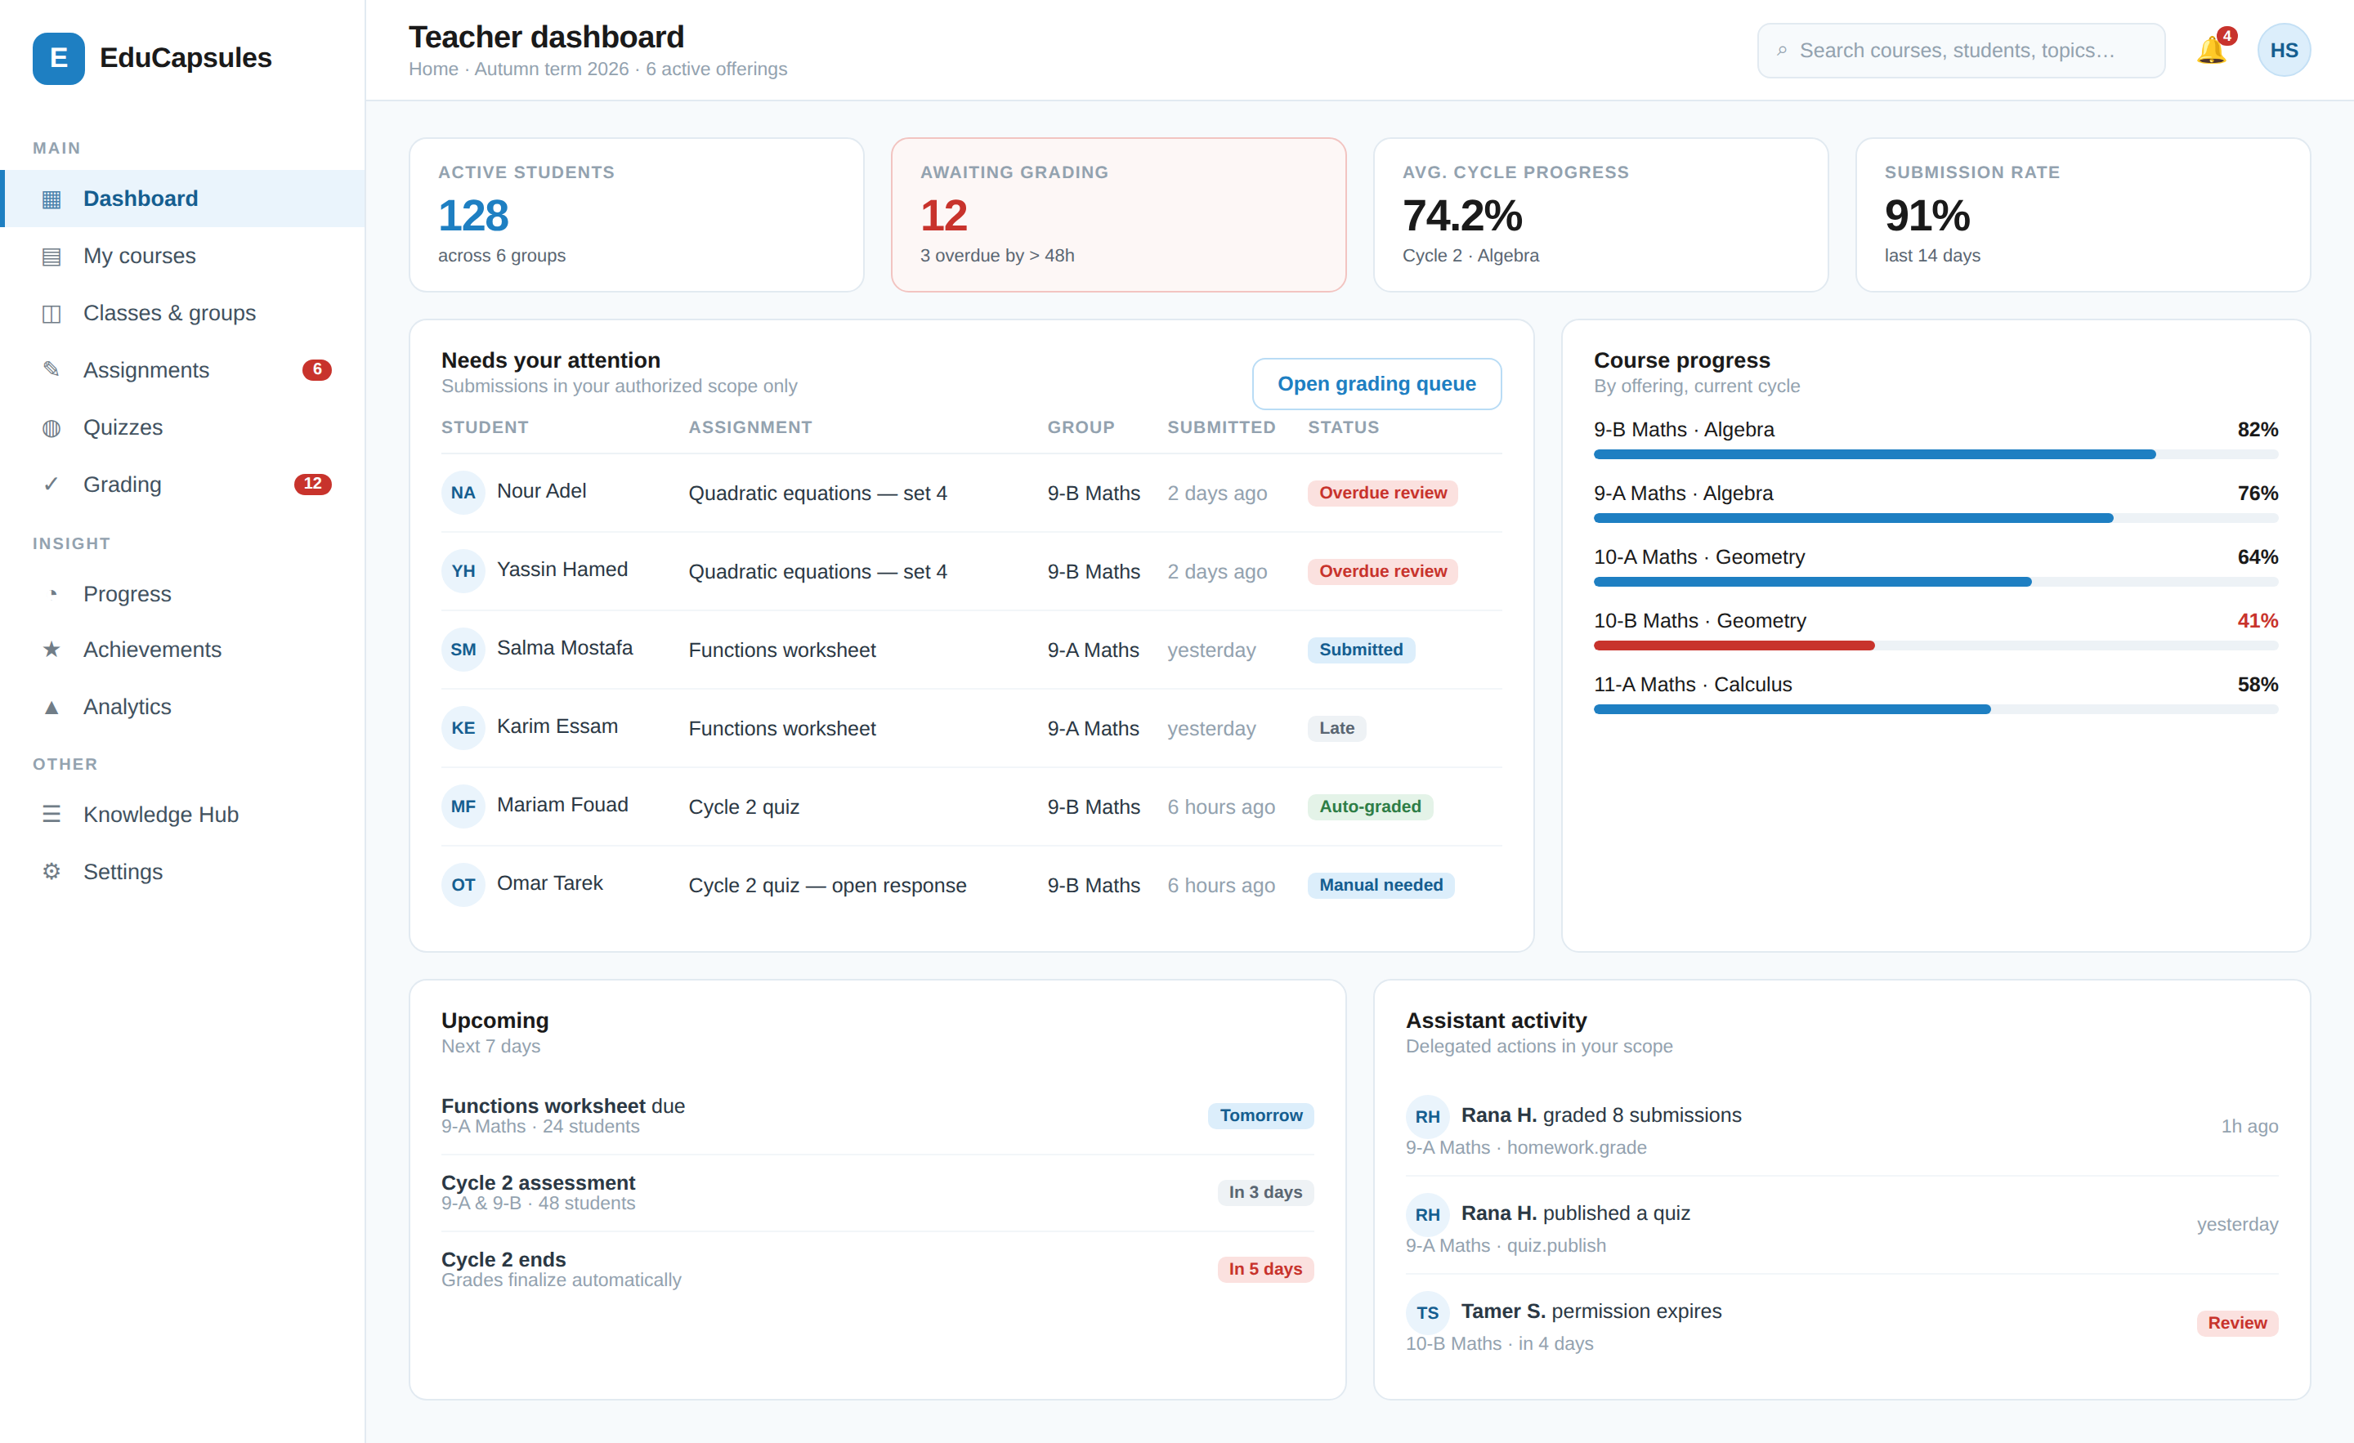
Figure 19.1 — Teacher dashboard — reference layout (§42). The grading queue is surfaced at top level because an ungraded backlog is the fastest way to lose student trust.

20. Student Experience
STU-000 · THE STUDENT AUTHORIZATION RULE
A Student may consume educational content, participate in assigned educational activities, see their own academic progress, and take part in permitted social and gamification features — but may not modify academic authority or any other student's data.

20.1 The four student pillars
The Student account model
1. LEARN Courses → Cycles → Topics → Materials
2. PARTICIPATE Activities → Homework · Quizzes · other types
3. PROGRESS Grades → Progress → Achievements → Points
4. ENGAGE Classroom → Group → permitted communication

20.2 Capability matrix
Capability | Student | Capability | Student
Manage own profile | ✔ | Earn achievements | ✔
Change own password | ✔ | View achievements | ✔
View own classroom | ✔ | Earn points | ✔
View own group | ✔ | View points history | ✔
View classmates | ⚙ | View leaderboards | ✔ ⚙
View subjects / courses / cycles / topics | ✔ | Send messages | ⚙
View published learning materials | ✔ | Receive announcements | ✔
Download materials | ⚙ per content policy | Mark attendance | ✖
Submit / edit / resubmit homework | ✔ ⚙ | Create or grade any activity | ✖
Take quizzes | ✔ | Create or modify achievements | ✖
View quiz results | ⚙ on release | Modify grades or course content | ✖
View grades and feedback | ✔ on release | Manage classroom / students / staff | ✖
Track own progress | ✔ | Manage billing or change own role | ✖

Table 20.1 — Student capabilities. ⚙ = permitted only where the Teacher or content policy allows.

20.3 Requirements
ID | Requirement | Priority | Actor
STU-001 | Students shall manage their own profile, password and preferences. | MUST | Student
STU-002 | Students shall access only the Classrooms, Groups, Courses, Cycles, Topics, Sessions and Activities their memberships and targeting entitle them to. | MUST | System
STU-003 | A Student shall never access another Student's submissions, grades, feedback, files or private information — including within the same Group. | MUST | System
STU-004 | Students shall access published learning materials only through the protected delivery path (§16), never through Teacher Storage. | MUST | System
STU-005 | Students shall submit work, and edit or resubmit where the Activity permits. | MUST | Student
STU-006 | Students shall view their own released grades, feedback and progress. | MUST | Student
STU-007 | Students shall view their own achievements, points and permitted leaderboards. | MUST | Student
STU-008 | Students shall view their schedule and receive announcements and notifications. | MUST | Student
STU-009 | Students shall communicate only within permitted educational relationships. | MUST | Student
STU-010 | Students shall never modify their own membership, attendance, grades or role. | MUST | System
STU-011 | The student dashboard shall not expose staff management, other students' private data, grade editing, structure administration, achievement configuration, billing administration, Teacher Storage or administrative settings. | MUST | System
STU-012 | A Student's visible identity to other students shall be limited by the Organization's privacy configuration. | MUST | System

Table 20.2 — Student requirements.
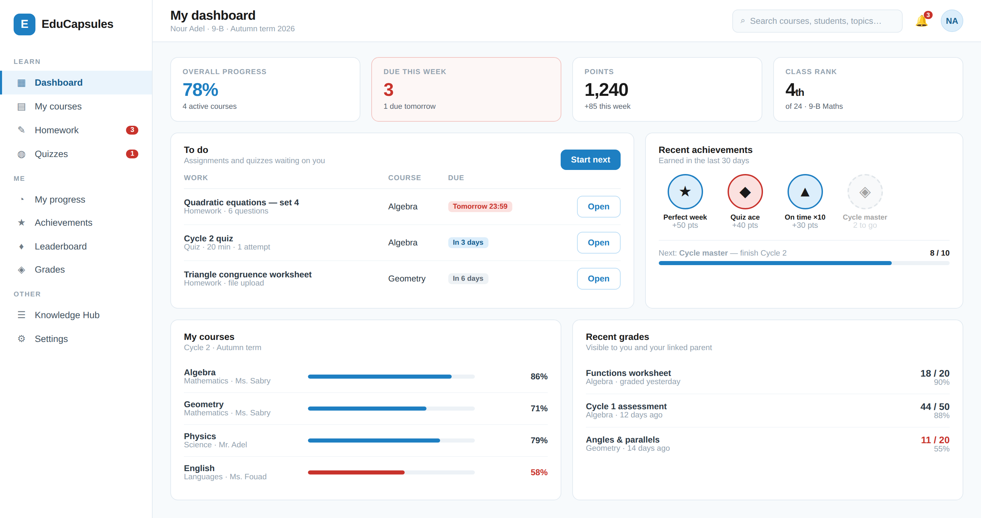
Figure 20.1 — Student dashboard — reference layout. Everything shown derives from membership and targeting; nothing is manually curated.

21. Assistant Experience & Delegation
GEN-006 · THE ASSISTANT RULE
Assistant access is always Assignment + Scope + Permissions. Being an Assistant, on its own, grants nothing at all. An Assistant can perform educational and operational tasks delegated by a Teacher, but never ownership, platform-administration, billing or unrestricted account-management functions.

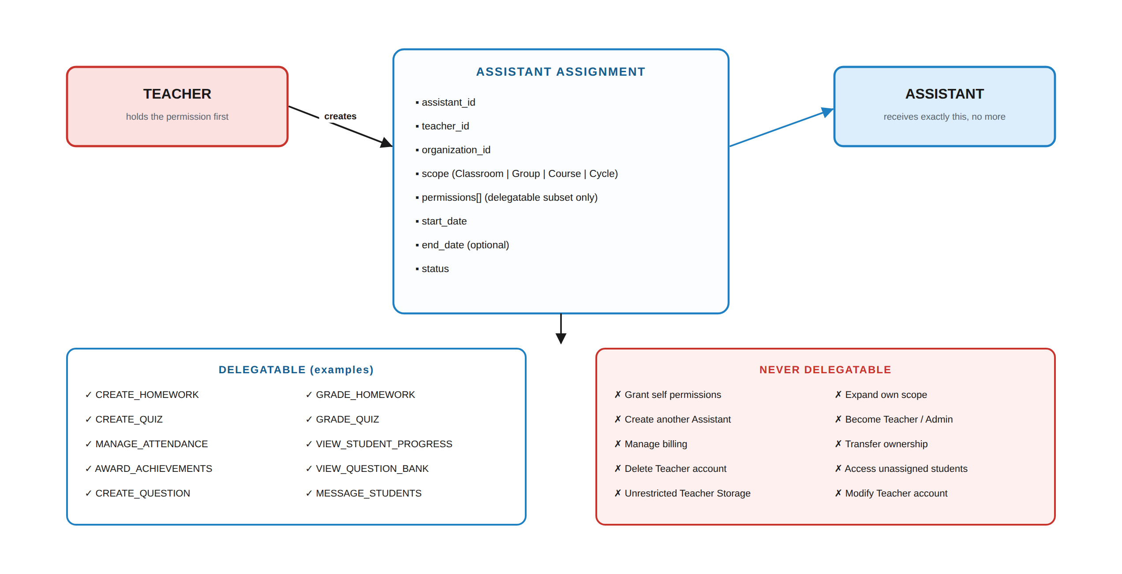
Figure 21.1 — The delegation model and its hard limits.

21.1 The Assistant Assignment
Field | Meaning
assistant · teacher · organization | Who is delegated to, by whom, in which tenant
scope | Classroom · Group · Course · Cycle, or a combination. The Assistant must satisfy every scope named on the assignment.
permissions[] | An explicit subset of the delegatable permission catalogue (§26.3)
start_date · end_date | Optional time bounds. Expiry terminates access automatically, with no further action required (AST-006).
status | ACTIVE · EXPIRED · REVOKED

21.2 Requirements
ID | Requirement | Priority | Actor
AST-001 | Assistant shall be a distinct account type, not a Teacher with fewer permissions. | MUST | System
AST-002 | An Assistant shall access only the scopes and permissions explicitly assigned. | MUST | System
AST-003 | Assistants shall perform activity creation and management, grading, attendance, progress viewing, achievement management, question-bank work, materials management and communication only where the corresponding permission is granted in scope. | MUST | System
AST-004 | An Assistant account shall never hold Admin permissions. | MUST | System
AST-005 | Every Assistant grant, modification, expiry and revocation shall be audited and visible to the delegating Teacher. | MUST | System
AST-006 | An Assistant Assignment shall support an optional expiry, after which its permissions cease automatically. | MUST | System
AST-007 | Revocation shall remove access immediately while preserving historical audit records and the attribution of work already performed. | MUST | System
AST-008 | The Assistant dashboard shall show only assigned scopes and permitted actions; hiding a control shall never be the enforcement mechanism. | MUST | System
AST-009 | An Assistant shall support multiple concurrent Teacher relationships, each with its own assignment, scope and permissions. | MUST | System
AST-010 | Assistants shall not access financial, subscription, billing or platform analytics. | MUST | System
AST-011 | Assistants shall access Teacher Storage only where explicitly shared, with only the granted operations. | MUST | System

Table 21.1 — Assistant requirements.

21.3 Hard prohibitions
An Assistant shall never… | Even if…
Grant themselves permissions or expand their own scope | they hold every other permission
Create, modify or remove another Assistant | the Teacher granted broad educational permissions
Become a Teacher or Admin, or change their own role | they administer the whole classroom
Transfer ownership, or delete or modify the Teacher account | the Teacher is inactive
Manage subscriptions, billing or payment methods | they process payment evidence (§27)
Access students, classrooms or groups outside their assignment | the students share an Organization
Access unrestricted Teacher Storage | they can publish content
Access or modify Parent accounts or remove parent relationships | they message parents
Permanently delete students, or transfer students between unrelated Teachers | asked to by a student

Table 21.2 — AST-004, SEC-006. These are structural, not configuration.

22. Parent Experience & Linking
PAR-000 · THE PARENT AUTHORIZATION RULE
The Parent has read-oriented access to their linked child's educational information and controlled communication capabilities, but has no authority to alter the child's academic records, grades, activities, achievements, classroom assignments or educational structure.

22.1 Capability matrix
Capability | Parent | Capability | Parent
Manage own profile / password | ✔ | View grades | ✔
View linked children | ✔ | View achievements & points | ✔
Add child / remove child relationship | ⚙ verified process | View leaderboards | ⚙
View child's classroom | ✔ | View schedule | ✔
View child's group | ⚙ | Receive announcements | ✔
View child's subjects / courses | ✔ | Send messages | ⚙
View course / cycle / topic progress | ✔ | Submit homework or take quizzes | ✖
View learning materials | ⚙ per policy | Modify grades / schedule / achievements | ✖
View homework & status | ✔ | Manage classroom / courses / students / staff | ✖
View homework grade & feedback | ✔ | Access Teacher Storage or unrelated students | ✖
View quizzes | ✔ | Manage billing (unless designated payer) | ⚙
View quiz results | ⚙ on release | Change own or child's role · impersonate child | ✖

Table 22.1 — Parent capabilities.

22.2 Requirements
ID | Requirement | Priority | Actor
PAR-001 | A Parent shall access academic information only for Students to whom they hold an ACTIVE ParentLink. | MUST | System
PAR-002 | A Parent↔Student relationship shall be established through an explicit, verified process and confirmed by an authorized Teacher, Organization or Admin. Claiming a relationship, or knowing a Student's ID or email, shall never be sufficient. | MUST | System
PAR-003 | Parent access shall be read-oriented; no Parent action shall write to an academic record. | MUST | System
PAR-004 | A Parent with multiple linked children shall switch between them, and each switch shall re-evaluate authorization. | MUST | System
PAR-005 | Parents shall never view another student's identifiable academic data, private Teacher or Assistant information, or internal administrative data. | MUST | System
PAR-006 | A ParentLink shall be revocable by an authorized Teacher or Admin, taking effect immediately. | MUST | System
PAR-007 | Parents shall receive notifications only for events concerning a linked child. | MUST | System
PAR-008 | A Parent shall never impersonate their child, submit work on the child's behalf, or take an assessment on the child's behalf. | MUST | System
PAR-009 | ParentLink issuance, confirmation, modification and revocation shall be audited. | MUST | System
PAR-010 | The Parent dashboard shall be optimised to answer “how is my child doing, and what needs my attention?” | SHOULD | System

Table 22.2 — Parent requirements.
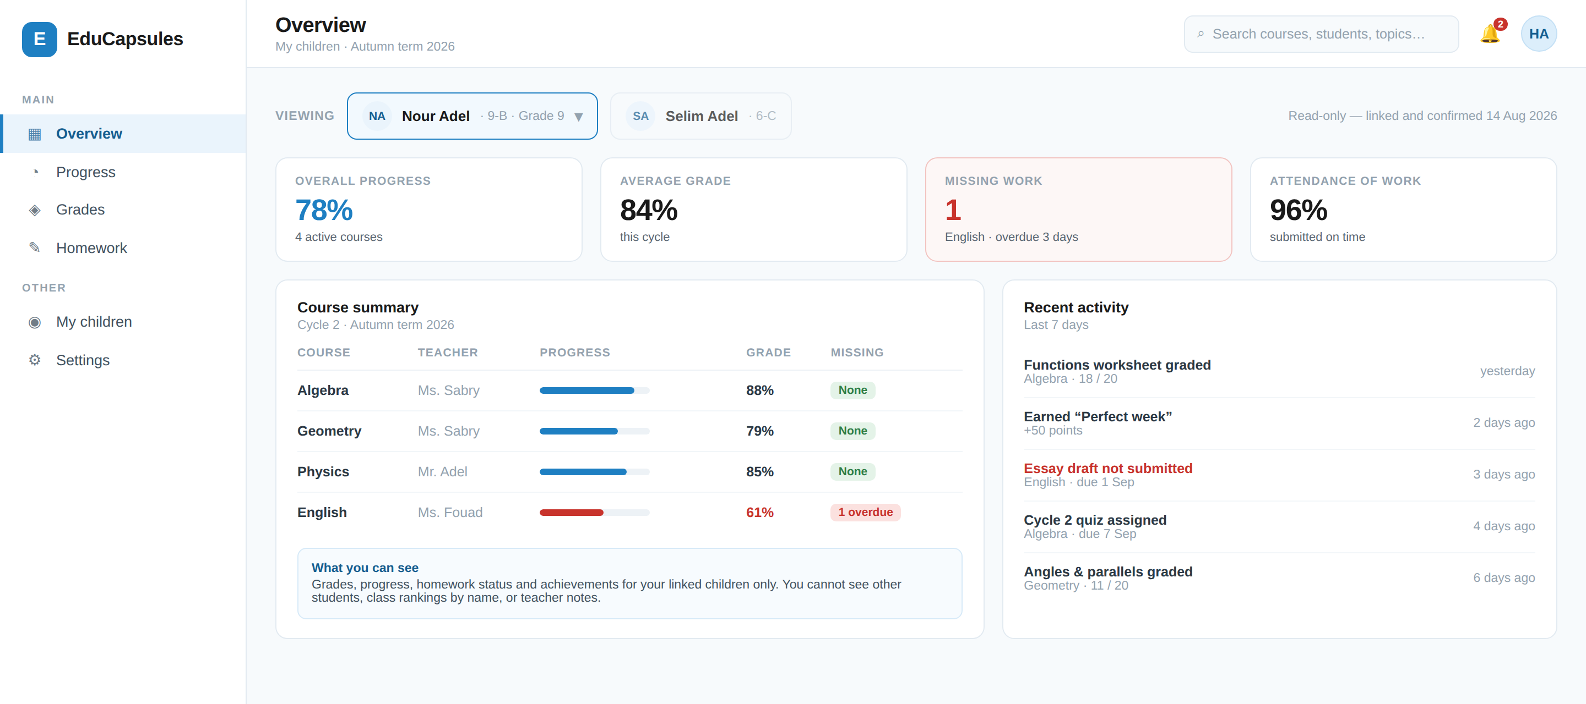
Figure 22.1 — Parent overview — reference layout. The screen states its own boundary; what a parent can and cannot see is visible in the interface, not only in this document.

23. Admin Experience & Platform Governance
GEN-002 · ADMIN IS NOT AN EDUCATIONAL ACCOUNT
Admin = Platform Governance + Operations + Security + Support. An Admin does not become a Teacher because they can oversee Teacher activity. Admin access is itself permission-based, scoped and auditable — there is no “god mode” account.

23.1 Administrative roles
Role | Primary responsibility | Typically holds | Never holds by default
Platform Owner | Highest-level governance and recovery | All permissions | — (but every action is audited)
Super Admin | Broad platform operations | User, org, content, audit, support, system config | Nothing structurally, but each grant is explicit
Operations Admin | Day-to-day platform operations | User and organization operations, academic oversight | Security response, billing, system configuration
Security Admin | Security monitoring and response | Security events, sessions, audit, security configuration | Billing, content moderation actions
Support Admin | User support | User lookup, tickets, limited account actions | Billing, security configuration, private content
Billing Admin | Commercial operations | Plans, subscriptions, payments, refunds, invoices | Security, moderation, user administration
Moderation Admin | Reports and content moderation | Reports, content review and restriction | Billing, security configuration, system configuration

Table 23.1 — Administrative roles. A single Admin may hold several if explicitly assigned. `is_admin = true` is never sufficient.

23.2 Requirements
ID | Requirement | Priority | Actor
ADM-001 | The system shall provide each Admin with a unique immutable Admin ID. | MUST | System
ADM-002 | The system shall maintain an Admin profile separate from educational roles. | MUST | System
ADM-003 | The system shall support multiple administrative roles. | MUST | System
ADM-004 | The system shall support granular administrative permissions rather than a single administrator flag. | MUST | System
ADM-005 | The system shall support administrative scope: global, organization, or functional. | MUST | System
ADM-006 | The system shall support secure Admin authentication with stronger controls than ordinary accounts. | MUST | System
ADM-007 | MFA shall be required for administrative accounts. | MUST | System
ADM-008 | The system shall provide Admin session and device management. | MUST | Admin
ADM-009 | Authorized Admins shall manage platform users: search, verify, suspend, restore, lock, force password reset, revoke sessions, review history. | MUST | Admin
ADM-010 | Authorized Admins shall manage Organizations. | MUST | Admin
ADM-011 | The system shall provide platform-level academic oversight without granting normal teaching authority. | MUST | Admin
ADM-012 | Authorized Admins shall review, restrict, remove and restore reported content. | MUST | Admin
ADM-013 | Authorized Admins shall monitor platform storage usage, quotas, failures, malware detections and suspicious activity. | MUST | Admin
ADM-014 | Authorized Admins shall administer billing: plans, subscriptions, payments, refunds, invoices, entitlements. | MUST | Admin
ADM-015 | Authorized Admins shall manage support tickets. | MUST | Admin
ADM-016 | Authorized Admins shall monitor security events and respond to incidents. | MUST | Admin
ADM-017 | The system shall maintain tamper-resistant, append-only audit records of administrative actions. | MUST | System
ADM-018 | Critical administrative operations shall require elevated authorization: permission check → re-authentication → MFA → stated reason → confirmation → action → audit event. | MUST | System
ADM-019 | Administrative impersonation, if enabled, shall be explicit, permission-controlled, temporary, reason-required, visibly indicated and fully audited. | SHOULD | Admin
ADM-020 | Impersonation sessions shall be clearly identified in the interface and shall restrict sensitive actions. | MUST | System
ADM-021 | Admins shall not modify audit records through any administrative interface. | MUST | System
ADM-022 | Admin access shall be revoked when an Admin account is suspended or deactivated. | MUST | System
ADM-023 | Administrative audit history shall be preserved after account deactivation and shall continue to identify the acting Admin. | MUST | System
ADM-024 | Admins shall not access resources outside their assigned administrative scope. | MUST | System
ADM-025 | Platform administration shall be separated from educational authority. | MUST | System
ADM-026 | Private Teacher Storage shall be protected from unauthorized administrative access. | MUST | System
ADM-027 | Exceptional administrative access to restricted private data shall require permission, re-authentication, MFA, a stated reason and confirmation, and shall be fully audited. | MUST | System
ADM-028 | An Admin shall never have a generic “log in as user” capability. | MUST | System
ADM-029 | Administrative grade override, if provided, shall require elevated permission, a stated reason and a high-severity audit event. | MUST | System
ADM-030 | Authorized Admins shall manage system configuration, feature flags, platform limits, rate limits, supported file types and maintenance mode; dangerous settings shall require elevated authorization and confirmation. | MUST | Admin

Table 23.2 — Admin requirements.

23.3 Exceptional access
ADM-027 · The only route to restricted private data
Permission check
→ re-authentication
→ MFA
→ stated reason (recorded, not free of consequence)
→ explicit confirmation
→ action
→ high-severity audit event, visible to Security Admin

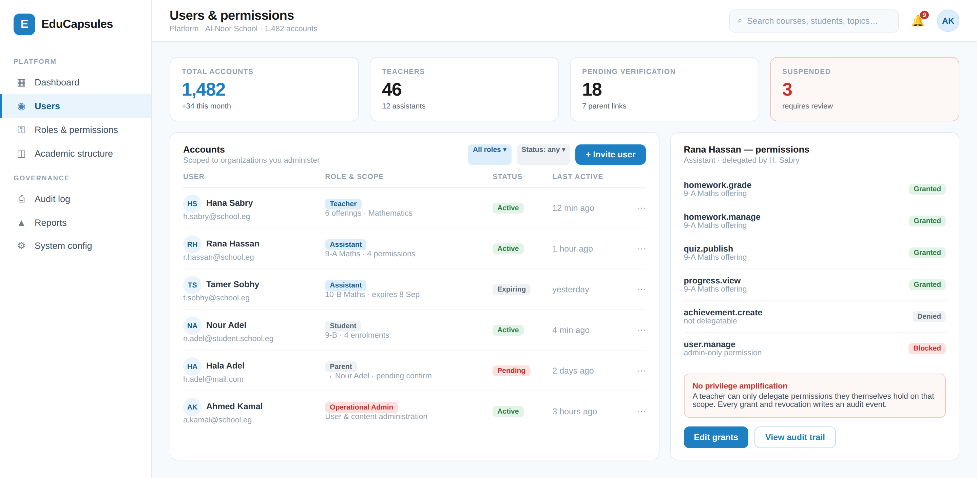
Figure 23.1 — Administrative user and permission management — reference layout. The right-hand panel shows an Assistant's grants including the ones structurally blocked.

24. Dashboards & Navigation
Five role experiences over one authorization system. The dashboards are not independent security systems — they are different views of the same authorised data (GEN-004).

24.1 Purpose per role
Role | Dashboard purpose | First question it answers
Student | Learning and progress centre | What do I need to do, and how am I doing?
Teacher | Teaching, management, assessment and analytics centre | What needs my attention today?
Assistant | Operational teaching-support centre | What have I been asked to do, and where?
Parent | Family monitoring and communication centre | How is my child doing, what needs my attention?
Admin | Platform operations, governance, security and support | Is the platform healthy and safe?

24.2 Primary widgets
Student | Teacher | Assistant | Parent | Admin
My classes · courses | My classrooms · groups | Assigned classrooms | My children | Platform overview
Continue learning | Courses · active cycles | Assigned groups | Overall progress | System health
Upcoming activities | Upcoming activities | Assigned courses | Homework status | Active users
Recent activities | Pending grading | Pending grading | Upcoming deadlines | Organizations
Grades | Student progress | Upcoming activities | Quiz results · grades | Subscriptions
Progress | Attendance | Student progress | Teacher feedback | Storage
Achievements | Achievements | Achievements | Achievements | Security alerts
Leaderboard | Leaderboards | Announcements | Leaderboard ⚙ | Reports
Calendar | Announcements · messages | Messages | Attendance | Support tickets
Announcements | Storage | Calendar | Calendar | Moderation queue
Messages | Calendar · analytics | Shared storage | Announcements · messages | Recent audit events

Table 24.1 — Dashboard widget inventory per role, consolidated from the source dashboard specifications.

24.3 Permission-driven interface
GEN-003 · HIDING A BUTTON IS NOT AUTHORIZATION
The Assistant dashboard in particular is dynamic: it shows only what that Assistant's assignment permits. That is a usability measure. The backend independently enforces every permission on every request, and a hidden control is never the reason an action fails (UI-014, SEC-002).

24.4 Screen inventory
# | Screen | Roles | Key requirements | Illustrated
S-01 | Student dashboard | Student | STU-011 | §20.3
S-02 | Teacher dashboard | Teacher | TCH-001, TCH-022 | §19.4
S-03 | Assistant dashboard | Assistant | AST-008 | —
S-04 | Parent overview | Parent | PAR-004, PAR-005 | §22.2
S-05 | Admin console | Admin | ADM-009…016 | §23.3
S-06 | Course builder | Teacher, Assistant ⚙ | CRS-001…008, TOP-001 | §25
S-07 | Teaching session planner & attendance | Teacher, Assistant ⚙ | SES-002…016 | —
S-08 | Activity builder | Teacher, Assistant ⚙ | ACT-011…022 | —
S-09 | Question bank | Teacher, Assistant ⚙ | QBN-001…034 | —
S-10 | Activity participation | Student | ACT-029, ACT-035 | §25
S-11 | Quiz attempt | Student | QBN-039, ACT-017 | §25
S-12 | Grading queue & detail | Teacher, Assistant ⚙ | GRD-001…009 | §25
S-13 | Teacher storage | Teacher, Assistant ⚙ | STR-001…022 | —
S-14 | Protected content viewer | Student, Parent ⚙ | CNT-014, CNT-015 | —
S-15 | Achievements & leaderboard | Student, Parent ⚙ | ACH-001, LDB-002 | §25
S-16 | Messages & announcements | All | MSG-001…010 | —
S-17 | Calendar | All | CAL-001…005 | —
S-18 | Payment evidence & approval | Student/Payer, Teacher, Assistant ⚙ | PAY-003…008 | —
S-19 | Security centre (sessions & devices) | All | AUTH-108, AUTH-109 | —
S-20 | Audit log viewer | Admin | ADM-017, AUD-008 | —

Table 24.2 — The V1 screen inventory. Nine are illustrated in this document (v1.1 correction: previously stated as seven).

25. Reference Interface Screens
These screens are specification, not decoration. Where a screen shows a rule being enforced or explained to the user, that is a requirement about the interface (§38), not a designer's suggestion. Visual styling is subject to §38.1.
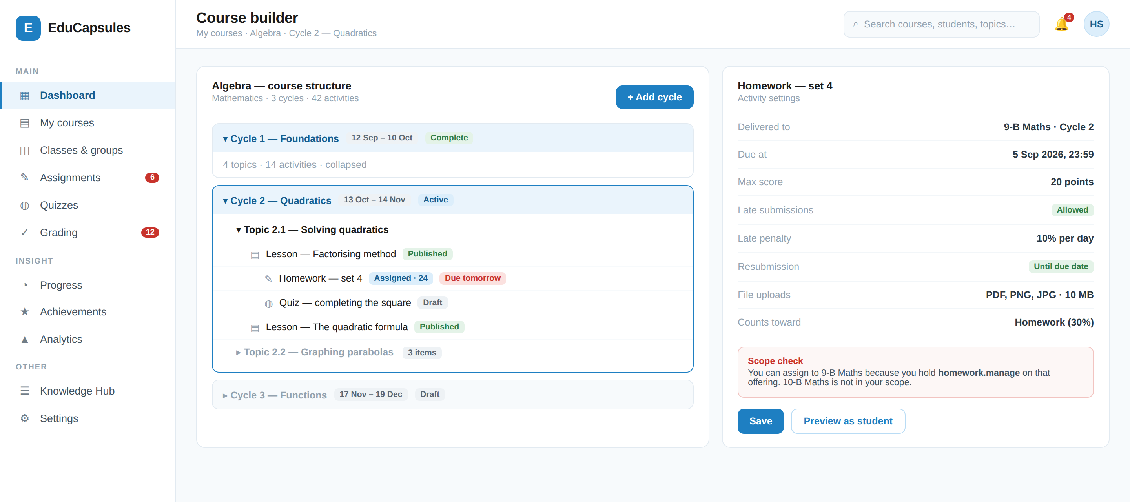
Figure 25.1 — S-06 Course builder. The scope check in the right panel makes SEC-005 visible to the Teacher rather than surfacing as a failure after the fact.
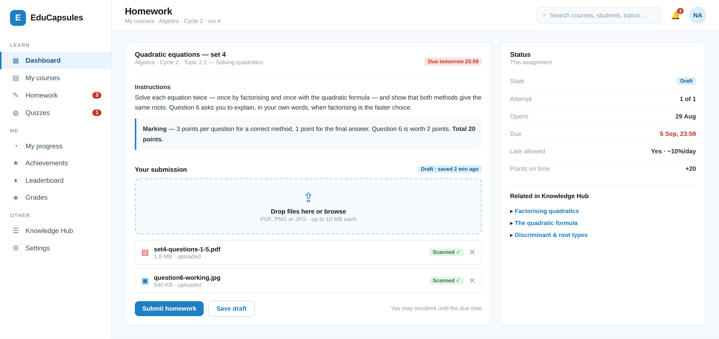
Figure 25.2 — S-10 Activity participation. The rules that will be applied — attempts, late policy, points — are shown **before** the student submits (UI-007).
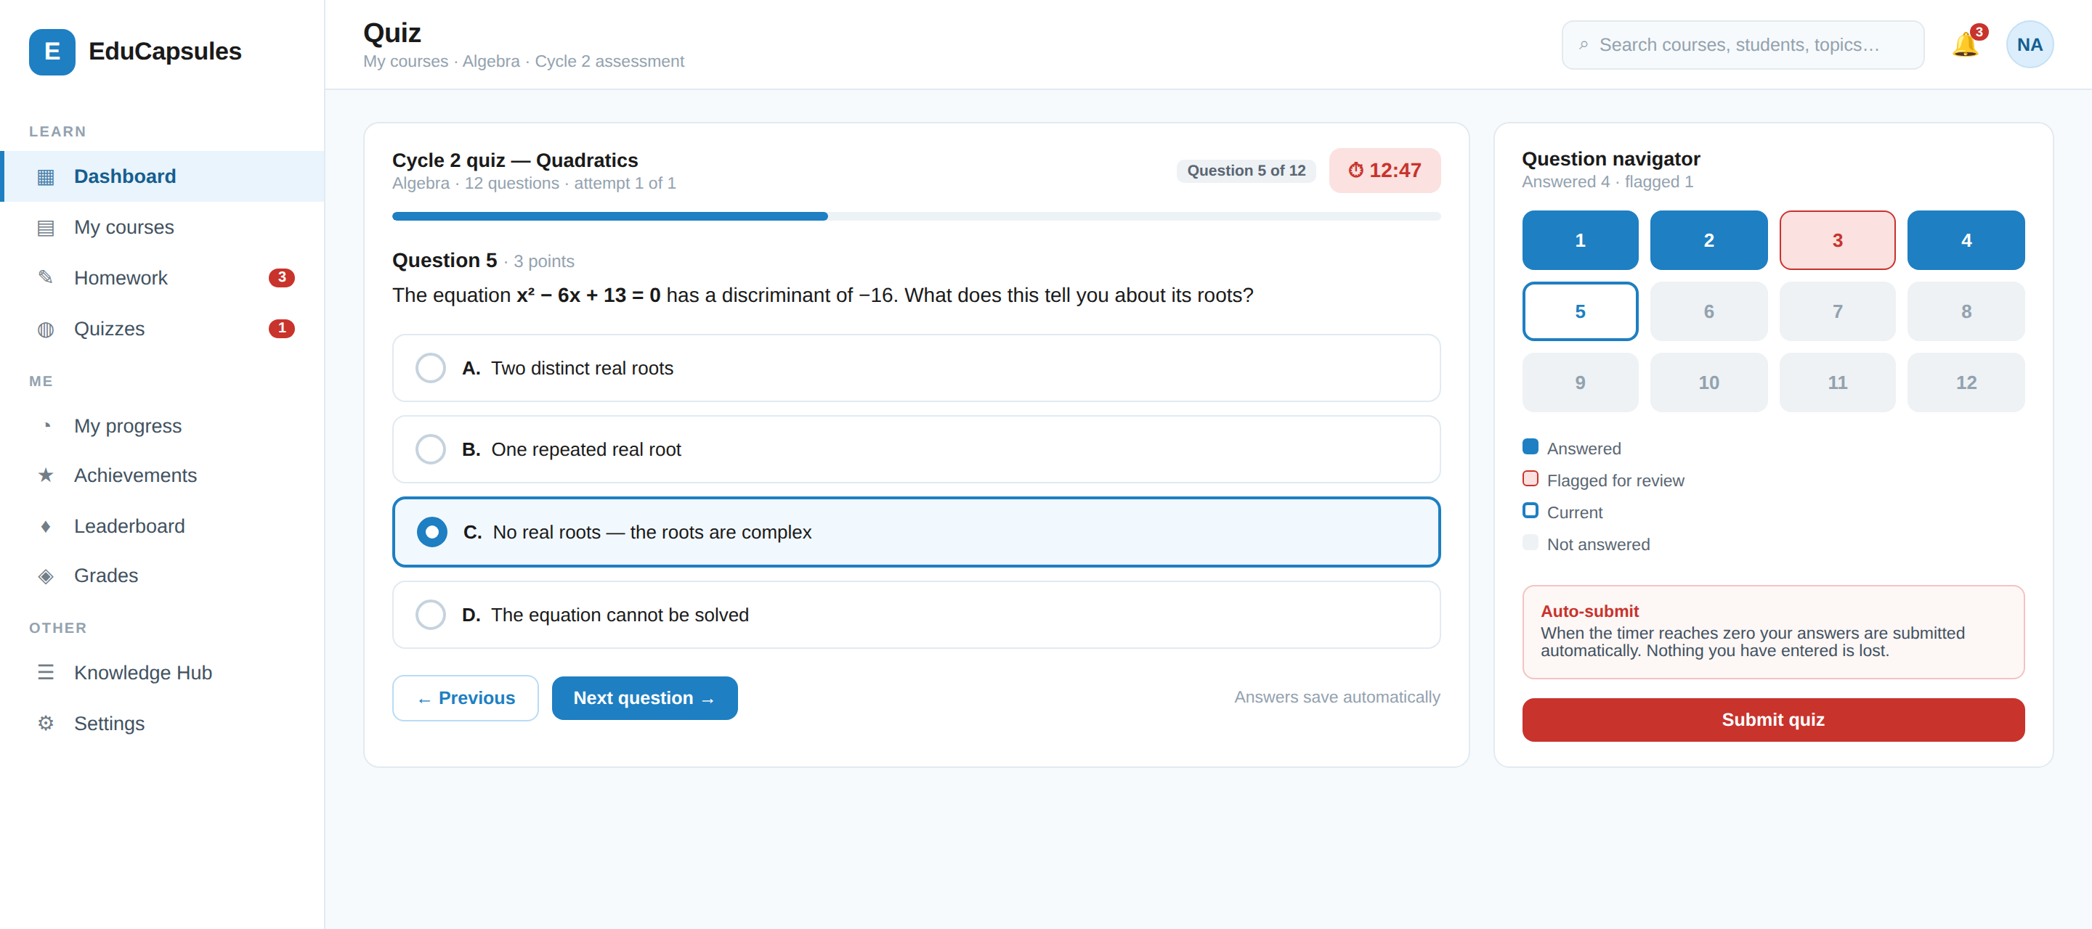
Figure 25.3 — S-11 Quiz attempt. Auto-submit behaviour is stated on the screen; a timer that discards work without warning is the fastest way to lose a student's trust (ACT-035).
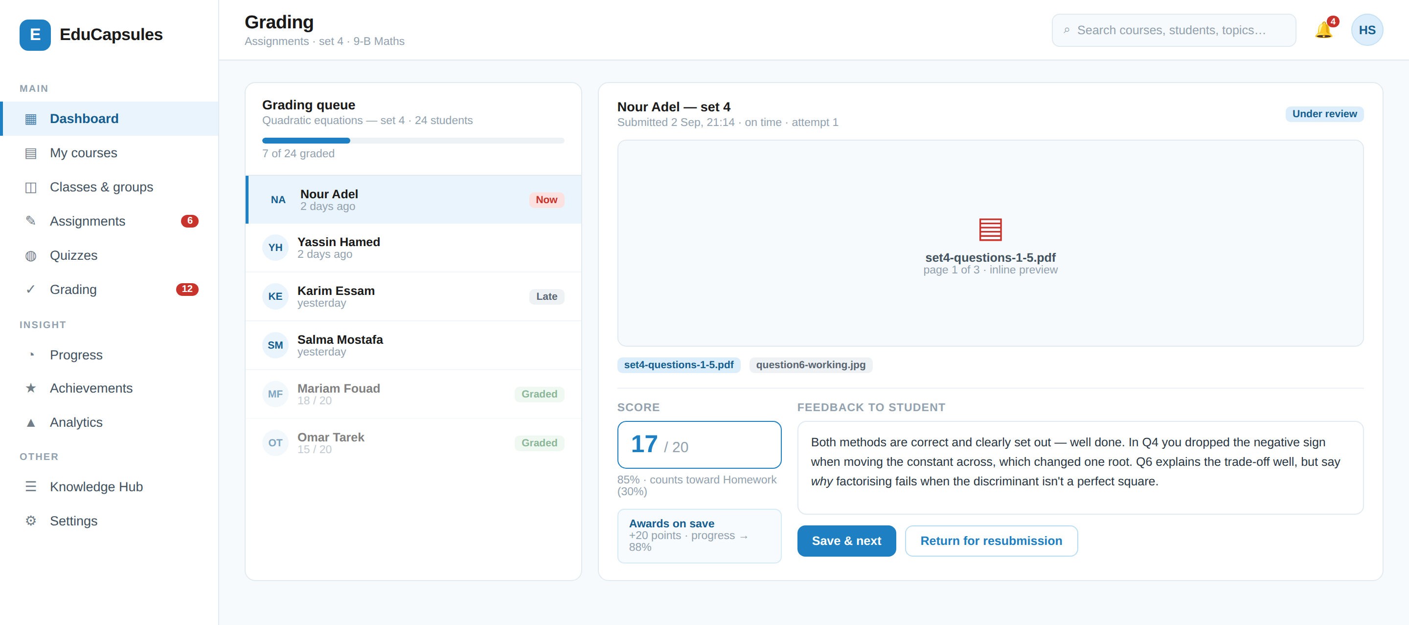
Figure 25.4 — S-12 Grading queue and detail. The consequences of saving — points awarded, progress recomputed — are shown to the grader before they commit.
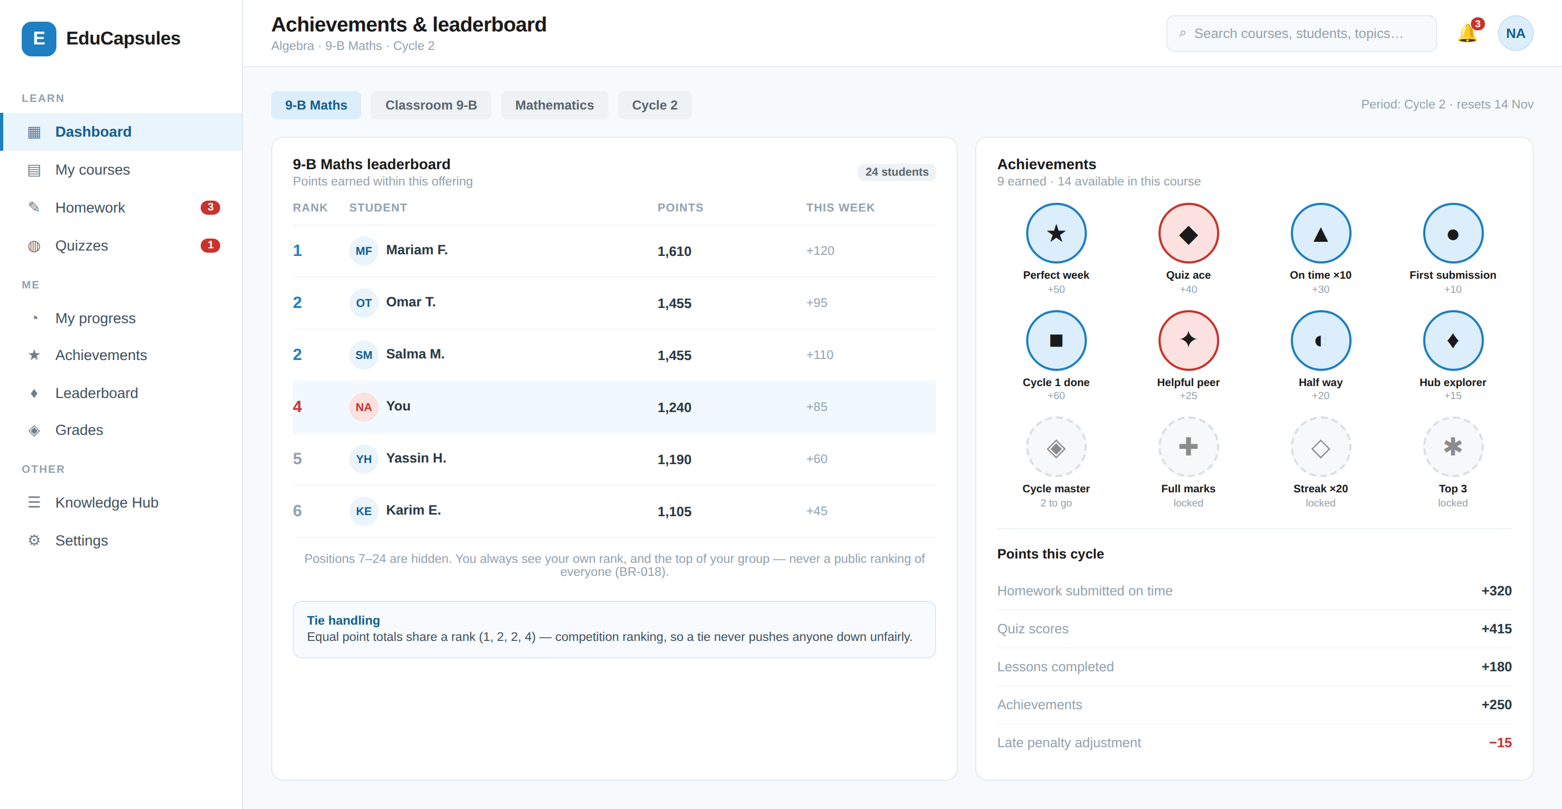
Figure 25.5 — S-15 Achievements and leaderboard. The privacy rules of §18.2 are visible in the interface: most positions are simply not rendered.
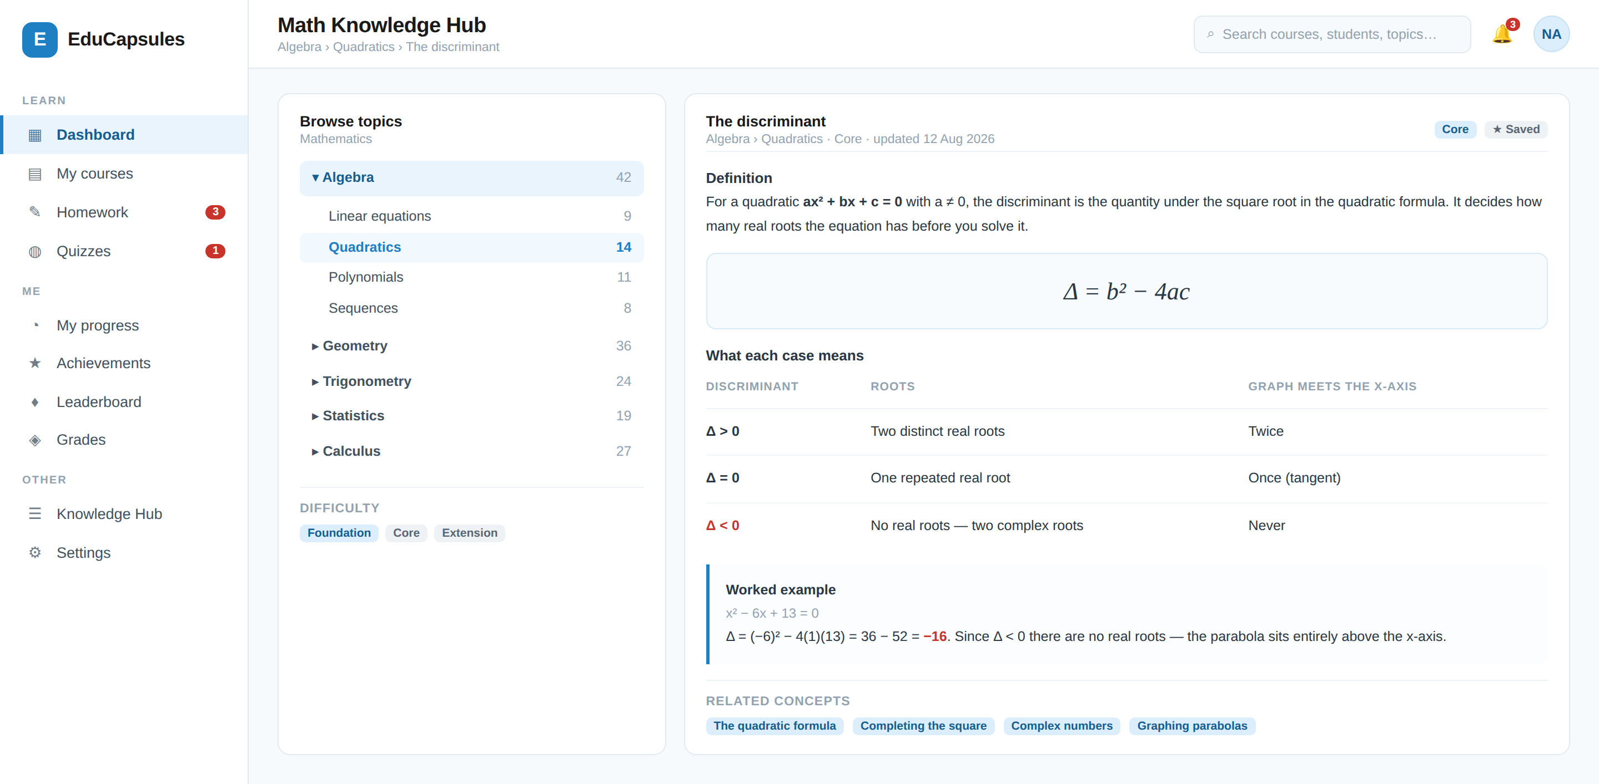
Figure 25.6 — Structured reference content rendered through the protected viewer path (§16). Definition, cases, worked example and related concepts.

26. Permission Catalogue & Matrix
The permission catalogue is closed: an action with no permission code cannot be performed. Adding a capability is therefore a deliberate act with a traceable requirement (§1.5).

26.1 Permission naming
Naming convention
Educational permissions VERB_NOUN e.g. GRADE_HOMEWORK
Administrative permissions NOUN_VERB e.g. USER_SUSPEND

Every permission is evaluated together with a scope; a permission code alone
authorises nothing (SEC-001).

26.2 Educational permission catalogue
Permission | Allows | Default holder | Delegatable to Assistant?
VIEW_STUDENTS | See students in scope | Teacher | Yes
MANAGE_STUDENTS | Manage student membership in scope | Teacher | Yes ⚙
VIEW_STUDENT_PROGRESS | See progress in scope | Teacher | Yes
VIEW_STUDENT_ACTIVITY | See activity state in scope | Teacher | Yes
VIEW_STUDENT_ATTENDANCE | See attendance in scope | Teacher | Yes
MANAGE_CLASSROOM | Create/edit classrooms and groups | Teacher | Yes ⚙
MANAGE_COURSE | Create/edit courses, cycles, topics | Teacher | Yes ⚙
PUBLISH_CONTENT | Publish content to students | Teacher | Yes ⚙
CREATE_SESSION · EDIT_SESSION | Schedule and manage teaching sessions | Teacher | Yes
MANAGE_ATTENDANCE | Record and update attendance | Teacher | Yes
CREATE_HOMEWORK · EDIT_HOMEWORK | Author homework activities | Teacher | Yes
GRADE_HOMEWORK | Grade homework submissions | Teacher | Yes
CREATE_QUIZ · EDIT_QUIZ | Author quizzes | Teacher | Yes
GRADE_QUIZ | Grade quiz submissions | Teacher | Yes
VIEW_GRADES · ENTER_GRADES | See and enter grades in scope | Teacher | Yes
EDIT_GRADES | Change a grade after entry | Teacher | Yes ⚙
RELEASE_GRADES | Make grades visible to student/parent | Teacher | Yes ⚙
VIEW_QUESTION_BANK | Browse the question bank in scope | Teacher | Yes
CREATE_QUESTION · EDIT_QUESTION | Author questions | Teacher | Yes
DELETE_QUESTION | Archive/remove questions | Teacher | Yes ⚙
IMPORT_QUESTIONS · EXPORT_QUESTIONS | Bulk question movement | Teacher | Yes ⚙
MANAGE_QUESTION_POOLS | Create and configure pools | Teacher | Yes
MANAGE_ACHIEVEMENTS | Configure achievement rules in scope | Teacher | Yes ⚙
CREATE_ACHIEVEMENT | Define a new custom achievement | Teacher | No
AWARD_ACHIEVEMENTS | Award an achievement to a student | Teacher | Yes
ADJUST_POINTS | Manually adjust points with reason | Teacher | No
MANAGE_LEADERBOARD | Configure or disable a leaderboard | Teacher | Yes ⚙
MESSAGE_STUDENTS · MESSAGE_PARENTS | Communicate within scope | Teacher | Yes ⚙
CREATE_ANNOUNCEMENTS | Post announcements in scope | Teacher | Yes ⚙
VIEW_STORAGE · UPLOAD_FILES | Work with shared Teacher Storage | Teacher | Yes ⚙
DOWNLOAD_ORIGINAL | Download original stored files | Teacher | Yes ⚙
MANAGE_STORAGE_PERMISSIONS | Change who may access stored files | Teacher | No
ASSIGN_ASSISTANT | Create or modify an Assistant Assignment | Teacher | No
VIEW_ANALYTICS | Educational analytics in scope | Teacher | Yes

Table 26.1 — Educational permission catalogue. “No” in the last column means structurally non-delegatable (SEC-006) — not merely off by default.

26.3 Administrative permission catalogue
Permission | Allows | Typical role
USER_VIEW · USER_SUSPEND · USER_RESTORE | Account administration | Operations, Support
ORG_VIEW · ORG_MANAGE | Organization administration | Operations, Super
CONTENT_REVIEW · CONTENT_RESTRICT · CONTENT_REMOVE | Content moderation | Moderation
BILLING_VIEW · REFUND_MANAGE · PLAN_MANAGE | Commercial operations | Billing
SECURITY_VIEW · SECURITY_RESPOND | Security monitoring and response | Security
AUDIT_VIEW | Read the audit log | Security, Super
SUPPORT_MANAGE | Support tickets and user issues | Support
SYSTEM_CONFIG · FEATURE_FLAG_MANAGE | Platform configuration | Super, Platform Owner
IMPERSONATE_USER | Controlled support impersonation | Support (elevated)
PRIVATE_DATA_ACCESS | Exceptional access to restricted private data | Elevated + audited

Table 26.2 — Administrative permission catalogue.

26.4 Administrative permission matrix
Permission area | Platform Owner | Super | Security | Support | Billing | Moderation
User management | ✔ | ✔ | Limited | Limited | ✖ | Limited
Organization management | ✔ | ✔ | ✖ | ✖ | ✖ | ✖
Security events | ✔ | ✔ | ✔ | Limited | ✖ | Limited
Billing | ✔ | ✔ | ✖ | ✖ | ✔ | ✖
Reports & moderation | ✔ | ✔ | ✔ | ✔ | ✖ | ✔
Content moderation actions | ✔ | ✔ | Limited | Limited | ✖ | ✔
Audit logs | ✔ | ✔ | ✔ | Limited | Limited | Limited
System configuration | ✔ | ✔ | Security only | ✖ | ✖ | ✖
Private content access | Exceptional | Exceptional | Exceptional | Exceptional | ✖ | Case-based
Grant admin privileges | ✔ | ⚙ | ✖ | ✖ | ✖ | ✖

Table 26.3 — Administrative separation of duties. Every “Exceptional” cell requires the §23.3 flow.

27. Communication
Communication is role- and scope-based. It is also the highest child-safety surface in the product, so its rules are stated as requirements rather than as policy alone.

27.1 Permitted channels
Channel | Permitted | Condition
Teacher ↔ Student | ✔ | Student is in the Teacher's authorised scope
Teacher ↔ Parent | ✔ | Parent holds an ACTIVE link to a student in the Teacher's scope
Teacher ↔ Assistant | ✔ | An Assistant Assignment exists between them
Assistant ↔ Student | ⚙ | MESSAGE_STUDENTS granted, student inside assigned scope
Assistant ↔ Parent | ⚙ | MESSAGE_PARENTS granted, parent linked to an in-scope student
Student ↔ Teacher / Assistant | ⚙ | Within the student's own educational relationships
Student ↔ Student | ✖ (V1) | Not supported in V1 — see §49
Parent ↔ Parent | ✖ | Never
Organization announcements | ⚙ | Authorized staff, scoped to the announcement's audience

Table 27.1 — Communication channels. Every message is authorised against the same model as any other resource (SEC-001).

27.2 Requirements
ID | Requirement | Priority | Actor
MSG-001 | The system shall support direct messages within permitted channels only. | MUST | System
MSG-002 | The system shall support announcements scoped to a Classroom, Group, Course or Organization. | MUST | Teacher/Assistant ⚙
MSG-003 | A message shall never be deliverable to a user outside the sender's authorised relationships. | MUST | System
MSG-004 | Attachments in messages shall follow the same validation, scanning and authorization rules as all other files (§14). | MUST | System
MSG-005 | The system shall provide reporting of abusive or inappropriate messages by any participant. | MUST | System
MSG-006 | Authorized Moderation Admins shall review reported communications; access to reported content shall be permission-controlled and audited. | MUST | Admin
MSG-007 | The system shall support restricting or blocking a communication relationship where policy requires. | SHOULD | System
MSG-008 | Communication metadata shall be auditable; message content shall be accessible only under an authorised moderation or legal process. | MUST | System
MSG-009 | The platform shall not represent that private messages are manually monitored, because they are not. | MUST | System
MSG-010 | Assistants shall not access conversations outside their assigned scope. | MUST | System

Table 27.2 — Communication requirements.
MSG-009 · DO NOT OVERSTATE MODERATION
The platform provides reporting, review and enforcement. It does not manually monitor every private message, and no requirement, interface text or legal document shall imply that it does. Overstating moderation creates an obligation the product cannot meet and a false sense of safety for parents.

28. Notifications
ID | Requirement | Priority | Actor
NOT-001 | Students shall be notified of new activities, activity opening, approaching deadlines, late status, grade release, feedback availability, returned work and cancellation. | MUST | System
NOT-002 | Parents shall be notified of new homework, upcoming deadlines, missing work and grade release for linked children only. | MUST | System
NOT-003 | Teachers shall be notified of new submissions, late submissions, pending grading, deadlines, student completion, parent messages, assistant activity, session changes, storage warnings and security alerts. | MUST | System
NOT-004 | Assistants shall be notified of submissions, late work, questions, announcements and teacher instructions within assigned scope. | MUST | System
NOT-005 | Admins shall be notified of security, platform, business and moderation events per their administrative role. | MUST | System
NOT-006 | Students shall be notified of achievement awards. | MUST | System
NOT-007 | The system shall support in-app notifications as the authoritative record of what a user was told. | MUST | System
NOT-008 | The system shall support email notification for defined categories. | SHOULD | System
NOT-009 | Users shall configure notification preferences per category and channel. | SHOULD | All
NOT-010 | A notification shall never contain data the recipient is not authorised to see. | MUST | System
NOT-011 | Notification fan-out shall be scope- and relationship-aware. | MUST | System
NOT-012 | Security notifications — new device login, password change, MFA change, email change, recovery change, suspicious activity — shall always be delivered regardless of preference. | MUST | System
NOT-013 | Push and SMS notification are FUTURE and require native clients and consent handling. | FUTURE | System
NOT-014 | Notification delivery failure shall be retried and shall never block or roll back the originating transaction. | MUST | System

Table 28.1 — Notification requirements.

29. Calendar
ID | Requirement | Priority | Actor
CAL-001 | The system shall provide a calendar per role combining Teaching Sessions, activity deadlines, quizzes, exams and events within the user's authorised scope. | MUST | All
CAL-002 | Students shall see only their own entitled entries; Parents only their linked children's. | MUST | System
CAL-003 | Assistants shall see only entries within their assigned scope. | MUST | System
CAL-004 | Calendar entries shall reflect Session status changes (rescheduled, cancelled, postponed) without losing the original record. | MUST | System
CAL-005 | Calendar export or subscription, if provided, shall use authorised, revocable, per-user links and shall not expose unauthorised entries. | SHOULD | System

Table 29.1 — Calendar requirements.

30. Payments — Early-Release Model
PAY-000 · CONFIRMED · THE EARLY-RELEASE PAYMENT MODEL
For the early release, payments are made directly between the Teacher or Assistant and the Student. The platform does not process money in V1. The platform's role is to carry the evidence, the approval and the resulting entitlement, and to make all three auditable.
This is a deliberate, recorded business decision. It is NOT replaced by a payment provider in this version; §30.6 defines the seam that lets a provider be added later without redesign.

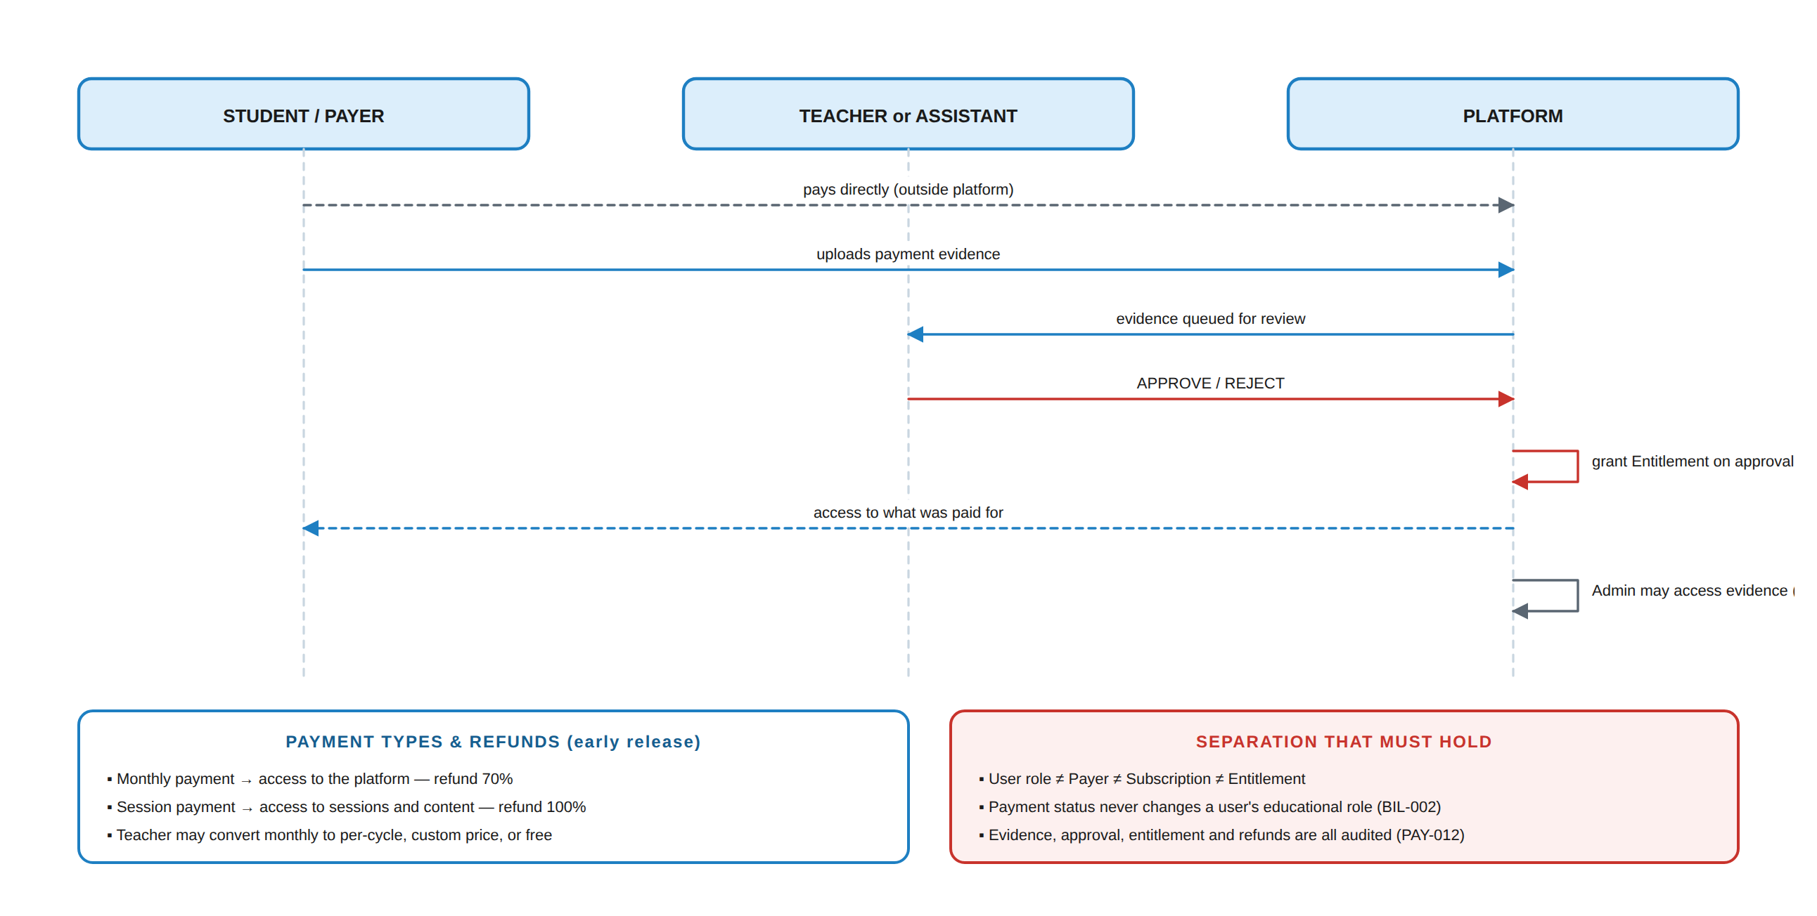
Figure 30.1 — The early-release payment flow. Access follows approval, never upload.

30.1 Confirmed business rules
ID | Rule | Status
BR-001 | All payments are made directly between the Teacher/Assistant and the Student. | CONFIRMED
BR-002 | Payment evidence must be uploaded through the platform for every payment. | CONFIRMED
BR-003 | The Teacher or Assistant must review and approve the evidence before the Student receives access to what was paid for. | CONFIRMED
BR-004 | Authorized Admins have access to payment evidence. | CONFIRMED
BR-005 | Monthly payments grant access to the platform. | CONFIRMED
BR-006 | Session payments grant access to sessions and their content. | CONFIRMED
BR-007 | Refunds are available for all payment types. | CONFIRMED
BR-008 | Session payment refund: 100%. | CONFIRMED
BR-009 | Monthly payment refund: 70%. | CONFIRMED
BR-010 | A Teacher may convert the monthly payment model to payment-per-cycle, and may customise the price — including free or any other price. | CONFIRMED
BR-011 | Miss Selvia receives 10%–15% of the monthly fees students pay to their teachers. | CONFIRMED
BR-012 | Miss Selvia receives 100% from her own students. | CONFIRMED
BR-013 | Moustafa Mahgoub receives 5,000 EGP plus 10% monthly from Miss Selvia. | CONFIRMED
BR-014 | Moustafa Mahgoub receives 6,500 EGP per month from any other teacher. | CONFIRMED

Table 30.1 — Early-release commercial rules, recorded verbatim as business rules. BR-011…014 are revenue-share arrangements, not platform-enforced payment flows — see PAY-014.

30.2 Requirements
ID | Requirement | Priority | Actor
PAY-001 | The system shall record a Payment with payer, beneficiary, type, amount, currency, period and status. | MUST | System
PAY-002 | The system shall support payment types: monthly (platform access), session (session and content access), and per-cycle where the Teacher configures it. | MUST | System
PAY-003 | A payer shall upload payment evidence against a Payment. | MUST | Student/Parent
PAY-004 | Payment evidence shall be stored as a private file subject to §14 validation, scanning and access control. | MUST | System
PAY-005 | The receiving Teacher, or an Assistant explicitly permitted to do so, shall review evidence and approve or reject it with a reason. | MUST | Teacher/Assistant ⚙
PAY-006 | Entitlement shall be granted only on approval — never on upload. | MUST | System
PAY-007 | Approval shall create an Entitlement scoped to exactly what was paid for, with a start and end. | MUST | System
PAY-008 | Rejection shall notify the payer with the reason and shall grant no access. | MUST | System
PAY-009 | Authorized Admins shall access payment evidence; such access shall be audited. | MUST | Admin
PAY-010 | The system shall support refund requests, approval and recording, applying the configured percentage per payment type (BR-008, BR-009). | MUST | System
PAY-011 | A refund shall revoke or reduce the corresponding Entitlement according to the refund terms. | MUST | System
PAY-012 | Payment creation, evidence upload, approval, rejection, entitlement grant, refund and evidence access shall all be audited. | MUST | System
PAY-013 | A Teacher shall configure their own pricing model, including per-cycle and free. | MUST | Teacher
PAY-014 | Platform revenue-share arrangements (BR-011…014) shall be recorded as reportable figures for authorized Billing Admins; the platform shall not automatically execute these transfers in V1. | MUST | System
PAY-015 | The system shall never store raw card numbers or CVV. | MUST | System
PAY-016 | Assistants shall handle payment evidence only where explicitly permitted, and shall never manage subscriptions, plans, refunds policy or billing settings. | MUST | System

Table 30.2 — Payment requirements.

30.3 Payment states
PAY-006 · Access follows approval, never upload
AWAITING_EVIDENCE ─▶ EVIDENCE_SUBMITTED ─▶ UNDER_REVIEW
│
┌─────────────────────┴──────────┐
▼ ▼
APPROVED REJECTED
│ │
▼ (no entitlement,
ENTITLEMENT_ACTIVE payer notified)
│
┌─────────────┼──────────────┐
▼ ▼ ▼
EXPIRED REFUND_REQUESTED REVOKED
│
▼
REFUNDED (100% session · 70% monthly)

31. Subscriptions, Entitlements & Billing Separation
GEN-020 · THE FOUR THINGS THAT MUST NOT BE CONFUSED
User Role ≠ Payer ≠ Subscription ≠ Entitlement. A Teacher does not have to be the payer. A Parent may be the payer. An Organization may be the payer. Payment status never redefines a user's educational role.

31.1 Billing capability matrix
⚙ = permitted only if that account is the designated payer or subscription owner.
Action | Teacher | Assistant | Student | Parent | Admin
View own subscription | ⚙ | ✖ | ✖ | ⚙ | ⚙
Make payment | ⚙ | ✖ | ✖ | ⚙ | ✖
Add / change payment method | ⚙ | ✖ | ✖ | ⚙ | ✖
View invoices | ⚙ | ✖ | ✖ | ⚙ | ⚙
Cancel subscription | ⚙ | ✖ | ✖ | ⚙ | ⚙
Request refund | ⚙ | ✖ | ✖ | ⚙ | —
Approve refund | ✖ | ✖ | ✖ | ✖ | ⚙
Manage billing settings | ⚙ | ✖ | ✖ | ⚙ | ⚙
Modify subscription plan | ⚙ | ✖ | ✖ | ⚙ | ⚙
Review payment evidence | ✔ | ⚙ | ✖ | ✖ | ⚙
View another user's billing | ✖ | ✖ | ✖ | ✖ | ⚙ audited

Table 31.1 — Billing capabilities. The Student is never a billing actor even when they are the one uploading evidence for their own payment — that is a payment action, not a billing one.

31.2 Requirements
ID | Requirement | Priority | Actor
BIL-001 | The system shall model Payer, Subscription and Entitlement as records separate from User Role. | MUST | System
BIL-002 | A user's educational role shall never change as a consequence of payment status. | MUST | System
BIL-003 | A Subscription shall have a designated payer, which may be the user, a Parent, or an Organization. | MUST | System
BIL-004 | Only the designated payer or an authorized Billing Admin shall perform billing actions on a subscription. | MUST | System
BIL-005 | Entitlement shall be derived from payment, subscription or explicit grant, and shall carry its own validity period. | MUST | System
BIL-006 | No educational user shall be able to manipulate their own or another user's entitlement. | MUST | System
BIL-007 | Expiry of a subscription or entitlement shall deny new protected-content access while leaving academic history intact and accessible. | MUST | System
BIL-008 | Subscription state shall include at least: TRIAL · ACTIVE · PAST_DUE · GRACE · CANCELED · EXPIRED · SUSPENDED · REFUNDED. | MUST | System
BIL-009 | Billing operations shall be auditable. | MUST | System
BIL-010 | The architecture shall allow a payment provider to be introduced later behind a payment interface, without changing the Entitlement model. | MUST | System

Table 31.2 — Subscription, entitlement and billing separation requirements.

32. Privacy & Data Protection
EduCapsules processes children's educational records. Privacy is therefore enforced by architecture (GEN-023), not only by policy.

32.1 Data classification
Level | Class | Examples | Controls
1 | Public | Public marketing content, explicitly public announcements | Standard web serving
2 | Internal | General course information, non-sensitive educational resources | Authentication required
3 | Confidential | Grades · submissions · quiz results · progress · attendance · messages · achievement history · Teacher, Assistant and Parent information | Authorization + scope + relationship + object-level checks; audit on change
4 | Highly Confidential | Credentials · password hashes · tokens · payment-related tokens · security logs · recovery information · encryption keys | Never returned by any API; encrypted; key management; access strictly limited and audited

Table 32.1 — Data classification. Everything a student produces is at minimum Level 3.

32.2 Requirements
ID | Requirement | Priority | Actor
PRV-001 | The system shall collect only personal data required by a stated requirement. | MUST | System
PRV-002 | APIs and interfaces shall return only the fields the requesting role needs. | MUST | System
PRV-003 | A Student shall access only their own grades, submissions, progress, achievements and messages. | MUST | System
PRV-004 | A Parent shall access only their linked child's permitted information. | MUST | System
PRV-005 | A Teacher shall not access unrelated Teachers' private data, students outside their scope, or another Teacher's Storage. | MUST | System
PRV-006 | An Assistant shall access only information within their delegated scope. | MUST | System
PRV-007 | The system shall define and apply retention periods per data category. | MUST | System
PRV-008 | The system shall support data export for a user's own data, and for a guardian of a linked child, where legally applicable. | SHOULD | System
PRV-009 | Deletion shall follow documented policy; educational and audit records may be retained or de-identified rather than destroyed (§43). | MUST | System
PRV-010 | Real student data shall never be copied into development or staging environments. | MUST | System
PRV-011 | The platform shall not sell students' personal information. | MUST | System
PRV-012 | Children's data shall receive additional protection per the applicable child-privacy requirements, to be confirmed by counsel (§33). | MUST | System
PRV-013 | Every feature shall answer “who needs to see this data?” before implementation; defaults shall be restrictive (GEN-024). | MUST | System

Table 32.2 — Privacy requirements.

32.3 Retention
Retention periods are jurisdiction-dependent and are deliberately marked TBD rather than invented; they are the first item for legal review (§33). The single authoritative retention schedule is Table 44.3 (§44.3, Account Lifecycle, Retention & Deletion) — it is not repeated here, so a future retention decision is recorded once and cannot drift between two copies.
v1.1: this section previously carried its own partial retention table with different category boundaries than §44.3; it is replaced by this pointer to remove the duplication.

33. Legal & Policy Requirements
THIS SECTION SPECIFIES SYSTEM SUPPORT FOR LEGAL DOCUMENTS — IT IS NOT LEGAL ADVICE
The policy suite below must be drafted and reviewed by a qualified Egyptian lawyer against applicable Egyptian law, and against the law of every other market EduCapsules serves, before publication. This document specifies only what the system must do to support it.

33.1 The policy suite
# | Document | Purpose | # | Document | Purpose
1 | Terms of Service | Master agreement | 8 | Content Protection Policy | Anti-copying and circumvention
2 | Privacy Policy | Data handling | 9 | Community & Communication Rules | Messaging conduct
3 | Acceptable Use Policy | Prohibited behaviour | 10 | Child Safety Policy | Minor protection
4 | Student & Parent Terms | Minors and guardians | 11 | Copyright Reporting Policy | Infringement complaints
5 | Teacher / Assistant Terms | Staff and content | 12 | Security & Account Policy | Account security
6 | Content & IP Policy | Ownership and licensing | 13 | Cookie Policy | If tracking is used
7 | Payment & Refund Policy | Billing and refunds

Table 33.1 — The thirteen-document policy suite. Documents cross-reference rather than repeat.

33.2 Ownership positions — CONFIRMED
Asset | Position
Teacher content | Ownership remains with the Teacher unless otherwise agreed. The Teacher grants EduCapsules the limited licence necessary to host, process, display, deliver to authorised students, back up and secure the content.
EduCapsules platform | EduCapsules owns its software, source code, UI, branding, logos, designs, documentation, platform technology, proprietary systems, algorithms and security systems. Users receive a limited licence to use the platform, not ownership of it.
Student content | Homework answers, quiz responses, messages, comments and uploads receive a narrow platform licence sufficient to operate the service — not broad ownership.
Uploaded third-party material | The uploading Teacher warrants they hold the necessary rights. The platform provides copyright reporting and takedown (document 11).

Table 33.2 — Intellectual property positions to be reflected in documents 6 and 8.

33.3 System requirements supporting the legal framework
ID | Requirement | Priority | Actor
LEG-001 | The system shall record, for every account, the exact version of each legal document accepted, with user, document, version, timestamp and acceptance type. | MUST | System
LEG-002 | The system shall store historical versions of every legal document with effective dates. | MUST | System
LEG-003 | Material changes shall require renewed acceptance where legally required; the system shall support re-acceptance flows. | MUST | System
LEG-004 | Acceptance of unrelated policies shall not be bundled into a single checkbox where separate consent is required. | MUST | System
LEG-005 | The system shall prevent a Parent from accessing an unlinked Student (PAR-001). | MUST | System
LEG-006 | The system shall record unauthorized protected-content access attempts. | MUST | System
LEG-007 | The system shall support user reporting for abuse, harassment, bullying, inappropriate content, copyright violation, course theft, impersonation, fraud, security violation, spam, technical abuse and child-safety concerns. | MUST | System
LEG-008 | Each report shall carry id, reporter, target, category, description, evidence, status, assigned Admin, timestamps and resolution. | MUST | System
LEG-009 | The system shall support moderation workflow: NEW → UNDER_REVIEW → INVESTIGATION → ACTION_REQUIRED → RESOLVED, with actions dismiss · warn · restrict · remove · suspend · escalate. | MUST | Admin
LEG-010 | The system shall support evidence preservation for suspected violations, subject to applicable privacy law. | MUST | System
LEG-011 | The system shall support account suspension and termination, distinguishing temporary restriction from permanent termination. | MUST | Admin
LEG-012 | The system shall support an appeal mechanism for account actions. | SHOULD | System
LEG-013 | The system shall provide a security-vulnerability reporting channel. | SHOULD | System
LEG-014 | No system message, interface text or policy shall claim that data cannot be breached or that content cannot be copied. | MUST | System
LEG-015 | The system shall support recording of guardian consent where required for minors. | MUST | System

Table 33.3 — Legal-support requirements.

33.4 Prohibited conduct the system must be able to detect or record
Category | Examples | System support
Content theft | Downloading, copying, recording, redistributing or selling protected content; circumventing DRM, watermarks, viewers or access tokens | CNT-020…024, LEG-006, audit
Technical abuse | Scraping, bots, bulk API requests, automated downloading, reverse-engineering APIs, circumventing rate limits | CNT-019, CNT-020, SEC rate limiting
Security circumvention | Bypassing authentication or authorization, token manipulation, privilege escalation, exploiting vulnerabilities | §34 controls, SecurityEvent
Account abuse | Credential sharing, impersonation, fraudulent accounts, subscription abuse | AUTH-113, concurrent-session control, reporting
Academic abuse | Cheating, impersonating another student, manipulating grades, submitting another's work | GRD-005, audit, reporting
Child safety | Grooming, solicitation, harassment, bullying, threats, extortion, harmful content | LEG-007…010, moderation workflow

34. Security Architecture
Security is a core system requirement, not a feature. The architecture uses defense in depth, least privilege, zero trust, RBAC, scope-based authorization and object-level authorization together — no single mechanism is trusted on its own.
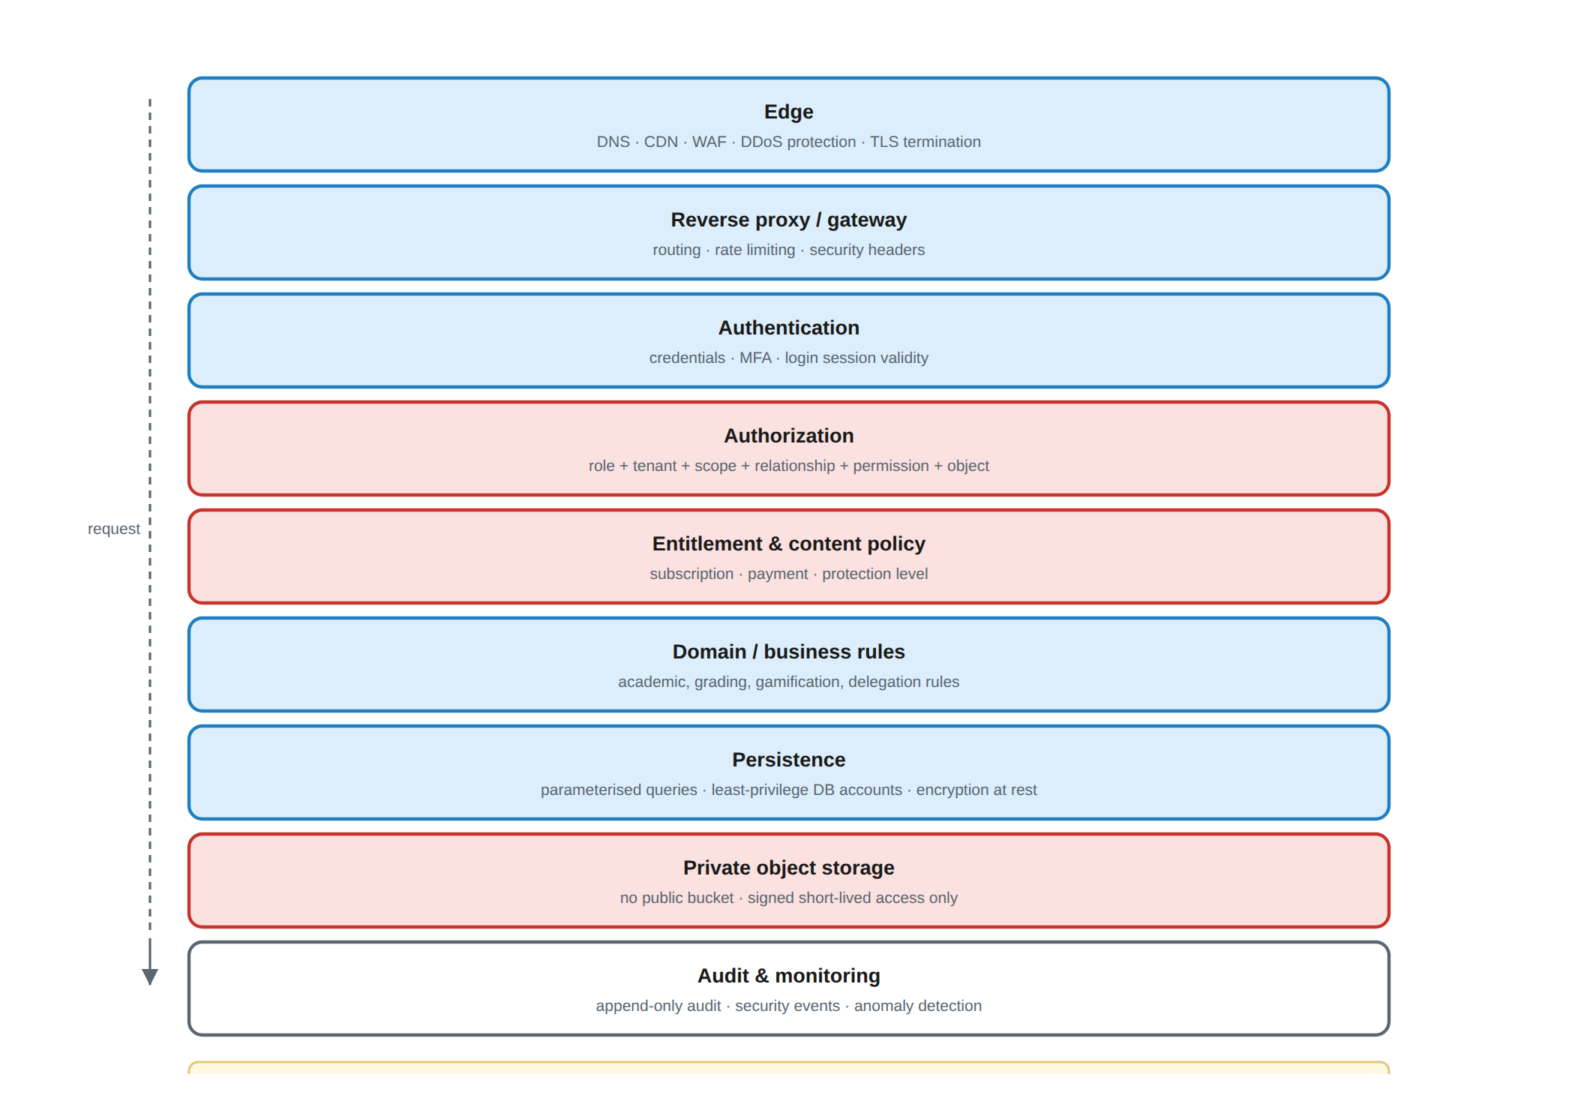
Figure 34.1 — The security layers. Every request passes through all of them.

34.1 Security objectives
Objective | Meaning in EduCapsules
Confidentiality | No user reaches data outside their role, scope, relationship and entitlement
Integrity | Grades, submissions, attendance and audit records cannot be silently altered
Availability | Legitimate users can teach and learn; abuse controls do not lock out real users
Authenticity | Users and services are properly authenticated before any decision is made
Authorization | Users perform only actions they are explicitly permitted to perform
Accountability | Every consequential action is attributable to an actor and a time
Privacy | Personal and educational information is exposed only when necessary
Resilience | A security failure does not destroy educational data

34.2 Requirements
ID | Requirement | Priority | Actor
SEC-020 | Every scoped query shall be constrained by the caller's organization. | MUST | System
SEC-021 | All application traffic shall use HTTPS/TLS with modern configuration; HTTP shall redirect or be disabled. | MUST | System
SEC-022 | Sensitive data shall be encrypted at rest, including database storage, object storage and backups. | MUST | System
SEC-023 | Passwords shall be stored only as hashes using a modern memory-hard algorithm (Argon2id preferred; bcrypt acceptable) with unique salts and an appropriate work factor. | MUST | System
SEC-024 | Passwords shall never appear in logs or API responses. | MUST | System
SEC-025 | All external input shall be validated for type, length, format, range, allowed values, relationships, file type and size before use. | MUST | System
SEC-026 | Database access shall use parameterised queries or a safe data-access layer; SQL shall never be constructed from raw user input. | MUST | System
SEC-027 | User-generated content shall be sanitised and safely encoded on output; the application shall apply a strong Content Security Policy. | MUST | System
SEC-028 | State-changing requests shall be protected against CSRF where cookie-based authentication is used. | MUST | System
SEC-029 | CORS shall permit only explicitly authorized origins; wildcard origins shall not be used for authenticated APIs. | MUST | System
SEC-030 | The system shall defend against and be tested for broken access control, cryptographic failures, injection, insecure design, misconfiguration, vulnerable components, authentication failures, integrity failures, logging failures and SSRF. | MUST | System
SEC-031 | Rate limiting shall protect login, password reset, OTP, file upload, messaging, search, content delivery and public endpoints, without being so aggressive that legitimate users are easily locked out. | MUST | System
SEC-032 | The system shall defend against brute force and credential stuffing using rate limiting, progressive delays, MFA and suspicious-login detection. | MUST | System
SEC-033 | Uploaded files shall be validated and malware-scanned in quarantine before becoming available to other users. | MUST | System
SEC-034 | Secrets shall never be committed to source control, embedded in client bundles, or stored in plaintext; a secrets/key-management system shall be used. | MUST | System
SEC-035 | Encryption keys shall have controlled access, defined rotation and recovery procedures. | MUST | System
SEC-036 | The database shall not be publicly accessible and shall accept connections only from authorized application infrastructure, using least-privilege accounts. | MUST | System
SEC-037 | Production errors shall not expose queries, stack traces, internal paths, secrets or infrastructure details (§40). | MUST | System
SEC-038 | The application shall set appropriate security headers, including HSTS, CSP, X-Content-Type-Options, Referrer-Policy and clickjacking protection. | MUST | System
SEC-039 | Infrastructure shall provide DDoS protection and network segmentation; the database and backups shall not be directly exposed to the internet. | MUST | System
SEC-040 | Dependencies shall be version-controlled, regularly updated and vulnerability-scanned in CI. | MUST | System
SEC-041 | Backups shall be encrypted, access-controlled, isolated, versioned and restore-tested. | MUST | System
SEC-042 | Development and staging shall use synthetic or anonymised data and shall be isolated from production credentials. | MUST | System
SEC-043 | The system shall support a documented incident response process: detect → contain → investigate → eradicate → recover → review → improve. | MUST | Admin
SEC-044 | On suspected account compromise the system shall support session revocation, credential reset, forced re-authentication, MFA enforcement and audit review. | MUST | System
SEC-045 | Security testing shall include dependency scanning, static analysis, secret scanning, API security tests, and manual authorization, authentication, file-upload and multi-tenant isolation testing. | MUST | QA

Table 34.1 — Security architecture requirements.

34.3 Threat model
Threat | Realistic form in EduCapsules | Countered by
IDOR / BOLA | A student changes an ID to read another student's grades or submission | GEN-025, SEC-005, SEC-009, TC-001
Horizontal escalation | An Assistant reaches a class outside their assignment | GEN-006, AST-002, TC-002
Vertical escalation | An Assistant grants themselves permissions or becomes a Teacher | SEC-006, AST-004, TC-003
Unauthorized parent access | Someone claims to be a child's parent, or a link code is forwarded | PAR-002, LEG-005, TC-004
Answer-key disclosure | A student reads correct answers from a quiz API response | GEN-026, QBN-039, TC-011
Content theft | Bulk downloading or scraping a paid course | CNT-012…024, GEN-016, TC-008
Storage enumeration | Guessing file identifiers or storage URLs | STR-015, CNT-012, TC-007
Cross-tenant leakage | One Organization reads another's data | ORG-003, SEC-020, TC-005
Session hijacking / fixation | Stolen or reused session credentials | AUTH-104, AUTH-110, AUTH-115, AUTH-119
Credential attacks | Password reuse and stuffing against student accounts | SEC-023, SEC-032, AUTH-111
Grade tampering | A grade changed without trace | GRD-005, GRD-006, AUD-003
Malware upload | A malicious file distributed to a class | SEC-033, STR-007
Insider access | An Admin reads private records with no legitimate need | ADM-025, ADM-027, AUD-007
Data loss near a deadline | A submission lost during an outage | ACT-035, NFR-002

Table 34.2 — The threats this specification is written against, and where each is addressed.

34.4 Security risk priorities
Priority | Areas
Critical | Authorization and access control · student privacy · parent–child relationships · authentication · database security · file access · grade integrity
High | Encryption · backup security · audit logging · API security · account recovery · multi-tenant isolation · content protection
Medium | DDoS protection · security analytics · advanced anomaly detection

35. Authentication & Login Sessions
A Login Session is a controlled, authenticated period during which a user is authorized to interact with EduCapsules. It is not a Teaching Session (§3.2). A session proves *who* is authenticated; it decides nothing about *what* they may do (SEC-003).

35.1 Session types
Type | For | Policy
Standard user session | Student · Parent · Teacher · Assistant | Normal idle and absolute timeouts
Admin session | All administrative roles | Mandatory MFA, shorter timeouts, stronger monitoring, re-authentication for sensitive actions
Elevated session | Any role performing a sensitive operation | Short-lived, requires re-authentication; used for password/MFA change, security settings, sensitive admin and billing operations
Support impersonation session | Support Admin, if enabled | Temporary, explicitly authorized, reason-required, visibly indicated, fully logged, sensitive actions restricted
Content access session | Protected content delivery | Short lifetime, scoped to resource, optionally device-bound, rate-limited, watermark identity, concurrent-playback limited

Table 35.1 — Session types. The content access session is deliberately separate from the account session — this is what makes a stolen content URL useless.

35.2 Requirements
ID | Requirement | Priority | Actor
AUTH-101 | The system shall create an authenticated session only after successful authentication. | MUST | System
AUTH-102 | Session credentials shall be generated using cryptographically secure randomness. | MUST | System
AUTH-103 | The system shall never store plaintext passwords or plaintext long-lived session credentials. | MUST | System
AUTH-104 | The system shall support session expiration with configurable idle and absolute timeouts per role. | MUST | System
AUTH-105 | The system shall support server-side session revocation. | MUST | System
AUTH-106 | The system shall support logout of the current session. | MUST | All
AUTH-107 | The system shall support revocation of all active sessions. | MUST | All
AUTH-108 | Users shall see their active sessions and devices with platform, last activity and approximate location. | MUST | All
AUTH-109 | Users shall revoke individual sessions. | MUST | All
AUTH-110 | The system shall rotate or invalidate session credentials after authentication events, and shall not reuse a pre-authentication session as an authenticated one. | MUST | System
AUTH-111 | Session credentials shall never appear in URLs or logs. | MUST | System
AUTH-112 | Authorization shall be enforced independently of session validity. | MUST | System
AUTH-113 | Administrative sessions shall apply stricter controls than ordinary sessions. | MUST | System
AUTH-114 | The system shall record security-relevant session events (§36.2). | MUST | System
AUTH-115 | The system shall detect and respond to refresh-token or session-token reuse. | MUST | System
AUTH-116 | The system shall support MFA for roles requiring elevated security, and shall require it for administrative accounts. | MUST | System
AUTH-117 | Suspending an account shall terminate or restrict its sessions. | MUST | System
AUTH-118 | The system shall prevent cross-user and cross-tenant session access. | MUST | System
AUTH-119 | Changing a password shall revoke existing sessions and establish a new trusted session. | MUST | System
AUTH-120 | Protected content shall require additional authorization beyond a valid account session (§16). | MUST | System
AUTH-121 | The system shall support email/password authentication, verified email, secure password reset with short-lived single-use tokens, and account recovery. | MUST | System
AUTH-122 | Password reset and account-existence responses shall not reveal whether an email address is registered. | MUST | System
AUTH-123 | The system shall support concurrent-session limits configurable per role, plan and protection level. | SHOULD | System
AUTH-124 | The system shall evaluate session risk signals — new device, unusual location, impossible travel, abnormal request volume, rapid content extraction, repeated authorization failures, token reuse — and respond proportionately. | SHOULD | System
AUTH-125 | Browser sessions shall use Secure, HttpOnly, SameSite cookies where the architecture permits. | MUST | System
AUTH-126 | Passkeys, hardware security keys and enterprise SSO are FUTURE. | FUTURE | System
AUTH-127 | Where MFA is enabled or required, the system shall provide a defined recovery path (single-use backup codes issued at enrolment, or admin-assisted reset after identity verification) so a lost MFA factor cannot permanently lock a user out of their own account. Recovery-code use and admin-assisted MFA reset shall each raise a security-relevant audit event and a notification per NOT-012. (Added in v1.1.) | MUST | System

Table 35.2 — Authentication and login-session requirements. These are the former SES-001…020 plus the additions required by §34; the mapping is in §51.2.

35.3 Session timeouts
Role | Idle timeout | Absolute timeout | Status
Student · Parent | Longer of the two bands | Longer of the two bands | TBD — §50 D-14
Teacher · Assistant | Medium | Medium | TBD
Admin | Shortest | Shortest | TBD

Table 35.3 — Indicative bands from the source material were 30–60 min idle / 7–30 days absolute for students and 10–20 min / 8–12 hours for admins. Final values are set during security testing (§50, D-14) rather than fixed here.

36. Audit, Logging & Monitoring
GEN-018 / GEN-021 · WHAT THE AUDIT TRAIL IS FOR
The audit trail exists to answer, months later: who did what, to whose record, when, and why. It is separate from application logging — application logs are for engineers and are disposable; audit records are evidence and are not.

36.1 Requirements
ID | Requirement | Priority | Actor
AUD-001 | The system shall record an audit event for every security- or record-significant action. | MUST | System
AUD-002 | An audit event shall capture actor, actor role, action, target type and identifier, organization and scope, outcome, timestamp, reason where applicable, before/after values where applicable, device/IP/session metadata where appropriate, and a correlation identifier. | MUST | System
AUD-003 | Grade changes shall record old value, new value, actor, time and reason. | MUST | System
AUD-004 | Audit records shall be append-only and tamper-resistant; no user, including any Admin, shall modify or delete them through any interface. | MUST | System
AUD-005 | Audit records shall remain attributable after an account is deactivated or deleted. | MUST | System
AUD-006 | Authorized Admins shall query audit records by actor, target, action, scope and date range. | MUST | Admin
AUD-007 | Exceptional access to private data shall raise a high-severity audit event. | MUST | System
AUD-008 | Users shall be able to see their own relevant security events (login history, device activity, security alerts). | SHOULD | All
AUD-009 | Application logs shall never contain credentials, tokens, or complete personal records. | MUST | System
AUD-010 | The system shall monitor repeated failed logins, unusual login patterns, excessive API requests, repeated authorization failures, suspicious uploads, unusual account activity and unexpected administrative actions. | MUST | System

Table 36.1 — Audit and logging requirements.

36.2 Audited events
Domain | Events
Authentication | LOGIN_SUCCESS · LOGIN_FAILED · LOGOUT · SESSION_CREATED · SESSION_REFRESHED · SESSION_REVOKED · SESSION_EXPIRED · ALL_SESSIONS_REVOKED · NEW_DEVICE_LOGIN · MFA_CHALLENGE · MFA_SUCCESS · MFA_FAILED · PASSWORD_CHANGED · SUSPICIOUS_SESSION · TOKEN_REUSE_DETECTED · ACCOUNT_LOCKED
Access control | ROLE_GRANTED / REVOKED · PERMISSION_GRANTED / REVOKED · ASSISTANT_ASSIGNED / MODIFIED / EXPIRED / REVOKED · PARENT_LINK_REQUESTED / CONFIRMED / REVOKED
Academic | GRADE_CREATED / UPDATED / RELEASED · ATTENDANCE_RECORDED / CHANGED · ACTIVITY_PUBLISHED / CLOSED / CANCELED · ACHIEVEMENT_AWARDED / REVOKED · POINTS_ADJUSTED · MEMBERSHIP_CHANGED
Content & storage | FILE_UPLOADED / DOWNLOADED / DELETED / RESTORED / SHARED · CONTENT_PUBLISHED / UNPUBLISHED · CONTENT_ACCESSED · CONTENT_ABUSE_DETECTED · STORAGE_PERMISSION_CHANGED
Commercial | PAYMENT_RECORDED · EVIDENCE_UPLOADED · EVIDENCE_APPROVED / REJECTED · ENTITLEMENT_GRANTED / REVOKED · REFUND_REQUESTED / APPROVED · SUBSCRIPTION_CHANGED
Administration | USER_SUSPENDED / RESTORED · ADMIN_ACTION · IMPERSONATION_STARTED / ENDED · PRIVATE_DATA_ACCESSED · SYSTEM_CONFIG_CHANGED · REPORT_RESOLVED
Legal | POLICY_ACCEPTED · CONSENT_RECORDED · DATA_EXPORTED · DELETION_REQUESTED / EXECUTED

Table 36.2 — The audited event catalogue, consolidated across all source specifications.

37. Data Model & Database Requirements
This section defines the logical data model. It is normative for entity identity, relationships, ownership and invariants. Physical concerns — index strategy, partitioning, engine-specific types — are architecture decisions constrained by, but not fixed in, this SRS (GEN-013).
DB-000 — MODELLING DISCIPLINE
Not every concept in this document becomes a table. Where a normalised structure, a typed column, a JSON document column or a derived projection expresses the concept more cleanly, the implementation shall use it. What is normative here is: the entity set, the relationships, the ownership boundaries and the invariants.
Status: CONFIRMED · Source: Master prompt, 'Do not blindly create every entity as a table'

37.1 Data model principles
# | Principle | Consequence
DB-001 | Every scoped row carries organization_id | Tenant isolation is enforced at the query layer and by database constraint, not by application convention alone. Composite FKs include organization_id so a cross-tenant reference is structurally impossible.
DB-002 | Surrogate primary keys, opaque and non-guessable externally | Internal keys may be integer or UUID. Any identifier exposed in a URL, an API response or a share link shall be non-sequential (UUIDv7 or ULID) so that resource enumeration is not possible.
DB-003 | Soft delete for user-visible academic and content records | deleted_at / deleted_by / deletion_reason. Hard delete is reserved for the erasure pipeline (§44) and for transient technical rows.
DB-004 | Immutable audit tables | AuditLog, GradeHistory, ContentAccessEvent, SecurityEvent, PaymentEvent are append-only. No UPDATE or DELETE grant is issued to the application role on these tables.
DB-005 | Historical academic facts are snapshotted, never recomputed | A released grade, an awarded achievement and a recorded attendance mark retain the values, scales and criteria that were in force when they were created (GEN-018).
DB-006 | Versioned content is copy-on-write | QuestionVersion, FileVersion and LessonVersion create a new row; the prior row is never mutated. Consumers pin a version id.
DB-007 | Portable types only | No vendor-proprietary column types in the core schema. Timestamps are UTC with explicit timezone semantics; money is integer minor units plus an ISO-4217 currency code; text is UTF-8.
DB-008 | All timestamps are UTC; presentation timezone is a user attribute | created_at / updated_at on every mutable table. Academic due dates additionally store the organisation timezone in force so that a later timezone change does not retroactively move a past deadline.
DB-009 | Referential integrity is declared, not assumed | Foreign keys are declared in the schema. Where the MVP platform has weaker FK support, the constraints are still declared and additionally enforced in the data-access layer, so the production schema is a superset, not a rewrite.
DB-010 | No business logic in database triggers | Triggers are permitted only for audit capture and updated_at maintenance. Educational rules live in the application layer so they remain testable and portable (GEN-013).

Table 37.1 — Normative data-model principles.

37.2 Consolidated entity–relationship model
Figure 37.1 shows the complete entity set grouped into six ownership bands. Cardinality is shown on the connectors; a solid connector is a mandatory relationship, a dashed connector is optional or conditional.

Figure 37.1 — Consolidated Entity–Relationship Model
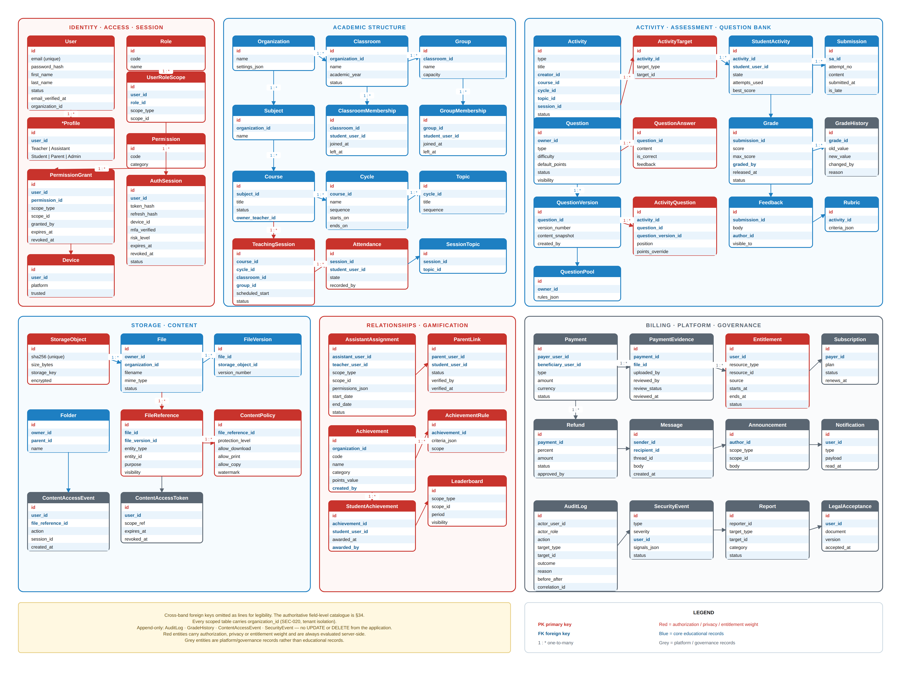
Figure 37.1 — EduCapsules consolidated entity–relationship model. Six bands: identity & tenancy, academic structure, delivery & assessment, content & storage, engagement, and commercial & governance. Cross-band references always carry organization_id.

37.3 Entity catalogue
Each entity is listed with its owner band, its identity rule and the invariant that the implementation must guarantee. Key attributes is indicative, not exhaustive.

37.3.1 Identity, tenancy and access control
Entity | Key attributes | Invariant
Organization | id, name, slug, timezone, locale, academic_year_policy, status, plan_id | Root of every scope chain. Deleting an Organization is a lifecycle operation (§44), never a cascade delete.
User | id, organization_id, email, phone, password_hash, status, locale, timezone, mfa_enabled, created_at | email is unique per organization, not globally. A natural person with accounts in two organisations has two User rows and no shared credential.
UserProfile | user_id, display_name, avatar_file_id, bio, contact_preferences | Separated from User so that authentication data and profile data have different access policies and different retention rules.
Role | id, organization_id (nullable for system roles), key, name, is_system | System roles (STUDENT, TEACHER, ASSISTANT, PARENT, ADMIN*) are immutable. Custom roles are organisation-scoped.
Permission | id, key, category, is_delegatable, description | Global catalogue (§26). Rows are created by migration, never by end users.
RolePermission | role_id, permission_id | Defines the role's baseline. A grant here never exceeds the role's ceiling.
UserRoleAssignment | id, organization_id, user_id, role_id, scope_type, scope_id, granted_by, valid_from, valid_until, status | A user holds a role within a scope. The same user may be TEACHER in one Subject and STUDENT in another. scope_type ∈ {ORG, CLASSROOM, GROUP, SUBJECT, COURSE}.
PermissionGrant | id, organization_id, grantee_user_id, permission_id, scope_type, scope_id, granted_by, reason, valid_from, valid_until, revoked_at | Explicit fine-grained grant, chiefly used for assistant delegation. Cannot grant a permission the grantor does not itself hold in an equal-or-wider scope (GEN-025).
AssistantAssignment | id, organization_id, assistant_user_id, teacher_user_id, scope_type, scope_id, permission_set, valid_from, valid_until, status | The delegation record. Expiry is enforced at authorisation time, not by a nightly job (AST-007).
ParentLink | id, organization_id, parent_user_id, student_user_id, relationship, confirmed_at, confirmed_by, revoked_at, status | A parent sees a student only through a CONFIRMED link. An unconfirmed link grants nothing (PAR-002).
LoginSession | id, user_id, device_fingerprint, ip_hash, user_agent, session_type, issued_at, last_seen_at, expires_at, revoked_at, revocation_reason | Distinct from TeachingSession (§3.2). Revocation is immediate and server-side (AUTH-118).
MfaFactor | id, user_id, type, secret_ref, verified_at, last_used_at, status | Secret material is stored in the secret manager; the table stores a reference, never the secret itself.

Table 37.2 — Identity, tenancy and access-control entities.

37.3.2 Academic structure
Entity | Key attributes | Invariant
AcademicPeriod | id, organization_id, name, starts_on, ends_on, status | Enrolment, grading scales and leaderboard windows are bound to a period so historical data does not blend across years.
Classroom | id, organization_id, name, grade_level, academic_period_id, homeroom_teacher_id, status | The administrative unit a student belongs to. A student has exactly one active Classroom per AcademicPeriod (BR-015).
Group | id, organization_id, classroom_id (not nullable), name, purpose, status | A subdivision of exactly one Classroom (GEN-008, GRP-001); classroom_id is mandatory. [v1.1: corrected — this row previously allowed a nullable classroom_id for a cross-classroom Group, contradicting the confirmed golden rule GEN-008 and GRP-001.]
Membership | id, organization_id, user_id, container_type, container_id, role_in_container, joined_at, left_at, status | Single polymorphic membership table for Classroom and Group. left_at is set rather than the row deleted, so historical attribution survives (GEN-018).
Subject | id, organization_id, name, code, description, status | The academic discipline (e.g. Mathematics). Subjects are organisation-level; they are not owned by an individual teacher.
Course | id, organization_id, subject_id, title, description, owner_teacher_id, academic_period_id, visibility, status | A taught instance of a Subject, owned by one teacher. Co-teachers are modelled as UserRoleAssignment rows scoped to the Course, not as additional owner columns.
CourseAudience | id, course_id, target_type, target_id | Which classrooms and groups the course serves. Replaces a single classroom_id so a course can serve several groups without duplication.
Cycle | id, organization_id, course_id, title, sequence_no, starts_on, ends_on, status | An ordered teaching block within a Course. sequence_no is unique per course.
Topic | id, organization_id, cycle_id, title, sequence_no, learning_objectives, status | The smallest planned academic unit. Activities and lesson content attach here.
Enrollment | id, organization_id, student_user_id, course_id, academic_period_id, enrolled_at, withdrawn_at, status, source | Distinct from Membership: membership is structural, enrolment is academic. Withdrawal preserves the row and all grades earned (BR-015).

Table 37.3 — Academic structure entities.

37.3.3 Delivery, assessment and results
Entity | Key attributes | Invariant
TeachingSession | id, organization_id, course_id, cycle_id, topic_id, title, scheduled_start, scheduled_end, mode, location, status, conducted_by | A scheduled meeting. Cancelling a session does not delete attendance already recorded; the records are marked VOID with a reason (SES-014).
AttendanceRecord | id, organization_id, teaching_session_id, student_user_id, state, recorded_by, recorded_at, note | state ∈ {PRESENT, ABSENT, LATE, EXCUSED, VOID}. Any change writes an AttendanceHistory row; the current row always reflects the latest state.
Activity | id, organization_id, course_id, cycle_id, topic_id, type, title, instructions, max_score, weight, opens_at, due_at, closes_at, late_policy, attempt_limit, time_limit_seconds, grading_mode, visibility, status, created_by | The single generic container. Homework, Quiz and Exam are values of type, not separate tables (ACT-001). Fields not meaningful for a given type are null.
ActivityTarget | id, activity_id, target_type, target_id | target_type ∈ {CLASSROOM, GROUP, STUDENT}. An activity with no target row is not assigned to anyone and cannot open (ACT-009).
ActivityQuestion | id, activity_id, question_version_id, sequence_no, points, is_required | Pins a version, not a question. Editing the bank question afterwards cannot alter a published assessment (QBN-025).
Question | id, organization_id, subject_id, topic_tag, type, difficulty, owner_user_id, visibility, status | The stable identity of a bank item. Carries no content; content lives in versions.
QuestionVersion | id, question_id, version_no, stem, media_refs, options, answer_key, explanation, created_by, created_at, status | Immutable once referenced by a published activity. answer_key is never serialised to a student-facing response (GEN-026).
Submission | id, organization_id, activity_id, student_user_id, attempt_no, started_at, submitted_at, is_late, state, autosave_ref | Unique on (activity_id, student_user_id, attempt_no). attempt_no ≤ Activity.attempt_limit.
SubmissionAnswer | id, submission_id, activity_question_id, response, auto_score, manual_score, grader_comment, graded_by, graded_at | Auto and manual scores are stored separately so an override is visible, not destructive.
SubmissionFile | id, submission_id, file_id, original_name, uploaded_at | References the file layer (§37.3.4); submission storage is not a separate storage system.
Grade | id, organization_id, activity_id, student_user_id, submission_id, raw_score, max_score, scaled_score, grading_scale_snapshot, state, released_at, released_by | state ∈ {DRAFT, PENDING_REVIEW, RELEASED, VOID}. A student sees only RELEASED (GRD-006).
GradeHistory | id, grade_id, previous_values, new_values, changed_by, changed_at, reason | Append-only. Every change after first release requires a reason (GRD-009).
Feedback | id, organization_id, target_type, target_id, author_user_id, body, visibility, created_at | Feedback can attach to a submission, an answer or a student-in-course, with independent visibility.
ProgressSnapshot | id, organization_id, student_user_id, scope_type, scope_id, computed_at, completion_pct, components | A derived projection, rebuildable from source rows. Never the system of record (PRG-006).

Table 37.4 — Delivery, assessment and results entities.

37.3.4 Content, files and protection
Entity | Key attributes | Invariant
StorageObject | id, sha256, byte_size, mime_type, storage_backend, storage_key, created_at, refcount | The physical blob, private and never publicly addressable. Deduplicated by sha256 across tenants, invisibly: the shared object carries no tenant identity itself, and every File row pointing at it keeps its own organization_id, owner and access rules (STR-IMP-011, STR-IMP-012). [v1.1: corrected — this row previously said cross-tenant deduplication was prohibited, contradicting the confirmed design in §14.4; now matches §14.4.]
File | id, organization_id, owner_user_id, folder_id, display_name, current_version_id, protection_level, status, deleted_at | The logical, user-visible file. Renaming or moving touches this row only.
FileVersion | id, file_id, version_no, storage_object_id, created_by, created_at, note | Copy-on-write. Restoring an old version creates a new version pointing at the old StorageObject (STR-014).
FileReference | id, file_id, referrer_type, referrer_id, created_at | Every use of a file by a lesson, activity, submission or message. A File with live references cannot be hard-deleted (STR-023).
Folder | id, organization_id, owner_user_id, parent_folder_id, name, path_cache, status | Teacher-private by default. Sharing is a permission grant, never a copy.
ContentItem | id, organization_id, topic_id, type, title, body, file_id, sequence_no, protection_level, visibility, publish_at, status | Published learning material. protection_level ∈ {0,1,2,3} per §16.
ContentAccessGrant | id, content_item_id, principal_type, principal_id, valid_from, valid_until | Who may open the item, over and above the course audience. Evaluated by the Content Gateway on every request.
ContentAccessEvent | id, organization_id, content_item_id, user_id, login_session_id, ip_hash, device_fingerprint, action, occurred_at | Append-only. Feeds anomaly detection (CNT-026). Retained per §32.
ContentAbuseSignal | id, organization_id, user_id, content_item_id, signal_type, score, detected_at, resolution | Never an automatic punishment; it raises a case for human review (CNT-029).
Watermark | id, content_access_event_id, payload_hash, issued_at | Lets a leaked artefact be traced back to a viewing event without embedding personal data in the artefact itself.

Table 37.5 — Content, file and protection entities.

37.3.5 Engagement, communication and commerce
Entity | Key attributes | Invariant
Achievement | id, organization_id, key, name, description, icon_ref, category, criteria, points_value, scope_type, scope_id, created_by, status | criteria is a declarative rule document, not code. Editing criteria never retroactively revokes awards (ACH-007).
AchievementAward | id, organization_id, achievement_id, student_user_id, awarded_at, awarded_by, criteria_snapshot, revoked_at, revocation_reason | Append-and-revoke, never delete. The snapshot preserves why it was earned.
PointsLedger | id, organization_id, student_user_id, delta, reason_type, reason_ref, scope_type, scope_id, created_by, created_at | A student's balance is the sum of the ledger, never a stored mutable counter (PTS-003).
LeaderboardConfig | id, organization_id, scope_type, scope_id, metric, window, visibility_mode, tie_rule, is_enabled, configured_by | Leaderboards are off unless explicitly enabled for a scope (LDB-009).
Conversation / Message | id, organization_id, context_type, context_id, participants, body, attachments, sent_at, edited_at, deleted_at, moderation_state | Every conversation exists inside an educational context. There is no open student-to-student direct messaging in V1 (MSG-004).
Notification | id, organization_id, user_id, type, payload, channel, created_at, delivered_at, read_at, dismissed_at | A notification never contains data the recipient is not authorised to see; it carries a reference, and authorisation is re-checked on open (NOT-011).
NotificationPreference | user_id, type, channel, is_enabled | Security and legal notifications cannot be disabled (NOT-012).
CalendarEvent | id, organization_id, source_type, source_id, title, starts_at, ends_at, visibility_scope | Mostly a projection of TeachingSession and Activity dates; standalone events are permitted.
PaymentRecord | id, organization_id, payer_user_id, student_user_id, subject_ref, amount_minor, currency, method, reference_no, evidence_file_id, state, recorded_by, verified_by, verified_at | Records that a payment happened. EduCapsules stores no card number and no CVV (PAY-011).
Entitlement | id, organization_id, holder_user_id, resource_type, resource_id, source, valid_from, valid_until, revoked_at, state | The only thing the authorisation pipeline consults for paid access. Payment state and entitlement state are separate (BIL-003).
Subscription / Invoice | id, organization_id, plan_id, period, amount_minor, currency, state, issued_at, settled_at | Platform-to-organisation billing. Structurally separate from teacher-to-student payment (BIL-001).
AuditLog | id, organization_id, actor_user_id, actor_role, action, target_type, target_id, before_ref, after_ref, ip_hash, login_session_id, occurred_at, reason | Append-only, no application UPDATE/DELETE grant (AUD-002).

Table 37.6 — Engagement, communication, commercial and governance entities.

37.4 Critical relationships and cardinality
Relationship | Card. | Rule
Organization → User | 1..N | Every user belongs to exactly one organisation.
User ↔ Role | M..N via UserRoleAssignment | Scoped. Multi-role is normal, not exceptional.
Classroom → Student | 1..N per period | One active classroom per student per AcademicPeriod.
Group ↔ Student | M..N via Membership | A student may be in many groups simultaneously.
Subject → Course | 1..N | A subject has many courses; a course has exactly one subject.
Course → Cycle → Topic | 1..N → 1..N | Strictly ordered, strictly nested.
Course ↔ Audience | M..N via CourseAudience | A course may serve several classrooms/groups.
Topic → Activity | 1..N | An activity belongs to at most one topic; topic may be null for course-level activities.
Activity ↔ Target | 1..N via ActivityTarget | Mixed targets permitted; ≥1 required to open.
Activity ↔ QuestionVersion | M..N via ActivityQuestion | Version-pinned.
Submission → Grade | 1..0..1 | A submission has at most one current Grade; history is unbounded.
File → FileVersion | 1..N | current_version_id points to one of them.
File → StorageObject | N..1 through versions | Many files may share one blob within a tenant.
Parent ↔ Student | M..N via ParentLink | A parent may have several children; a student may have several linked guardians.
Teacher ↔ Assistant | M..N via AssistantAssignment | Scoped and time-bounded.

Table 37.7 — Cardinality rules that the schema must enforce structurally.

37.5 Integrity, concurrency and consistency
ID | Requirement | Priority | Actor
DB-011 | Every scoped table shall declare a foreign key on organization_id and every cross-table foreign key within a tenant shall be composite on (organization_id, id). | MUST | Backend
DB-012 | Unique constraints shall be scoped by organization_id (e.g. UNIQUE(organization_id, email), UNIQUE(course_id, sequence_no)). | MUST | Backend
DB-013 | Submission creation shall be idempotent under retry: a client-supplied idempotency key prevents a duplicate attempt being created by a repeated request. | MUST | Backend
DB-014 | Grade writes shall use optimistic concurrency (version column). A conflicting concurrent edit shall be rejected with a 409, never silently overwritten. | MUST | Backend
DB-015 | Quiz auto-scoring, grade creation and points-ledger entry for one submission shall occur in a single transaction, or be made eventually consistent through a durable outbox with at-least-once delivery and idempotent consumers. | MUST | Backend
DB-016 | Points balance, progress percentage and leaderboard rank shall be computed or materialised from source rows and shall be fully rebuildable from them. | MUST | Backend
DB-017 | Every table with user-generated content shall carry created_at, updated_at, created_by and, where deletion is possible, deleted_at and deleted_by. | MUST | Backend
DB-018 | Schema changes shall be delivered as forward-only, reviewed migrations under version control. Destructive migrations require an explicit approved change record. | MUST | DevOps
DB-019 | The schema shall avoid stored procedures and database-specific functions in business paths, so the same migrations can target the MVP and production engines. | MUST | Backend
DB-020 | Indexes shall exist for every foreign key used in a filter, and for the access patterns listed in Table 37.8. Index design beyond that is an implementation decision. | SHOULD | Backend

Table 37.8 — Integrity and concurrency requirements.

37.5.1 Primary access patterns the schema must serve efficiently
# | Access pattern | Driving screen
AP-1 | All open activities for one student across all enrolled courses, ordered by due_at | Student dashboard (S-02)
AP-2 | All submissions awaiting grading for one teacher across owned courses | Grading queue (S-07)
AP-3 | One student's full result history within one course and period | Student progress (S-05), Parent view (S-16)
AP-4 | Attendance roll for one teaching session | Attendance (S-09)
AP-5 | Points ledger sum per student per scope per window | Leaderboard (S-13)
AP-6 | Folder listing with current version metadata for one teacher | Storage (S-11)
AP-7 | Question bank search by subject, topic tag, type and difficulty | Quiz builder (S-08)
AP-8 | Audit trail for one target object, newest first | Admin audit (S-19)
AP-9 | Unread notifications for one user | All screens
AP-10 | Entitlement check for one user against one resource | Every protected request

Table 37.9 — Access patterns that drive index and projection design.
D-01 — READ-MODEL STRATEGY
Whether AP-2, AP-3 and AP-5 are served by direct queries, materialised views or a separate read store is deferred to architecture. The SRS requires only that the response-time targets in §43 be met and that every projection be rebuildable from source rows (DB-016).
Decision required before: schema freeze

38. API Requirements
The API is the contract between every client and the platform. It is the only way a client reaches data: there is no client that talks to the database directly, and no business rule that exists only in a client (GEN-011).

38.1 API principles
# | Requirement | Note
API-001 | The API shall be resource-oriented HTTP/JSON over TLS 1.2+ only. | A GraphQL or RPC edge may be added later for a specific client; it must sit on the same service layer, not bypass it.
API-002 | The API shall be versioned in the path (/api/v1/...). Breaking changes require a new version; additive changes do not. | Clients pin a major version. Two adjacent major versions run concurrently during migration.
API-003 | Every request shall be authenticated except a short, explicitly enumerated public allow-list (login, registration, password reset, health, legal documents). | The allow-list is a code-level constant, reviewed at each release.
API-004 | Authorisation shall be enforced server-side on every request through the §7 pipeline. Client-side checks are presentation only. | GEN-024 — a hidden button is not a permission.
API-005 | Every list endpoint shall be paginated with a stable cursor and a bounded page size (default 25, maximum 100). | Offset pagination is not permitted for datasets that change during traversal.
API-006 | Every mutating endpoint shall accept an Idempotency-Key header and shall return the original result for a repeated key within the retention window. | Protects submissions and payment records from double-submit on flaky networks.
API-007 | Responses shall never include fields the caller is not authorised to read; authorisation shall filter the projection, not just the row set. | An answer key, another student's score and a private note are filtered at serialisation (GEN-026).
API-008 | The API shall return RFC 9457 problem-detail error objects with a stable machine-readable code, a human-readable message and a correlation id. | See §40.
API-009 | All timestamps in requests and responses shall be RFC 3339 UTC with explicit offset. | Clients localise; the server never guesses a timezone.
API-010 | Money shall be transmitted as integer minor units plus an ISO-4217 currency code, never as a floating-point value. | Prevents rounding drift in payment records.
API-011 | The API shall be documented as a machine-readable OpenAPI 3.1 specification kept in the same repository and validated in CI against the implementation. | Documentation drift is a build failure, not a documentation task.
API-012 | File upload and download shall not stream through the application API; clients use short-lived, scoped, signed URLs issued by the API. | Except for protection level 2–3 content, which is served through the Content Gateway (§16).
API-013 | The API shall not expose internal identifiers, stack traces, engine names, library versions or SQL fragments in any response. | See ERR-006.
API-014 | Bulk endpoints shall be provided for grading, attendance and enrolment so that common teacher workflows do not require N sequential requests. | Partial success is reported per item, not as an all-or-nothing failure.

Table 38.1 — Normative API requirements.

38.2 Resource surface
The table below fixes the resource vocabulary and the principal operations. It is the shape of the API, not the full endpoint list; the OpenAPI specification (API-011) is authoritative for exact paths, parameters and schemas.
Resource group | Principal operations | Primary actors
/auth | login · logout · refresh · mfa/challenge · mfa/verify · password/forgot · password/reset · sessions (list, revoke, revoke-all) | All
/me | profile · preferences · notifications · devices · consents · data-export | All
/organizations/{id} | read · settings · academic-periods · branding | Admin
/users | create · read · list · update · suspend · restore · roles · permissions | Admin
/classrooms · /groups | CRUD · members (add, remove, list) · transfer | Admin, Teacher
/subjects · /courses | CRUD · publish · archive · audience · co-teachers · enrolment | Teacher, Admin
/courses/{id}/cycles · /cycles/{id}/topics | CRUD · reorder | Teacher
/teaching-sessions | CRUD · start · complete · cancel · attendance (bulk) | Teacher, Assistant
/activities | CRUD · publish · targets · questions · open · close · extend · submissions | Teacher, Assistant
/activities/{id}/submissions | start · autosave · submit · list · grade (bulk) · return | Student, Teacher, Assistant
/questions | CRUD · versions · search · import · export · share | Teacher
/grades | read · update · release (bulk) · history · export | Teacher, Admin
/progress | student · course · cycle · cohort | Student, Teacher, Parent
/achievements · /points · /leaderboards | CRUD · award · revoke · ledger · standings | Teacher, Admin, Student (read)
/files · /folders | upload-url · commit · download-url · versions · move · rename · share · trash · restore | Teacher, Student
/content | CRUD · publish · access-grants · gateway-ticket | Teacher
/messages · /conversations | create · list · read · report | All
/notifications | list · mark-read · preferences | All
/calendar | list · event CRUD | All
/payments | record · evidence-upload · verify · reject · list | Teacher, Admin
/entitlements | list · grant · revoke · check | Admin, internal
/parents | link-request · confirm · revoke · children · child-summary | Parent, Admin
/admin | audit · reports · impersonation · system-config · moderation-queue | Admin
/health · /ready | liveness · readiness | Infrastructure

Table 38.2 — API resource surface.

38.3 Rate limiting and abuse control
ID | Requirement | Priority | Actor
API-015 | The API shall apply per-identity and per-IP rate limits, with separate, stricter budgets for authentication, password reset, file download and content-gateway endpoints. | MUST | Backend
API-016 | Exceeding a limit shall return 429 with a Retry-After header and shall not reveal whether the underlying resource exists. | MUST | Backend
API-017 | Authentication endpoints shall additionally apply progressive delay and account lockout per §35, independently of the IP-based limit. | MUST | Backend
API-018 | Rate-limit events shall be recorded as SecurityEvent rows and shall feed the abuse detection pipeline. | MUST | Backend
API-019 | Bulk endpoints shall enforce a maximum batch size and shall count each item against the caller's budget. | SHOULD | Backend

Table 38.3 — Rate limiting requirements.
D-02 — CONCRETE RATE-LIMIT VALUES
Exact request budgets (requests per minute per endpoint class) are marked TBD. They depend on the measured V1 load profile and shall be fixed during load testing (§43.1). Publishing invented numbers here would create untestable requirements.
Decision required before: load-test plan sign-off

39. Backend & Application Architecture Requirements
This section states what the backend must be true of, not which framework builds it (GEN-013).

39.1 Layering
Layer | Responsibility | May not
Edge | TLS termination, WAF, DDoS mitigation, static asset delivery, caching of public assets, geographic routing. | Make authorisation decisions about educational data.
Transport / API | Request parsing, schema validation, authentication, rate limiting, correlation-id assignment, serialisation, error mapping. | Contain educational business rules.
Authorisation | The §7 eleven-stage pipeline: identity → session → tenant → role → scope → relationship → permission → entitlement → object state → constraint → audit. | Be bypassed by any other layer, including background jobs.
Domain / Service | Educational rules: enrolment, activity lifecycle, grading, progress, achievements, points, storage semantics, payment state. | Depend on HTTP types, on the specific database engine, or on the client platform.
Persistence | Repositories, transactions, migrations, query construction. | Contain educational decisions or authorisation logic.
Integration | Email/SMS/push delivery, object storage, payment evidence handling, video packaging, external identity providers. | Be called directly from the transport layer.
Background | Queues, scheduled jobs, projections, notification fan-out, retention sweeps, anomaly scoring. | Skip authorisation or audit because 'the system' is the actor.

Table 39.1 — Layer responsibilities and prohibitions.
ID | Requirement | Priority | Actor
BE-001 | Educational business rules shall exist in exactly one place — the domain layer — and shall be reachable identically from the API, from background jobs and from administrative tooling. | MUST | Backend
BE-002 | The domain layer shall have no compile-time dependency on the HTTP framework, the database driver or the hosting platform. | MUST | Backend
BE-003 | Background jobs shall execute under an explicit principal (a service principal or an impersonated user with recorded justification) and shall be audited like any other actor. | MUST | Backend
BE-004 | Every externally triggered side effect (email, push, payment evidence processing, video packaging) shall be idempotent and retry-safe. | MUST | Backend
BE-005 | Long-running work (bulk import, export, video packaging, report generation) shall be asynchronous with an observable job status resource. | MUST | Backend
BE-006 | The backend shall be stateless with respect to request handling; all session and workflow state shall live in the datastore or cache, so any instance can serve any request. | MUST | Backend
BE-007 | Configuration shall come from the environment, never from committed files. Secrets shall come from a secret manager and shall never appear in source, logs or error messages. | MUST | DevOps
BE-008 | The platform-abstraction boundary (object storage, queue, cache, mail, scheduler) shall be expressed as interfaces with at least two implementations exercised in CI, so the MVP → production migration (§41.5) is a configuration change, not a rewrite. | MUST | Backend
BE-009 | Every service shall expose a liveness endpoint, a readiness endpoint and structured metrics. | MUST | DevOps
BE-010 | Feature flags shall gate incomplete or risky functionality so that deployment and release are separable. | SHOULD | Backend

Table 39.2 — Backend architecture requirements.
GEN-013 RESTATED FOR IMPLEMENTERS
This SRS deliberately does not name a language, framework or ORM. What it does fix is the portability contract in BE-008: anything that touches a hosting-platform primitive sits behind an interface. A design that calls a platform SDK from a service class violates this requirement even if it works.
Status: CONFIRMED

40. Error Handling & System Behaviour

40.1 Error response contract
Canonical error object (RFC 9457 problem detail, extended)
HTTP 4xx / 5xx
{
"type": "https://errors.educapsules.app/submission-window-closed",
"title": "Submission window has closed",
"status": 409,
"code": "ACT_WINDOW_CLOSED", // stable, machine-readable
"detail": "This homework closed on 12 May 2026 at 23:59 (Africa/Cairo).",
"instance": "/api/v1/activities/01H.../submissions",
"correlationId": "01J8QK7Z...", // matches the server log entry
"errors": [ // field-level, validation only
{ "field": "answers[3].response", "code": "REQUIRED" }
]
}

ID | Requirement | Priority | Actor
ERR-001 | Every error response shall carry a stable machine-readable code, a human-readable title safe to display, and a correlation id. | MUST | Backend
ERR-002 | Error messages shown to users shall state what happened, why it happened where the reason is safe to disclose, and what the user can do next. | MUST | Frontend
ERR-003 | The correlation id shall be shown in the client's error surface so a user can quote it to support, and shall appear in the corresponding server log entry. | MUST | Full stack
ERR-004 | Validation errors shall be returned as a complete list, not one at a time. | MUST | Backend
ERR-005 | Authorisation failures shall not disclose the existence of resources the caller cannot see: an unauthorised read of an existing object and a read of a non-existent object shall be indistinguishable (404), except where the caller is authorised to know the object exists but not to act (403). | MUST | Backend
ERR-006 | No response shall contain a stack trace, an internal path, an SQL fragment, a framework or engine name, a library version, or an internal hostname. | MUST | Backend
ERR-007 | Authentication failures shall use a single generic message regardless of whether the identifier exists, the password is wrong or the account is locked; the distinction shall be recorded server-side only. | MUST | Backend
ERR-008 | The client shall preserve unsaved user work across a transient error: quiz answers, grading entries, long-form content and messages shall survive a failed request and be re-submittable. | MUST | Frontend
ERR-009 | Transient failures shall be retried with exponential backoff and jitter, bounded by a total attempt budget; non-idempotent operations shall be retried only with an idempotency key. | MUST | Full stack
ERR-010 | A dependency failure shall degrade the feature, not the platform: if notifications, leaderboards or analytics are unavailable, teaching, submission and grading shall continue. | MUST | Backend
ERR-011 | Unhandled server errors shall return 500 with a correlation id and shall raise an alert; the rate of 500s is a monitored SLI (§43). | MUST | DevOps
ERR-012 | Scheduled maintenance shall present a maintenance state with an expected end time; unscheduled outage shall present a status page reference. | SHOULD | DevOps

Table 40.1 — Error-handling requirements.

40.2 Error class to response mapping
Condition | HTTP | Code family | User-visible?
Malformed request / schema violation | 400 | REQ_* | Yes — field-level
Missing, expired or revoked credential | 401 | AUTH_* | Yes — generic
MFA required or MFA challenge failed | 401 | AUTH_MFA_* | Yes
Authenticated but not permitted, existence known to caller | 403 | PERM_* | Yes
Not permitted and existence not known to caller | 404 | NOT_FOUND | Yes — generic
Entitlement absent (unpaid / not granted) | 403 | ENT_* | Yes — with next step
State conflict (window closed, already submitted, stale version) | 409 | *_CONFLICT | Yes — actionable
Business-rule violation (attempt limit, scope containment, self-grant) | 422 | BR_* | Yes — names the rule
Rate limit exceeded | 429 | RATE_LIMITED | Yes — with Retry-After
Unhandled server fault | 500 | INTERNAL | Generic + correlation id
Dependency unavailable / degraded | 503 | DEPENDENCY_* | Yes — degraded state
Maintenance | 503 | MAINTENANCE | Yes — with end time

Table 40.2 — Canonical condition → response mapping.
WHY 404 SOMETIMES REPLACES 403
If an unauthorised teacher probing /courses/{id} received 403 for real courses and 404 for imaginary ones, the API would leak the course inventory of every other teacher. ERR-005 removes that oracle. The rule is applied by whether the caller is already inside the object's scope: inside the scope, 403 is safe and more helpful; outside it, 404.

41. Frontend, Client Applications & Infrastructure

41.1 Client platform scope
Client | V1 status | Notes
Responsive web application | CONFIRMED — V1 | The primary and only mandatory V1 client. Must be fully usable on a phone browser, since a large share of students will have no other device.
Installable PWA (offline shell, add-to-home-screen, push) | PROPOSED — V1 if effort permits | Delivers most of the perceived benefit of a mobile app at a fraction of the cost, and reuses the same codebase.
Native mobile applications (iOS, Android) | FUTURE | Justified when a requirement genuinely needs native capability — stronger content protection, true offline study, or platform DRM.
Desktop applications (Windows, macOS) | FUTURE | No V1 requirement is unmet by the web client. Revisit only if a protected-content or proctoring requirement demands it.

Table 41.1 — Client platform scope for V1.
PLATFORM DECISION
V1 ships one responsive web client. This is a deliberate scope decision, not an omission: shipping one excellent web client that works on a low-end Android phone serves the mission better than three half-finished clients. §49 records the native applications as a roadmap item with explicit entry criteria.
Status: CONFIRMED · Supersedes the multi-platform ambition in the original project context for the V1 timeframe only

41.2 Frontend requirements
ID | Requirement | Priority | Actor
FE-001 | The web client shall function on the two most recent major versions of Chrome, Edge, Firefox and Safari, and on Chrome and Safari on mobile. | MUST | Frontend
FE-002 | The client shall never contain a business rule that is not also enforced by the server; client checks exist only to improve the experience. | MUST | Frontend
FE-003 | The client shall never receive data the user is not authorised to see, including in hidden DOM, in a preloaded store, in a source map or in a bundled fixture. | MUST | Frontend
FE-004 | Protected course content shall never be embedded in JavaScript, in a bundle or in a durable client cache (GEN-017). | MUST | Frontend
FE-005 | Every destructive or irreversible action shall require explicit confirmation naming the object and the consequence. | MUST | Frontend
FE-006 | The client shall autosave long-form work (quiz attempts, grading, content authoring, messages) and shall recover it after a reload or a crash. | MUST | Frontend
FE-007 | The client shall present explicit empty, loading, partial, error and offline states for every data-bearing view (§38 UI/UX). | MUST | Frontend
FE-008 | Time-limited assessments shall display a server-authoritative countdown; the client clock shall never determine expiry. | MUST | Frontend
FE-009 | The client shall be internationalisation-ready: no concatenated sentence fragments, externalised strings, and layout that tolerates a right-to-left direction. | MUST | Frontend
FE-010 | Initial interactive load on a mid-range mobile device over a 3G-class connection shall be a measured, budgeted target; the budget shall be enforced in CI. | MUST | Frontend
FE-011 | The client shall degrade usefully when a non-critical subsystem is unavailable: a failed leaderboard or notification feed shall not blank a dashboard. | MUST | Frontend
FE-012 | Client-side logging shall never include tokens, answer keys, grades of other students, or personal data beyond the acting user. | MUST | Frontend

Table 41.2 — Frontend requirements.
D-03 — ARABIC AND RIGHT-TO-LEFT SUPPORT
The source material is written in English but the primary deployment context is Egypt. Whether V1 ships an Arabic locale, and whether the interface must support RTL layout at launch, is an OPEN decision with real architectural consequences (layout, typography, content authoring, PDF export). FE-009 makes the client ready for it either way; the launch locale set is TBD.
Decision required before: UI implementation begins

41.3 MVP infrastructure — Cloudflare
The MVP runs entirely on Cloudflare. Figure 41.1 shows the topology and the boundaries that the portability contract (BE-008) protects.
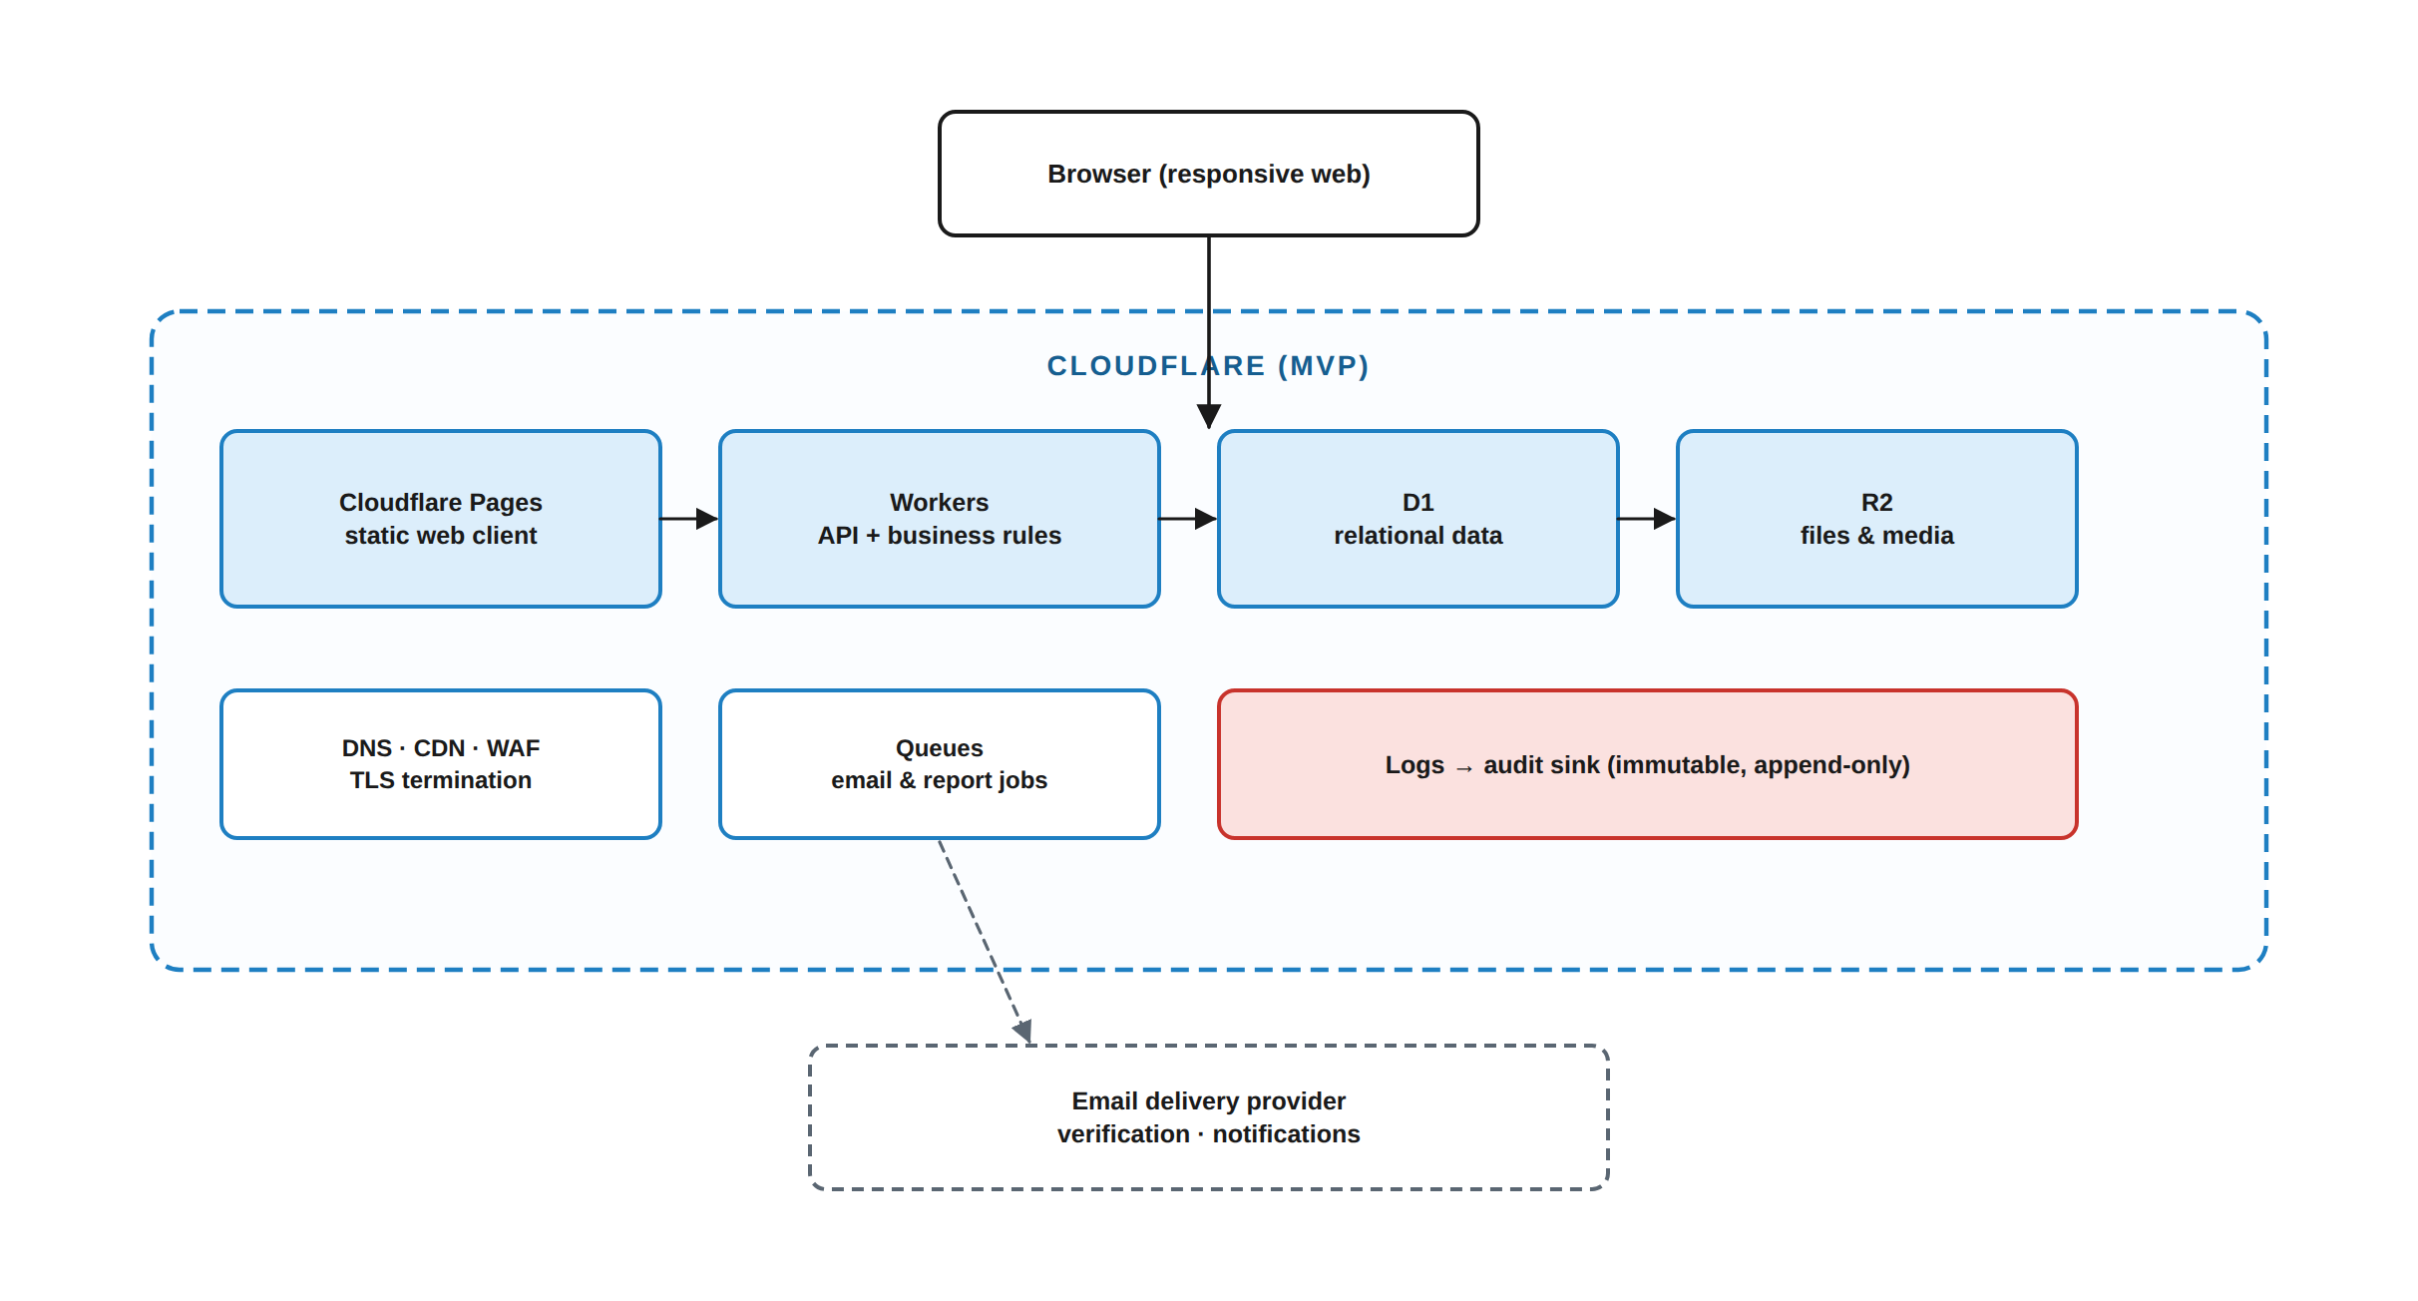
Figure 41.1 — MVP deployment topology on Cloudflare. Each platform primitive is reached only through the abstraction interfaces required by BE-008.
Concern | MVP service | Abstraction that protects portability
Static client delivery | Pages | Build output is a plain static bundle; no platform-specific runtime in the client.
Application runtime | Workers | Domain layer is framework-agnostic (BE-002); the Worker is a thin transport adapter.
Relational data | D1 | Repository interfaces + portable SQL (DB-019). No engine-specific types or stored procedures.
Object storage | R2 | ObjectStore interface: put, get, signed-url, delete, copy, head.
Asynchronous work | Queues | JobQueue interface: enqueue, consume, retry, dead-letter.
Cache / ephemeral state | KV / Durable Objects where genuinely needed | Cache interface; no business state may live only here.
Edge security | WAF, DDoS, bot management, TLS | Retained in production (§41.4).
DNS | Cloudflare DNS | Retained in production.

Table 41.3 — MVP service mapping and the abstraction that keeps each one replaceable.
R-01 — PLATFORM-PRIMITIVE LEAKAGE
The single greatest threat to the migration is a service class that calls a Cloudflare SDK directly. It works, it ships, and it silently welds the product to the platform. Mitigation: BE-008 requires two implementations of each abstraction exercised in CI from the first sprint — not added later.
Severity: High · Likelihood: High without discipline · Owner: Software Engineer

41.4 Production infrastructure — InterServer VPS
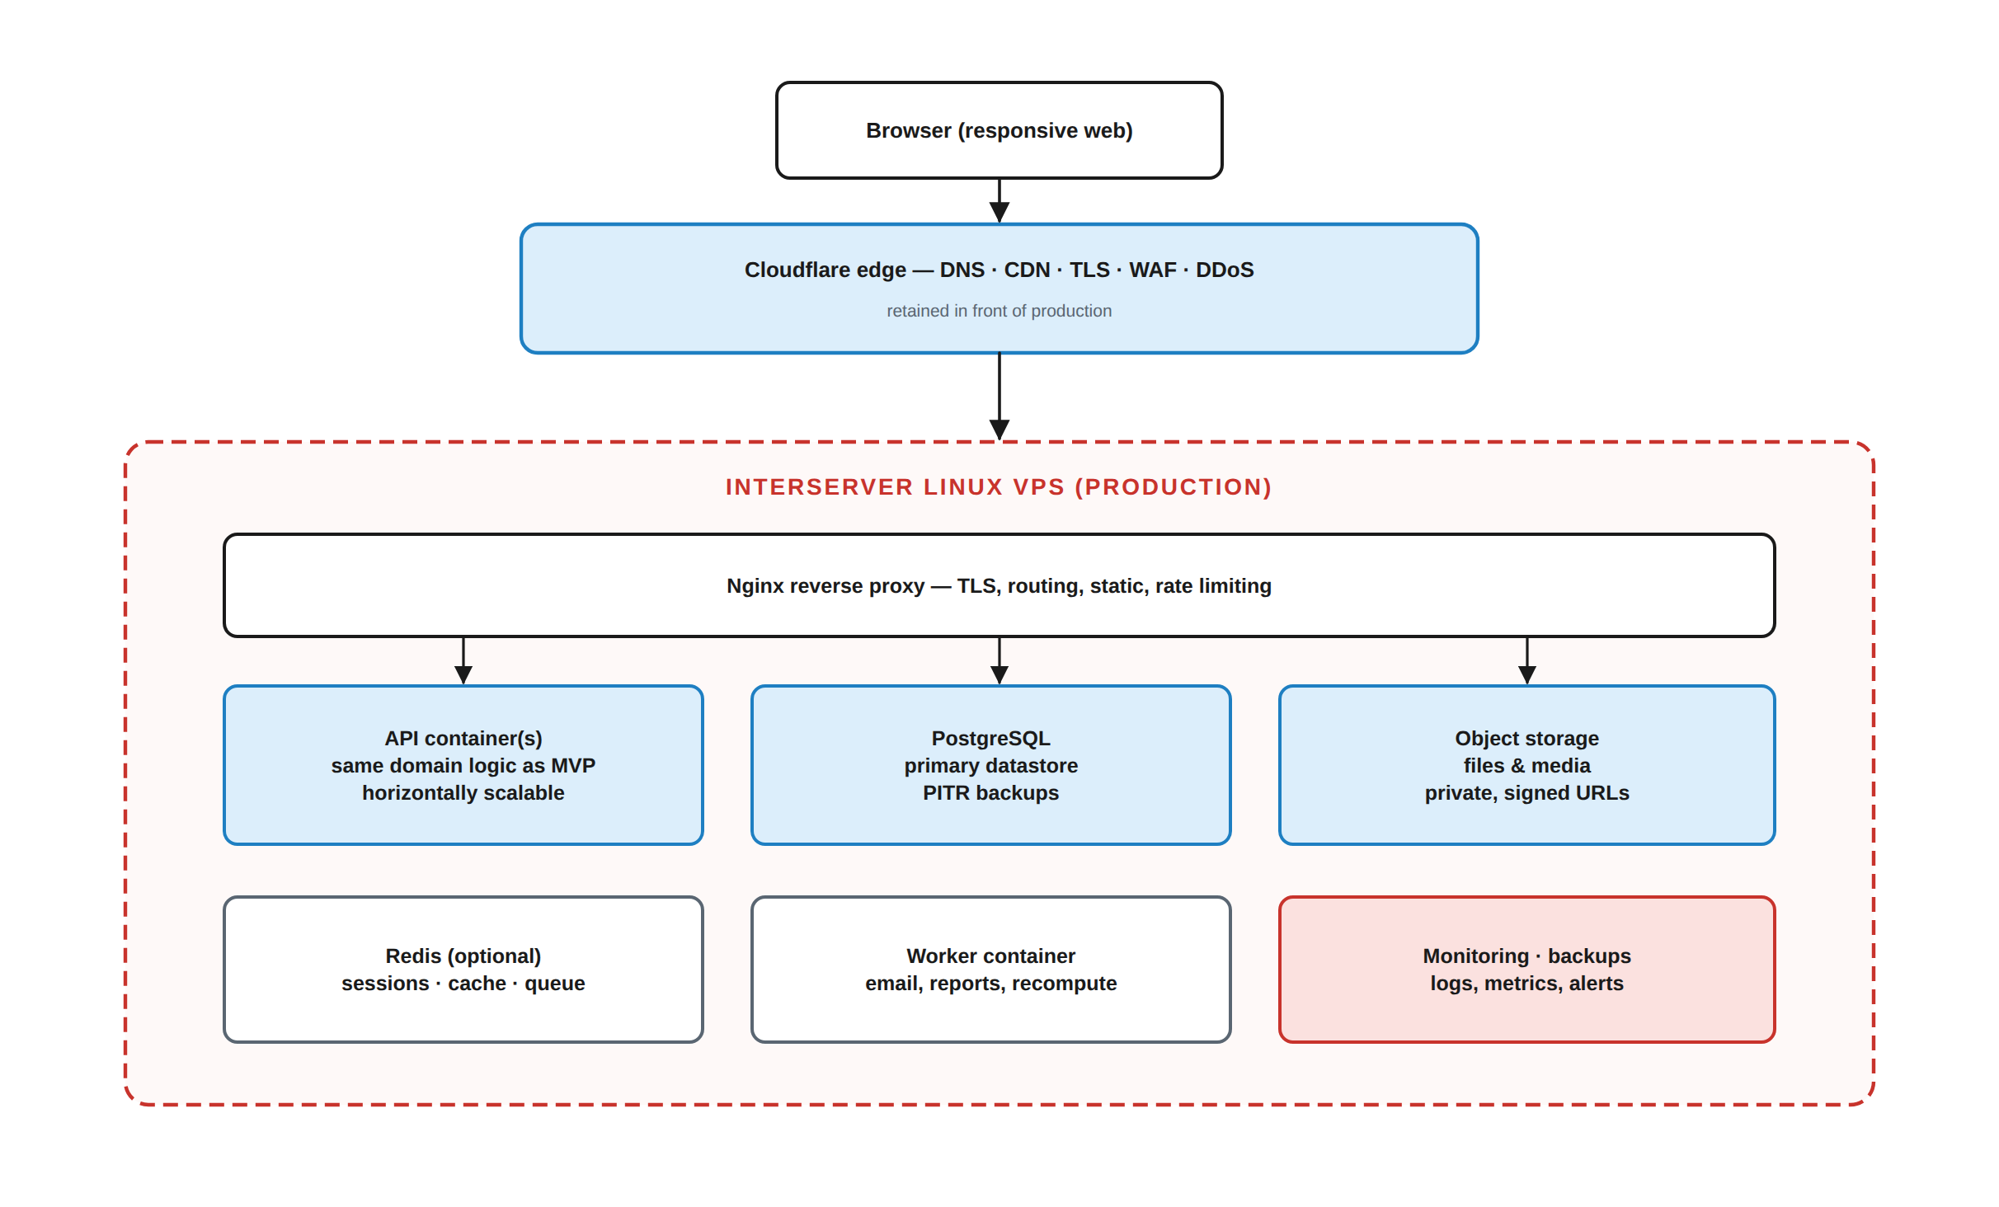
Figure 41.2 — Target production topology on an InterServer Linux VPS, with Cloudflare retained in front for DNS, CDN, TLS, WAF and DDoS mitigation.
Concern | Production approach | Requirement
Compute | Linux VPS, containerised services behind a reverse proxy | INF-001 — Every service shall run as an immutable, versioned container image.
Relational data | PostgreSQL | INF-002 — Migrations shall be the same forward-only set used on the MVP engine.
Cache / queue | Redis (cache, ephemeral state) and a durable queue | INF-003 — Same JobQueue and Cache interfaces as the MVP.
Object storage | S3-compatible storage or local volume with off-site replication | INF-004 — Same ObjectStore interface; signed URLs remain short-lived and scoped.
Edge | Cloudflare retained for DNS, CDN, TLS, WAF, DDoS | INF-005 — Origin shall accept traffic only from the edge; direct origin access is blocked.
Observability | Structured logs, metrics, traces, alerting | INF-006 — Correlation id shall propagate across every hop.
Backup | Automated encrypted backups with off-site copies | INF-007 — Backups shall be restore-tested on a defined cadence; an untested backup is not a backup.
Secrets | Secret manager, no secrets in images or environment files in the repository | INF-008 — Secret rotation shall not require a code change.

Table 41.4 — Production infrastructure requirements.

41.5 Migration path
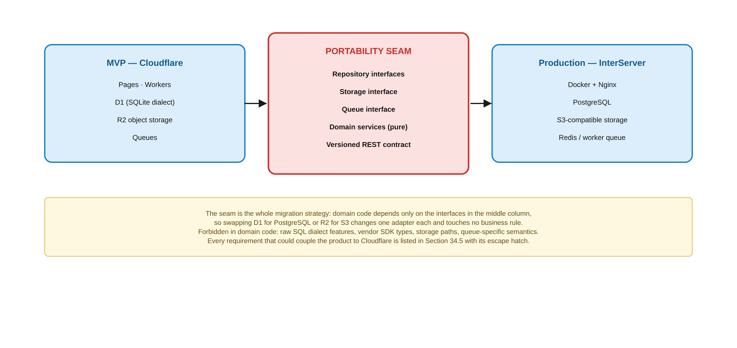
Figure 41.3 — MVP → production migration path. The application code does not change; the bindings behind the abstraction interfaces do.
ID | Requirement | Priority | Actor
INF-010 | The migration shall be executable as: provision production → run the same migrations → export and import data → repoint bindings → cut over DNS → verify → retain rollback for a defined window. | MUST | DevOps
INF-011 | A full migration rehearsal shall be performed against a copy of production-shaped data before the real cutover. | MUST | DevOps
INF-012 | Data export shall be engine-neutral and shall include object-storage contents with checksum verification of every object. | MUST | DevOps
INF-013 | Cutover shall have a documented rollback with a defined maximum data-loss window; the window shall be agreed before cutover, not discovered during it. | MUST | DevOps
INF-014 | Users shall be notified of the maintenance window in advance, and no assessment shall be scheduled to open, close or run within it. | MUST | PM
INF-015 | Deployment shall be automated and repeatable from a clean environment; no manual server configuration step shall be required to reproduce production. | MUST | DevOps

Table 41.5 — Migration requirements.
R-02 — MIGRATING DURING AN ACADEMIC PERIOD
A cutover in the middle of a term risks losing or duplicating submissions and grades — the two data classes the product cannot afford to damage. Mitigation: schedule the cutover between academic periods where possible, and enforce INF-014 absolutely where it is not.
Severity: High · Owner: Project Manager

42. UI/UX Design Language & Interface Requirements
This section defines the design system — the rules a designer and a frontend engineer apply to produce screens that belong to the same product. The reference screens in §25 are instantiations of these rules, not a substitute for them.
SCOPE OF THE VISUAL SPECIFICATION
The supplied material fixes the EduCapsules colour identity — light blue, red, black, on white — and that identity is carried through this document and through every reference screen. It does not fix a full brand token set (type scale, elevation, motion, dark-mode palette, logo usage). Those are recorded as D-04 and are to be produced by design, not invented here. What follows specifies structure, behaviour and the semantics each colour carries, which is what engineering needs and what a later brand refinement will not invalidate.

42.1 Design principles
# | Principle | What it means in practice
UX-P1 | Clarity over density | A teacher deciding a grade and a student reading a deadline must find the answer without hunting. Screens show the decision first and the detail second.
UX-P2 | The interface tells the truth about permissions | If an action is unavailable, the interface says why (scope, entitlement, window, delegation) rather than silently hiding it — except where disclosing existence would itself leak information (ERR-005).
UX-P3 | Consequences are stated before they happen | Releasing grades, awarding points, revoking an assistant and deleting content all show what will change, to whom, and whether it can be undone.
UX-P4 | Every state is designed | Empty, loading, partial, error, offline, permission-denied, expired and success are designed states with real copy — not an afterthought.
UX-P5 | Mobile is the primary case, not the fallback | The student experience is designed at 360 px first. If a workflow only works on a desktop, it is not finished.
UX-P6 | Motivation without exposure | Gamification celebrates the individual. It never publishes a ranking that identifies a struggling student (LDB-005).
UX-P7 | The user is never lost | Persistent breadcrumb of Course → Cycle → Topic → Activity. The user can always tell which role and which scope they are acting in.
UX-P8 | Nothing is silently lost | Autosave, recoverable drafts, explicit confirmation on destructive actions, and an undo window where the operation permits one.
UX-P9 | Accessibility is a requirement, not a preference | Colour never carries meaning alone; keyboard reaches everything; contrast is measured.
UX-P10 | Consistency is enforced by components | A table, a form field, a status pill and a confirmation dialog have exactly one implementation. A one-off variant is a defect.

Table 42.1 — Design principles, each testable against a real screen.

42.2 Colour semantics
Colour in EduCapsules carries meaning, and the meaning is fixed even if the exact hex values are refined by brand work. The mapping below is normative; the values are the current working reference.
Role | Working value | Meaning — normative | Never used for
Primary — light blue | #1E7FC2 | Structure, navigation, primary action, informational emphasis, links, selected state. | Errors, destructive actions, warnings.
Accent — red | #C8332C | Attention that requires a decision: destructive actions, validation errors, overdue items, security notices, required markers. | Decoration, ordinary emphasis, achievement colour.
Foreground — black / near-black | #111418 | Body text, headings, data. | Backgrounds of interactive surfaces in light mode.
Surface — white | #FFFFFF | Page and card background; the default canvas. | Text in light mode.
Neutral scale | grey 100 → 700 | Borders, dividers, disabled state, secondary text, table zebra striping. | Status meaning.
Status — success | green (TBD) | Completed, submitted on time, verified payment, present. | Primary actions.
Status — caution | amber (TBD) | Due soon, pending verification, partial completion, late but accepted. | Errors.
Status — danger | red family | Overdue, failed, rejected, revoked, suspended. | Neutral information.

Table 42.2 — Normative colour semantics with current working values.
ID | Requirement | Priority | Actor
UI-001 | Colour shall never be the sole carrier of meaning. Every status expressed by colour shall also carry a text label and, where space permits, an icon. | MUST | Frontend, Design
UI-002 | Text and interactive elements shall meet WCAG 2.1 AA contrast (4.5:1 body, 3:1 large text and UI boundaries) in every supported theme. | MUST | Frontend, Design
UI-003 | Red shall be reserved for destructive, erroneous, overdue or security-relevant meaning. A red element that is merely decorative is a defect. | MUST | Design
UI-004 | Colour tokens shall be defined once, referenced by semantic name (surface, text-primary, action-primary, status-danger), and never hard-coded in a component. | MUST | Frontend

Table 42.3 — Colour requirements.
D-04 — FULL BRAND TOKEN SET
Type scale, font family, elevation/shadow scale, corner radius scale, spacing scale, motion durations, icon set, logo lockups and the dark-mode palette are TBD. UI-004 requires them to be expressed as semantic tokens, so a later brand definition changes values without touching component code.
Decision required before: component library implementation · Owner: Design

42.3 Layout and navigation model
Region | Contents | Behaviour
Global header | Product mark · global search · notifications · role/scope indicator · account menu | Persistent. On mobile it collapses to mark, search icon, notification icon and avatar.
Primary navigation | Role-appropriate destinations only (§24 screen inventory) | Sidebar on ≥1024 px; bottom tab bar on mobile with at most five destinations.
Context bar | Breadcrumb: Organisation → Course → Cycle → Topic → Activity, plus the active scope | Every level is a link. Truncates from the left on narrow viewports, never hides the leaf.
Content region | One primary object per screen | A screen answers one question. Secondary detail goes in a panel or a drawer, not a competing column.
Contextual panel | Properties, targeting, scope checks, help | Right-side drawer on desktop; full-screen sheet on mobile.
Action zone | Primary action right-aligned; destructive actions separated and never adjacent to the primary | Sticky on long forms so the user never scrolls to find Save.
System messaging | Toasts for transient confirmation; inline banners for persistent state; modals only for decisions that block | A modal that can be dismissed without a decision should have been a drawer.

Table 42.4 — Layout regions and their behaviour.
ID | Requirement | Priority | Actor
UI-005 | Primary navigation shall show only destinations the user is authorised to reach in at least one scope; it shall not show disabled entries for other roles. | MUST | Frontend
UI-006 | The active role and scope shall be visible at all times for any user who holds more than one role, and switching scope shall be an explicit, reversible action. | MUST | Frontend
UI-007 | Breadcrumbs shall reflect the true academic hierarchy and shall never skip a level that exists. | MUST | Frontend
UI-008 | Navigation depth to any routine task shall be at most three levels from the role's dashboard. | SHOULD | Design

Table 42.5 — Navigation requirements.

42.4 Core component specification
Component | Required behaviour
Data table | Sticky header · sortable columns marked as such · server-side pagination with the total or a clear 'more' affordance · per-row actions in a consistent position · bulk selection with a persistent action bar showing the selected count · a designed empty state · horizontal scroll on mobile with the identity column pinned.
Form | Label above field · required marked in text as well as colour · inline validation on blur, full validation on submit · error text below the field naming the fix · unsaved-change guard on navigation · disabled submit only while a request is in flight, never as a substitute for validation messaging.
Card | One object, one decision. Title, status pill, at most three metadata items, one primary action. If a card needs a fourth metadata row it should be a table row.
Status pill | Text + colour + optional icon. The vocabulary is fixed per domain (§45 state machines) so 'Closed' means the same thing everywhere.
Modal | Title states the decision · body states the consequence · primary action is a verb naming the outcome ('Release 24 grades'), never 'OK' · destructive primary is red and requires the object name to be visible · Escape and the backdrop cancel, never confirm.
Drawer / panel | Non-blocking. Retains its scroll position. Closing never discards unsaved work without a guard.
Toast | Transient confirmation only. Never the sole channel for an error the user must act on. Auto-dismiss, with a manual dismiss and a pause on hover.
Banner | Persistent state: degraded subsystem, unverified payment, expiring assistant assignment, pending consent. Dismissible only when the state is informational.
Timer (assessment) | Server-authoritative remaining time · visible at all times during an attempt · escalating emphasis at defined thresholds · states the auto-submit behaviour before it happens (FE-008).
File uploader | Accepted types and size limit stated before selection · per-file progress · per-file failure with retry · virus/type rejection message that names the reason · resumable for large files.
Content viewer | Renders protected content through the gateway path only (§16) · never exposes a direct object URL · shows the protection level and the applicable rules to the viewer.
Notification centre | Grouped by type · unread state · deep link that re-checks authorisation on open (NOT-011) · preference entry point.

Table 42.6 — Core component behavioural specification.

42.5 Screen states
State | Requirement | Example copy pattern
Empty — never had data | Explain what would appear here and offer the action that creates it. | “No activities yet. Create homework or a quiz for this topic.”
Empty — filtered to nothing | Distinguish from the above and offer to clear filters. | “No submissions match these filters. Clear filters.”
Loading — first load | Skeleton matching the final layout, not a spinner over a blank page. | —
Loading — refresh | Keep existing content visible; show a subtle progress indicator. | —
Partial | Render what loaded; mark the failed region and offer a retry for that region only. | “Leaderboard unavailable. Retry.”
Error — recoverable | State what failed, what is preserved, and the next action. Include the correlation id. | “Your answers are saved. We couldn’t submit — retry. Ref: 01J8QK7Z.”
Error — permission | State that access is not available and who can grant it, without revealing what exists (ERR-005). | “You don’t have access to this course. Ask the course teacher.”
Offline | State offline status, what still works, and that work is preserved locally. | “You’re offline. Your answers are saved on this device.”
Expired / closed | State the deadline that passed and whether late submission is permitted. | “This closed on 12 May at 23:59. Late submission isn’t accepted.”
Success | Confirm the outcome and its scope, and offer undo where the operation supports it. | “24 grades released to students in 10-B. Undo (2 min).”
Destructive confirmation | Name the object, the consequence and the reversibility. | “Delete ‘Trigonometry Set 3’? 18 submissions are attached. This can be restored for 30 days.”

Table 42.7 — Required screen states with copy patterns.

42.6 Accessibility and responsiveness
ID | Requirement | Priority | Actor
UI-010 | The web client shall conform to WCAG 2.1 Level AA. | MUST | Frontend, Design
UI-011 | Every interactive element shall be reachable and operable by keyboard, in a logical order, with a visible focus indicator. | MUST | Frontend
UI-012 | All non-decorative images, icons and charts shall have text alternatives; data visualisations shall also be available as a table. | MUST | Frontend
UI-013 | Form fields shall have programmatically associated labels; errors shall be announced to assistive technology. | MUST | Frontend
UI-014 | Modals and drawers shall trap focus while open and restore focus on close. | MUST | Frontend
UI-015 | The interface shall support browser zoom to 200% and OS text scaling without loss of content or function. | MUST | Frontend
UI-016 | Motion shall respect prefers-reduced-motion; no essential information shall be conveyed by animation alone. | MUST | Frontend
UI-017 | Layout shall be responsive across the defined breakpoints, with the student experience verified on a 360 px viewport. | MUST | Frontend
UI-018 | Touch targets shall be at least 44 × 44 CSS pixels. | MUST | Frontend
UI-019 | Time-limited assessments shall provide an accommodation mechanism (extended time per student) that is recorded and auditable. | MUST | Backend, Frontend
UI-020 | Dark mode shall be supported as a theme built from the same semantic tokens. | SHOULD | Frontend, Design

Table 42.8 — Accessibility and responsiveness requirements.
Breakpoint | Range | Layout
Compact | < 640 px | Single column · bottom tab navigation · panels become full-screen sheets · tables scroll with a pinned identity column
Medium | 640 – 1023 px | Single or dual column · collapsible sidebar · drawers overlay
Expanded | 1024 – 1439 px | Persistent sidebar · content + contextual panel
Wide | ≥ 1440 px | Content width capped for readability; extra space is margin, not additional columns

Table 42.9 — Responsive breakpoints.

42.7 Role-specific interface behaviour
Role | The dashboard answers | Deliberate interface constraint
Student | “What do I have to do, by when, and how am I doing?” | No aggregate comparison against named peers. No access to any answer key or unreleased grade.
Teacher | “What needs my attention across everything I teach?” | Every bulk action states its blast radius before it commits.
Assistant | “What has been delegated to me, in which scope, until when?” | The scope and expiry of the delegation are visible on every screen; actions outside it are explained, not hidden (UX-P2).
Parent | “How is my child doing, and what is coming up?” | Read-only by construction. The screen states its own boundary — what a parent can and cannot see (PAR-006).
Admin | “What is the state of the platform and what needs a decision?” | Exceptional access (impersonation, private-data view) requires a stated reason in the interface and is visibly audited (ADM-021).

Table 42.10 — Role-specific dashboard focus and constraints.

42.8 Security-sensitive interface patterns
Situation | Required pattern
Displaying protected content | Rendered through the gateway viewer with the applicable protection level stated. No direct URL, no download control at level 2–3, dynamic watermark where configured. The interface shall not claim screenshots are prevented (GEN-022).
Answer keys and unreleased grades | Never present in any client payload for a user without the permission — not hidden, absent (FE-003).
Delegation | Granting an assistant permission shows exactly which permissions, which scope, which expiry, and that the grant cannot exceed the grantor’s own (GEN-025).
Impersonation | A persistent, unmissable banner naming the impersonated user and the reason, with a one-click exit. Every action taken is audited under both identities.
Payment evidence | Upload states that the image is reviewed by a human and stored as evidence. The interface shall not request a card number or CVV under any circumstances (PAY-011).
Session management | The user can see every active login session with device and last-seen information, and can revoke any or all of them; revocation takes effect immediately (AUTH-118).
Consent and policy | Version-stamped, with the change summarised. Continued use is not treated as consent where explicit consent is required.
Data export and deletion | The user can see what will be exported or deleted, and the retention obligations that prevent immediate erasure of certain records (§44).

Table 42.11 — Security-sensitive interface patterns.

43. Non-Functional Requirements
Every requirement in this section is measurable or it is not a requirement (GEN-027). Where a realistic target cannot yet be derived from a measured load profile, the requirement states the metric and its measurement method and marks the threshold TBD rather than inventing a number.

43.1 Performance
ID | Metric | Target | Method
PERF-001 | API read latency, p95, standard authenticated request under V1 load | TBD — fixed at load test | Server-side histogram, excluding client network
PERF-002 | API read latency, p99 | TBD | As above
PERF-003 | API write latency, p95 (submission, grade, attendance) | TBD | As above
PERF-004 | Time to interactive, student dashboard, mid-range Android, 3G-class link | TBD — budget enforced in CI | Synthetic lab measurement + field RUM
PERF-005 | Client JavaScript bundle, initial route, compressed | TBD — budget in CI | Build-time budget check
PERF-006 | Quiz answer autosave round trip, p95 | TBD | Server histogram
PERF-007 | Bulk grade release, 200 students | TBD | Job completion timing
PERF-008 | File upload throughput, 50 MB, typical link | TBD | Signed-URL transfer timing
PERF-009 | Protected video start time, p95 | TBD | Player telemetry
PERF-010 | Search result latency, question bank, p95 | TBD | Server histogram

Table 43.1 — Performance metrics. Thresholds are deliberately TBD until measured (D-05).
D-05 — PERFORMANCE THRESHOLDS
Publishing “95% of requests under 300 ms” before any load measurement produces a number that is either trivially met or impossible, and in both cases untestable. The metrics, measurement points and instrumentation are fixed now; the thresholds are set from the first load test against production-shaped data and then become contractual.
Decision required before: V1 launch readiness review · Owner: Software Engineer + QA

43.2 Capacity and scalability
ID | Requirement
PERF-020 | The V1 capacity model shall be stated as concurrent active users, peak simultaneous assessment attempts, submissions per hour and storage growth per month. Initial values are TBD pending the first cohort size from the project owner.
PERF-021 | The system shall scale horizontally at the application tier without code change; no request handling shall depend on instance-local state (BE-006).
PERF-022 | The dominant load event is a simultaneous timed assessment for a full cohort. Capacity planning and load testing shall use this as the primary scenario, not an average-traffic model.
PERF-023 | Read-heavy projections (dashboards, progress, leaderboards) shall be cacheable with an explicit, documented staleness bound; grades and submissions shall never be served stale.
PERF-024 | File and video delivery shall not consume application compute; it shall be served from object storage or the edge via signed URLs or the content gateway.
PERF-025 | The system shall degrade predictably under overload — queue and shed non-essential work (analytics, leaderboards, digests) before affecting assessment and grading.

Table 43.2 — Capacity and scalability requirements.

43.3 Availability, reliability and recovery
ID | Requirement | Target
NFR-001 | Monthly availability of core educational functions (authentication, content access, submission, grading) | TBD — MVP and production targets set separately
NFR-002 | Planned maintenance shall occur in an announced window and never overlap a scheduled assessment (INF-014) | Absolute
NFR-003 | Recovery Point Objective — maximum tolerable data loss | TBD; assessment and grade data target is the strictest class
NFR-004 | Recovery Time Objective — maximum tolerable restoration time | TBD
NFR-005 | Backups shall be automated, encrypted, off-site and restore-tested on a defined cadence (INF-007) | Restore test ≥ quarterly
NFR-006 | No single point of failure shall exist in the production topology for the core educational path | Design review gate
NFR-007 | A submission accepted by the system shall be durably persisted before the acknowledgement is returned to the student | Absolute — no buffered-write acknowledgement
NFR-008 | Data corruption shall be detectable: checksums on stored objects, referential verification jobs, and reconciliation of ledger sums against derived balances | Scheduled verification

Table 43.3 — Availability and recovery requirements.
NFR-007 IS NOT NEGOTIABLE
A student who sees “submitted” and later finds no submission has lost work that may not be reproducible, at a moment that may not recur. Every other performance target may be traded; this one may not.
Status: CONFIRMED

43.4 Maintainability, observability and quality attributes
ID | Requirement
NFR-010 | All source shall be version-controlled with reviewed changes; no direct commit to the release branch.
NFR-011 | Automated tests shall gate every merge. Coverage thresholds are defined in §47; authorisation, grading and payment paths carry the strictest requirements.
NFR-012 | Every request shall carry a correlation id propagated across services, jobs and logs (INF-006).
NFR-013 | Logs shall be structured, queryable, and free of secrets, tokens, answer keys and unnecessary personal data (FE-012, §32).
NFR-014 | Golden-signal metrics (rate, errors, duration, saturation) shall exist for every service, with alerting on defined SLIs.
NFR-015 | Runbooks shall exist for the defined operational scenarios (§47.5) before launch.
NFR-016 | Dependencies shall be pinned, inventoried (SBOM) and scanned for known vulnerabilities in CI.
NFR-017 | Documentation — OpenAPI specification, schema migrations, architecture decision records and this SRS — shall be updated in the same change that alters behaviour.
NFR-018 | The codebase shall enforce a single formatting and linting standard automatically.

Table 43.4 — Maintainability and observability requirements.

43.5 Usability, compatibility and localisation
ID | Requirement | Verification
NFR-020 | A first-time teacher shall complete the create-course → add-cycle → add-topic → publish-homework path without written instructions. | Moderated usability test, ≥ 5 participants
NFR-021 | A first-time student shall locate and submit an assigned homework on a phone without assistance. | Moderated usability test on a 360 px device
NFR-022 | Browser support per FE-001. | Cross-browser test matrix in CI
NFR-023 | The client shall function on a mid-range Android device released within the last four years. | Device-lab verification
NFR-024 | All user-facing strings shall be externalised and free of concatenated grammar. | Lint rule + pseudo-localisation build
NFR-025 | Date, time, number and currency formatting shall follow the user’s locale; stored values remain canonical. | Automated test per locale
NFR-026 | The launch locale set and RTL support are TBD (D-03); the implementation shall not preclude either. | Architecture review

Table 43.5 — Usability, compatibility and localisation requirements.

44. Account Lifecycle, Retention & Deletion
Educational records, audit records and personal data have different lifetimes and different legal weight. Treating them as one thing produces either unlawful retention or destroyed academic history. This section separates them.

44.1 Account states
State | Meaning | Can sign in? | Data visible to others?
PENDING | Created, not yet verified or activated | No | Minimal — name only where required
ACTIVE | Normal operation | Yes | Per authorisation rules
SUSPENDED | Administratively blocked (policy, conduct, non-payment at organisation level) | No | Yes — historical records remain attributed
LOCKED | Security lock after failed authentication or a detected compromise | No — until recovery | Yes
DEACTIVATED | User-initiated or end-of-relationship; account dormant | No | Historical records remain
ANONYMISED | Erasure executed; identity severed from retained academic and audit records | No | Records remain, attributed to a non-identifying token
PURGED | All data removed where no retention obligation applies | No | No

Table 44.1 — Account states.

44.2 Deletion and erasure requirements
ID | Requirement | Priority | Actor
LIF-001 | A user shall be able to request account deletion from within the product, and the request shall be acknowledged, recorded and auditable. | MUST | All users
LIF-002 | Deletion shall be a defined pipeline — request → verify identity → grace period → anonymise → purge-where-permitted — not an immediate destructive operation. | MUST | Backend
LIF-003 | The system shall distinguish personal data (erasable) from academic records and audit records (retained under obligation). Erasure shall sever the link to the person without destroying the academic and audit record. | MUST | Backend
LIF-004 | Before deletion executes, the user shall be shown exactly what will be erased, what will be retained, why, and for how long. | MUST | Frontend
LIF-005 | A grace period shall apply during which the user can cancel the request; its length is TBD (D-06). | MUST | Backend
LIF-006 | Deleting a teacher account shall not delete the courses, content, grades or assessment history of their students. Ownership shall transfer to a designated successor or to the organisation (BR-021). | MUST | Admin
LIF-007 | Deleting a student account shall not delete another user's records that reference it (e.g. a class average, a teacher's grade history); references shall be anonymised. | MUST | Backend
LIF-008 | A user shall be able to export their own data in a portable, machine-readable format, delivered through an authenticated, time-limited download. | MUST | All users
LIF-009 | For a minor's account, deletion and export shall be exercisable by a confirmed guardian, and the exercise shall be audited. | MUST | Parent, Admin
LIF-010 | Deletion shall propagate to backups by policy: backups expire on their normal schedule and are not selectively edited; the policy and the maximum residual window shall be documented and disclosed. | MUST | DevOps
LIF-011 | Orphaned StorageObjects whose refcount reaches zero shall be garbage-collected after a defined delay, with the delay chosen so that an accidental deletion is still recoverable. | MUST | Backend
LIF-012 | Every step of the deletion pipeline shall be audited, including the decision not to erase a record and the retention basis relied on. | MUST | Backend

Table 44.2 — Account lifecycle and erasure requirements.
BR-021 · PROPOSED · OWNERSHIP TRANSFER ON TEACHER DELETION (added in v1.1 — cited by LIF-006 since v1.0 but never separately stated):
When a Teacher account is deleted or permanently deactivated, ownership of that Teacher’s Courses, Cycles, Topics, Activities, Question Bank items and Teacher Storage transfers to an Admin-designated successor Teacher within the same Organization, or — where none is designated — to the Organization itself pending reassignment. Transfer never deletes or alters existing grades, submissions, attendance or audit records, and every such transfer is itself audited (AUD-002) and notified to affected co-teachers where CRS-009 applies. Rejected: leaving orphaned courses without an owner, which would leave grading, content-update and student-support authority for live students unreachable.

44.3 Retention schedule
Data class | Retention basis | Period
Authentication credentials and MFA factors | Operational | Until account deletion, then immediate purge
Login session records | Security | TBD — short (weeks)
Academic records: enrolment, grades, grade history, attendance, submissions | Educational record obligation | TBD — long (years); set by the project owner against local requirements
Submitted files | Educational record | TBD — aligned with academic records
Teacher-authored content and storage | Ownership (§33) | Until owner deletes or ownership transfers
Trashed files pending purge (STR-012, LIF-011) | Recoverability window | TBD — short; long enough that an accidental deletion is recoverable, short enough to bound storage growth
Content access events | Security / abuse detection | TBD — medium (months)
Audit log | Governance | TBD — long; minimum bound set by legal review
Payment records and evidence | Financial record obligation | TBD — set by local financial record rules
Messages | Operational + safeguarding | TBD — medium
Notifications | Operational | TBD — short
Analytics aggregates (non-identifying) | Product | Indefinite once non-identifying
Backups | Recovery | TBD — per backup rotation policy (LIF-010)

Table 44.3 — Retention schedule. Periods are TBD pending legal review (D-06).
D-06 — RETENTION PERIODS AND APPLICABLE LAW
Retention periods are legal determinations, not engineering preferences. The primary deployment jurisdiction, the applicable data-protection regime, the treatment of minors' data and the financial record-keeping obligation must be confirmed by qualified legal advice before these values are fixed. This document does not provide legal advice and does not state a period it cannot justify.
Decision required before: production launch · Owner: Project Owner + external counsel

45. State Machines
These state machines are normative. Any transition not listed is invalid and shall be rejected with a 409 or 422 (ERR-005, Table 40.2). Every transition writes an audit entry.

45.1 Activity lifecycle
From | Event | To | Guard
DRAFT | publish | SCHEDULED | ≥1 ActivityTarget · max_score set · questions attached if type requires · opens_at in the future
DRAFT | publish (opens_at ≤ now) | OPEN | As above
DRAFT | delete | — | No submissions exist
SCHEDULED | opens_at reached | OPEN | Automatic
SCHEDULED | edit | DRAFT | Teacher/owner or delegated permission
SCHEDULED | cancel | CANCELED | Reason required · targets notified
OPEN | due_at reached | OPEN_LATE | Only if late policy permits; otherwise → CLOSED
OPEN | closes_at reached | CLOSED | Automatic · in-flight attempts auto-submitted
OPEN | close now | CLOSED | Teacher action · states the effect on in-flight attempts
OPEN_LATE | closes_at reached | CLOSED | Automatic
CLOSED | reopen | OPEN | Reason required · audited · notifies affected students
CLOSED | extend for student | CLOSED (+ per-student window) | Accommodation (UI-019) · audited
CLOSED | all graded and released | COMPLETED | Automatic
Any | archive | ARCHIVED | Read-only; grades and submissions preserved (GEN-018)

Table 45.1 — Activity state machine.

45.2 Submission lifecycle
From | Event | To | Guard
— | start attempt | IN_PROGRESS | Activity OPEN or OPEN_LATE · attempt_no ≤ attempt_limit · entitlement present
IN_PROGRESS | autosave | IN_PROGRESS | Server timestamps every save
IN_PROGRESS | submit | SUBMITTED | Required answers present · window open
IN_PROGRESS | time limit reached | SUBMITTED | Auto-submit · flagged as auto
IN_PROGRESS | window closes | SUBMITTED | Auto-submit · is_late set per policy
IN_PROGRESS | abandon | ABANDONED | Only if policy permits; otherwise auto-submitted
SUBMITTED | auto-score | AUTO_GRADED | Objective question types only
SUBMITTED / AUTO_GRADED | grade | GRADED | Grader holds GRADE permission in scope
AUTO_GRADED | manual override | GRADED | Reason recorded · GradeHistory written
GRADED | release | RETURNED | Grade state → RELEASED · student notified · points posted
RETURNED | request resubmission | IN_PROGRESS (new attempt) | Policy permits · new attempt_no
RETURNED | regrade | GRADED | Reason required · GradeHistory written · student notified
Any | void | VOID | Admin/teacher with reason · original preserved

Table 45.2 — Submission state machine.

45.3 Other lifecycles
Object | States | Notable rules
Grade | DRAFT → PENDING_REVIEW → RELEASED → (VOID) | Student sees RELEASED only. Any post-release change requires a reason and writes GradeHistory (GRD-009).
Enrollment | REQUESTED → ACTIVE → (WITHDRAWN | COMPLETED | TRANSFERRED) | Withdrawal and transfer preserve all grades earned (BR-015).
Course | DRAFT → PUBLISHED → (ARCHIVED) | Archiving is read-only, never destructive. Unpublishing hides future content but does not revoke released grades.
TeachingSession | SCHEDULED → IN_PROGRESS → COMPLETED | CANCELED | Cancelling voids attendance with a reason rather than deleting it (SES-014).
AssistantAssignment | PENDING → ACTIVE → (EXPIRED | REVOKED | SUSPENDED) | Expiry is evaluated at authorisation time (AST-007); revocation is immediate.
ParentLink | REQUESTED → CONFIRMED → (REVOKED) | REQUESTED grants nothing (PAR-002).
PaymentRecord | RECORDED → EVIDENCE_SUBMITTED → UNDER_REVIEW → VERIFIED | REJECTED → (REFUND_REQUESTED → REFUNDED) | Verification is a human decision. Entitlement is granted on VERIFIED, and is a separate object (BIL-003).
Entitlement | PENDING → ACTIVE → (EXPIRED | REVOKED) | The authorisation pipeline consults this, never the payment state.
File | DRAFT → ACTIVE → TRASHED → (RESTORED | PURGED) | Purge is blocked while any FileReference is live (STR-023).
ContentItem | DRAFT → SCHEDULED → PUBLISHED → (UNPUBLISHED | ARCHIVED) | Unpublishing removes future access; it does not retract already-granted offline copies at protection level 0–1.
User account | PENDING → ACTIVE → (SUSPENDED | LOCKED | DEACTIVATED) → ANONYMISED → PURGED | See §44.
LoginSession | ACTIVE → (EXPIRED | REVOKED) | Revocation is server-side and immediate (AUTH-118).
AchievementAward | AWARDED → (REVOKED) | Criteria changes never retroactively revoke (ACH-007).

Table 45.3 — Remaining object lifecycles.
GEN-028 RESTATED
State is authoritative on the server. A client may render a state, predict a transition or optimistically show a result, but the transition happens only when the server has applied the guard, written the audit entry and persisted the new state.
Status: CONFIRMED

46. Use Cases
Twenty-two use cases cover the paths that define the product. Each is traceable to requirements (§48) and to test cases (§47). Four are given in full worked form because they carry the highest risk of being implemented incorrectly; the remainder are specified in compact form, which carries the same normative weight.

46.1 Use-case index
ID | Name | Primary actor | Risk if wrong
UC-001 | Sign in with MFA challenge | Any user | Account takeover
UC-002 | Recover a forgotten password | Any user | Account takeover via reset flow
UC-003 | Administrator provisions a user and assigns a scoped role | Admin | Over-privileged account
UC-004 | Teacher creates a course, cycle and topic structure | Teacher | Structural rework
UC-005 | Teacher enrols a classroom into a course | Teacher | Wrong audience sees content
UC-006 | Teacher authors a question and publishes a quiz | Teacher | Answer-key exposure
UC-007 | Student attempts a timed quiz and submits | Student | Lost work; unfair timing
UC-008 | System auto-scores objective questions | System | Wrong grades at scale
UC-009 | Teacher grades free-response work and releases grades | Teacher | Premature disclosure
UC-010 | Student submits homework with file attachments | Student | Lost submission
UC-011 | Assistant grades within a delegated scope | Assistant | Privilege escalation
UC-012 | Teacher delegates and later revokes assistant permissions | Teacher | Stale delegation
UC-013 | Parent requests and confirms a link to a student | Parent | Unauthorised child data
UC-014 | Parent reviews a child's progress | Parent | Over-disclosure
UC-015 | Teacher records attendance for a teaching session | Teacher | Record integrity
UC-016 | Teacher uploads protected content and publishes it | Teacher | Content leakage
UC-017 | Student views protected content through the gateway | Student | Content leakage
UC-018 | Student earns points and an achievement | System | Unfair or duplicated awards
UC-019 | Teacher records a payment and an admin verifies it | Teacher, Admin | Wrong entitlement
UC-020 | Student is transferred between classrooms mid-period | Admin | Lost academic history
UC-021 | Administrator uses exceptional access to investigate a report | Admin | Unaudited privacy breach
UC-022 | User requests account deletion and data export | Any user | Unlawful retention or destroyed records

Table 46.1 — Use-case index.

46.2 Worked use cases
UC-007 — Student attempts a timed quiz and submits
Priority | MUST
Actor | Student
Description | A student opens a published, currently open quiz activity, answers questions within a time limit, and submits — or is auto-submitted when time expires.
Preconditions | Student is authenticated · is a member of a targeted Classroom, Group or is individually targeted · holds an active Entitlement for the course if one is required · Activity is OPEN or OPEN_LATE · attempts used < attempt_limit.
Main behaviour | 1. Student opens the activity. 2. System re-evaluates the §7 authorisation pipeline. 3. System creates a Submission (IN_PROGRESS) with attempt_no = used + 1 and a server-recorded started_at. 4. System returns the pinned QuestionVersions without answer keys (GEN-026). 5. Client renders a server-authoritative countdown (FE-008). 6. Client autosaves each answer; each save is server-timestamped. 7. Student submits. 8. System validates the window and required answers, sets submitted_at, transitions to SUBMITTED, and computes is_late. 9. System auto-scores objective items (UC-008). 10. System writes the audit entry and notifies the teacher's grading queue.
Alternative behaviour | · Time limit expires → auto-submit with whatever is saved, flagged as auto (Table 45.2). · Window closes during the attempt → auto-submit, is_late set per policy. · Network loss → answers persist locally and are re-sent on reconnect (ERR-008); duplicate submits are absorbed by the idempotency key (API-006). · Attempt limit already reached → 422 BR_ATTEMPT_LIMIT, stating attempts used and remaining. · Entitlement missing → 403 ENT_REQUIRED with the next step (§40).
Postconditions | A Submission exists in SUBMITTED or AUTO_GRADED. The student sees a confirmation with a server timestamp. No grade is visible until released (GRD-006).
Acceptance criteria | · A submission acknowledged to the student is durably persisted (NFR-007). · No response in the attempt contains an answer key or another student's data. · A client clock changed by the student does not extend the attempt. · Two concurrent submits produce exactly one Submission. · An auto-submitted attempt is distinguishable from a manual one in the record.
Traces to | ACT-009 · QBN-025 · GEN-026 · FE-008 · API-006 · DB-013 · NFR-007 · Table 45.2 · TC-007-*

UC-011 — Assistant grades within a delegated scope
Priority | MUST
Actor | Assistant
Description | An assistant grades submissions for activities inside the scope a teacher delegated to them, and cannot act outside it.
Preconditions | Assistant is authenticated · holds an ACTIVE AssistantAssignment whose scope contains the activity · the assignment includes the GRADE permission · valid_until has not passed · the delegating teacher still holds GRADE in an equal-or-wider scope.
Main behaviour | 1. Assistant opens the grading queue; the queue is filtered by the delegated scope, not by the teacher's full scope. 2. System evaluates the pipeline including the delegation stage and the no-amplification check (GEN-025). 3. Assistant enters a score and feedback. 4. System writes the Grade in DRAFT or PENDING_REVIEW according to the teacher's configuration. 5. System writes an audit entry naming the assistant as actor and the delegating teacher as the authority. 6. If the teacher requires review, the teacher is notified; otherwise the assistant may release if the delegation includes RELEASE.
Alternative behaviour | · Assignment expired → 403 PERM_DELEGATION_EXPIRED, evaluated at request time, not by a nightly job (AST-007). · Activity outside the delegated scope → 404 (ERR-005) since the assistant is not inside that scope. · Teacher's own permission was revoked → the derived delegation fails immediately (GEN-025). · Delegation excludes RELEASE → grade is saved but the release action is unavailable and the interface states why (UX-P2).
Postconditions | A Grade exists attributed to the assistant, with the delegation recorded. The student sees nothing until the grade is RELEASED.
Acceptance criteria | · An assistant cannot grade one submission outside the delegated scope, through any endpoint. · Revoking the delegation takes effect on the next request, with no cached permission. · An assistant can never hold a permission the delegating teacher does not hold. · Every assistant action names both identities in the audit log.
Traces to | AST-007 · SEC-014 · GEN-025 · ERR-005 · AUD-004 · Table 45.3 · TC-011-*

UC-017 — Student views protected content through the gateway
Priority | MUST
Actor | Student
Description | A student opens course content at protection level 2 or 3; the platform serves it through the Content Gateway rather than exposing an object URL.
Preconditions | Student is authenticated · is in the content's audience or holds a ContentAccessGrant · holds any required Entitlement · the ContentItem is PUBLISHED.
Main behaviour | 1. Student requests the item. 2. API evaluates the pipeline and issues a short-lived, single-use gateway ticket bound to the user, the item and the login session. 3. Client requests the stream or render from the gateway with the ticket. 4. Gateway re-validates the ticket and the authorisation independently of the API. 5. Gateway applies the protection level: dynamic watermark, no-download rendering, segmented delivery. 6. Gateway writes a ContentAccessEvent. 7. Anomaly scoring evaluates the event asynchronously (CNT-026).
Alternative behaviour | · Ticket expired or replayed → 403; a new ticket must be requested. · Entitlement absent → 403 ENT_REQUIRED. · Abnormal access pattern → a ContentAbuseSignal is raised for human review; access is not automatically terminated (CNT-029). · Gateway unavailable → the failure is scoped to content viewing; submission and grading continue (ERR-010).
Postconditions | The student has viewed the content. A ContentAccessEvent exists, with a watermark payload hash where watermarking applies. No durable object URL was exposed.
Acceptance criteria | · No response at any layer contains a direct storage URL for level 2–3 content. · A ticket cannot be replayed, shared, or used from a different login session. · The content is not present in the client bundle or in a durable client cache (FE-004). · The platform nowhere claims that screenshots are prevented (GEN-022).
Traces to | CNT-018 · CNT-026 · CNT-029 · GEN-017 · GEN-022 · FE-004 · API-012 · TC-017-*

UC-020 — Student is transferred between classrooms mid-period
Priority | MUST
Actor | Administrator
Description | A student moves from one classroom to another during an academic period without losing any academic history.
Preconditions | Administrator holds the membership-management permission at organisation scope · both classrooms exist in the same AcademicPeriod · the student has an ACTIVE membership in the source classroom.
Main behaviour | 1. Admin selects the student and the destination classroom. 2. System shows the consequences: which courses the student will gain and lose, which activities are already targeted, which grades exist, and which will remain visible. 3. Admin confirms. 4. System sets left_at on the source Membership rather than deleting it (GEN-018). 5. System creates the destination Membership. 6. System evaluates Enrollments: enrolments driven by the source classroom are marked TRANSFERRED, not withdrawn; enrolments driven by the destination classroom are created. 7. All existing Grades, Submissions, AttendanceRecords and AchievementAwards are retained unchanged. 8. Progress projections are recomputed. 9. Points earned remain in the ledger; leaderboard standings are recomputed for both scopes. 10. Audit entries are written for every affected object.
Alternative behaviour | · An activity is open and targeted at the source classroom → the student retains access to complete it unless the admin explicitly chooses otherwise; the choice is recorded. · Destination classroom is in a different AcademicPeriod → rejected (422 BR_PERIOD_MISMATCH); this is a new enrolment, not a transfer. · Student has an in-progress timed attempt → the transfer is blocked until it completes or is voided, with the reason stated.
Postconditions | The student is a member of the destination classroom. Every grade, submission, attendance mark and achievement earned before the transfer is intact and still attributable.
Acceptance criteria | · No grade, submission or attendance record is deleted or altered by a transfer. · Historical records remain attributed to the classroom in which they were earned. · The student's points balance is unchanged. · The admin saw the full consequence list before confirming (UX-P3).
Traces to | BR-015 · GEN-018 · PTS-003 · PRG-006 · AUD-003 · Table 45.3 · TC-020-*

46.3 Compact use-case specifications
ID | Trigger → main flow | Critical guard / exception
UC-001 | Credentials submitted → validate → MFA challenge if enabled → create LoginSession → issue tokens → land on role dashboard | Generic failure message regardless of cause (ERR-007) · progressive delay and lockout (AUTH-1xx) · new-device notification
UC-002 | Reset requested → always respond identically → send single-use, short-lived, bound token → verify → set password → revoke all sessions | No account-existence disclosure · token single-use · all existing sessions revoked on success
UC-003 | Admin creates user → assigns role within a scope → invitation sent → user activates and sets credentials | Scope is mandatory; an unscoped educational role is rejected · admin cannot grant beyond own authority (GEN-025) · fully audited
UC-004 | Teacher creates Course under a Subject → adds Cycles in sequence → adds Topics | sequence_no unique per parent · publishing requires at least one Cycle and one Topic
UC-005 | Teacher adds a Classroom or Group to CourseAudience → members gain access | Audience change never retroactively grants access to already-closed assessments · notifies affected students
UC-006 | Teacher authors Question → creates QuestionVersion → builds Activity → pins versions via ActivityQuestion → publishes | Publishing freezes the pinned versions (QBN-025) · answer key never serialised to a student response (GEN-026)
UC-008 | Submission enters SUBMITTED → objective items scored against the pinned QuestionVersion → AUTO_GRADED → Grade created in DRAFT | Scoring uses the pinned version, never the current bank version · auto and manual scores stored separately · idempotent under retry
UC-009 | Teacher opens grading queue → enters scores and feedback → bulk-releases | Release is explicit (GRD-006) · post-release change writes GradeHistory with a reason (GRD-009) · blast radius shown before commit
UC-010 | Student opens homework → uploads files via signed URL → commits → submits | Type, size and content validation server-side · late flag per policy · files become SubmissionFiles referencing the file layer
UC-012 | Teacher creates AssistantAssignment with scope, permission set and expiry → later revokes | Cannot exceed the teacher's own authority · expiry evaluated at request time · revocation immediate · both actions audited and notified
UC-013 | Parent requests link → student or admin confirms → link becomes CONFIRMED | REQUESTED grants nothing (PAR-002) · confirmation is auditable · either side can revoke
UC-014 | Parent opens child summary → sees released grades, attendance, progress, upcoming work | Read-only · no submission content, no unreleased grades, no other students, no leaderboard positions of others
UC-015 | Teacher opens session roll → marks states in bulk → saves | Any change writes AttendanceHistory · cancelling a session voids marks with a reason rather than deleting them (SES-014)
UC-016 | Teacher uploads to storage → sets protection level → attaches as ContentItem → publishes | FileReference created; the file can no longer be hard-deleted (STR-023) · protection level determines the delivery path
UC-018 | Qualifying event occurs → criteria evaluated → PointsLedger entry and AchievementAward written → student notified | Balance is the ledger sum, never a counter (PTS-003) · idempotent: one event cannot award twice · later criteria changes never revoke past awards (ACH-007)
UC-019 | Teacher records payment → uploads evidence → admin reviews → VERIFIED → Entitlement granted | No card number or CVV is ever collected (PAY-011) · verification is a human decision · entitlement is a separate object from the payment (BIL-003)
UC-021 | Admin states a reason → exceptional access granted → banner shown throughout → access ends | Reason mandatory · every action audited under both identities · the affected user's record shows that exceptional access occurred (ADM-021)
UC-022 | User requests deletion/export → identity verified → consequences shown → grace period → anonymise → purge where permitted | Academic and audit records are retained and de-identified, not destroyed (LIF-003) · guardian may exercise for a minor (LIF-009) · every step audited

Table 46.2 — Compact use-case specifications. These carry the same normative weight as the worked cases.

47. Testing & Quality Assurance

47.1 Test strategy
Level | Scope | Gate
Unit | Domain rules in isolation: grading arithmetic, scope containment, points calculation, state-machine guards, late policy, attempt limits. | Runs on every commit. A failing unit test blocks merge.
Integration | Service + persistence + authorisation together, against a real database engine, not a mock. | Runs on every pull request.
Contract | Every endpoint validated against the OpenAPI specification in both directions. | A drift between specification and implementation fails the build (API-011).
End-to-end | The 22 use cases of §46 driven through the real client. | Runs before every release.
Security | Authorisation matrix tests, IDOR probes, injection, XSS, CSRF, SSRF, upload abuse, rate-limit behaviour, token replay, session revocation. | Runs on every pull request; full sweep before release.
Performance / load | The full-cohort simultaneous assessment scenario (PERF-022), plus the AP-1…AP-10 access patterns. | Before launch and before any release that changes an assessment path.
Accessibility | Automated axe-class checks on every screen plus manual keyboard and screen-reader passes on the core flows. | Automated on every pull request; manual before release.
Migration | Full MVP → production rehearsal against production-shaped data (INF-011). | Before cutover, and after any schema change that touches an academic table.
Usability | Moderated tests for NFR-020 and NFR-021. | Before launch.
Disaster recovery | Restore from backup into a clean environment and verify integrity (INF-007). | Quarterly and before launch.

Table 47.1 — Test levels and gates.

47.2 Coverage requirements
Area | Requirement
Authorisation pipeline | Every stage of the §7 pipeline shall have negative tests. Every role × scope × permission combination in the §26 matrix shall have an automated allow and deny test.
Grading and points | Every grading mode, scale, override, release and regrade path shall be covered, including the GradeHistory write.
Assessment integrity | Timer expiry, window closure, attempt limits, concurrent submit, network loss and answer-key exclusion shall each have a dedicated test.
State machines | Every transition in §45 shall have a positive test, and every invalid transition shall have a rejection test.
Payment and entitlement | Every state in the PaymentRecord machine, and the separation of payment state from entitlement state (BIL-003).
Data lifecycle | Deletion, anonymisation, export and retention-hold behaviour (§44).
Multi-tenancy | A cross-tenant read or write attempt shall be tested for every scoped resource group.
Portability | Both implementations of each abstraction in BE-008 shall be exercised by the integration suite.

Table 47.2 — Mandatory coverage areas.
COVERAGE PERCENTAGE IS NOT THE TARGET
A line-coverage number can be met without testing a single authorisation denial. The requirement is the matrix in Table 47.2: every deny path, every invalid transition, every cross-tenant attempt. A release that meets a coverage percentage but lacks these is not ready.
Status: CONFIRMED · Owner: QA

47.3 Defect classification
Severity | Definition | Release rule
S1 — Critical | Data loss, incorrect grade, unauthorised access, payment or entitlement error, assessment integrity failure, platform unavailable. | Blocks release. No exceptions.
S2 — Major | A core workflow cannot be completed; a significant role is blocked; a security control is degraded but not bypassed. | Blocks release unless a documented workaround is accepted by the project owner.
S3 — Moderate | A workflow is completable but impaired; incorrect non-academic display; accessibility barrier on a non-core path. | May ship with an agreed fix date.
S4 — Minor | Cosmetic, copy, or low-impact inconsistency. | May ship.

Table 47.3 — Defect severity and release rules.

47.4 Test data and environments
ID | Requirement | Priority | Actor
QA-001 | Test environments shall never contain real student personal data. Test data shall be synthetic or irreversibly anonymised. | MUST | QA, DevOps
QA-002 | A reproducible seed dataset shall exist covering: multiple organisations, all roles, multi-role users, delegated assistants, confirmed and unconfirmed parent links, all activity types, all protection levels, and every state in §45. | MUST | QA
QA-003 | Environments shall be: local, CI, staging (production-shaped), production. Staging shall run the same images and migrations as production. | MUST | DevOps
QA-004 | No test shall depend on a real payment, a real email delivery to a real address, or a real third-party account. | MUST | QA
QA-005 | Every S1 defect shall gain a regression test before its fix is merged. | MUST | QA

Table 47.4 — Test data and environment requirements.

47.5 Operational readiness
Runbook | Must exist before launch
Assessment in progress during an incident | How to extend windows fairly, and how the extension is recorded and communicated.
Suspected content leak | How to investigate ContentAccessEvents, what may and may not be concluded, and who decides.
Suspected account compromise | Session revocation, credential reset, audit review, notification.
Grade correction at scale | How a systematic scoring error is corrected with GradeHistory intact and students informed.
Restore from backup | Full restore, verification, and the decision on what to do about work done in the lost window.
Migration cutover and rollback | The INF-010 sequence, the verification checklist and the rollback decision point.
Data subject request | Export and deletion handling, retention holds, guardian requests.

Table 47.5 — Required operational runbooks (NFR-015).

48. Acceptance Criteria & Traceability

48.1 V1 acceptance gate
V1 is accepted when every statement below is demonstrably true. These are not aspirations; each maps to an automated or witnessed test.
# | Acceptance statement | Evidence
AC-01 | A teacher can create a course with cycles and topics, publish homework and a quiz, grade both, and release grades — end to end, unaided. | E2E UC-004…UC-009 + NFR-020 usability session
AC-02 | A student can find, complete and submit assigned work on a 360 px phone, and see the grade only after release. | E2E UC-007, UC-010 + NFR-021 usability session
AC-03 | No user can read or write any data outside their authorised scope through any endpoint, including by identifier manipulation. | Full §26 permission-matrix test suite + IDOR sweep
AC-04 | An answer key is never present in any client-bound payload for a user without the permission. | Automated payload inspection across every assessment endpoint
AC-05 | An assistant cannot exceed the delegating teacher's authority, and revocation takes effect immediately. | E2E UC-011, UC-012 + negative matrix
AC-06 | A parent sees only what §22 permits, and only through a confirmed link. | E2E UC-013, UC-014 + negative matrix
AC-07 | A submission acknowledged to a student is durably persisted and recoverable. | NFR-007 durability test + kill-during-write test
AC-08 | A classroom transfer loses no grade, submission, attendance mark or achievement. | E2E UC-020 with before/after record comparison
AC-09 | Level 2–3 content is never delivered by a direct object URL and never appears in a client bundle or durable cache. | Network and bundle inspection + E2E UC-017
AC-10 | No card number or CVV is collected, transmitted or stored anywhere in the system. | Code and schema audit + payment E2E
AC-11 | Every entry in the §36 audited-event catalogue is written, immutable, and queryable by target object. | Audit completeness suite
AC-12 | A cross-tenant read or write is impossible for every scoped resource group. | Multi-tenancy negative suite
AC-13 | The full-cohort simultaneous assessment scenario meets the thresholds fixed under D-05. | Load test report
AC-14 | The client meets WCAG 2.1 AA on every core screen. | Automated + manual accessibility audit
AC-15 | A full MVP → production migration rehearsal completes with byte-level object verification and zero academic-record loss. | Rehearsal report (INF-011)
AC-16 | A restore from backup into a clean environment succeeds and the restored data passes integrity verification. | DR test report (INF-007)
AC-17 | Account deletion and data export behave per §44, with retained records correctly de-identified. | E2E UC-022 + record inspection
AC-18 | Every runbook in Table 47.5 exists and has been walked through by its owner. | Readiness review sign-off
AC-19 | No S1 or unwaived S2 defect is open. | Defect register
AC-20 | Every OPEN decision in §51 marked 'required before launch' is closed. | Decision register

Table 48.1 — V1 acceptance gate.

48.2 Traceability model
Traceability is maintained as a live artefact, not a document appendix. The chain is:
The traceability chain
Business rule (BR) → Requirement (§7–§45) → Use case (UC) → Test case (TC) → Acceptance (AC)

Every requirement must reach at least one TC. A requirement with no test is not a requirement.
Every TC must reach at least one requirement. A test with no requirement is scope creep.
Every AC must be satisfiable by named TCs. An AC with no evidence is an opinion.

ID | Requirement | Priority | Actor
TRC-001 | A traceability matrix shall be maintained in a machine-readable form in the repository, linking requirement ID → use case ID → test case ID → acceptance criterion. | MUST | QA, PM
TRC-002 | CI shall fail if a requirement marked MUST has no linked test case. | MUST | QA
TRC-003 | A change to a requirement shall require review of every linked use case, test case and business rule before merge (§1.5 change control). | MUST | PM
TRC-004 | Requirement status (Pending · In design · In development · In test · Accepted) shall be visible per requirement. | SHOULD | PM

Table 48.2 — Traceability requirements.

48.3 Traceability matrix — representative extract
Business rule | Requirement | Use case | Test case | Acceptance
BR-015 · Class change preserves history | CLS-009, CLS-010, GEN-018, PTS-003 | UC-020 | TC-020-01…07 | AC-08
Answer keys never leave the server | GEN-026, QBN-039, API-007, FE-003 | UC-006, UC-007 | TC-006-04, TC-007-09 | AC-04
Assistants never exceed teachers | GEN-025, AST-007, SEC-014 | UC-011, UC-012 | TC-011-01…12 | AC-05
Grades are released explicitly | GRD-004, GRD-006, GRD-009 | UC-009 | TC-009-01…08 | AC-01, AC-11
Parents see only confirmed children | PAR-002, PAR-006, SEC-012 | UC-013, UC-014 | TC-013-01…05 | AC-06
Protected content is gateway-only | CNT-018, GEN-017, API-012, FE-004 | UC-016, UC-017 | TC-017-01…09 | AC-09
No card data is stored | PAY-011, PRV-008 | UC-019 | TC-019-03 | AC-10
Payment ≠ entitlement | BIL-003, PAY-014 | UC-019 | TC-019-05…08 | AC-10
Every privileged action is audited | AUD-002, AUD-004, ADM-021 | UC-021 | TC-021-01…06 | AC-11
Tenant isolation | DB-001, DB-011, SEC-004 | All | TC-MT-01…20 | AC-12
A submission is never lost | NFR-007, DB-013, ERR-008 | UC-007, UC-010 | TC-007-11, TC-010-06 | AC-07

Table 48.3 — Representative traceability extract. The complete matrix is maintained per TRC-001.

49. V1 Scope & Roadmap

49.1 V1 scope — MoSCoW
Capability | V1 | Note
Authentication, MFA, session management, password recovery | MUST | §35
Users, scoped roles, permission matrix, admin management | MUST | §8, §26
Classroom, Group, Subject, Course, Cycle, Topic, Enrolment | MUST | §9, §10
Teaching sessions and attendance | MUST | §11
Activities: homework, quiz, exam; targeting; windows; attempts | MUST | §12
Question bank with version pinning | MUST | §13
Teacher storage, file versioning, references | MUST | §14
Content publishing, protection levels 0–2 | MUST | §15, §16
Grading, feedback, explicit release, grade history | MUST | §17
Progress tracking | MUST | §17
Assistant delegation with scope and expiry | MUST | §21
Parent linking and read-only child view | MUST | §22
Notifications (in-app + email) | MUST | §28
Audit log | MUST | §36
Payment recording with evidence and manual verification | MUST | §30
Entitlements | MUST | §31
Achievements and points | SHOULD | §18 — core motivational value; low technical risk
Leaderboards | SHOULD | §18 — ships disabled by default (LDB-009)
Contextual messaging | SHOULD | §27
Calendar view | SHOULD | §29
Content protection level 3 (DRM, hardened streaming) | COULD | Significant cost; justified only by a demonstrated leak problem
Math Knowledge Hub as a structured content library | COULD | Deliverable as protected content in V1; the interactive hub is a later product
Analytics beyond per-course reporting | COULD | §25
Installable PWA | COULD | §41.1
Native mobile applications | WON'T | §49.2
Desktop applications | WON'T | §49.2
Online payment gateway integration | WON'T | V1 records payments; it does not process them
AI-assisted content, grading or tutoring | WON'T | §49.2 — requires its own requirements, privacy analysis and evaluation regime
Public course marketplace | WON'T | Out of product scope for V1
Open student-to-student direct messaging | WON'T | Safeguarding (MSG-004)

Table 49.1 — V1 scope classification.

49.2 Roadmap with entry criteria
A roadmap item is not a promise; it is a decision with a stated trigger. Each item below states what must be true before it is worth building.
Horizon | Item | Entry criteria
Next | Installable PWA with offline study | V1 stable · measured evidence that students lose work or access to connectivity
Next | Online payment gateway integration | Transaction volume makes manual verification the bottleneck · a compliant processor selected · EduCapsules still stores no card data
Next | Richer analytics and cohort reporting | Teachers ask a question the current reports cannot answer · the underlying events are already captured
Later | Native mobile applications | A requirement exists that the web client provably cannot meet — hardened content protection, true offline, or platform DRM
Later | Content protection level 3 / DRM | A demonstrated, measured leakage problem that level 2 does not contain · licensing cost accepted
Later | Interactive Math Knowledge Hub | The content library exists and is used · a specific pedagogical model is defined, not just a topic tree
Later | Multi-organisation / district administration | More than one organisation is live and shares governance needs
Exploratory | AI-assisted authoring, feedback and study support | Its own SRS section · a privacy analysis of what student data is processed and where · a defined evaluation method for output quality · a stated position on the use of student work as training data (§33)
Exploratory | Desktop applications | A requirement no web or native mobile client can meet

Table 49.2 — Roadmap with explicit entry criteria.
SCOPE DISCIPLINE
Every item in Table 49.2 is currently excluded. Moving one into scope requires a recorded change per §1.5: the trigger that fired, the requirements affected, the schedule impact, and the project owner's approval. Silent scope growth is the most likely way this project fails to ship.
Status: CONFIRMED · Owner: Project Manager

50. Risks & Constraints

50.1 Constraints
# | Constraint | Consequence for design
CON-01 | The MVP runs on Cloudflare only (project decision). | Every platform primitive sits behind an abstraction (BE-008); no Cloudflare SDK call from a service class.
CON-02 | Production is an InterServer Linux VPS. | Single-region, self-managed. Availability targets and DR must be honest about what one VPS provides (§43.3).
CON-03 | The delivery team is small — one owner, one engineer, one tester. | Scope discipline (§49) is a survival requirement, not a preference. Automation over manual process everywhere.
CON-04 | Payments are recorded manually with evidence; no gateway in V1. | Verification is a human workflow with an SLA, and the interface must set that expectation.
CON-05 | Students are expected to use low-end mobile devices on constrained connections. | Performance budgets and offline tolerance are functional requirements, not polish.
CON-06 | Some users are minors. | Guardian consent, safeguarding constraints on messaging, and retention rules for minors' data are non-negotiable (§32, §33, §44).
CON-07 | The product's commercial value rests on protected teaching content. | Content protection is a core requirement, and the platform must be honest about its limits (GEN-022).

Table 50.1 — Project constraints.

50.2 Risk register
# | Risk | Sev. | Mitigation | Owner
R-01 | Platform-primitive leakage welds the product to Cloudflare (§41.3). | High | BE-008 two implementations in CI from sprint one; architecture review gate. | Engineer
R-02 | Migration during an academic period damages assessment or grade data. | High | INF-011 rehearsal; INF-014 window rules; schedule between periods. | PM
R-03 | Scope creep exhausts a three-person team before launch. | High | §49 MoSCoW is contractual; §1.5 change control; roadmap entry criteria. | PM
R-04 | Authorisation defect exposes student data or answer keys. | Critical | §7 single pipeline; full negative permission matrix in CI (Table 47.2); AC-03, AC-04. | Engineer + QA
R-05 | Content leaks despite protection, damaging teacher trust. | High | Levels 0–3, gateway-only delivery, watermarking, anomaly detection — and honest communication that no web platform prevents screen capture (GEN-022). | Engineer
R-06 | Simultaneous cohort assessment overwhelms the MVP platform. | High | PERF-022 is the primary load scenario; thresholds fixed by measurement (D-05) before launch. | Engineer + QA
R-07 | Manual payment verification becomes the operational bottleneck. | Medium | Bulk verification tooling; measured queue time; roadmap trigger for gateway integration. | Owner
R-08 | Retention and minors' data handling is set without qualified legal advice. | High | D-06 blocks production launch; periods are TBD until counsel confirms. | Owner
R-09 | Assessment integrity is compromised (shared answers, proxy attempts). | Medium | Question randomisation, version pinning, attempt limits, anomaly signals — and an explicit statement that V1 does not proctor. | Engineer
R-10 | Leaderboards cause reputational or wellbeing harm. | Medium | Off by default (LDB-009); visibility modes; no identification of low performers (LDB-005). | Owner
R-11 | Single-VPS production creates an availability ceiling. | Medium | Honest NFR-001 target; Cloudflare edge in front; tested restore (INF-007); documented upgrade path. | Engineer
R-12 | Requirements drift as the document ages and code diverges from it. | Medium | NFR-017 — the SRS changes in the same change that alters behaviour; TRC-003 review gate. | PM
R-13 | Two source specifications were referenced but not supplied (§1.4, Appendix D). | Medium | Assistant and classroom requirements were reconstructed from the surrounding material and are marked for confirmation. | Owner

Table 50.2 — Risk register.

51. Open Decisions Register
Every item below is a decision this document deliberately did not make, because making it would have required inventing a fact. Each states who decides, and what it blocks.
# | Decision required | Blocks | Owner
D-01 | Read-model strategy for dashboards, progress and leaderboards (§37.5.1). | Schema freeze | Engineer
D-02 | Concrete rate-limit budgets per endpoint class (§38.3). | Load-test plan | Engineer
D-03 | Launch locale set and whether right-to-left layout ships in V1 (§41.2). | UI implementation | Owner
D-04 | Full brand token set: type scale, spacing, elevation, motion, icons, dark palette (§42.2). | Component library | Design
D-05 | Performance thresholds, set from measurement rather than assertion (§43.1). | Launch readiness | Engineer + QA
D-06 | Retention periods, applicable data-protection regime, and minors' data rules (§44.3). | Production launch | Owner + counsel
D-07 | V1 capacity model: cohort size, peak concurrent assessment, storage growth (§43.2). | Capacity planning | Owner
D-08 | Grade scale definition: numeric, letter, or configurable per organisation (§17). | Grading implementation | Owner
D-09 | Whether achievements and leaderboards ship in V1 or immediately after (Table 49.1). | Sprint plan | Owner
D-10 | Assistant permission defaults: which permissions are delegatable out of the box (§26). | Permission catalogue freeze | Owner
D-11 | Whether the Math Knowledge Hub is content in V1 or a distinct product surface (§20). | Content model | Owner
D-12 | Payment verification SLA and who performs it at volume (§30). | Operational readiness | Owner
D-13 | Whether teacher content ownership permits platform reuse, and on what terms (§33). | Terms of service | Owner + counsel
D-14 | Session and token lifetimes per session type (§35). | Auth implementation | Engineer
D-15 | Whether V1 supports more than one organisation in production (§8). | Tenancy testing scope | Owner
D-16 | Confirmation of the two source specifications not supplied with this package (Appendix D). | Assistant and classroom requirement sign-off | Owner
D-17 | Progress weighting formula per Activity type for the overall completion figure (§17.2). | Progress computation implementation | Owner
D-18 | Leaderboard ranking source, tie rule and reset period (§18.2); default visibility mode is fixed by LDB-009 (disabled until enabled). | Enabling any leaderboard | Owner

Table 51.1 — Open decisions register. Items D-03, D-05, D-06, D-07 and D-08 are required before launch (AC-20).
HOW AN OPEN DECISION CLOSES
It closes by being recorded: the decision, its rationale, its date, its owner, and the sections updated as a result (§1.5). A decision made in conversation and not written here has not been made.
Status: CONFIRMED

52. Appendices

52.1 Appendix A — Requirement prefix registry
Prefix | Area | Prefix | Area
GEN | Architectural golden rules (§4) | MSG | Communication (§27)
SEC | Security & authorisation (§7, §34) | NOT | Notifications (§28)
ORG / PER | Organisation & tenancy, academic periods (§8) | CAL | Calendar (§29)
CLS / GRP | Classroom & group (§9) | PAY | Payments (§30)
SUB / CRS / CYC / TOP | Academic structure (§10) | BIL | Billing & entitlement (§31)
SES | Teaching sessions & attendance (§11) | PRV | Privacy (§32)
ACT | Activities (§12) | LEG | Legal (§33)
QBN | Question bank (§13) | AUTH | Authentication & login sessions (§35)
STR | Teacher storage (§14) | AUD | Audit (§36)
CNT | Content & protection (§15, §16) | DB | Data model (§37)
GRD | Grading (§17) | API | API (§38)
PRG | Progress (§17) | BE | Backend architecture (§39)
ACH / PTS / LDB | Gamification (§18) | ERR | Error handling (§40)
TCH | Teacher experience (§19) | FE / INF | Frontend / infrastructure (§41)
STU | Student experience (§20) | UI / UX-P | Interface & design (§42)
AST | Assistant experience (§21) | PERF / NFR | Non-functional (§43)
PAR | Parent experience (§22) | LIF | Lifecycle & deletion (§44)
ADM | Administration (§23) | QA / TRC | Quality & traceability (§47, §48)
BR | Business rules | UC / TC / AC | Use cases, test cases, acceptance
D | Open decisions (§51) | R / CON | Risks and constraints (§50)

Table 52.1 — Requirement prefix registry. PER added in v1.1 (§8.1); the Gamification and Organisation/tenancy area citations corrected.

52.2 Appendix B — Requirement ID reconciliation
Consolidating sixteen source specifications produced collisions where two documents used the same prefix for different things. The mapping below is normative: implementers and testers should use the this document column, and the source column exists so a reader holding an original specification can locate the corresponding requirement.
Source usage | This document | Reason
SES-001…020 (login sessions) | AUTH-101…126 | 'Session' meant two different things. Teaching sessions keep SES; login sessions move to AUTH (§3.2).
SES-001…017 (teaching sessions) | SES-001…017 (unchanged) | Retained as the academic meaning.
QB-001…042 | QBN-001…042 | QB collided with an abbreviation used for question banks and question blocks in two documents.
FILE-* | STR-* (storage) and CNT-* (published content) | The source used one prefix for private teacher storage and for published learning content; these have different permissions, lifecycles and protection rules (§14 vs §15).
ACH-* covering points | ACH-* (achievements) and PTS-* (points) | Points and achievements are separate mechanisms with separate ledgers (§18).
PAY-* covering subscriptions | PAY-* (teacher↔student) and BIL-* (platform↔organisation) | Two different commercial relationships (§30 vs §31).
Assorted 'SYS-*' | Distributed to BE-*, INF-*, ERR-*, NFR-* | A catch-all prefix is untraceable; each requirement moved to the area that owns it.

Table 52.2 — Requirement ID reconciliation map.

52.3 Appendix C — Glossary
Term | Definition in EduCapsules
Activity | The single generic container for assigned work. Homework, quiz and exam are types of activity, not separate entities (§12).
Assistant | Educational staff acting under a teacher's delegated, scoped, time-bounded authority. Never a junior teacher (§21).
Classroom | The administrative unit a student belongs to for an academic period. Structural.
Group | A flexible teaching or working set. A student may belong to many. Structural.
Course | A taught instance of a Subject, owned by one teacher, serving one or more classrooms or groups.
Cycle | An ordered teaching block within a Course.
Topic | The smallest planned academic unit within a Cycle. Content and activities attach here.
Teaching Session | A scheduled meeting where teaching happens and attendance is recorded (§11). Prefix SES.
Login Session | An authenticated client session with tokens, devices and revocation (§35). Prefix AUTH.
Enrolment | A student's academic relationship with a Course. Distinct from Membership, which is structural.
Entitlement | The only object the authorisation pipeline consults for paid access. Separate from payment state (§31).
Scope | The container within which a role or permission applies: organisation, classroom, group, subject or course.
Delegation | A teacher granting a subset of their own authority, within a subset of their own scope, for a bounded time (§21).
Protection level | 0–3, describing how strongly a content item is defended in delivery (§16).
Content Gateway | The independent authorisation and delivery path for protected content. Never returns a durable object URL.
StorageObject / File / FileVersion | Physical blob / logical user-visible file / immutable revision (§14).
Question / QuestionVersion | Stable bank identity / immutable content revision pinned by an activity (§13).
Released grade | A grade whose state is RELEASED. It is the only grade state a student can see (§17).
Points ledger | The append-only record whose sum is a student's balance. There is no stored counter (§18).
Organisation | The tenancy root. Every scoped row carries its identifier (§8).

Table 52.3 — Glossary of EduCapsules-specific terms.

52.4 Appendix D — Source material and reconciliation
This SRS consolidates the specification package supplied by the project owner. It is a reconstruction and formalisation of that material, not a summary of it: conflicts were resolved (§1.4), gaps were completed and marked, and every completion is labelled CONFIRMED, PROPOSED, OPEN or FUTURE.
Item | Status
Sixteen specification documents supplied and extracted | Consolidated into this document
assistant_acc — assistant account specification | REFERENCED BUT NOT SUPPLIED. Assistant requirements in §21 were reconstructed from the delegation rules stated across the other documents. Requires confirmation (D-16, R-13).
classroom_details — classroom specification | REFERENCED BUT NOT SUPPLIED. Classroom requirements in §9 were reconstructed from the academic hierarchy and membership rules stated elsewhere. Requires confirmation (D-16, R-13).
Six substantive conflicts between source documents | Resolved and recorded as C-1…C-6 (§1.4)
Prior EduCapsules SRS v1.0 | Superseded by this document. Concepts present there but absent from the supplied package (notably CourseOffering) were not reintroduced, in line with the instruction to preserve the decisions in the supplied material.

Table 52.4 — Source material status.

52.5 Appendix E — Document change log
Version | Date | Author | Summary
0.1 | — | Project team | Initial draft specification.
0.2 | — | M. Mahgoub | Consolidated SRS with diagrams, mockups and worked requirements; project team and approval recorded.
1.0 | 8 Sep 2026 | M. Mahgoub | Master SRS. Full reconstruction from the sixteen supplied specifications: conflict resolution (§1.4), 28 architectural golden rules (§4), consolidated data model (§37), API, backend, error, infrastructure, UI/UX, NFR, lifecycle, state machine, use case, QA, traceability, scope, risk and open-decision sections. Requirement IDs reconciled per Appendix B.
1.1 | 11 Sep 2026 | Audit pass | Systematic audit of v1.0 against its own decisions, data model and traceability chain. No CONFIRMED decision reversed. Contradictions resolved: Group/Classroom cardinality (§37.3.2 vs GEN-008/GRP-001); cross-tenant storage deduplication (§37.3.4 vs §14.4); duplicate ID BR-014 split — classroom/group-change rule renumbered BR-015, payment rule keeps BR-014. Broken cross-references repaired: §3 terminology citation, §17.2/§18.2 open-decision citations (now D-17/D-18), §35.3 citation (D-14), QBN-018→QBN-025, GEN-021→GEN-017, LDB-002→LDB-009, STR-016→STR-023, SEC-012→SEC-014 where it meant assistant delegation, §24.4 illustration count, §49.1/§52.1 section and area citations. New requirements closing gaps the document's own structure already implied: GEN-029, SEC-012...015, ACT-009, STR-023, LDB-009, AUTH-127, ORG-009/010, §8.1 PER-001...006, CRS-009/010, BR-021. Editorial: §32.3's retention table (duplicated §44.3) replaced with a pointer; §44.3 gained a trashed-file retention row. D-17 added to the launch-blocking list in Table 51.1.

Table 52.5 — Document change log.
END OF SPECIFICATION
This document is the single source of truth for EduCapsules. Where it is silent, it is silent deliberately — an open decision (§51) or an implementation choice (GEN-013). Where behaviour changes, this document changes in the same change (NFR-017). A decision taken in conversation and not recorded here has not been taken.

