Prepared by:

**COMPANY BANK DETAILS:**

Bank Name: **ADCB AL RIGGA ROAD BRANCH**

Account No: **12623348820001**

IBAN: **AE740030012623348820001**

Account Title: **Manila Finest Technical Serv Est**

Swift Code: **ADCBAEAA**



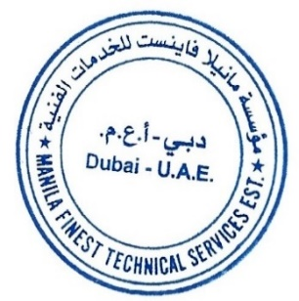**AIRA SHANE BALMES**

Administrative Officer



Approved by:

**JOSELITO DE LOS REYES**

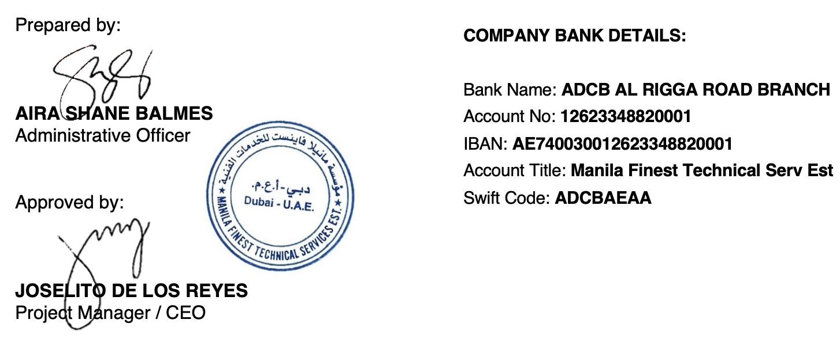Project Manager / CEO