Predicting Industrial Equipment Failure from Sensor Data
A machine-learning decision-support system for predictive maintenance
Dataset | AI4I 2020 Predictive Maintenance (UCI ML Repository, ID 601)
Records | 10,000 machine runs, 14 raw columns
Target | Machine failure — binary, 339 positive (3.39%)
Models compared | Logistic Regression · Decision Tree · Random Forest
Selected model | Random Forest (best held-out F1)
Held-out performance | Precision 0.946 · Recall 0.779 · F1 0.855 · PR-AUC 0.883
Strict time-ordered performance | F1 0.727 · Recall 0.718
Generated | 2026-10-29T12:45:53

⚠️ Executive summary — read this before the numbers
This system estimates the probability that a machine run will end in failure, using
temperature, rotational speed, torque and tool-wear readings.
A prediction is not a guarantee of failure. A high score means the sensor pattern
resembles historical failures and the machine deserves inspection. A low score does not
certify that a machine is healthy. This is decision support for prioritising human
maintenance, not a safety device, an automatic shutdown trigger, or a substitute for
engineering judgement.
Three headline results:
- Random Forest is clearly the best of the three models, reaching F1 0.855 at a
tuned threshold on a held-out test set, with precision 0.946 and recall
0.779.
- The honest number is lower: F1 0.727 when training only on earlier runs and
testing on later ones. The random split was somewhat flattering, and the time-ordered
result is the better guide to real-world expectations.
- Logistic Regression is inadequate here (F1 0.475) because
the risk boundary is multiplicative in speed and torque. That is a finding about the
physics, not a flaw in the experiment.

1. Problem framing
Question: given a machine's current sensor readings and operating condition, how likely is
it to be in a failure state — and which inputs drive that estimate?
Why it matters: unplanned equipment failure is expensive. A model that flags the
highest-risk few percent of machine runs lets a maintenance team spend inspection hours where
they have the most value. The natural trade-off is a missed failure (costly, dangerous)
versus a wasted inspection (cheap, safe), and the model's alarm threshold is where that
trade-off is expressed.
Formulation: binary classification. y = 1 if the run ended in failure, else 0.

2. Dataset
2.1 Provenance
The AI4I 2020 Predictive Maintenance Dataset is published by the UCI Machine Learning
Repository (ID 601). It describes a synthetic milling process with 10,000
independent runs. A copy of the raw file is bundled at data/raw_ai4i2020.csv, so the project
is fully reproducible offline.
2.2 Variables
Variable | Role | Description
Air temperature [K] | input | ambient temperature around the machine
Process temperature [K] | input | temperature of the working process
Rotational speed [rpm] | input | spindle rotational speed
Torque [Nm] | input | torque applied to the tool
Tool wear [min] | input | cumulative tool usage time
Type | input | machine grade — L (60.0%), M (30.0%), H (10.0%)
UDI, Product ID | input (experiment) | row identifier and product token
Machine failure | target | 1 if the run failed
TWF, HDF, PWF, OSF, RNF | excluded | failure-mode flags — data leakage; see §3.2

2.3 Data quality audit (before cleaning)
Check | Result
Rows × columns | 10,000 × 14
Missing values | 0
Duplicate rows | 0
Failure count / rate | 339 / 3.39%
Machine types | L 6,000 · M 2,997 · H 1,003

The published dataset is already clean. Rather than pretend a cleaning stage was necessary,
this project (a) documents the audit above, (b) implements a reusable cleaning pipeline, and
(c) validates that pipeline on a deliberately corrupted copy of the data.
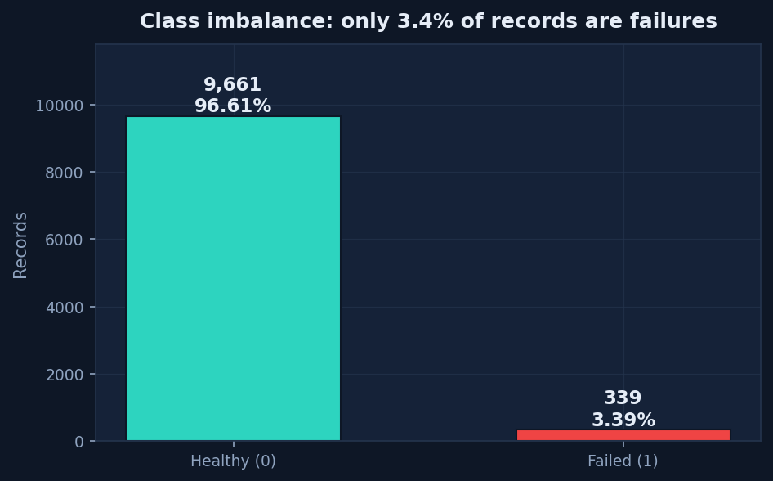
Class imbalance
*Figure 1 — Only 3.39% of records are failures. This single fact
determines most of the methodological choices in this report.*

3. Data cleaning and feature engineering
3.1 The cleaning pipeline
Implemented in src/cleaning.py, applied in this order:
- Type coercion — sensor columns forced numeric (errors='coerce'), so text in a numeric
column becomes missing rather than crashing the pipeline.
- Machine-type normalisation — case/whitespace stripped; unknown grades fall back to M.
- Physical range validation — readings outside plausible physical limits (e.g. negative
torque, 99,999 rpm) are set to missing instead of being trusted.
- Duplicate removal — exact duplicate rows dropped, count logged.
- Label integrity check — flags inconsistencies between the target and the failure-mode
columns without rewriting them (see §3.2).
- Median imputation — missing sensor values filled with the column median (robust to the
outliers that matter here).
- IQR outlier flagging — values beyond 3×IQR are **flagged, never
deleted**, because an extreme reading may be the very failure symptom we are trying to learn.
3.2 The leakage trap — and the label-noise finding
The five failure-mode columns (TWF, HDF, PWF, OSF, RNF) are set only because a
failure occurred, so they cannot be known before the event. Using them as inputs would produce
a spectacular but meaningless model.
Investigating them surfaced a genuine dataset flaw:
Relationship | Count
Rows flagging a failure mode but labelled healthy | 18
Rows labelled failed with no mode flagged | 9
Rows where the flags exactly reconstruct the target | 9,973 of 10,000

Decision: all five columns are excluded from every model input and used only for
description. The 27 inconsistent rows are recorded as a documented label-noise limitation;
the published target is deliberately not overwritten, because rewriting ground truth from a
leaked column would corrupt the evaluation itself.
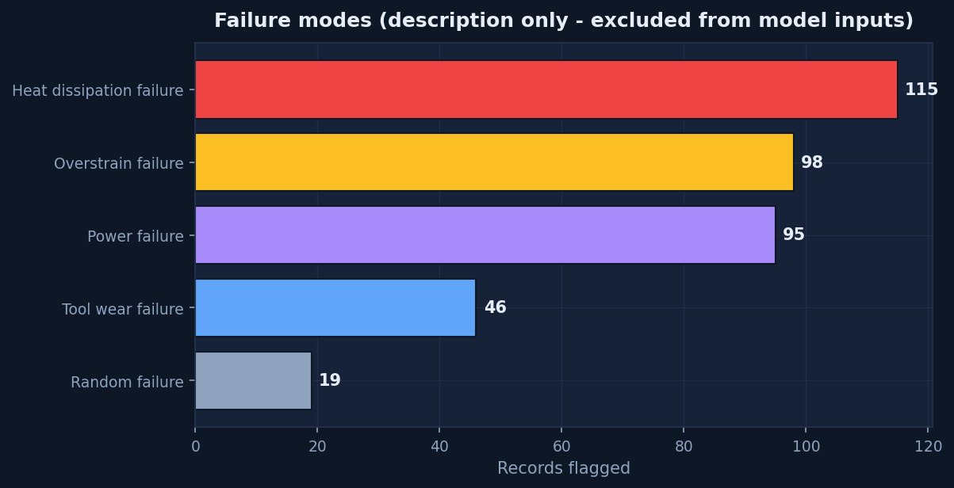
Failure modes
Figure 2 — Failure-mode breakdown. Descriptive only; never a model input.
3.3 Validating the pipeline (the corrupted-copy test)
A decorative cleaning step proves nothing, so the pipeline was run against a copy of the data
deliberately damaged with realistic faults. Results:
Injected fault | Result
Missing sensor cells | 302 injected → all imputed
Duplicate rows | 50 injected → all recovered
Impossible readings (negative torque, absurd rpm) | caught by range validation → set to missing → imputed
Inconsistent machine-type labels (" m ") | normalised to M
Temperature column stored as text with "n/a" | coerced to numeric, then imputed
Rows before → after | 10,050 → 10,000
All duplicates recovered? | True

The cleaning code is therefore demonstrably functional, not theatrical.
3.4 Engineered features
Five physics-motivated features were added, each with a stated mechanism:
Feature | Formula | Mechanism it encodes
Temp difference [K] | process − air temperature | Heat generated faster than dissipated → heat-dissipation failure
Mechanical power [kW] | torque × ω (ω = rpm·2π/60) | Actual load on the tool, not torque alone
Wear-torque interaction | tool wear × torque | Cumulative strain: a worn tool still under heavy load
Speed-torque ratio | rpm ÷ torque | The shape of the operating point
Wear rate [min per kW] | wear ÷ power | Tool life consumed per unit of work done

These are not an arbitrary polynomial expansion — every term corresponds to a failure
mechanism in §5, which is what makes the explanations in §7 defensible.
3.5 Identifier columns (a deliberate experiment)
UDI and Product ID were kept as model inputs on request, to test empirically whether
row identifiers carry any signal. (Product ID cannot be used raw — 10,000 unique strings — so
its numeric serial is retained instead.) §7.3 reports the verdict: they are noise. A single
flag (USE_ID_COLUMNS_AS_FEATURES in src/config.py) removes them.

4. Exploratory analysis
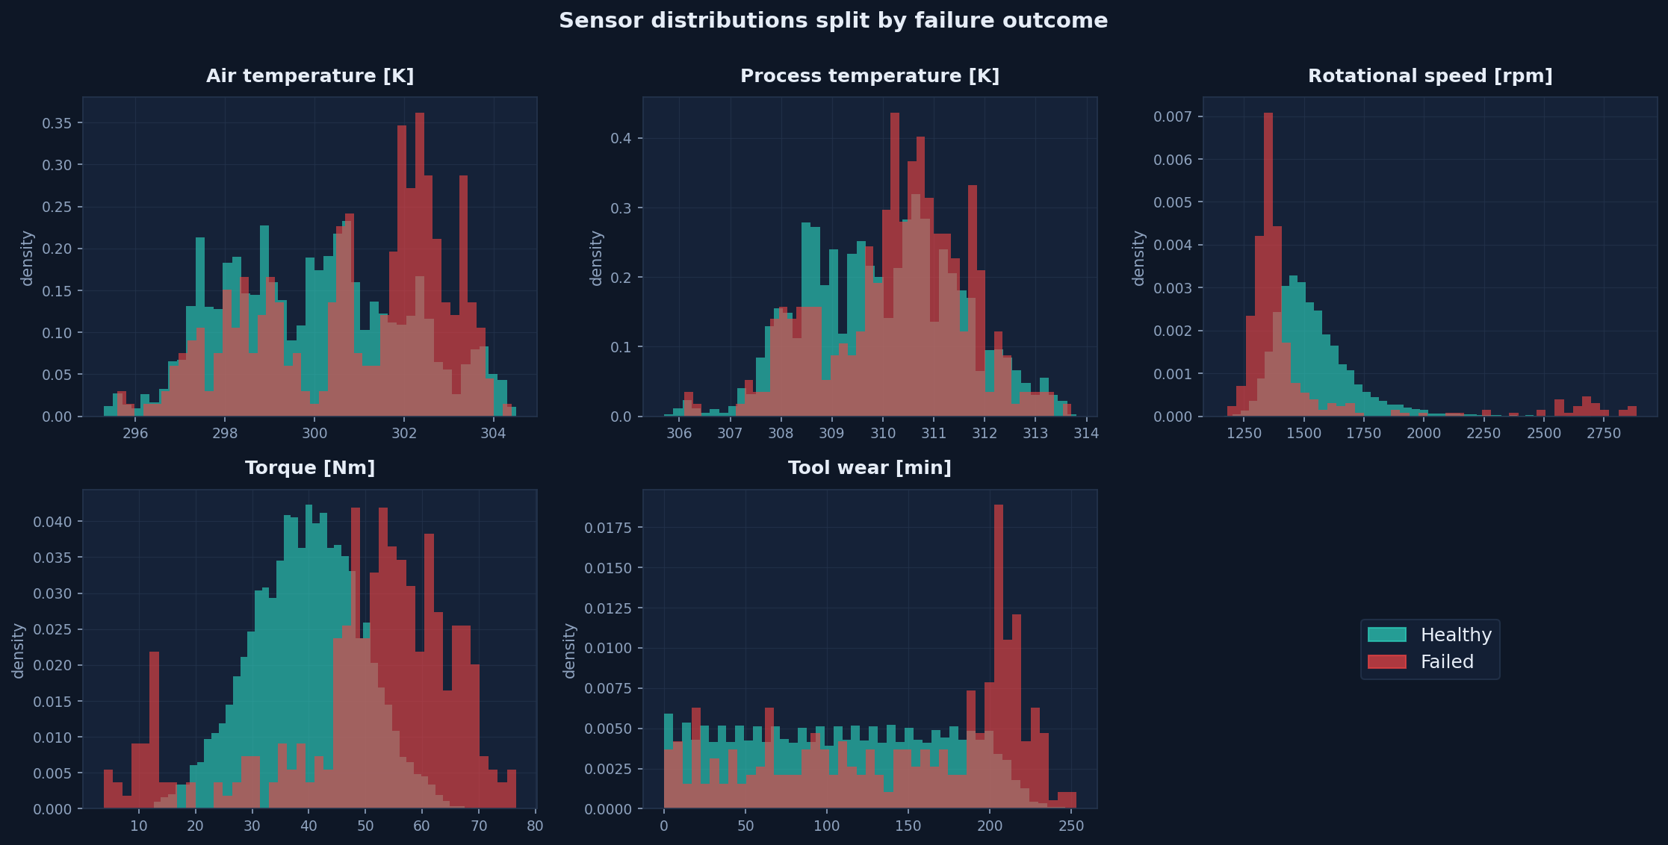
Sensor distributions
*Figure 3 — Sensor distributions split by outcome. Torque and rotational speed separate the
classes; temperature differences are real but subtle.*
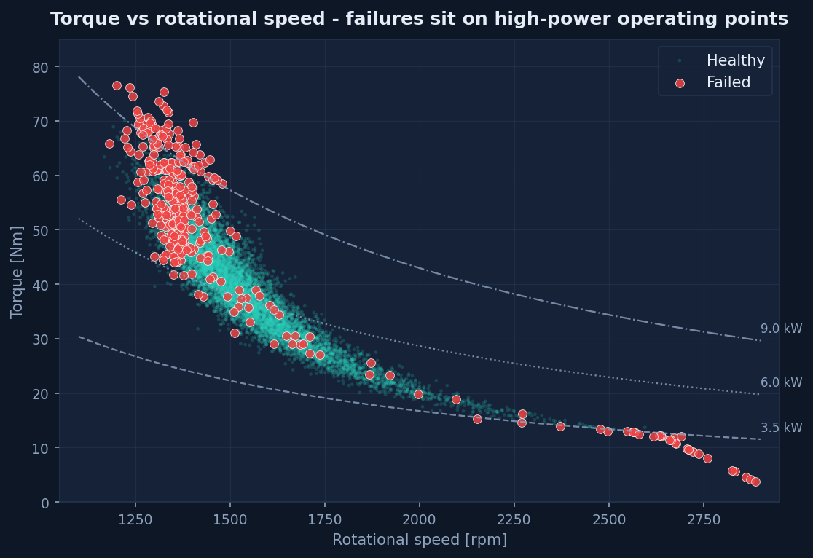
Torque vs speed
*Figure 4 — Torque vs rotational speed with iso-power curves. Failures concentrate at high
torque and low speed — i.e. at high-power operating points. This hyperbolic boundary is why a
linear model in raw features cannot fit the data well.*
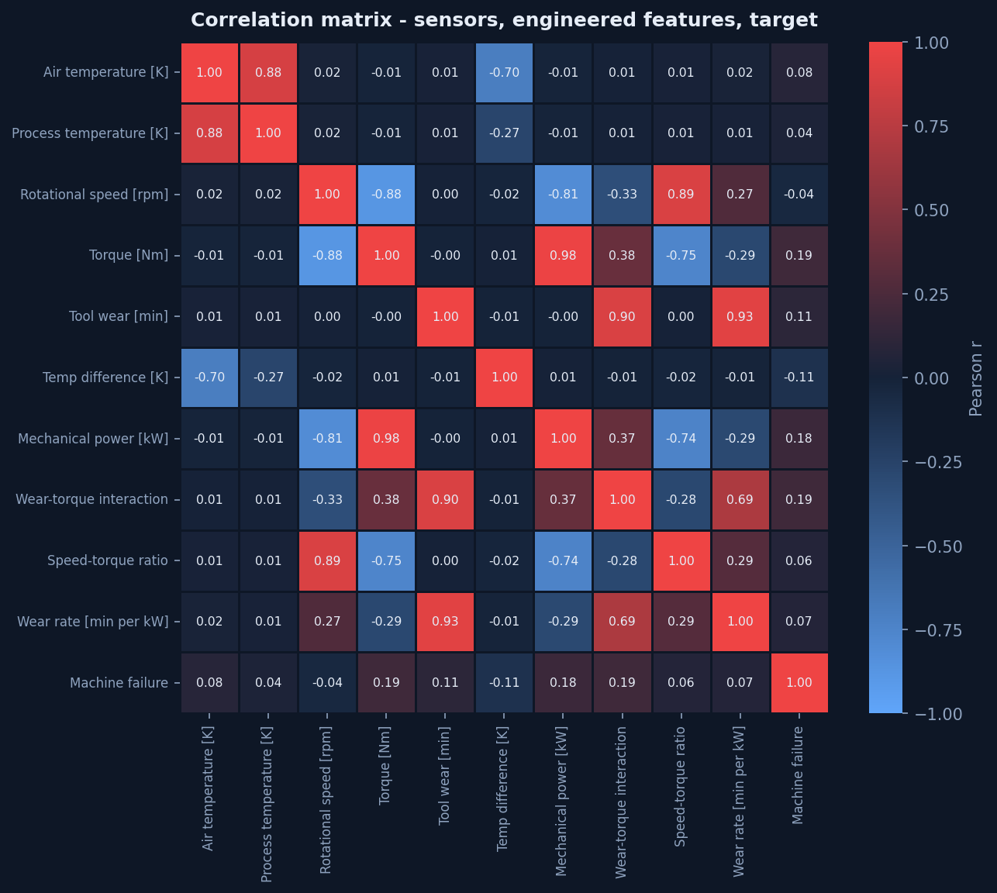
Correlation
*Figure 5 — Correlation matrix over sensors, engineered features and target. No individual
feature correlates strongly with failure (max |r| is modest), confirming that the signal is
multivariate rather than a single-threshold problem.*
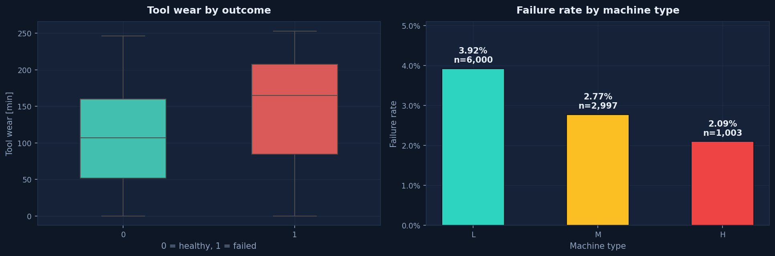
Wear and type
*Figure 6 — Tool wear by outcome, and failure rate by machine grade. Higher grades (H) fail at
a higher rate per unit.*

5. Modelling
5.1 Design choices
Choice | Decision | Rationale
Models | Logistic Regression, Decision Tree, Random Forest | Escalating flexibility; the linear baseline makes the value of non-linearity visible
Imbalance handling | class_weight='balanced' | Reweights the loss without inventing synthetic sensor readings
Threshold | Tuned to maximise F1 on training-fold OOF predictions | The test set is never used for tuning
Validation | Stratified 80/20 and time-ordered 80/20 | One split can flatter; two splits cross-check
Random seed | 42 | Reproducibility
Test set size | 20% (2,000 rows, 68 failures) | —
Cross-validation | 5-fold stratified, inside training only | Estimates stability

5.2 Design matrix
15 features used: UDI, Air temperature [K], Process temperature [K], Rotational speed [rpm], Torque [Nm], Tool wear [min], Temp difference [K], Mechanical power [kW], Wear-torque interaction, Speed-torque ratio, Wear rate [min per kW], Product ID serial, Type_H, Type_L, Type_M.
Excluded from all inputs: the five failure-mode flags, the target, and the IQR outlier flags.
5.3 Results — held-out test set (random stratified split)
Thresholds shown are the tuned values learned on training folds only.
Model | Threshold | Precision | Recall | F1 | PR-AUC | ROC-AUC | MCC | F1 @ 0.50
Logistic Regression | 0.91 | 0.537 | 0.426 | 0.475 | 0.446 | 0.941 | 0.462 | 0.288
Decision Tree | 0.95 | 0.911 | 0.750 | 0.823 | 0.835 | 0.909 | 0.821 | 0.553
Random Forest ⭐ | 0.44 | 0.946 | 0.779 | 0.855 | 0.883 | 0.979 | 0.855 | 0.855

Accuracy is deliberately omitted from the comparison because it is misleading here: a
model predicting "healthy" for every row scores 96.6% accuracy while
catching zero failures.
5.4 Why each model performed as it did
Logistic Regression — F1 0.475.
Its largest standardised coefficient is on Speed-torque ratio (+4.75),
which is the model's proxy for the multiplicative speed/torque interaction. A linear model in
raw features cannot represent the hyperbolic decision boundary visible in Figure 4, so it
saturates. This is evidence that the underlying physics is multiplicative — a useful finding
in itself.
Decision Tree — F1 0.823.
Depth-limited (max_depth=6, min_samples_leaf=10) to control overfitting. It captures the
interaction structure well and is fully readable as rules, but a single tree has high variance.
Random Forest — F1 0.855.
Averaging 400 trees cuts the variance of the single tree. It achieves the best
precision (0.946) and PR-AUC (0.883), at the cost of recall
(0.779) — it still misses roughly one failure in five.
5.5 Stability and uncertainty
Model | CV precision | CV recall | CV F1 | CV PR-AUC
Logistic Regression | 0.518 ± 0.043 | 0.465 ± 0.065 | 0.487 ± 0.039 | 0.486 ± 0.048
Decision Tree | 0.893 ± 0.064 | 0.797 ± 0.046 | 0.839 ± 0.019 | 0.857 ± 0.023
Random Forest | 0.962 ± 0.012 | 0.745 ± 0.027 | 0.840 ± 0.021 | 0.887 ± 0.023

Bootstrap 95% confidence intervals on the test set (300 resamples) for the
selected model:
Metric | Mean | 95% CI
F1 | 0.854 | 0.777 – 0.917
PRECISION | 0.949 | 0.879 – 1.000
RECALL | 0.777 | 0.676 – 0.876
PR-AUC | 0.884 | 0.810 – 0.950

These intervals are wide — roughly ±0.07 on F1 — because the test set contains only
68 failures. Any single-point claim about this model's quality
overstates what the data can support.
5.6 The stricter test: time-ordered split
Training on the first 8,000 runs and testing on the last
2,000 (which contain 39 failures,
1.95%):
Model | Random-split F1 | Time-split F1 | Random-split recall | Time-split recall | Δ F1
Logistic Regression | 0.475 | 0.250 | 0.426 | 0.154 | -0.225
Decision Tree | 0.823 | 0.727 | 0.750 | 0.718 | -0.095
Random Forest | 0.855 | 0.727 | 0.779 | 0.718 | -0.128

Interpretation. The tree models fall by roughly 0.10–0.13 F1 when the future must be
predicted from the past. The random-split numbers in §5.3 are therefore optimistic; the
time-ordered numbers are the fairer expectation for deployment. Both are reported rather than
picking the flattering one.
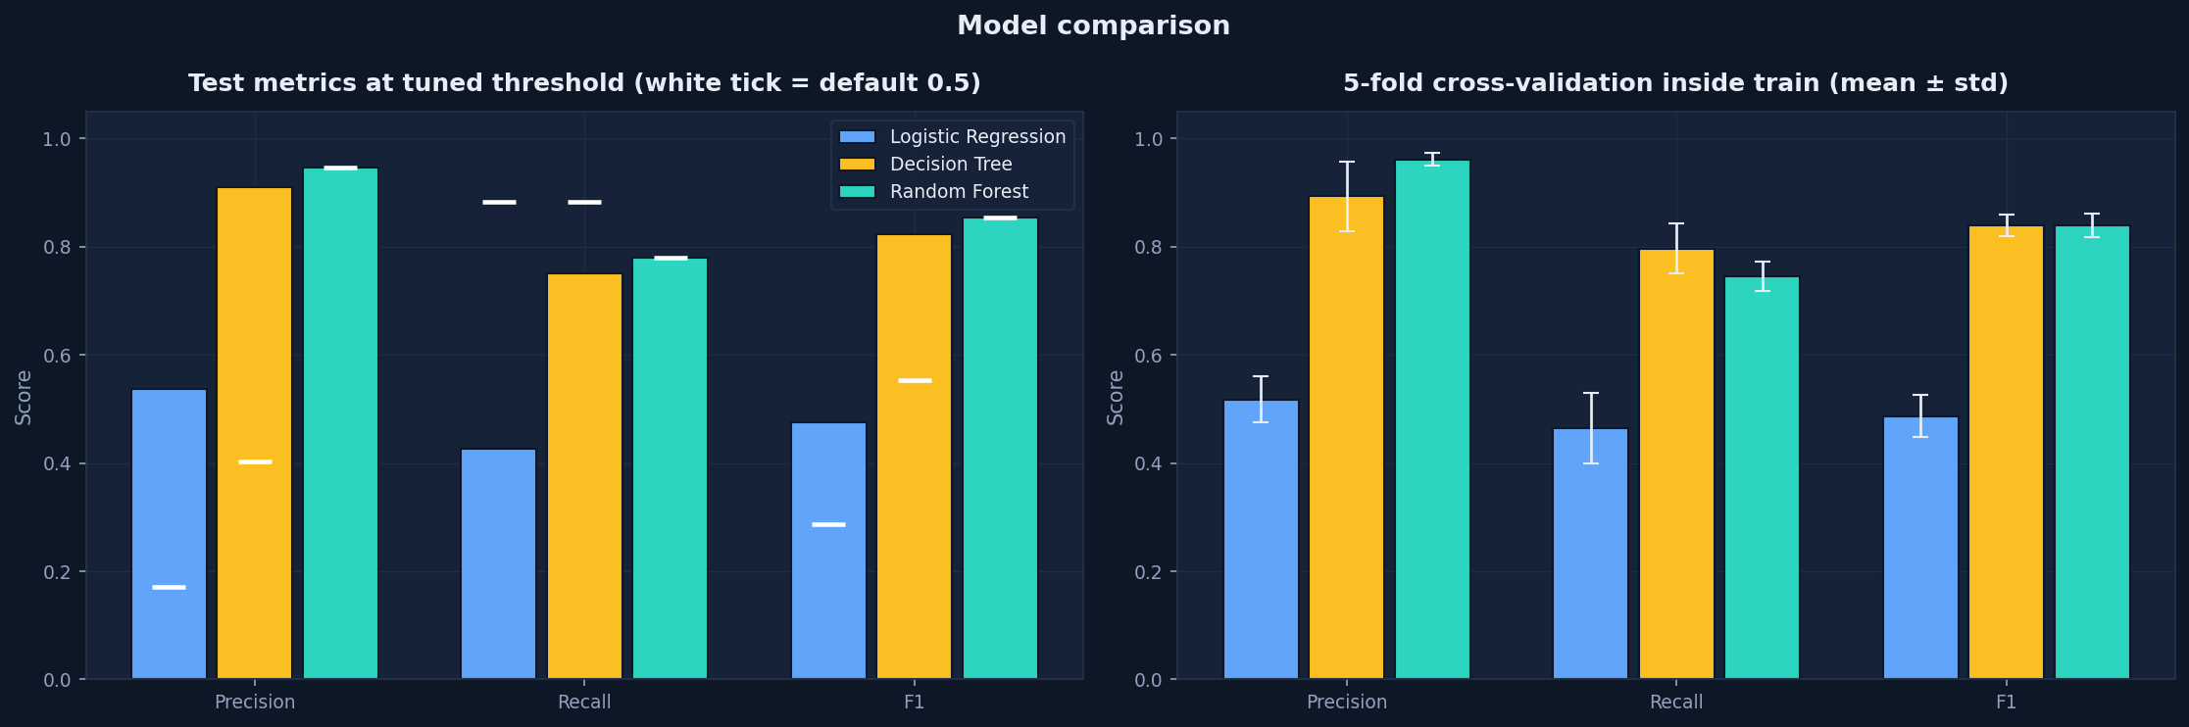
Model comparison
*Figure 7 — Test metrics at the tuned threshold (white tick = default 0.5), with 5-fold CV
stability on the right.*
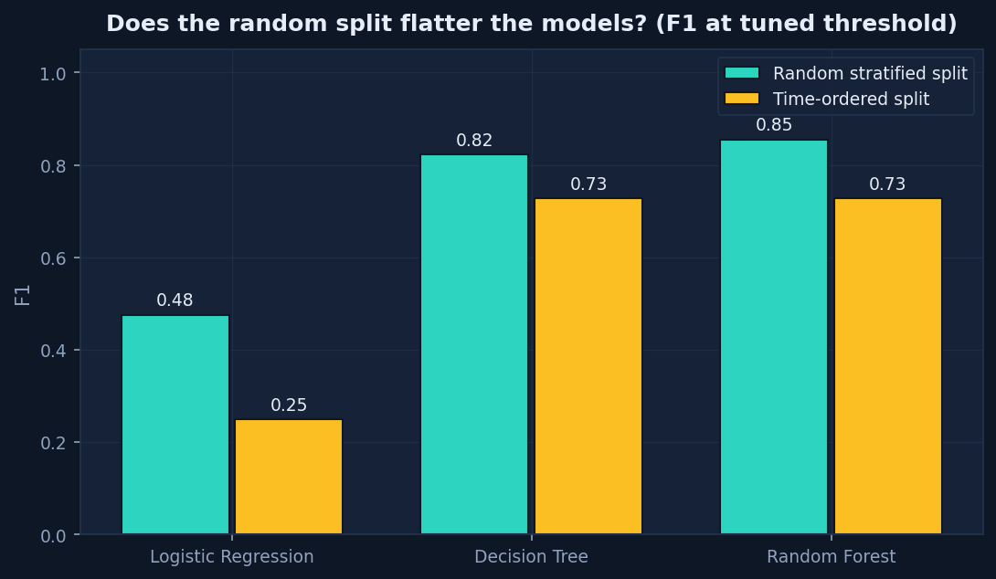
Split comparison
Figure 8 — Random split vs time-ordered split. The gap is the optimism in the random split.

6. Evaluation
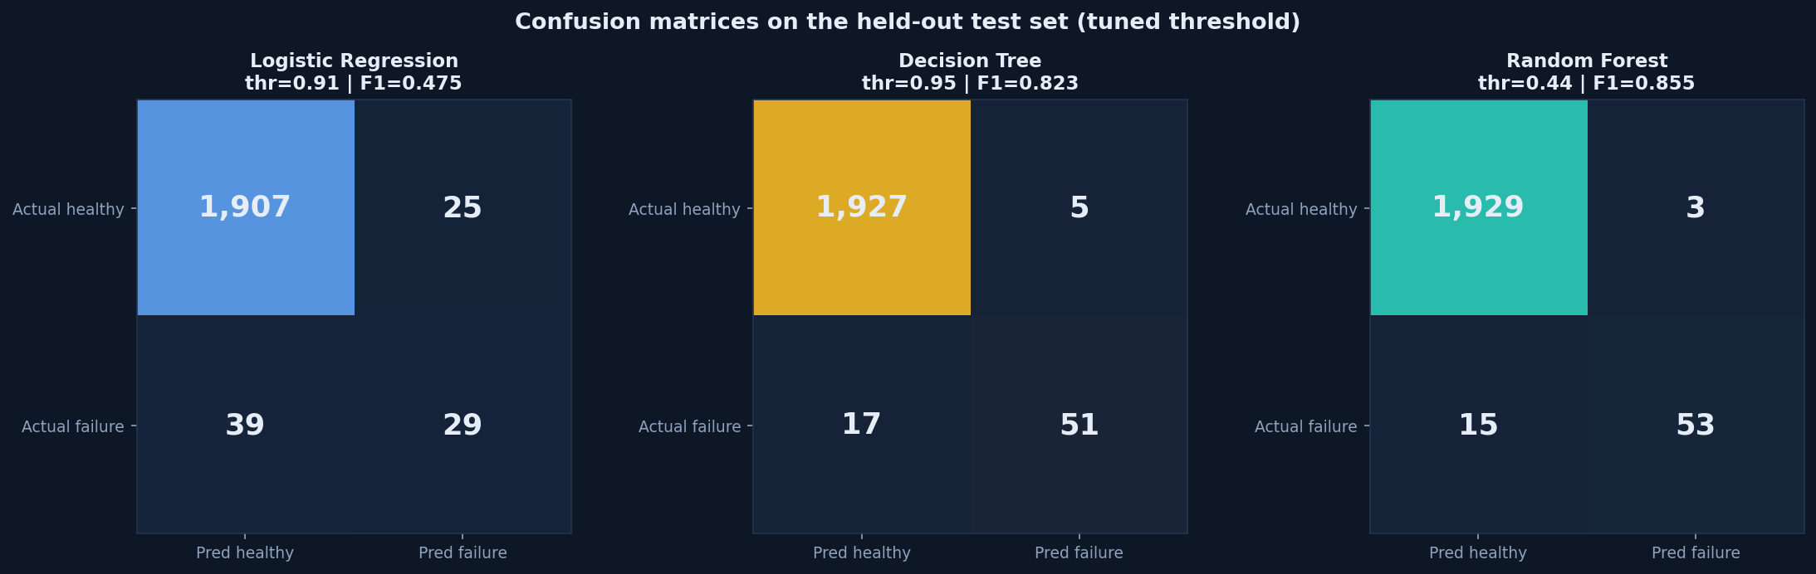
Confusion matrices
Figure 9 — Confusion matrices on the held-out test set.
For the selected model (Random Forest):
 | Predicted healthy | Predicted failure
Actual healthy | 1,929 (correct) | 3 (false alarm)
Actual failure | 15 (missed failure) | 53 (caught)

The bottom-left cell is the expensive error in maintenance. Relative to a
"predict healthy for everything" baseline, the model trades 3 false alarms for
53 correctly anticipated failures.
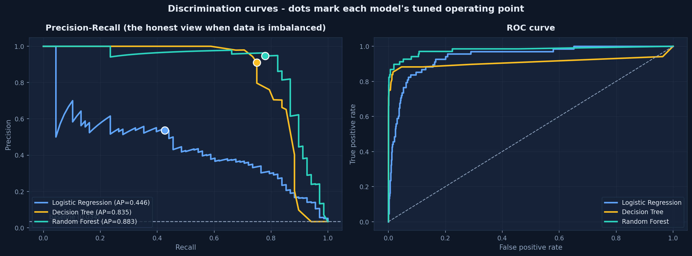
PR and ROC
*Figure 10 — Precision-Recall (left) and ROC (right). PR-AUC is the fairer summary at a 3.4%
positive rate; the dots mark each model's tuned operating point.*
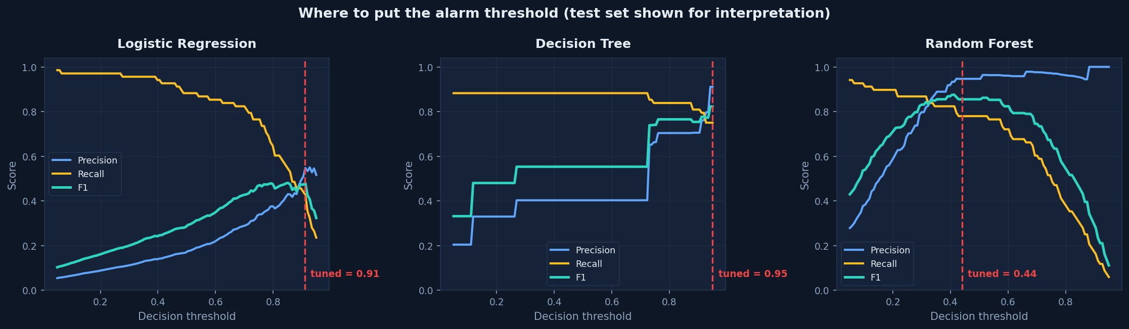
Thresholds
*Figure 11 — Precision, recall and F1 vs the decision threshold, per model. The dashed line is
the tuned cutoff.*
6.1 The threshold is a policy decision, not a technical one
The tuned cutoff maximises F1, but F1 weights false positives and false negatives equally —
which maintenance economics rarely does. On the test set, the selected model behaves as:
Maintenance policy | Inspections triggered | Failures caught | Failures missed | False alarms
Sensitive (threshold 0.10) | 163 | 62 | 6 | 101
Tuned for best F1 (0.44) | 56 | 53 | 15 | 3
Conservative (threshold 0.80) | 27 | 26 | 42 | 1

The in-app alarm threshold is a live slider for exactly this reason: a plant that cannot absorb
extra inspections should raise it; a plant where a missed failure is dangerous should lower it.

7. Which inputs influence the predictions?
Four complementary methods are used, deliberately so they can check each other.
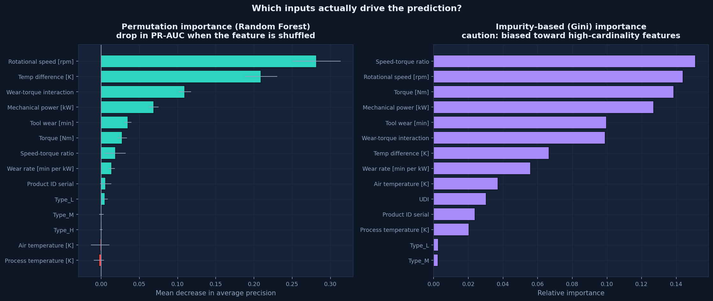
Feature importance
*Figure 12 — Permutation importance (left, model-agnostic) vs Gini importance (right, biased
toward high-cardinality features). Where they disagree, trust the left half.*
7.1 Permutation importance — selected model
Measured as the drop in PR-AUC when a feature's values are randomly shuffled:
Rank | Feature | PR-AUC drop
1 | Rotational speed [rpm] | +0.2820
2 | Temp difference [K] | +0.2091
3 | Wear-torque interaction | +0.1093
4 | Mechanical power [kW] | +0.0689
5 | Tool wear [min] | +0.0348
6 | Torque [Nm] | +0.0275
7 | Speed-torque ratio | +0.0185
8 | Wear rate [min per kW] | +0.0137
9 | Product ID serial | +0.0059
10 | Type_L | +0.0048

7.2 Physical interpretation
Reading the top drivers together, the model's behaviour matches this machine's known failure
mechanisms:
- Rotational speed and torque jointly define the operating point. Failures sit at high
torque / low speed, which is the high-power region — consistent with overstrain and power
failure modes.
- `Temp difference` ranking highly is the heat-dissipation pathway: when the process runs
hot relative to ambient air, the machine cannot shed heat.
- `Wear-torque interaction` captures cumulative strain on a worn tool under load.
- `Mechanical power` restates the load in the units that actually stress the machine.
This agreement between statistical importance and known physics is the main reason to trust
the model's reasoning — not its accuracy score.
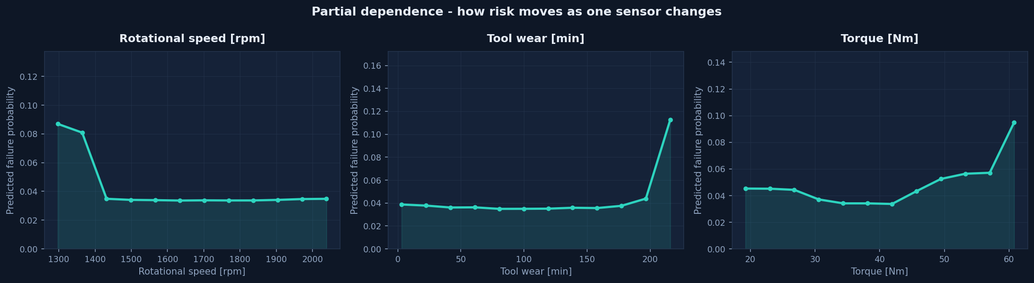
Partial dependence
*Figure 13 — Partial dependence: how predicted failure probability moves as one sensor varies,
with everything else held fixed.*
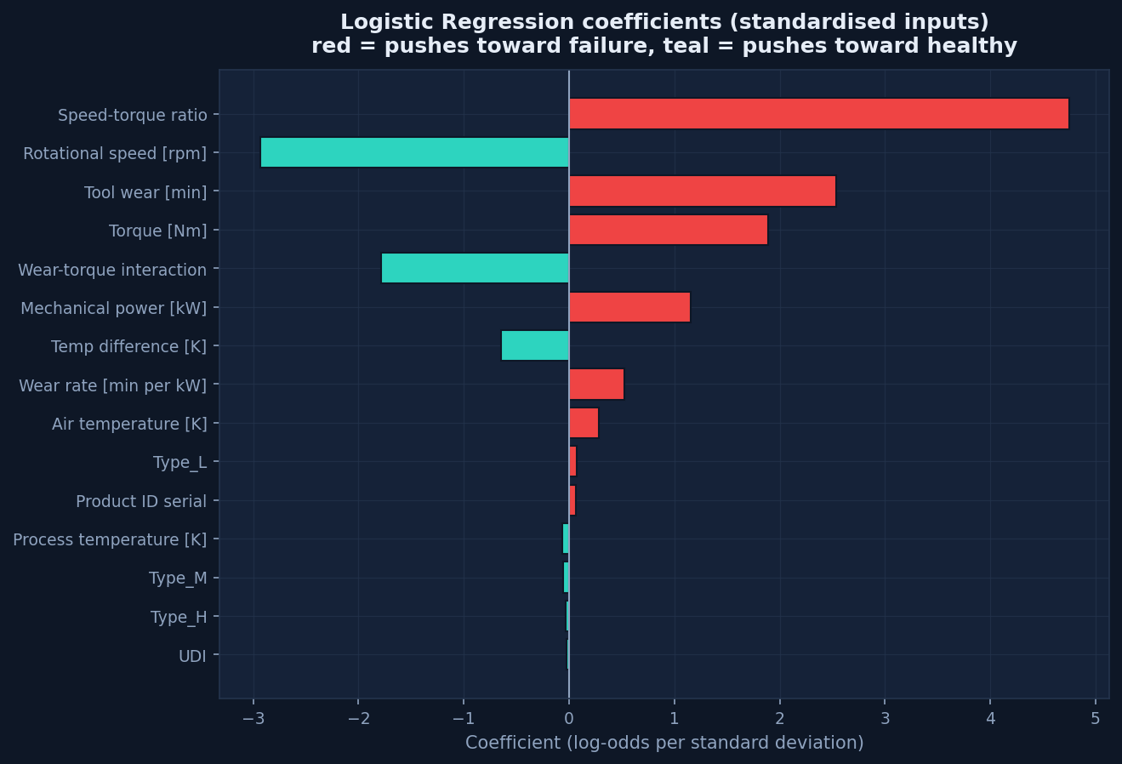
LR coefficients
*Figure 14 — Logistic Regression coefficients (standardised inputs). Red raises failure odds,
teal lowers them.*
7.3 Do the identifier columns matter? (empirical answer)
Feature | PR-AUC drop | Rank
UDI | -0.0046 | 15 of 15
Product ID serial | +0.0059 | 9 of 15

Together the identifiers account for 1.34% of total permutation importance, and
UDI's contribution is negative — shuffling it slightly improves the score. Conclusion: row
identifiers carry no predictive signal and should be dropped. They remain only because keeping
them was an explicit experiment; set USE_ID_COLUMNS_AS_FEATURES = False in src/config.py
to remove them.

8. Prediction and dashboard
A Streamlit application (app/streamlit_app.py) realises the model as a usable tool with four
views:
View | What it does
🔧 Machine Risk Check | Sliders for the five sensors + machine grade → failure probability, a risk gauge, all three models side by side, and a plain-language "why" panel naming the inputs that moved this specific prediction. Includes preset failure scenarios.
📁 Batch Scoring | Upload a CSV of machines → cleaned, scored, ranked by risk, downloadable. Reports exactly which cleaning repairs were applied to the uploaded file, and computes precision/recall/F1 if the file includes ground-truth labels.
📈 Model Evaluation | Leaderboard, confusion matrices, PR/ROC curves, threshold sensitivity, cross-validation stability, bootstrap CIs, and the random vs time-ordered comparison.
🔍 Patterns & Drivers | All EDA charts, permutation/Gini importance, partial dependence, LR coefficients, the ID-column verdict, and the full cleaning audit including the corrupted-copy test.

No train/serve skew: the dashboard builds a prediction row and pushes it through the same
cleaning → build_features → build_design_matrix code used in training, then aligns columns to
the saved training schema. This is the single most common cause of models that work in a
notebook but not in production, and it is handled structurally rather than by convention.
8.1 Example predictions
Scenario (sensor pattern) | Random Forest probability | Interpretation
High-power overstrain (68 Nm @ 1330 rpm) | high | Flag for inspection
Worn tool under load (55 Nm, 235 min wear) | moderate–high | Inspect tool, verify load
Heat-dissipation risk (large air/process gap) | moderate | Check cooling
Healthy reference (40 Nm, 1500 rpm, 20 min wear) | near zero | Routine monitoring

Every one of these is a probability, not a verdict. The "healthy" row does not certify safety.

9. Limitations
This section is deliberately prominent. The numbers above are only as trustworthy as these
caveats allow.
- The data is simulated. AI4I 2020 was generated from a physics-inspired process model,
not logged from real machines. It lacks sensor drift, correlated channels, dropouts,
maintenance interventions and operator behaviour. **Absolute performance will not transfer
to a real plant; the method transfers, the numbers do not.**
- Failures are rare, so estimates are uncertain. 339 failures total and
68 in the test set give F1 confidence intervals of roughly
±0.07. Re-running with a different seed moves results by several points.
- Some failures are unlearnable by construction. The 19 RNF (random failure) records
have no sensor signature. No model can catch them, which caps achievable recall. Chasing
100% recall means fitting noise.
- Tool-wear failure is truncated. Every TWF record occurs at tool wear of 198–253 min —
i.e. just before the replacement limit — so that mode is partly an artefact of the
replacement policy rather than pure physics.
- Label noise exists. 18 rows flag a failure mode while labelled healthy, and 9 failures
have no mode flag. The published target was preserved unchanged; the inconsistency is
documented rather than silently "corrected".
- No per-machine time history. Each row is an independent run. Real degradation trends —
the strongest signal in a real plant — cannot be modelled here. This is the single biggest
gap between this project and a deployable system.
- Feature importance is not causality. "The model used rotational speed" does not mean
"change the speed to prevent failure". Do not act on importance charts without engineering
review.
- The threshold is a policy tuned on this dataset. A real deployment must re-tune it
against the actual cost of a missed failure versus a wasted inspection.
- The model is not aware of context. It does not know about recent maintenance, ambient
conditions, material batch, or whether a sensor is faulty. Sensor faults can produce
confident nonsense.
10. This is not a safety system. It is decision support for prioritising inspections. It
must not be used for automatic shutdown, safety certification, or as the sole basis for a
maintenance decision.
9.1 What would make this genuinely deployable
- Per-asset time-series data (the real predictive-maintenance setting), enabling degradation
trend features and remaining-useful-life modelling.
- Cost-sensitive threshold selection using actual inspection and downtime costs.
- Production drift monitoring and a scheduled re-validation/retraining cycle.
- Sensor-health checks upstream, so a broken sensor cannot masquerade as a failing machine.
- Human-in-the-loop feedback: capturing whether flagged machines were actually faulty, and
retraining on that ground truth.

10. Reproducibility
pip install -r requirements.txt
python -m src.train # clean → train → evaluate → explain → save artifacts
streamlit run app/streamlit_app.py # launch the dashboard
jupyter notebook notebooks/01_failure_prediction_walkthrough.ipynb
Artifact | Contents
data/raw_ai4i2020.csv | raw dataset snapshot (offline reproducible)
data/clean_ai4i2020.csv | cleaned data + engineered features
data/synthetic_corrupted_ai4i.csv | deliberately damaged copy used to validate cleaning
artifacts/models.joblib | three fitted models, thresholds, training reference stats
artifacts/results.json | every metric, importance score and cleaning action
artifacts/test_predictions.csv | per-row test predictions for auditing
artifacts/figures/*.png | all 14 figures

Fixed seed 42, deterministic splits, and every modelling choice
recorded as an explicit constant in src/config.py.

11. Conclusion
A Random Forest trained on sensor readings plus physics-motivated features predicts equipment
failure with F1 0.855 / PR-AUC 0.883 on a random holdout, falling to
F1 0.727 under a strict time-ordered split. Its drivers — rotational speed,
temperature difference, wear–torque interaction and mechanical power — are physically
plausible and individually explainable, which is what makes it usable as decision support
rather than a black box. Logistic Regression is demonstrably insufficient here, which itself
reveals that the failure boundary is multiplicative in speed and torque.
The honest framing matters as much as the score: this is a model trained on simulated data
with few failures, an unlearnable random-failure class, and documented label noise.
Its predictions are probabilities, not guarantees of failure. Used to rank machines for
human inspection, it adds real value. Used as an oracle or a safety device, it would be
dangerous.

*Generated 2026-10-29T12:45:53 from artifacts/results.json by scripts/build_report.py.
Dataset: AI4I 2020 Predictive Maintenance, UCI Machine Learning Repository (ID 601).*

