**DIGITAL PARKING MANAGEMENT SYSTEM FOR IIMS COLLEGE**

A system that manages the parking space allocation at IIMS COLLEGE, DHOBIDHARA, KTM

**Abstract**

This project is designed for vehicle parking to records the information of drivers. Typically, at IIMS COLLEGE, DHOBIDHARA, KATHMANDU, Looking out for a vacant parking slot, however it's a paid office with a security monitor. It is simple web-based application using Html, CSS, SQL, and PIIP. It is very user-friendly and easy to use and provides both benefits to customers and owners. This system can be edit if there is mistake on names, time, or other contents. This system can help tracking the entry and exit vehicles which helps to know there is place for parking or not inside the parking area. The purpose behind the documentation is to give the explanation about the process of design and usage alongside description of usefulness gave by the system and plans for what's to come in future. This system will record all the details of customer's vehicle that is parked in parking area. These systems also save more time for owner. An iterative approach also helps to solve the problem and primary method is used to research the problem solution. This system will helpful to the admin as well as to the customer also.

**Introduction**

In the early days there was no such system as there is today. But nowadays in the age of internet and technology they have become a part of our daily life. Many businesses and organizations have integrated these technologies, the software "Vehicle Parking Management System for IIMS College" online system to provide free services to their customers. The overall structure of this report consists of five main chapters: summary, introduction, data collection, analysis, synthesis, evaluation, conclusion and recommendation. All this content consists of their subdivisions. The first part introduces the car parking management system, how it works, what tools and technologies are used to develop the system. And the second part is to collect information that contains all the information and data that I used to build my system. Gathering information such as: literature review, research methodology, and system development methodology. I choose research methods such as questionnaires, fact-finding skills, primary data sources, and secondary data sources. Part 1 of the analysis includes some sub-materials such as process model, functional requirement, non-functional requirement, constraint and assumption, feasibility, software requirement. In the synthesis section I’ve designed all the diagrams like Use Case diagram, Activity diagram, Gantt Chart. The diagnostic section does all the testing and also finds all the objectives and scope that I’ve find in the information gathering. The final conclusion and recommendation section summarizes all of the systems, therefore, the software vehicle parking management system that helps to record the details of the customer standing in the parking area that helps to control the parking area. And also, the tools and technologies used to develop the system. Customer details are stored in the database.

**Background**

In today's days in many public places, such as, shopping centers, multiplex systems, medical clinics, offices, markets there is an urgent issue of vehicle parking. The vehicle parking area has many lanes/spaces for vehicle parking. So, to park a vehicle one needs to search for all the slots. In addition, this includes lot of time. So, there is a need to build up a computerized parking system that shows directly available of empty parking slots in any path directly at the passageway. The project includes record details of customer vehicle that are parked in parking area. So, the person can leave their vehicle safe and secure. The main aim of this project is to reduce the traffic in the parking area, Normally, we can find in the movie hall shopping mall there is an issue they need to search which line is empty and line is had spot to leave the vehicle for parking. So, to maintain this problem vehicle parking management system is implemented. Parking management system is the managing the records of the approaching and active vehicle in parking areas. Parking system has created such a way that is filled up with secure device such as parking control gates, vehicle checking device, CCTV, and others. Accordingly, we need to create and design a parking management system. This software "Vehicle parking management system" is a web based online system which is developed in PHP, as a front-end development and Xampp for connecting MYSQL server and Apache server for development for backend of my system. This system helps to record the number plate, in and out vehicle from parking area. The purpose behind this system is to make easier for vehicle owner to park safely and secure. This system solves the problem, by helping the user to locate parking areas, locate the place of parked area, and manage the parking fees.

The Parking areas are very necessary in everywhere especially within the cities of the countries. Every day the drivers are throwing time by searching parking area. In this era of increases need to travel, the more of vehicles likewise expands, which brings about addition in the space required for parking vehicles. The management of these parking areas is to be done in an extremely proficient manner utilizing limited assets. The goal of this project is to get data of the parking area at wherever and to give that data to the new coming vehicle There are two sections in our vehicle parking management system. The first section shows:

Customer Name

Vehicle Number

Vehicle Type

Vehicle Entry Time

Vehicle Exit Time

**Report**

Vehicle Parking Details: This report provides the brief summary of vehicle parking activities. It will show all the In and Out Vehicles details. It also shows the time of entry and exits and shows the cost according to the time.

**Transaction Details**

This detail shows the transaction of both the customers and the systems. It will have time in the transaction. Customer gets their printed receipt after they pay the parking cost.

**Problem Statement**

Problem Statement is the one of the fundamental and significant phases of the project. At the point when the essential issue is resolved, it is reported and the symptomatic issue is examined. At that point the current rundown of essential issue is finished. A system is essentially a lot of segments that communicate to achieve some reason.

➢ Every time the driver enters the parking area, they had turn to find an empty parking, it is more effective if the area has an automated vehicle parking system that can help drivers to park their car automatically.

➢ Lack of sufficient parking areas in events:

Special events can potentially disrupt traffic flow and require crowed management. Every occasion can create its own unique transportation issues.

➢ Overpopulation can lead to increase in number of vehicles that can cause unmanaged parking and other issues.

How many vehicles are parked in the parking area? And second part tells the time of the parked vehicle. However, solving the parking difficulty problem is now an emergent issue.

**Stake holders:**

In this system there are two holders they are:

Admin:

The admin will have full control of the system. The admin can remove or edit of the customers. The admin can also manage the price of the customers according to the time.

Customers:

The customers can park their vehicle safe and secure don't need to worry about anything. The customers get their paid printed receipt.

**Data Records**

Staff records

It provides details of staff that uses the vehicle parking management system. It helps to describes Office staffs like

❖ Staff names

❖ Address

❖ Contact Number

**User Records**

This record helps for the approval for utilizing Vehicle Parking Management System. It provides the Username and Password for the User. It likewise incorporates the authority that implies it

Separates the users and administrator.

**Vehicle Records**

The most important records which focuses in vehicle parking management system. It stores the

fundamental Vehicle record like:

• A 35% travel during times of heavy traffic searching parking spaces that are hard to find it.

That is the reason parking is very imperative to manage vehicle's How and reduce air

pollution.

• Lacking of space may cause parking conflict, so the management of it should maintain

proper space in order to reduce problems.

• CCTV surveillance should be kept in each part of parking area so that whoever goes against

the rules and regulation should be charged fines.

• Parking management should work computerized so that it won't be difficult to maintain

records of vehicles.

• Vehicles should be parked well in the proper area to avoid disturbance to other customers.

• There should be division of parking of four wheelers and others so that both vehicles find

comfort when doing up and downs

• Smart parking systems should be followed so that there won't be any problems regarding to

parking system in future. Penalty should be charged if someone violates the rules of parking

management system Providing proper information to the customers in order to reduce

parking management problems.

Data Security is not secured:

This is because of the manual method of recording the information. It is realized that, in

manual way, information is being put away by recording it on paper. Therefore, it can easily

get damage or mistakenly thrown away by anyone. Performance: Since the workplace

performs recording client data manually, it takes a lot of time in looking and information

recovering component of the system.

**Aim**

This project aim is to develop a vehicle parking management system based on web

application that runs on web/online. And to make system that everyone can use and satisfied

from that. Some of the aims are as follows

• To make the garage energy efficient by using efficient management

• To make a simple web-based site that keeps record of booking and parking vehicles that

is parked in the parking area.

• Increase the security in parking system.

• Make system that everyone can use and satisfied from that.

**Objectives**

Some of the objectives of vehicle parking management are as follows:

• To make good research about people's park and gather all important information that

helped in planning the parking management system.

• Monitoring of parking space and updated on empty parking slots

• Parking charges display

• Printed receipt

• To track in and out vehicle system

• To focus on more secure data backup rather than paper-based system

• To develop prototype as per design.

• To enhance the visitor's experience.

• In case of any damages and issue of vehicle that will guarantee take a responsive by

parking management.

• The main important benefit of digital parking management system is its advanced

technology. It follows latest technologies and concepts to assure profitable outcome.

• Another unique advantage of it is it’s a cost-effective technique with less manpower,

large sum of money is saved.

• Moreover, it saves manual labor and energy.

• For parking authorities of IIMS College and clients parking lot system resources are

flexible enough to operate and manage.

• This system can be easily handled by the attendants because of its well-organized

structure.

• The vehicle users are well assured on grounds of security and privacy.

• The system prohibits unauthorized entry or exit and is suitable for multiple entry and exit points

**Justification:**

With the development of technology, there has been needed of more vehicle just to make

case in daily life. And to manage the vehicle, more parking area should be established.

Parking must be in systematic way and need to record customer details in online so that

there won’t be any problem in the future. This system is purposed in order to enhance the

security with efficient management. We need a system that helps to know how many

vehicles are parking in the parking area.

My main goal is to provide this system to record the customer's details in parking areas

safe and secure in online. And how many vehicles enter last 7 days records. It will help in

parking areas. Parking system are essential in overseeing vehicles in different areas like

residencies, emergency clinics, shopping centers, workplaces, and other open spots. This

is on the grounds that they assist control with dealing whenever of day or night by

guaranteeing simple entry or exit of vehicles utilizing the parking area. With the new

system, we currently have incorporated stopping systems that give brilliant answers for

different parking issues. Here are five reasons why you should put money into the best

parking systems.

i. Improve security:

One of the significant points of parking system is that it builds the viability and

effectiveness of security systems. All the vehicles that enter the parking area are recorded

and checked. The parking system makes it simple for the parking records to regulate,

oversee and control data on the entries and exists from the premises.

ii. Prevents human errors:

Good parking management systems like my system; it is very simple to utilize and your

workers won't require any training. The effectiveness of computerization innovation

moderates’ human impedance in the whole parking process. This removes the dangers

related with date altering and manual mistakes. we will be sure of getting accurate

records and data and this will give us genuine feelings of mind.

without getting any concern. There are many vehicles parking area who record their

operation manually through paper work. My purpose system helps them to record all the

details of the customer. While the admin work in the system is to add delete and edit the

customer’s detail.

We do agree that such advanced level of parking control system will land up with a huge

cost, but positively it will make an extreme advance to stop robbery and improvise

security, by introducing parking control system. The system we include is login page,

dashboard for showing the number of vehicles that parked in parking area. There are two

types of scopes. they are: in-side system scope and out-side system scope In-side system

scope

Front end

• Front end coding is done to incorporate a powerful vibe for the application. This is

important to give recognizing highlights that will improve the client experience. Itis

likewise important to diminish the impression of the recently evolved system.

• Back end

Back-end coding is incorporated as it is important to help out a database to recover

item data and construct the interfaces the clients will see

• Database

database is built to show the vehicles in displayed on the application. The database

will hold data about number of vehicles (value, category of vehicle, numberplate, in

out vehicle.) in tables where suitable. An examination is required to affirm the

structure of the database.

• Software testing

To guarantee the vehicles carries on as indicated by administrator and gives suitable

outcomes to clients. This will help discover faults with current implementations,

allowing progress to be made in the future within the project.

By leaving the vehicle openly place the vehicle are frequently asserted by towing individual

however, during this case there's no towing issues and no found a good pace for affection or

cash we will leave our vehicle with safely.

**Scope:**

Vehicle parking management system will be the web-based system which is developed by

using Sublime text. Nowadays, many people have their personal vehicles. Vehicle is a basic

need in our daily life. Every parking area needs a system that records the details of vehicles

to give the facility. The main aim of this project is to record the information and to show how

many vehicles inside the parking area. The vital users of the system will be admin, and

customers. The admin will be progressively stressed over the reports and subtleties gave by

the system to which the data will be given by the entries made by the customer. In these days

parking management system is very important hence it is necessary for every vehicle owner

to park their vehicle in a safe design parking space available. To raise his types of system

different parking owners, have to co-ordinate themselves with advanced parking control

systems, which is very high tech and offers full undeniable parking services. Parking control

system has been created in such a way that it is filled with many secure gadgets, for e.g.,

blockades, slide gates, time and attendance machine and also to access this structure for each

vehicle entry and exit. In some area there is no parking facilities hence all the security

standards important to park a vehicle. This practicality study gives the top administration the

financial support for the new framework. The parking control system settle on a brilliant

decision as well as permit us to follow through on the correct cost.

#### **Use Case Diagram**

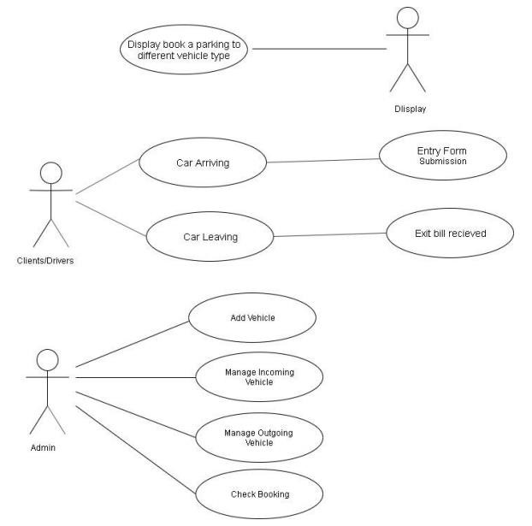

Fig: Use Case Diagram

##### Activity Diagram

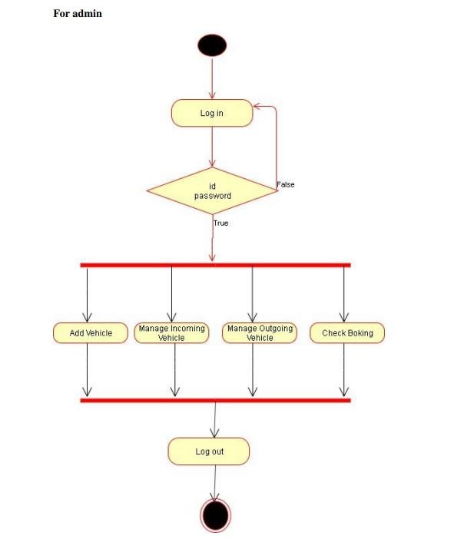

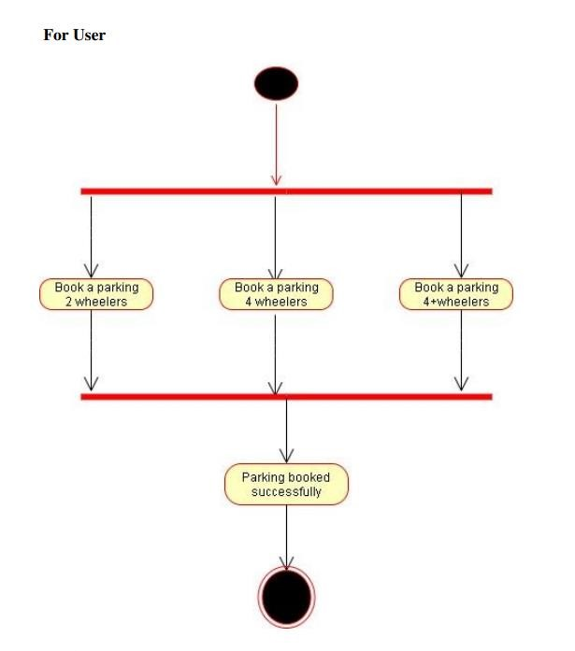

Fig: Activity Diagram

## CHAPTER 2: APPROACHES AND DELIVERABLES

## 2.1 Approaches

Kanban:

Kanban is a visual work management system designed to help us visualize work, boundaries.

Work in progress and maximum efficiency. The Kanban system was first used in Japan in the 1940s, and the concept has evolved ever since. The reason for choosing Kanban's approach is that it can work as well with one person as it does with a team of many. Since the proposed system will be developed in additional pieces and will be improved based on the suggestions of the project supervisors, Kanban's method seems very appropriate. Kanban is a non-disruptive method that encourages focus on the tasks at hand and promotes gradual improvement in a project. It uses the Kanban board to help you see all the work I need to do as a developer. Items will flow from one column of the board to another, indicating the completion of certain tasks. It will also help limit the progress of work by not allowing me to start a new job until my already started work is completed. Therefore, I am sure that Kanban will stand as a very helpful tool for me to manage the work that I need to do to complete this project.

## 2.2 Deliverables

* Automation of the existing parking systems to reduce the staffing.
* requirements for traffic control within the facility.
* Guiding the driver to find a parking space in a more efficient & convenient way.
* Reservation of the parking lots whenever or wherever for the customers.
* Parking lot statistics/report generation made easy for the parking.
* Provide a long-term car parking solution for users & operators.

|  |  |
| --- | --- |
| P**hases** | D**eliverables** |
| Planning and Requirement gathering | Project plan proposal document  SRS document |
| Design | Use case, sequence diagrams,  ERDs Context diagrams |
| Development | Source code |
| Testing and Deployment | Functional tests User Acceptance  Test |
|  |  |

##### 2.3 Major Milestone

The project was done for duration of six months from 1st June-15th November 2022 from the stage of analysis; data collection and system development; for the purpose of collecting righteous information to enable us develop the system.

|  |  |  |
| --- | --- | --- |
| Task | Task Duration | Start Date |

Initiating 15 days 01-Jun

Planning 1 month 16-Jun

Designing 1 month 17-Jul

Execution and Development 2.5 months 18-Aug

Testing 15 days 30-Oct

Deployment 15 days 15-Nov

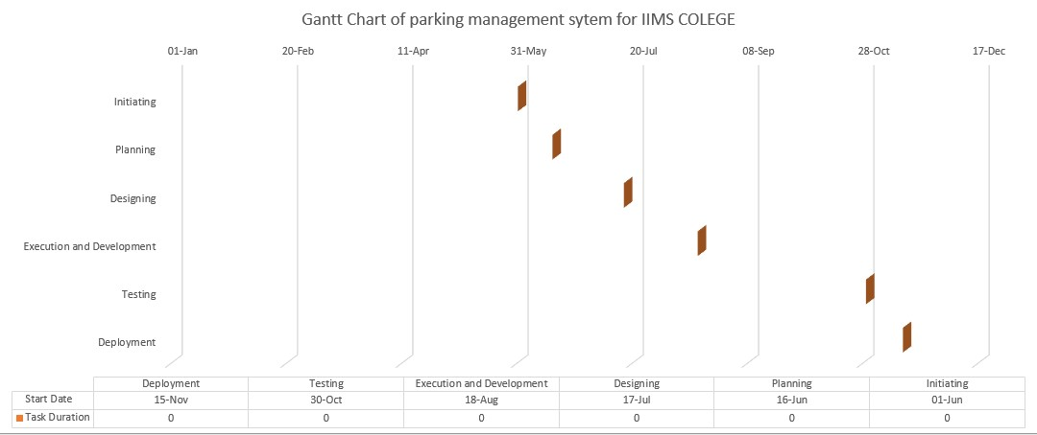

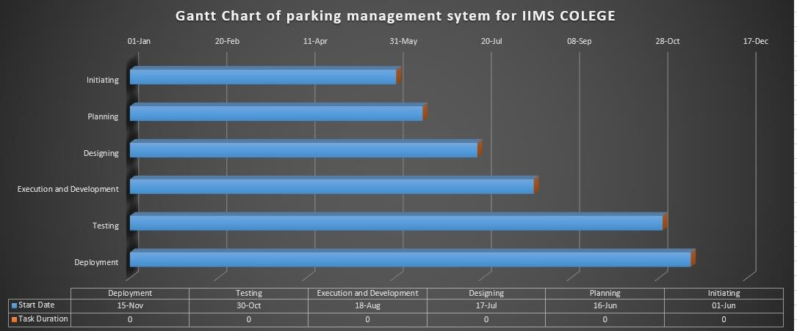

Fig: Gantt Chart